
the Institute of African Studies Presents:
“Troubling Tropes: The African Child in Colonial Postcards of the Early 1900s”
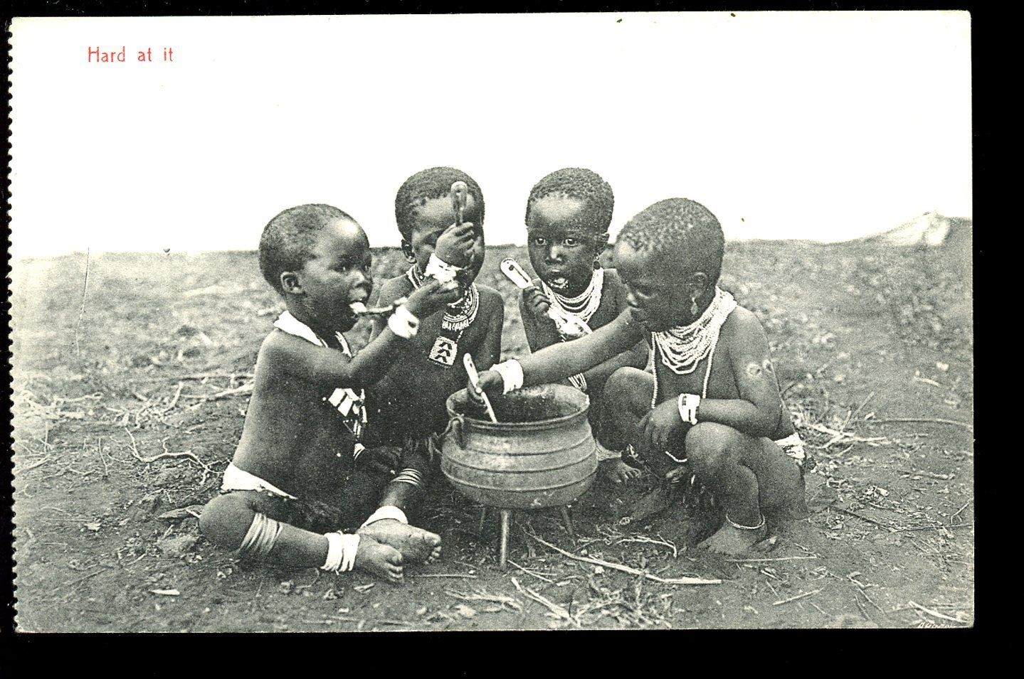
with
Monica Eileen Patterson, Assistant Professor, Carleton University
Wednesday, November 18, 1:00- 2:30 pm
433 Paterson Hall, Carleton University*
Monica Eileen Patterson is an Assistant Professor in the Institute of Interdisciplinary Studies at Carleton University. She received her doctorate in Anthropology and History and a certificate in Museum Studies from the University of Michigan. Patterson is co-editor of Curating Difficult Knowledge: Violent Pasts in Public Places (Palgrave Macmillan, 2011) and Anthrohistory: Unsettling Knowledge and Questioning Discipline (University of Michigan Press, 2011). As a scholar, curator, and activist, she is particularly interested in the intersections of memory, childhood, and violence in postcolonial Africa, and the ways in which they are represented and engaged in contemporary public spheres.
In this presentation, she will examine and contextualize the dominant tropes found in representations of African children in postcards produced in South Africa and beyond in the early 1900s. She will also consider the circulation of these images and the ideas about Africa and Africans that they reflected and helped produce, both then and now.

This is part of the African Studies Brownbag Seminar Series
(http://www.carleton.ca/africanstudies/)
For more information, please contact the Institute of African Studies at
613-520-2600 ext. 2220 or African_Studies@carleton.ca
*For a campus map, please see: http://carleton.ca/campus/map/

