Choices, pathways, and emerging renewables: Exploring the role of new renewable electricity technologies within illustrative pathways for Ontario’s electricity system

Daniel Rosenbloom
Doctoral Candidate, SPPA, Carleton University

Introduction
Ontario is at a critical juncture in its journey toward a decarbonized electricity system. At present, decision-makers face important choices about reinvigorating longstanding development paths (i.e. reinvesting in legacy generation assets) or breaking away from established paths (i.e. ramping up commitments to emerging energy innovations). Due to the considerable lifespans and sunk costs associated with electricity infrastructure, these choices will shape the future trajectory of Ontario’s power system (see Figure 1). Focusing on the next two decades, this paper interrogates central choices facing Ontario’s electricity sector and their implications for the place of new renewables such as solar, wind, and bioenergy. In doing so, this analysis develops illustrative transition pathways for the electricity system in Ontario and suggests that while commitments to new renewables are central to their prospects, the potential place of these sources also hinges on decisions made about other energy options. Although the decarbonization project is often framed as involving struggles between high-carbon and low-carbon arrangements, dynamics in Ontario’s electricity sector reveal that low-carbon possibilities are also in competition and that there is a danger that attending too closely to new renewables might lead Ontario's electricity system further from low-carbon objectives. Correspondingly, the role of new renewables should not be considered in isolation from broader efforts to decarbonize the electricity system (and other energy systems such as transport). This entails engaging with questions about the place of both legacy and emerging electricity options along with their fit with possible low-carbon pathways. In other words, decarbonization pathways involve the cumulative impact and layering of choices.

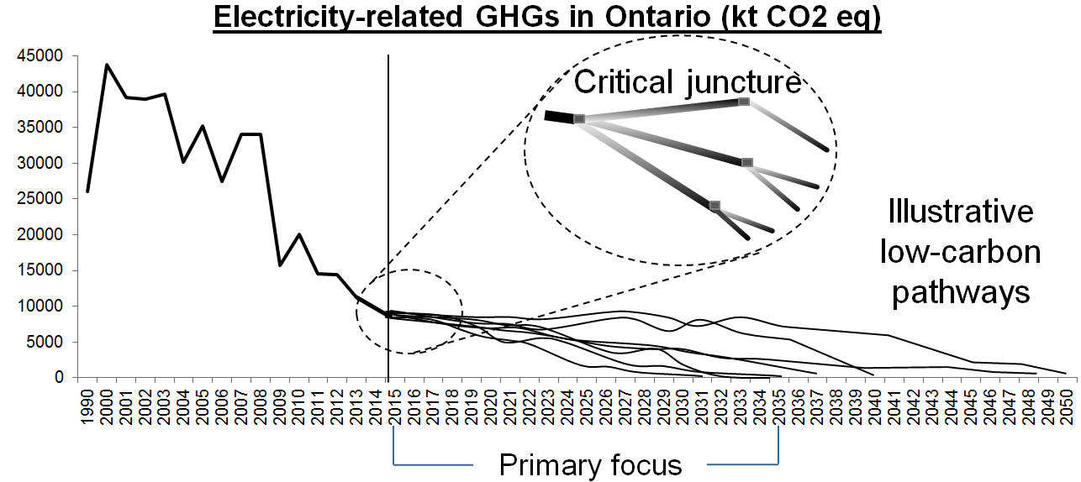
Figure 1: A critical juncture in the journey toward decarbonization

A critical juncture: Path dependence or path breaking?
At the present juncture, decision-makers in Ontario face choices surrounding commitments to legacy and emerging sources. On the one hand, the province has experienced the rapid diffusion of new renewables under the Feed-in Tariff (FIT) and its predecessor, the Renewable Standard Offer Program (RESOP; see Figure 2). As a result of this robust policy support, non-hydro new renewables now account for over 15% of installed capacity and roughly 7% of electricity generation in the province. Yet, the commitment to these emerging sources has waned due to political controversies and cost-containment imperatives. On the other hand, the majority of Ontario’s fleet of nuclear reactors require refurbishment in the coming decade or so (see Figure 3). These legacy assets account for roughly 60% of electricity generation in Ontario and will require substantial financial and political commitments to maintain their current position. While some refurbishment appears poised to proceed (Lea, 2015), there are serious questions about whether reinvestment will materialize as planned (McCarthy, 2015). Cost and risk concerns, in particular, appear to be undermining commitments to nuclear and prompting the consideration of alternative options such as trade agreements with hydro-based jurisdictions (Ministry of Energy, 2015).

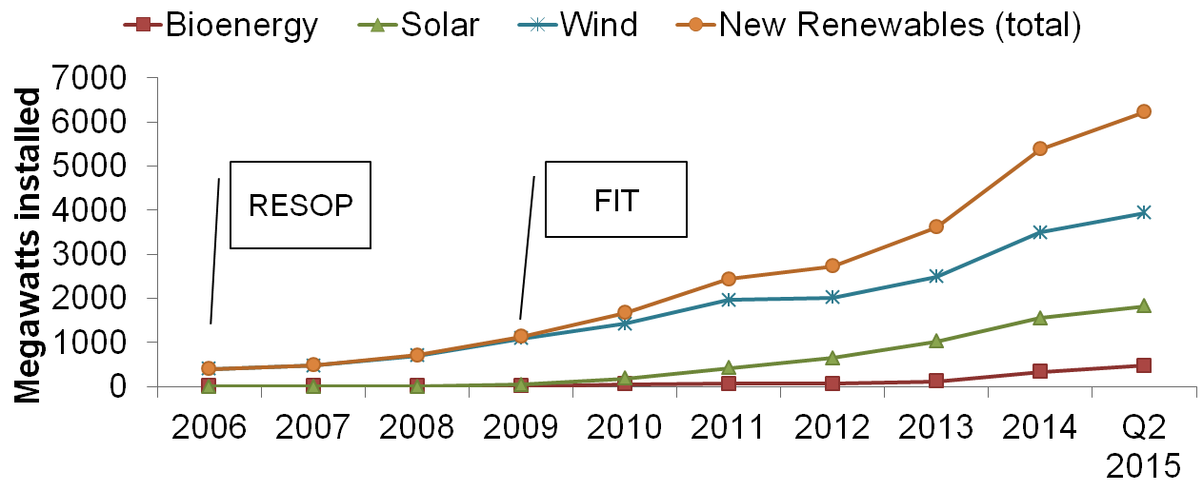
Figure 2: New renewable electricity diffusion in Ontario
Data for this figure are drawn from the Independent Electricity System Operator’s Progress reports.

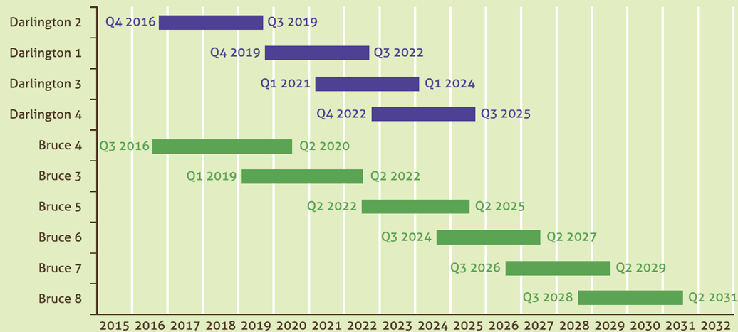
Figure 3: Nuclear reactor refurbishment sequence
This figure was taken from the Ministry of Energy’s Long-term energy plan 2013

Choices about electricity options are both social and technical in nature (see figure 4). Struggles between legacy and emerging sources are not confined to the technical operation of the system (e.g., variability and inflexibility conflicts). Rather, these tensions are also manifest in the political domain, where incumbents and challengers attempt to modify rule systems in their favour (e.g., curtailing variable sources or levying additional insurance requirements on small-scale distributed generators). Indeed, proponents of both nuclear and new renewable sources have become increasingly politically active in an attempt to build legitimacy for their favoured choices while delegitimizing rival options (Rosenbloom, Berton & Meadowcroft, forthcoming). In contrast to jurisdictions where these political struggles principally take place between high carbon interests and those supporting low-carbon arrangements, struggles in Ontario’s electricity sector also revolve around low-carbon sources.

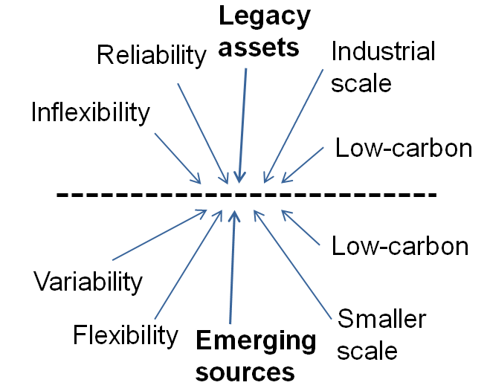
Figure 4: Conflicting socio-technical features

Ontario’s electricity system
Before further scrutinizing the current choices facing Ontario’s electricity system, it is important to examine how the system reached its present configuration. The features of the electricity system in Ontario reflect a layering of historical choices and investments. As Ontario’s electricity sector has a rich history, it is not possible to comprehensively trace its development. Rather, the most relevant historical developments and choices will be explored (see Rosenbloom & Meadowcroft, 2014 for a more in-depth examination of the evolution of Ontario's electricity system).

Three historical developments form the foundation of Ontario’s current electricity system. First, for much of the twentieth century (1922-1997), electricity system planning functioned under an expansionist orientation. This orientation manifested in a virtuous cycle of grid expansion and economic growth that benefitted industrial interests, core actors in the electricity system (e.g., the now defunct Ontario Hydro), and successive political administrations. Out of this orientation came the industrial-scale hydro and nuclear facilities that dominate the current system (see Figure 5). Beyond this, there remain tendencies toward expansion and the use of Ontario’s electricity system as a lever for industrial development. Second, the move toward deregulation (1998-2002) has had lasting impacts on the current system. Central planning was eroded, greater private participation was encouraged, and the system was subject to increased political control. From this, a hybrid market system has emerged whereby most new generation infrastructure is procured through government-directed power purchase agreements with investor-owned firms (the market provides insufficient signals to direct investment). The deregulation experience also saw the break-up of Ontario Hydro into several operational units that now form the core institutional actors in the sector (Ontario Power Generation, Hydro One, and others). Third, mounting environmental concern dating back to the 1970s has promoted the consideration of cleaner energy options and conservation.

Figure 5: Electricity generation and capacity by source in Ontario (2014)
Data for this figure are drawn from the Ontario Energy Board and IESO. Note that some capacity was deployed during the course of 2014 and was not in operation over the entire year.

Choices made in the recent past have also shaped the electricity configuration (see Figure 6). Over the past decade, the Liberal government of Ontario has directed core actors in the electricity sector to: (1) phase out coal power, (2) adopt cleaner power sources, and (3) engage more seriously with conservation and efficiency. While the move away from coal was initially resisted by core actors, coal generation was successfully phased out in 2014. Facilitated by the boom in shale gas development, this has encouraged a surge in natural gas investment. As of 2004, the Liberal government also began promoting the deployment of new renewables through incentive programs. The Green Energy and Green Economy Act, with the FIT as its centrepiece program, represents the most prominent form of support. Conservation and efficiency objectives have been advanced through the rollout of smart meters, time-of-use pricing, and other efforts (e.g., decoupling revenue from electricity consumption for local distribution companies). Nuclear, on the other hand, has enjoyed continued support as reflected by the refurbishment of a handful of reactors at Pickering and Bruce sites over the past decade.

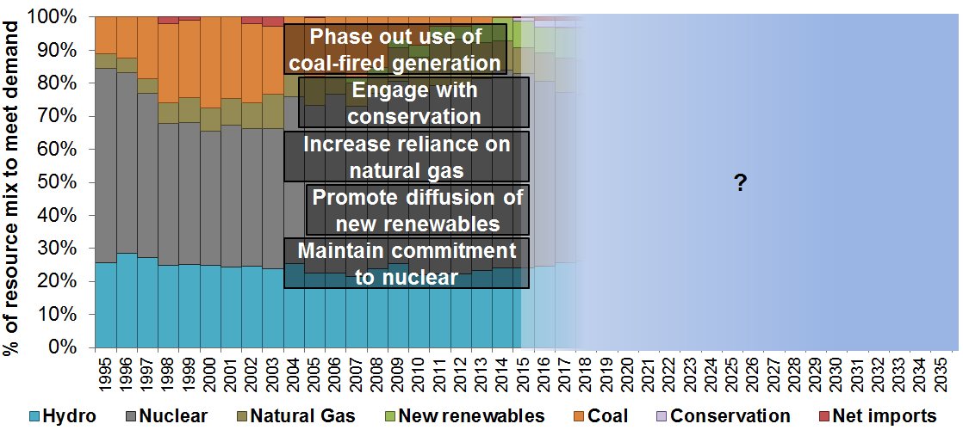
Figure 6: Summary of legacy choices (2003-2015)
This figure illustrates a number of choices made in the recent past that have shaped the current configuration. These choices have been mapped onto historical electricity generation in the province.

Currently, poor economic conditions and strengthened climate policy are impinging upon electricity decision-making. Limited economic growth has placed fiscal constraints on the government and motivated reforms within the electricity sector (e.g., the partial privatization of Hydro One and the exploration of opportunities to increase electricity imports from low-cost hydro-based jurisdictions). As part of this, cost containment has become an overarching priority in electricity system planning, eroding support for nuclear refurbishment and new renewable incentives. The governing Liberals have also moved to strengthen the climate policy framework by adopting a cap-and-trade system under the Western Climate Initiative (joining Québec and California). This raises questions about natural gas generation in the context of increasing carbon constraints (depending on whether natural gas generators negotiate temporary exemptions or favourable allowance allocations).

Choices, pathways, and emerging renewables in Ontario
The above discussion points to a number of interlocking choices that will shape potential low-carbon pathways and the role of new renewables. These choices principally revolve around whether: (1) to extend the commitment to nuclear power by refurbishing existing plants; (2) to reaffirm support for new renewables; (3) to augment the role of interconnection and electricity trade with neighbouring hydro-based jurisdictions; (4) to increase reliance on natural gas-fired generation (given increasing carbon constraints); and (5) to pursue conservation and efficiency over expansion. By varying the nature and timing of these choices, three illustrative low-carbon pathways are developed (see Figures 7-9). These illustrative pathways represent a typology of development possibilities. Actual development patterns are likely to mesh elements of the three pathways.

The first illustrative pathway – nuclear renewal – examines the timing and nature of choices associated with a relatively path dependent evolution of the electricity system. It closely mirrors the development trajectory established by core actors in the sector (e.g., the Long-term energy plan). This path hinges on nuclear commitments remaining relatively unchallenged and the successful negotiation of contracts for reactor refurbishment (i.e., shifting liabilities for delays and cost overruns to private sector firms). In this pathway, other existing sources would mainly be used to bridge supply shortfalls until nuclear reactors come back online. More vigorous support for new renewables and associated system innovations (e.g., changes to operational procedures or procurement criteria) would make little sense. Grid modernization efforts could be deployed incrementally to address the inflexibility of nuclear rather than integrate additional variable new renewables.

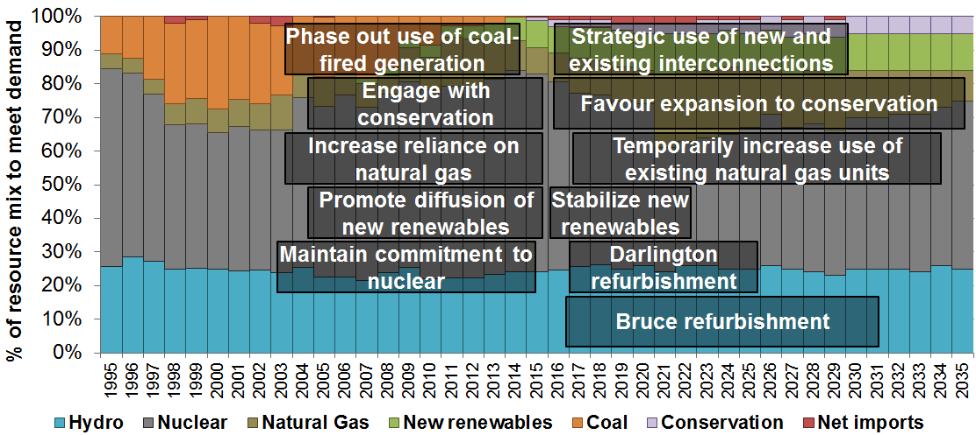
Figure 7: Illustrative pathway 1 – Nuclear Renewal

The second illustrative pathway – natural gas fills the gap – examines the timing and nature of choices associated with a more path breaking evolution of the electricity system. In marked contrast to nuclear renewal, this pathway revolves around an increasing reliance on natural gas generation as older nuclear reactors are gradually decommissioned. As nuclear reactors ramp down at the end of their useful lives, a more flexible system could emerge and open up additional space for a series of alternatives (e.g., variable new renewables, electricity trade, and enhanced conservation efforts). Yet, while this illustrative pathway may diverge from established trajectories, it is more carbon-intensive unless envisioned as a move toward carbon capture and storage (but this presents uncertainties and challenges). The unfolding of this pathway would likely depend on the delegitimization of reactor refurbishment (on cost or sustainability grounds) by rival actors (perhaps involving a strategic alliance between natural gas and new renewable advocates).

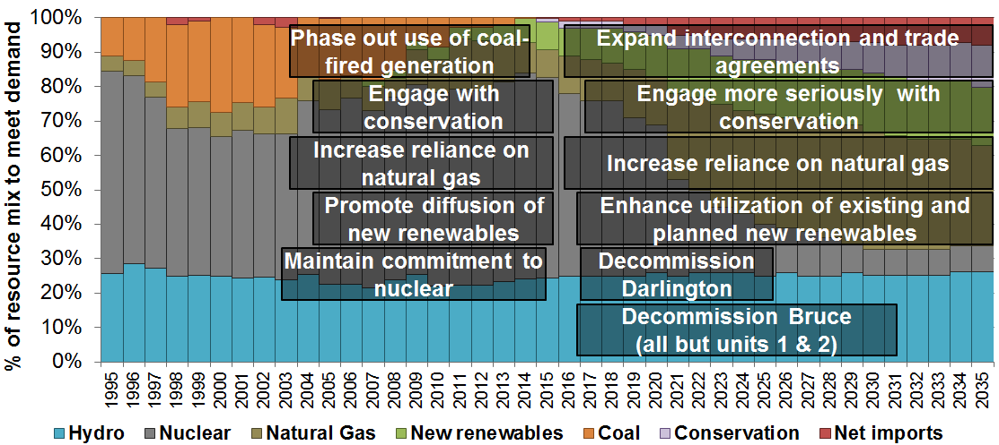
Figure 8: Illustrative pathway 2 – Natural gas fills the gap

The third illustrative pathway – integrated approach – represents the most path breaking evolution of the electricity system. This pathway emphasizes the accelerated diffusion of complementary emerging low-carbon innovations and practices in order to displace both nuclear and natural gas. As part of this, nuclear and natural gas possibilities would likely need to be delegitimized (perhaps linking to concerns about risks and intensified low-carbon objectives). Rather, natural gas could be envisioned as a stopgap for grid modernization efforts and vehicle-to-grid possibilities. Long-term trade agreements could also be negotiated with neighbouring jurisdictions to further enable new renewables and pick up the slack from declining conventional generation.

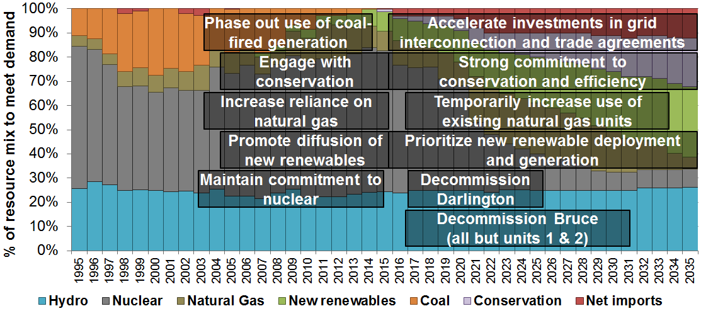
Figure 9: Illustrative pathway 3 – Integrated approach

Conclusion
Drawing on illustrative pathways, this analysis has identified and scrutinized critical choices shaping future trajectories for Ontario’s electricity system and the role of new renewables therein. These choices suggest that the place of new renewables hinges not only on direct support but also on decisions made about other electricity options (particularly legacy nuclear assets). Illustrative pathways also indicate that new renewables and decarbonization do not always coincide. High new renewable penetration can emerge within more carbon-intensive trajectories. So, while new renewable deployment is central to decarbonization, it is important to focus on the broader low-carbon transition and embed new renewable support within the pursuit of decarbonization pathways.

References
Lea, D. (2015). Nuclear manufacturer invests more than $10 million in new Oakville facility. Retrieved September 22, 2015, from http://www.insidehalton.com/news-story/5918338-nuclear-manufacturer-invests-more-than-10-million-in-new-oakville-facility/
McCarthy, S. (2015). Negotiations delay TransCanada’s Bruce Power nuclear reactor updates. Retrieved September 22, 2015, from http://www.theglobeandmail.com/report-on-business/industry-news/energy-and-resources/negotiations-delay-transcanadas-bruce-power-nuclear-reactor-updates/article23997933/
Ministry of Energy. (2015). Ontario and Newfoundland and Labrador Agree to Evaluate Clean Electricity Trade Opportunities. Retrieved September 22, 2015, from http://news.ontario.ca/mei/en/2015/07/ontario-and-newfoundland-and-labrador-agree-to-evaluate-clean-electricity-trade-opportunities.html
Rosenbloom, D., & Meadowcroft, J. (2014). The journey towards decarbonization: Exploring socio-technical transitions in the electricity sector in the province of Ontario (1885–2013) and potential low-carbon pathways. Energy Policy, 65, 670–679. http://doi.org/10.1016/j.enpol.2013.09.039

