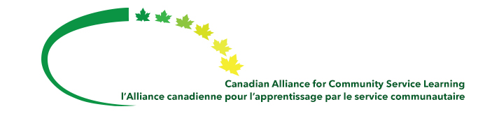

C²UExpo 2015 – May 26th to May 29th 2015
Citizen-Driven Policy: Strengthening Community Engagement for a Better World.

First and foremost, the C²U Expo 2015 conference provides the opportunity for participants to be inspired and energized by the successes of community-campus partnerships, community based research, and community service-learning. Furthermore, the conference provides a means for participants to build connections and share ideas through meaningful dialogue, work in solidarity to build on the cumulative legacy of the Expo’s networks, partnerships, and projects throughout Canada and the world.

The C²U Expo 2015 conference aims to build momentum for policy solutions that help civil society organizations navigate the current environment, and more effectively assert their interests through policy development and engagement; and Strengthen the growing national movement to deepen community-campus engagement as universities and colleges seek to enhance their potential to contribute to the development of Canada and the public good.

CACSL members will enjoy a 15% discount on the regular conference rate ($65.25 to $72.75 reduction).

Preconference Workshops
A number of pre-conference workshops and webinars will be offered prior to the conference in May.

The pre-conference workshops will be organized and facilitated by the Community-Campus Partnerships for Health, Canadian Alliance for Community Service-Learning and Volunteer Canada, Institute for Community Engaged Scholarship, and Community-Based Research Canada. Confirmed workshops are:
- Collective Impact Pre-Conference Event.
- Understanding and Advancing Impact, Policy and Funding for CBR and CCE.
- Engaged Practice Learning Exchange Workshop.
- Collective Impact and Community Engagement: From Idea to Action.
- How to Build a Research Shop.
- Translating Practice to Policy in Community-Campus Partnerships.

CACSL members will enjoy a $105 reduction in the Collective Impact pre-conference event.

The pre-conference webinars will be hosted by the University of Saskatchewan and Memorial University. Confirmed workshops are:
- Station 20 West – Community Enterprise Centre.

