Facilitator Guide:
  - Open Educational Resources

Appendix A: Module Slides and Notes (Face-to-Face)
Module Overview 5
Lesson Plan 6
Learning Outcomes 6
Topics and Subtopics 6
Part i – what are oer? 6
Part ii – Why use oer? 7
Teaching and Learning Activities (Online Delivery) 8
Teaching and Learning Activities (Face-to-Face Delivery) 9
Appendix A: Module Slides and Notes (Face-to-Face) 13

About the Guide
This guide is meant for facilitators who will be leading the Open Educational Resources (OER) module in online, face-to-face, or blended learning environments.
The guide includes suggested teaching and learning activities for both online and face-to-face delivery. The activities may be mixed or modified for a blended learning experience.
All activities and content in this module are customizable and may be modified for your purposes. All materials are licensed under Creative Commons license: Attribution-NonCommercial-ShareAlike 4.0 International (CC BY-NC-SA 4.0).

ACCESSIBILITY
Module components have been designed to be fully navigable by keyboard and assistive technologies. Participants are provided with a way to skip repetitive navigation links and information. All audio and video components include synchronized text captions and descriptive tags where appropriate.

Module Overview
The goal of this module is for participants to identify the benefits of using and/or developing open educational resources for higher educational purposes, and to locate appropriate materials for specific subject matter.
The open resource model proposed here allows for instructors to reuse, repurpose, and redesign any number of different open-license educational materials that are deemed appropriate for the use in a course. This is a departure from the traditional copyright model which restricts usage based on a paid model. This module will help instructors recognize how these resources can be implemented in their courses, and they should be aware of how open copyrights work and can be put to use on their own materials. If you are delivering a full program in blended and online teaching and learning, it is recommended that you include this module with the open access and open data modules.

Lesson Plan

Learning Outcomes
By the end of this module, participants should be able to:
- Define different copyright models and usage rights for educational resources
- Identify the benefits and challenges of OERs in teaching and learning
- Locate sources of OERs specific to their discipline
- Develop a learning activity that uses OERs in the design

Topics and Subtopics

Part i – what are oer?
- Defining Open education resources (OER)
  - What are OER?
    - “Open educational resources are digitized materials offered freely and openly for educators, students and self-learners to use and re-use for teaching, learning and research”. (CITE)
- What do they include:
  - Learning content: full courses, courseware, content modules, learning objects, collections and journals.
  - Tools: software to support the development, use, re-use and delivery of learning content.
  - Implementation resources
- Key characteristics of OER
  - No technical barriers
  - No price barriers
  - Few legal permission barriers
- Copyright and licensing models
  - What is Creative Commons
    - Overview of different licenses available
    - How to decide which type to use
    - Examples

Part ii – Why use oer?
- Why are individuals and institutions engaged in OER?
- Benefits
  - Quality improvement
  - Faster technical and scientific development
  - Increase publicity, reputation
  - Teachers and students’ viewpoints:
  - Flexibility in choosing materials
  - Save time and effort through reusing resources
  - Suggestions for improvement
  - Learning communities, collaborative learning environments.
- Arguments
  - Increased workload
  - Poor quality
  - Financial loss for authors
- How can OER make a difference in teaching and learning?
- Available Open education resources
  - Examples including open universities, iTunes U etc.

Teaching and Learning Activities (Online Delivery)
1. Content Delivery: Participants read module goals and learning outcomes listed directly on the course page within the module.
Then view “What are OER?”, which includes the following components:
- Quick definition & reflection question on using open educational resources.
- Slides: Different types of resources and key characteristics
- Video: Interviews with different instructors about their experiences using OER and how they integrated them into their course.
- Slides: Open copyright & licensing model (Creative Commons)
Approximate run time: 30 minutes
2. Content Delivery: Participants view “Why use OER?”, which includes the following components:
- Reflection: Ask participants to brainstorm their own benefits and challenges to using OER.
- Slides: Discussion on the primary arguments for and against the use of OER, and what kind of difference they can make in Higher Education.
Approximate run time: 10 minutes
3. Discussion Board/Group Activity: Create a discussion board called “Free education?” and ask participants their own thoughts on whether the benefits actually outweigh the challenges of using OER.
4. Assignment submission*: Share page of links to a variety of OER repositories. Ask participants to look for content that is particular to their expertise, then design a lesson or activity for delivery a module/lesson/activity and submit.
*Participants may use the assignment submission tool in your LMS.

Teaching and Learning Activities (Face-to-Face Delivery)
Approximate Duration: 3 hours with 15 min break
Recommended Materials: Flipchart or whiteboard, markers or whiteboard markers, laptop with projector and speakers
1. Introduction to Module & Agenda (5 mins):
Introduce yourself and explain your role at the school. You may edit slide to insert name, position, contact info. Lead participants through goal and learning outcomes of module. Provide an overview of how session will be divided.
2. Content Delivery: Why Open Education matters (2:27 min)
Watch the youtube video (https://youtu.be/gJWbVt2Nc-I)
*Please note that this video has not been professionally closed-captioned.
3. Group Activity: Think – Pair – Share (15 mins)
Ask participants to think about and share any knowledge or experience they have with OERs with a partner, then ask for volunteers to share with the whole group.
4. Content Delivery: What are OER? (15 mins)
View presentation “What are OER?”, which discusses different types of resources and key characteristics.
5. Content delivery: Video (10 mins)
Watch interviews with different instructors about their experiences using OER and how they integrated them into their course.
6. Group discussion (15 mins)
Discuss some of the ideas that were presented in the video and how they could be adapted for different situations relevant to participants.
7. Content delivery: Open copyright & licensing model (Creative Commons) (25 mins)
Present different open copyright & licensing models, highlighting different types of creative commons copyrights. Answer questions participants might have regarding different licenses. Go over steps to choosing an open license found here: http://www.wikihow.com/Choose-a-Creative-Commons-License
8. Group activity: Brainstorm (30 mins)
Ask participants to brainstorm benefits and challenges to using OER and share with a group of four and then create a class list.
9. Discussion: Why use OER? (10 mins)
Discussion about the primary arguments for the use of OER, and what kind of difference they can make in Higher Education.
10. Content delivery: Video (10 mins)
Watch interviews with different instructors discuss the benefits of using OERs.
11. Discussion: Why use OER? (10 mins)
Discussion about the primary arguments against the use of OER, and what kind of problems they can pose in Higher Education.
12. Content delivery: Video (10 mins)
Watch interviews with different instructors discuss the challenges of using OERs.
10. Assignment * (15 mins): Share page of links to a variety of OER repositories. Point out a few main resources related to different fields, and ask if any participants are aware of any other resources for their field. Ask participants to look for content that is particular to their expertise, then design a lesson or activity for delivery a module/lesson/activity and submit.
*Participants may use the assignment submission tool in your LMS.

Additional Resources and References
Allen et al. (2005, November 5). Foundations for OER Strategy Development. Retrieved January 15, 2017, from OER Strategy, http://www.oerstrategy.org/wp-content/uploads/2015/11/Foundations-for-OER-Strategy-Development.pdf
Assessing Social Presence in Asynchronous Text-based Computer Conferencing. (2001). Retrieved January 15, 2017, from Journal of Distance Education, http://auspace.athabascau.ca:8080/bitstream/2149/732/1/Assessing%20Social%20Presence%20In%20Asynchronous%20Text-based%20Computer%20Conferencing.pdf
Bates, T. (2015, February 16). Making sense of open educational resources. Retrieved January 15, 2017, from http://www.tonybates.ca/2015/02/16/making-sense-of-open-educational-resources/
Bates, T. (2015, April 5). Teaching in a digital age. Retrieved January 15, 2017, from Open Text BC, https://opentextbc.ca/teachinginadigitalage/part/10-trends-in-open-education/
Bryer, T. A. & Zavattaro, S. (2011). Social media and public administration: Theoretical dimensions and introduction to symposium. Administrative Theory & Praxis, 33(3).
Butcher, N. (2011). Commonwealth of Learning: A Basic Guide to Open Educational Resources. Retrieved January 15, 2017, from UNESCO, http://unesdoc.unesco.org/images/0021/002158/215804e.pdf
Cape Town open education declaration. (2007, September). Retrieved January 15, 2017, from The Cape Town Declaration, http://www.capetowndeclaration.org/read-the-declaration
CCCOER. (2017, January 9). Retrieved January 15, 2017, from Open Education Consortium, https://www.cccoer.org/
Contact North (2015, December 10). Focusing on the future of open educational resources (OER). Retrieved January 15, 2017, from Teachonline.ca, http://teachonline.ca/tools-trends/making-most-open-educational-resources-oers/focusing-future-open-educational-resources-oer
Foster, T., Fougere, B. (n.d) Home - open educational resources. Retrieved January 15, 2017, from Algonquin College, http://www.algonquincollege.com/oer/
OER Commons. Retrieved January 15, 2017, from OER Commons, https://www.oercommons.org/
Open course & educational resource guidelines. Retrieved January 15, 2017, from Copyright at University of British Columbia, http://copyright.ubc.ca/guidelines-and-resources/support-guides/open-course-educational-resource-guidelines/
OpenStax CNX. Retrieved January 15, 2017, from OpenStax CNX, https://cnx.org/
Wiley, D. Defining the “open” in open content and open educational resources. Retrieved January 15, 2017, from Open Content, http://opencontent.org/definition/

Appendix A: Module Slides and Notes (Face-to-Face)
Slide 1
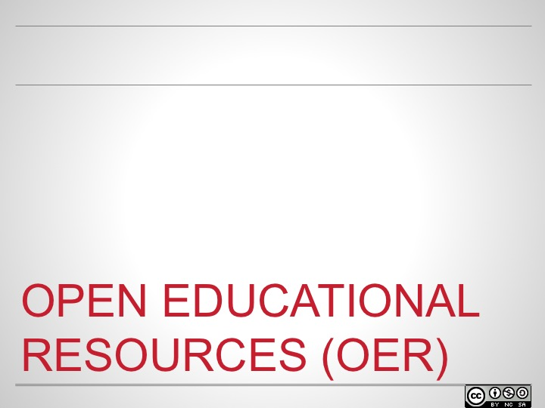

Slide 2
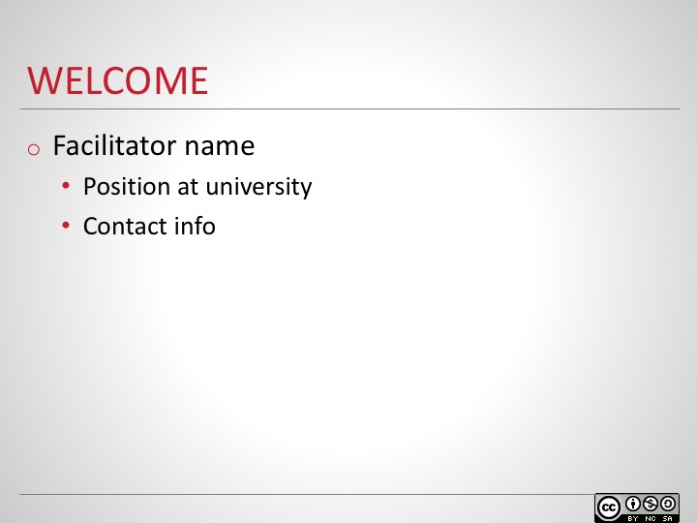
Introduce yourself and explain your role at the school. You may edit slide to insert name, position, contact info.
If this is the first of a series of modules, spend a little bit of time giving overview of the program. You may wish to insert a slide or two with that information.

Slide 3
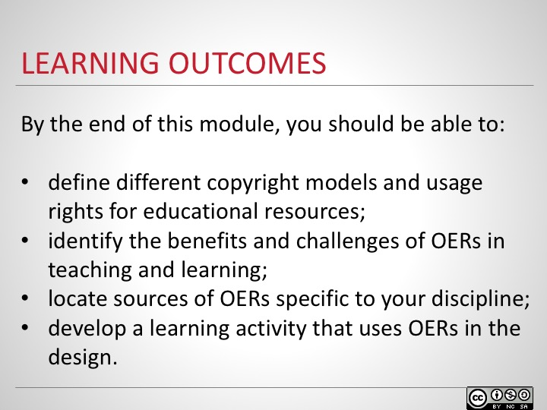
The goal of this module is for you to understand the benefits of using and/or developing open educational resources and to locate discipline-specific materials to integrate in course design.
After introducing the goal, lead participants through learning outcomes.

Slide 4
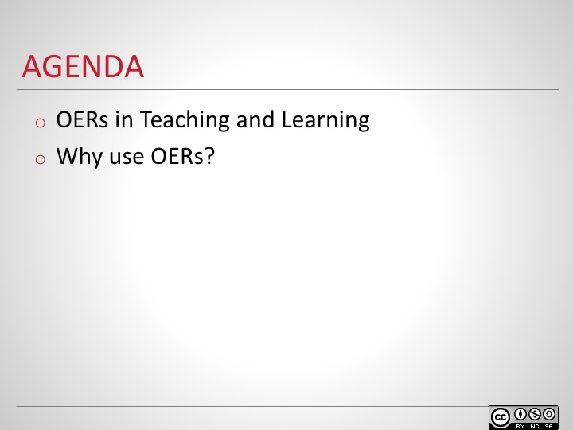
Provide an overview of how the session will be divided (if a different order makes more sense for your context, please feel free to reorder the slides and include additional materials).

Slide 5
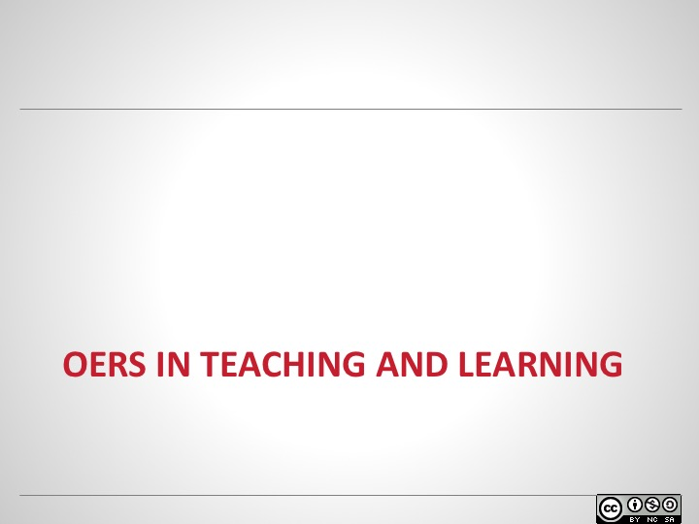

Slide 6
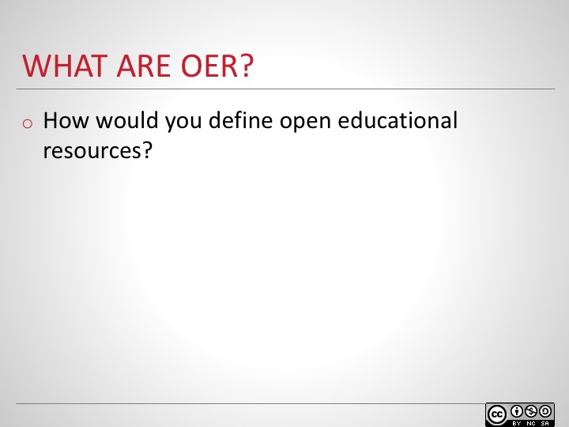
Give participants a moment to think on their own. Elicit a few responses before moving to the next slide.

Slide 7
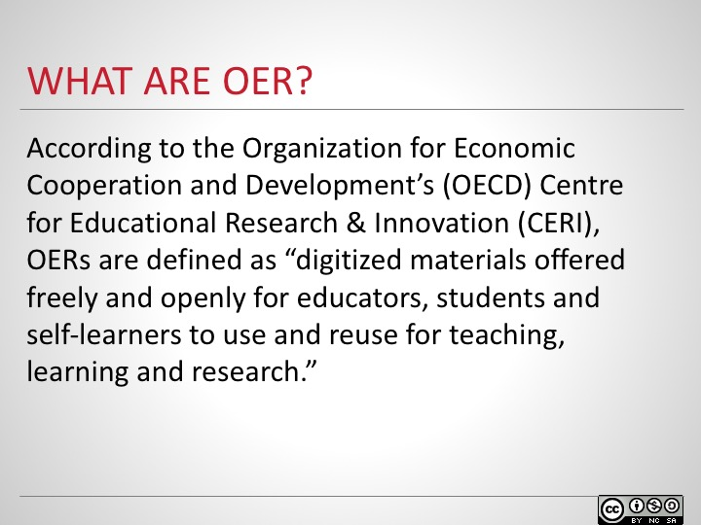
According to the Organization for Economic Cooperation and Development’s (OECD) Centre for Educational Research & Innovation (CERI), OERs are defined as “digitized materials offered freely and openly for educators, students and self-learners to use and reuse for teaching, learning and research.”
Ask participants whether their responses from the previous slide are included in this definition.

Slide 8
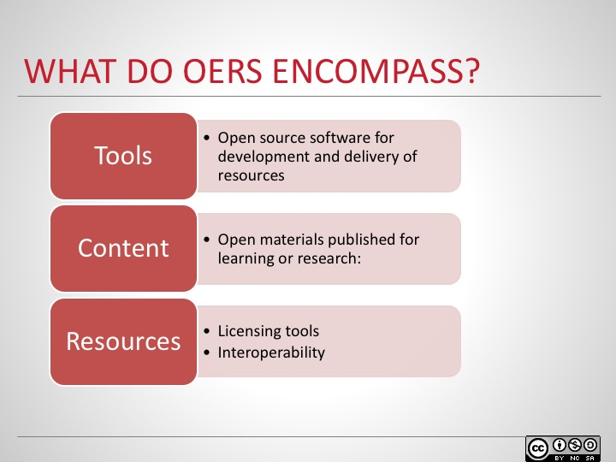
Review the three areas and highlight the examples given below.
It’s helpful to take a broad view of OERs and consider the types of tools, learning content, and implementation resources that are part of the ecosystem of open resources and approaches.
Tools:
- Open source software for development and delivery of resources
- Content management systems (CMS)
  - EduCommons
- Development Tools
  - Connexions
- Social Software
  - Wikis/H2O/OSLO Research
- Learning Management Systems (LMS)
  - Moodle/Sakai
Open materials published for learning or research:
- Learning resources
- Courseware:
  - MIT OCW, ParisTech, Japan OCW Consortium
- Learning objects:
  - Merlot/Connexions/ARIADNE
- Open textbooks are OER materials that are created in order to allow more access to knowledge in courses by reducing costs to students and giving faculty more control over instructional resources.
- Reference
- Collections:
  - Internet archive/Google Scholar/Library of congress/Wikis.
Implementation resources
- Licensing tools
  - Creative Commons
  - GNU Free Documentation License
- Best practices
  - CMU design principles
- Interoperability
  - IMS/SCORM

Slide 9
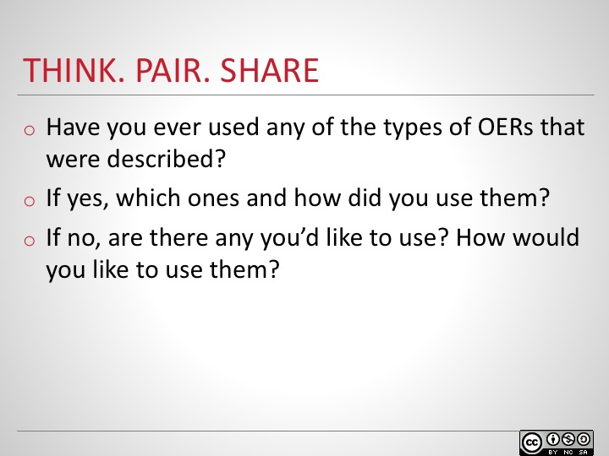
Ask participants to spend 2-3 minutes individually answering the questions, then spend 2-3 minutes discussing with a partner. Ask pairs to share their thoughts with the larger group. List participants’ answers on a whiteboard or flipchart to refer back to later.

Slide 10
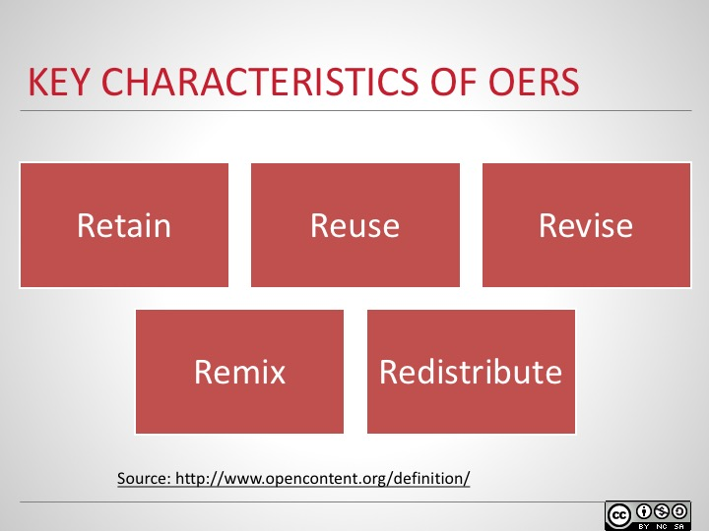
The key characteristics of open content and open educational resources are commonly referred to as 5R Activities, specifically the right to retain, reuse, revise, remix and redistribute materials. OERs are licensed in a way that allows others free and perpetual permission to engage in these activities.
Go over each of the activities as described below:
The first of the 5R activities is to retain, which provides users with the right to make, own, and control copies of the content. For example, the right to download, duplicate, store, and manage materials.
Reuse refers to the right to reuse the content in a variety of environments, such as in a class, in a study group, on a website or in a video.
The right to revise means the right to adapt, adjust, modify, or alter the content itself, such as translating content to a different language or editing materials to meet institutional-specific needs.
Remixing gives users the right to combine the original or revised content with other material to create something new, similar to a mashup of ideas.
Redistribution is the right to share copies of the original content, your revisions, or your remixes with others. For example, you can share a version with a colleague.

Slide 11
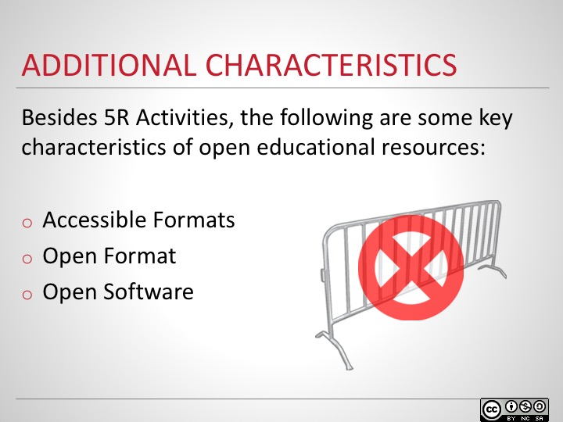
Share some additional key characteristics of OERs including accessible formats, meaning everyone can access the content without restrictions; open format, indicating the material is available in a format that anyone can use; and open software, meaning the source code is open and free to download and use.
Point out that there should be no barriers to accessing open educational materials.

Slide 12
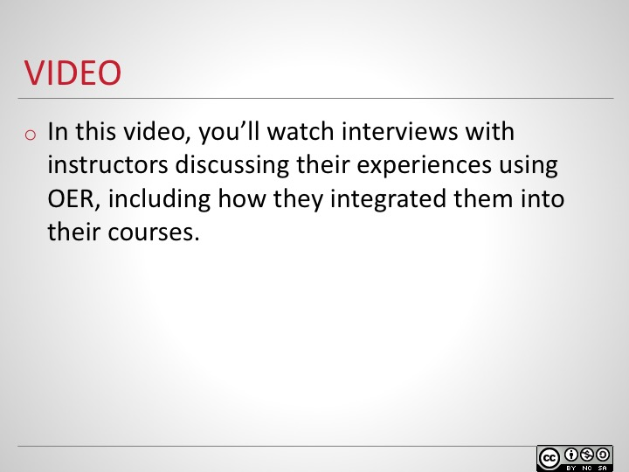
Introduce the video of instructors discussing their experiences using OER, including how they integrated them into their courses.
Ask participants to think about how these experiences might relate to their own.

Slide 13
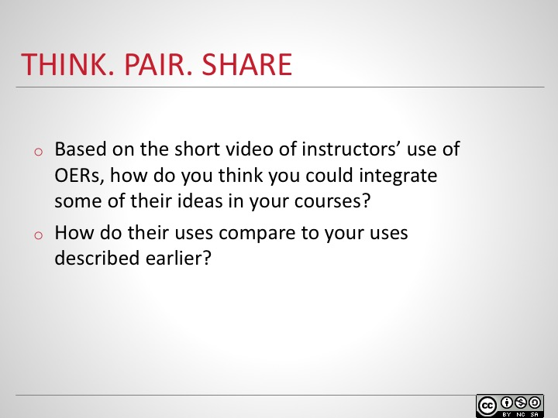
Ask participants to spend 2-3 minutes individually answering the questions, then spend 2-3 minutes discussing with a partner. Ask pairs to share their thoughts with the larger group. List participants’ answers on a whiteboard or flipchart to refer back to later.

Slide 14
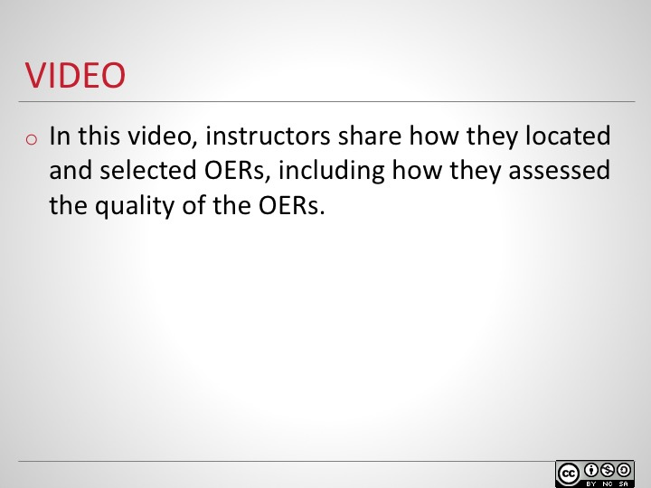
Introduce the video of instructors how they located and selected OER, including how they assessed the quality.
Ask participants to think about how they might select OER material in their own discipline.

Slide 15
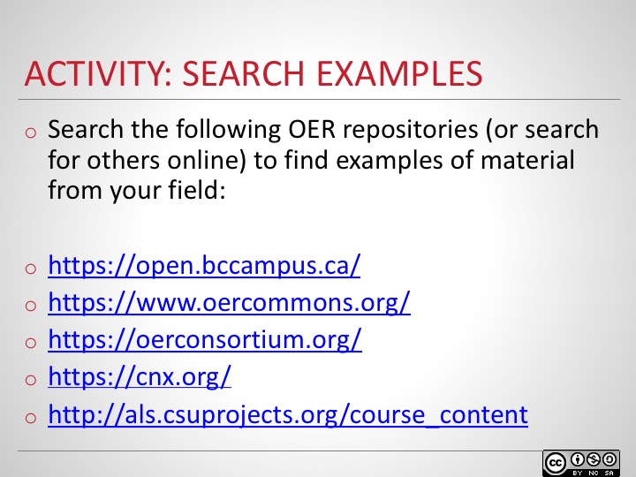
Ask participants to independently search for a variety of different OERs using the repositories supplied, or find others online that may be more relevant for their field of study.
After they’ve found a few, ask participants to share their selection process and how they determined whether the OER was of good quality.
Also ask how they might modify based on the 5R Activities shared earlier.

Slide 16
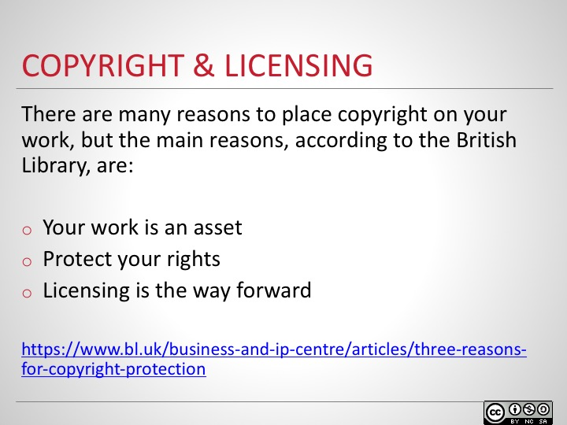
Publishing resources in an open way brings traditional copyright models into question. Go over the reasons provided below with the group and ask them if they can think of any others.
According to the British Library, the three main reasons to copyright work include:
Your work is an asset - A piece of creative work, may be worth something someday, so it’s in the best interest of the creator to place protection on the work to prevent copying.
Protect your rights - A copyright legally protects the creator from anyone infringing on their proprietary rights.
Licensing is the way forward - Licensing permits the creator to grant some or all rights to users to only use the work in the way their license allows.

Slide 17
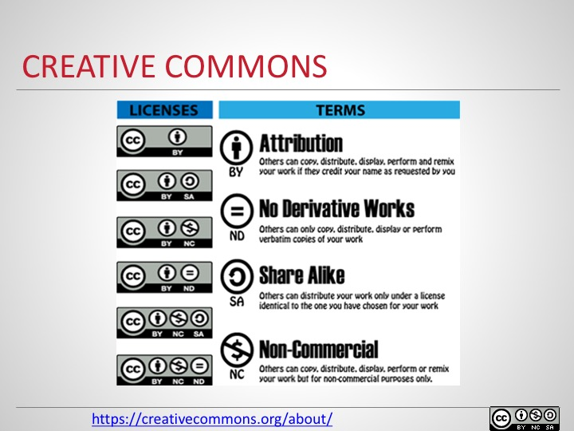
This image shows the different forms and permutations that creative commons licenses can take. Describe it to the participants and explain that the different terms can be combined to form multiple variations.
“Creative commons helps you legally share your knowledge and creativity to build a more equitable, accessible, and innovative world. We unlock the full potential of the internet to drive a new era of development, growth and productivity.” https://creativecommons.org/about/
The four main terms of the licenses include:
- Attribution, meaning others can copy, distribute, display, perform and remix your work if they credit your name.
- No derivative works means others can only copy, distribute, display or perform verbatim copies of your work.
- Share alike, where others can only distribute your work under a license identical to the one you have chosen.
- Non-commercial indicates that others can copy, distribute, display, perform or remix your work only for non-commercial purposes.
Slide 18
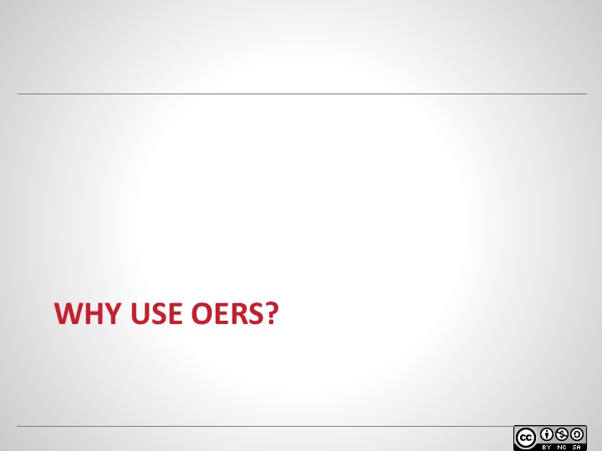

Slide 19
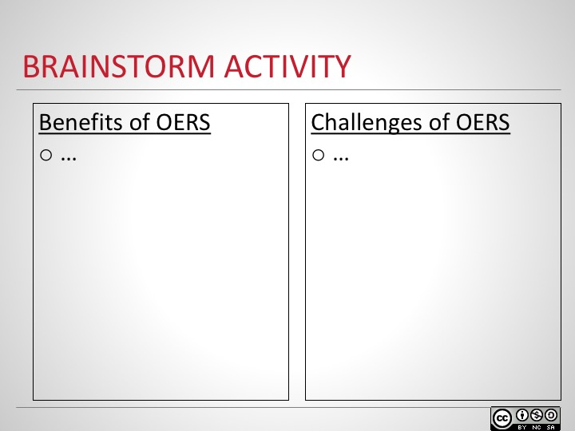
Ask participants to brainstorm benefits and challenges to using OER by creating two lists individually. After the each learner has created their lists, ask them to join in a group of 4 and discuss. Finally, create a class list of all the benefits and challenges that were discussed in the groups.

Slide 20
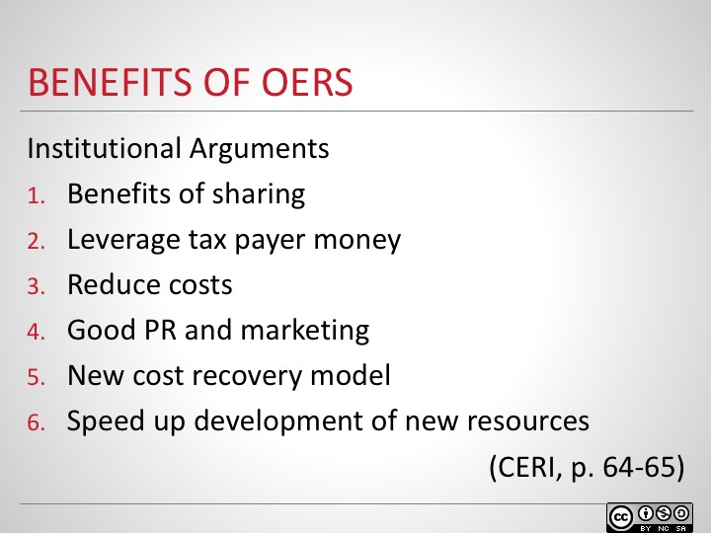
According to the Organization for Economic Cooperation and Development’s Centre for Educational Research and Innovation (CERI), there are six primary arguments in favour of OERs.
First, the altruistic benefit of sharing resources is intrinsic within academia. By sharing and accessing each other’s work, a body of knowledge will continue to grow and improve.
Next, there is an argument in favour of making publicly funded research available to the public. Particularly at public institutions, there is a movement to make work open to the tax payers who fund the work, and other members of the public who might benefit. If this research is pay per use or has other restrictions there is the potential for redundancy from repeated work resulting in waste.
Third, by adapting or repurposing work, development costs are greatly reduced. If research or other resources build on top of, or leverage, previous studies, making the research open reduces the amount of time and costs needed to create material.
Fourth, by opening up material to the world, a tremendous amount of exposure is created for the institution. Exposure, in turn, attracts new students who are drawn to study at that institution, such as with the MIT Open Courseware project.
Fifth, creating new cost recovery models by opening materials and lowering costs for potential students can actually increase revenues by attracting more and more students to their institution who might not have been able to attend previously due to financial limitations.
Sixth, the speed of development of learning materials increases, which means that learners have access to the most up-to-date materials. Inaccuracies and corrections can be quickly caught, implemented, and shared with students.

Slide 21
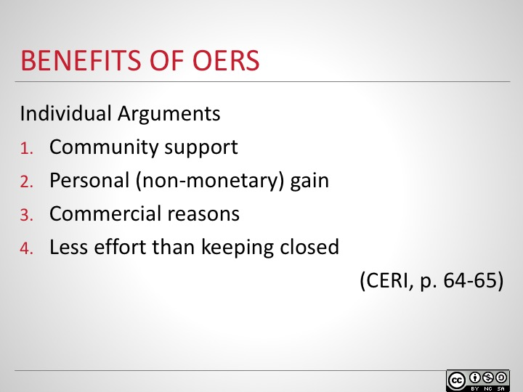
CERI also outlines individual motivators for adopting or creating OERs.
First, helping out the community contributes to the body of knowledge and moves the body of knowledge forward. By interacting and discussing with the wider community, more people are able to benefit from your knowledge.
Second, there is a tremendous amount to gain through non-monetary means, such as reputation. By contributing to and sharing OERs, knowledge of your work increases and invitations to write journal articles or participate in other research also increases.
Third, making materials open can be a commercial strategy. If you make a first draft or chapter available so others can see what you’re working on, they might be interested in purchasing the final or whole version. This is known as a ‘freemium’ model, where the free copy is very basic, but purchases are an improved and/or supported version.
Fourth, the effort of getting copyrights and maintaining vigilance can be more effort than it’s worth, particularly for smaller, incremental works, as opposed to much larger studies and projects.
Slide 22
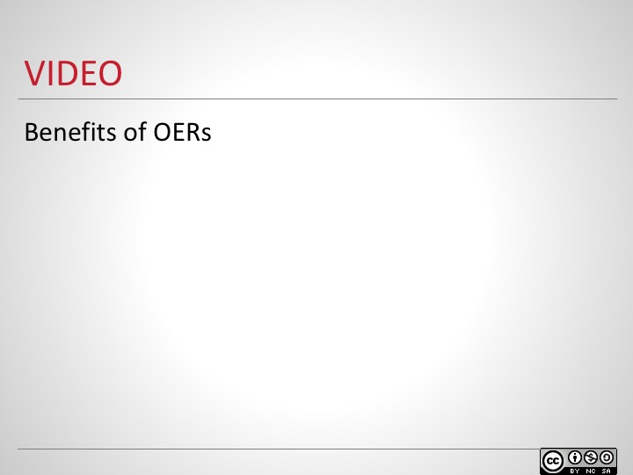
In this video, you’ll see instructors discuss the benefits of using OERs in their classes. While you are watching, note the reasons instructors have chosen to use OERs, and compare these to the reasons you listed earlier. Do you see any similarities or differences?

Slide 23
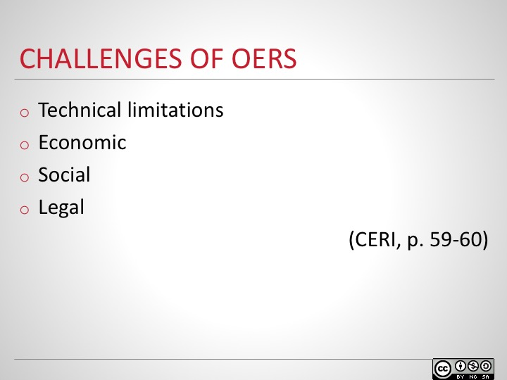
According to the CERI, there are four primary concerns or inhibitors to the further adoption of OERs.
One of the primary limitations is technology. There still aren’t enough computers or enough broadband internet available throughout the world for many open initiatives to be taken advantage of and, for some, this should be addressed before making more content open.
Economic factors also need to be taken into account. Some countries don’t have funding to invest in the infrastructure needed for institutions and to give access to the general population.
Social factors include the lack of knowledge or training to properly use specific open resources that require a particular ability or technical skills. A reluctance to share or distribute personal knowledge is also an inhibitor.
Finally, there are legal reasons why some work cannot be shared. Obtaining permission to openly share key pre-existing work can also prove to be difficult.

Slide 24
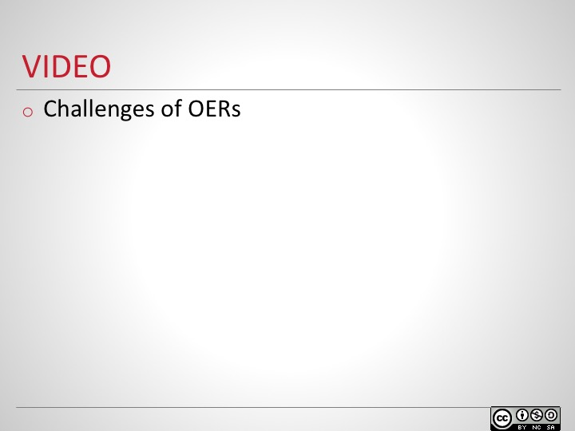
In this video, you’ll see instructors discuss the challenges of using OERs in their classes. While you are watching, note the reasons instructors provide, and compare these to the reasons you listed earlier. Do you see any similarities or differences?

Slide 25
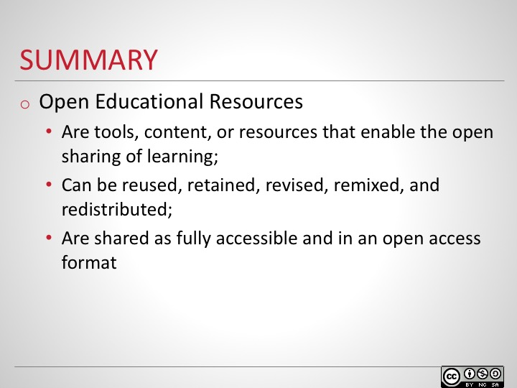

Slide 26
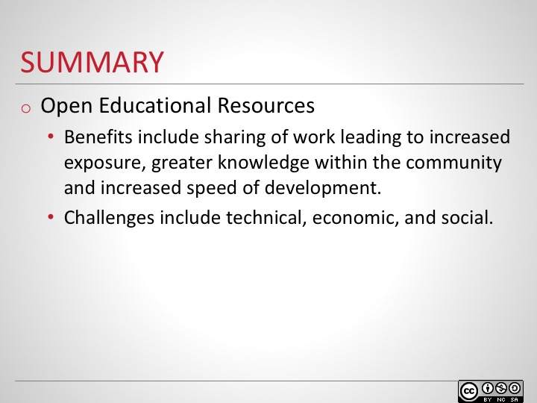

Slide 27
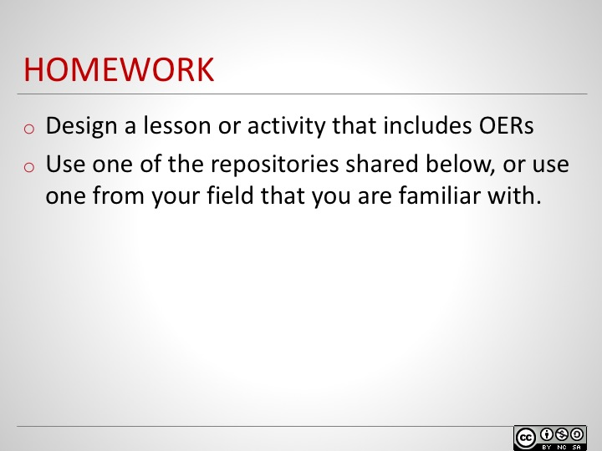
Share page of links to a variety of OER repositories. Point out a few main resources related to different fields, and ask if any participants are aware of any other resources for their field. Ask participants to look for content that is particular to their expertise, then design a lesson or activity for delivery a module/lesson/activity and submit.

Slide 28
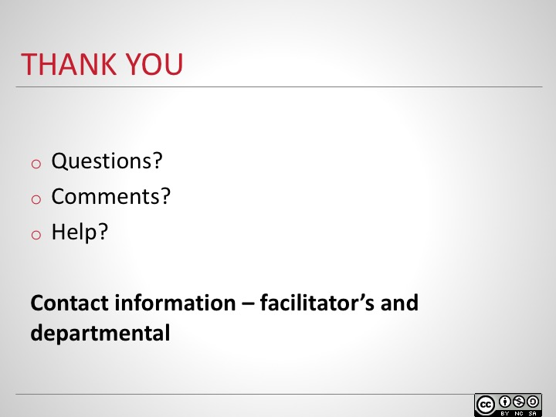

Slide 29
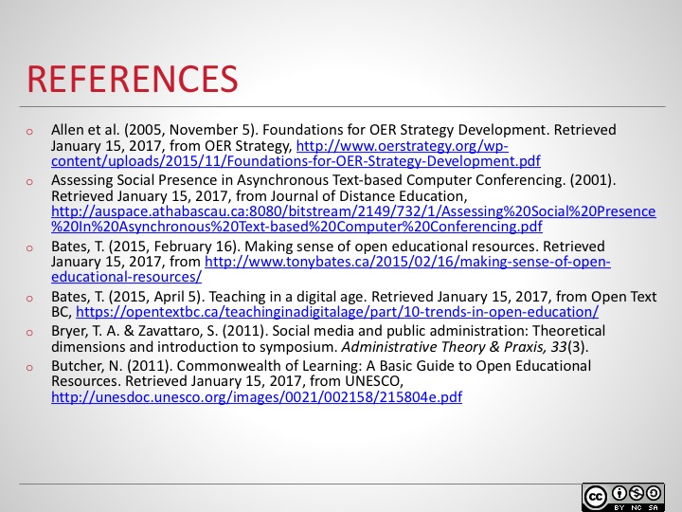

Slide 30
