Kazakhstan – A Young Country with an Ancient History

2:00 – 2:05pm | Welcome, Dr. Achim Hurrelmann, EURUS Director, and Dr. Andre Plourde, Dean of the Faculty of Public Affairs (FPA), Carleton University.
2:05 – 2:10pm | Introduction, Dr. Piotr Dutkiewicz, EURUS and Director of the Centre for Governance and Public Management (CGPM), Carleton University.
2:10 – 2:25pm | Remarks by His Excellency Konstantin V. Zhigalov, Ambassador of the Republic of Kazakhstan to Canada.
2:25 – 2:55pm | “The Kazakh Epic Tradition and Identity”, Dr. Alma Kunanbaeva, Stanford University.
2:55 – 3:20pm | “The Evolution of the Kazakh Khanship under Russian Rule”, Dr. Gulnar Kendirbai, Harriman Institute, Columbia University
3:20 – 3:40pm  3:40 – 3:55pm | “The Rebellion of 1916 in Kazakhstan and Central Asia”, Dr. Jeff Sahadeo, EURUS, Carleton University.  Q & A
3:55 – 4:00pm | Concluding Remarks, Dr. Achim Hurrelmann, EURUS Director. Carleton University.
4:00 – 5:00pm | Reception in the adjacent Alumni Board Room (RO 617), Robertson Hall.

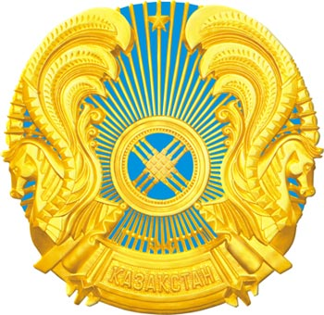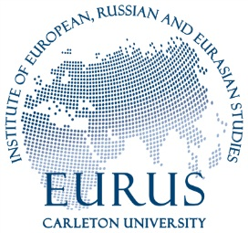
Embassy of the Republic of Kazakhstan

