Follow us on Twitter @CarletonHCon14 & use #CUHConf14 !

Front cover photo: Susan Ross, Urban Derelict, King Edward Avenue near Clarence Street, Lowertown East, Ottawa, 2010
2014 Graduate Student
Heritage Conservation Symposium
MIND THE GAP:
Crossing Borders in
Heritage and Conservation
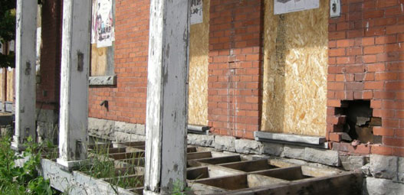

_{AND} the 2nd annual
HERB STOVEL
MEMORIAL LECTURE
_{WITH} Dr Jorge Otero-Pailos

WELCOME to the 9th annual Carleton University Graduate Student Heritage Conservation Symposium, Mind the Gap: Crossing Borders in Heritage and Conservation!

Heritage and conservation are in expansion, crossing diverse value systems, professional disciplines, and physical territories. How has ‘minding’ gaps – paying attention to but also caring for perceived borders –challenged and enriched the ideas and work of heritage conservation?
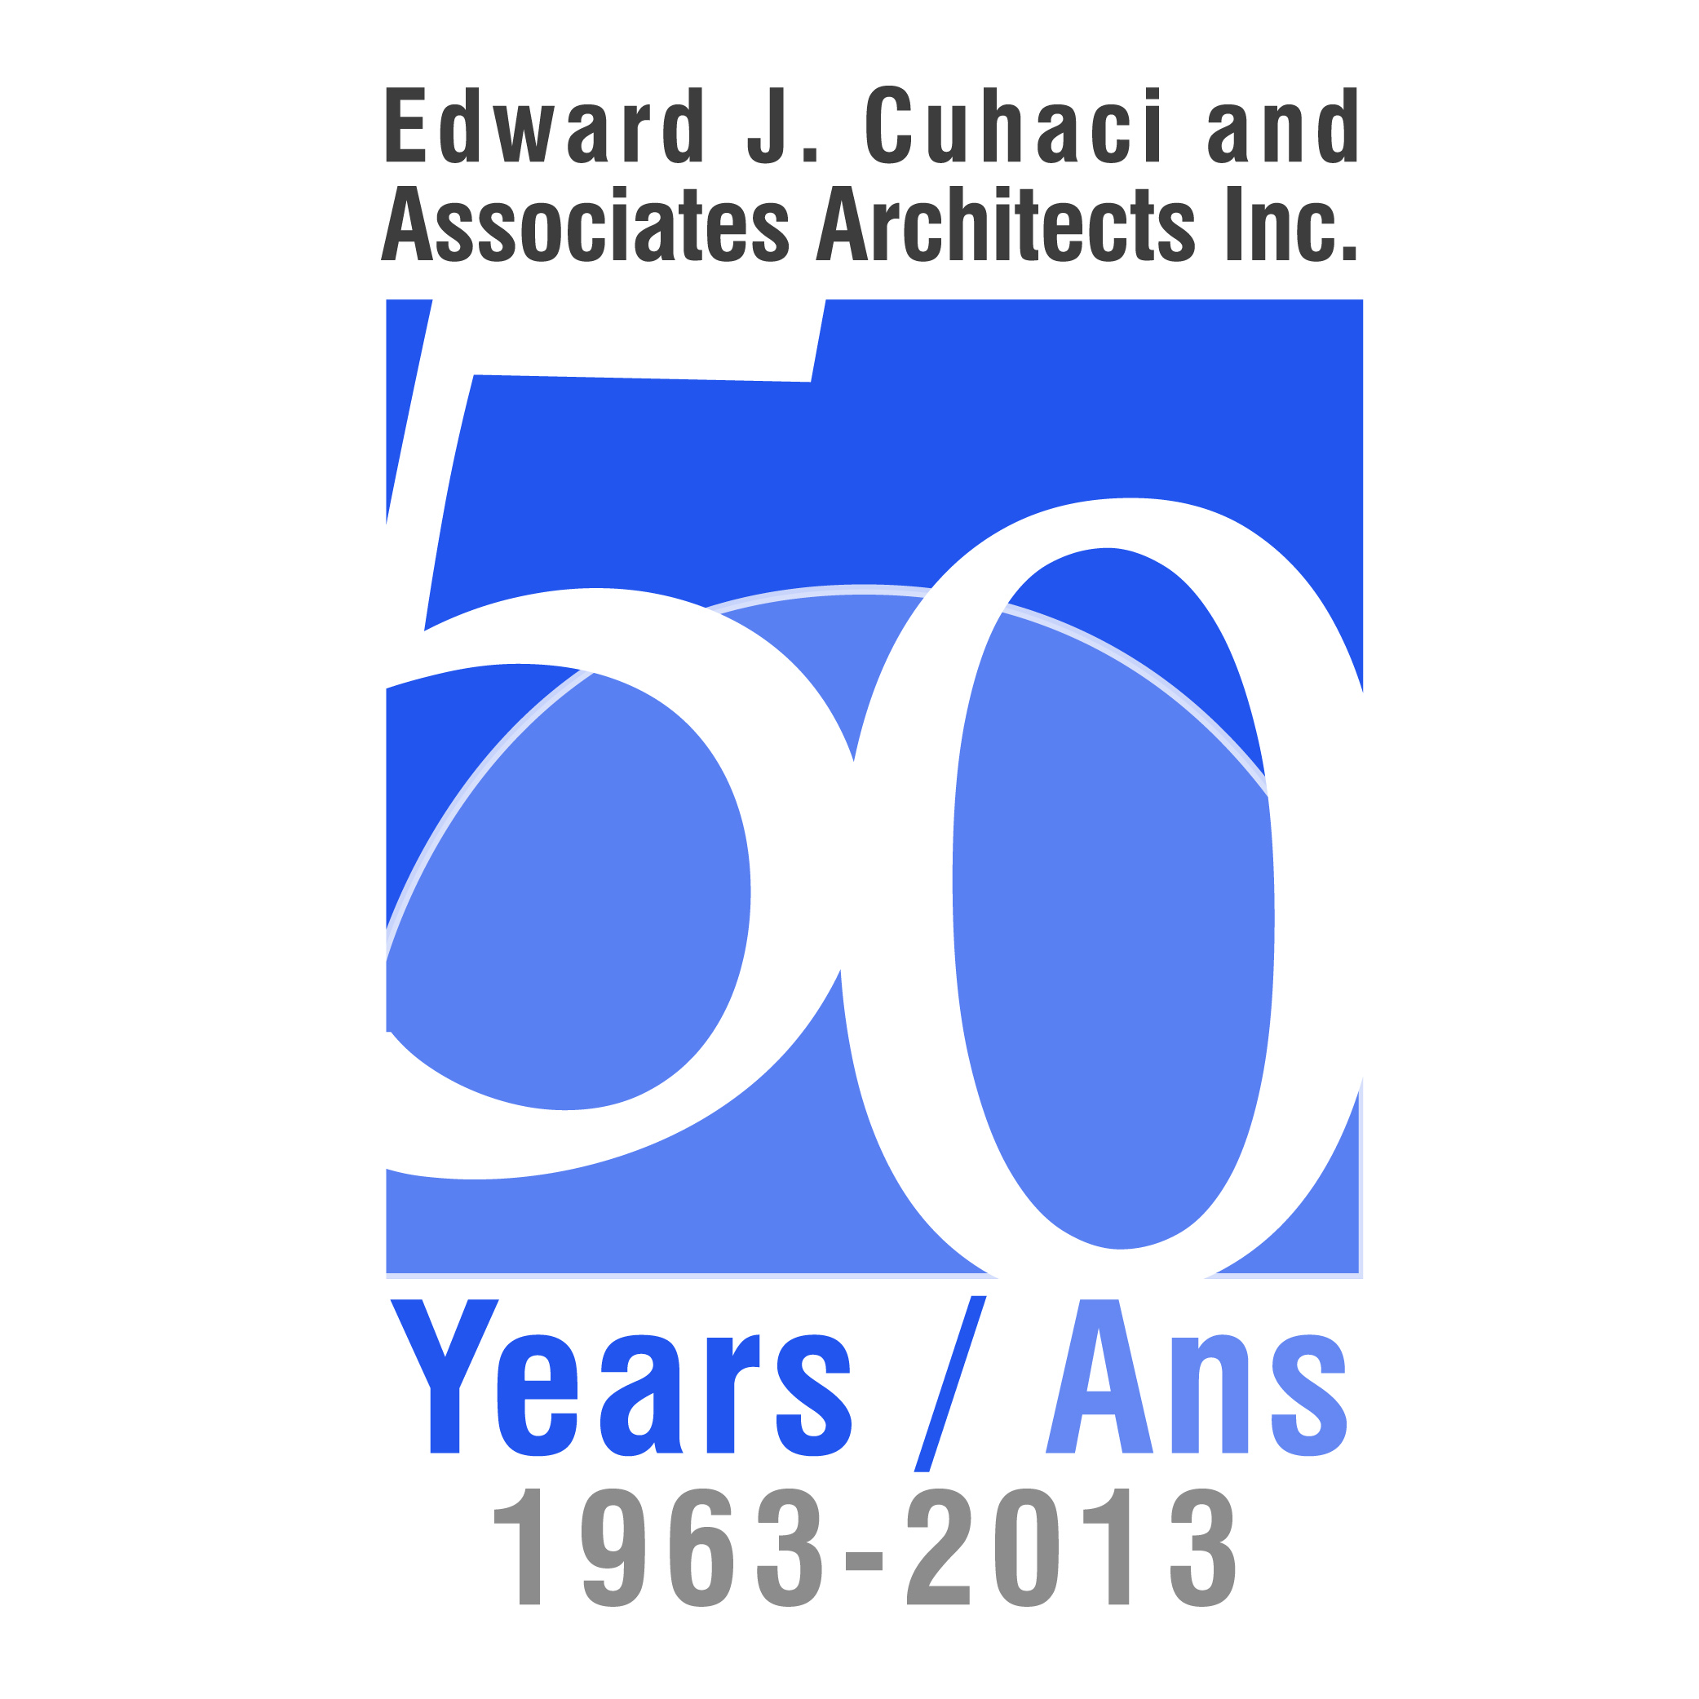
Today’s event will feature dynamic lectures from a variety of heritage professionals, scholars, and other practitioners, who will speak about the gaps in heritage and conservation – between disciplines, between physical landscapes – and highlighting new focus areas outside of the normal heritage scope.
We hope you enjoy today’s thought-provoking and compelling speakers, and that you will be inspired to “mind the gap” in your own heritage and/or conservation work.
Enjoy!
Margaret Caron-Vuotari, Stephanie Elliott, Victoria Ellis, Heather Leroux
Co-Chairs, Carleton University Heritage Conservation Symposium
MA Students, Canadian Studies – Heritage Conservation
March 2014

To our generous 2014 sponsors – THANK YOU!

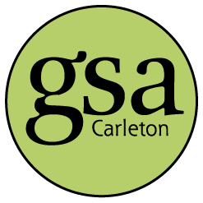

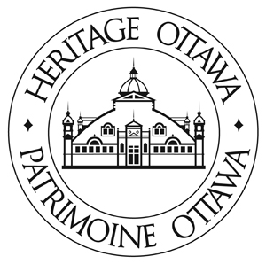

2014 Programme
8:30 – Registration opens
9:00 – Introductory Remarks Pauline Rankin
Acting Director of the School of Canadian Studies, Carleton University
9:10 - Session 1: Physical and Territorial Borders
9:15 – Heritage in the Borderlands: the Yukon Experience Nancy Oakley
Executive Director, Yukon Historical Society; MA, Carleton University School of Canadian Studies 2012
9:35 – What to Do with What We Know about
Conventional Housing for Inuit Julie Harris
President, Contentworks Inc. ; former Coordinator of Research and Writing, Qikiqtani Truth Commission
9:55 –Debunking Nationalist Ideas of Architectural Style
Timothy Di Leo Browne
Ph.D. candidate and contract instructor, Carleton University School of Canadian Studies
10:15 – Questions
10:30 – Morning Break

10:45 – Session 2: Heritage and Nationalism
10:50 – A true trompe-l’oeil:
la fresque des Québecois in the context of Palace Royale
Dr. Anne Trépanier
Assistant Professor, Carleton University School of Canadian Studies
11:10 – Heritage and Conservation in
the Royal 22e Regiment’s Centennial Victoria Edwards
Senior Analyst, Department of National Defence
11:30 – Session 3: Disciplinary Borders
Subverting the Disciplinary Silos:
The role of architectural history in
heritage conservation education Peter Coffman Supervisor, History and Theory of Architecture, Carleton University
11:50 – Questions
12:05-1:15 Lunch Break

1:15 – Session 4: Fighting and Letting Go
1:20 – Saint-Charles Church, Ottawa : Site of History and Memory
Mike Steinhauer
Department of Canadian Heritage; MA candidate, Art History, Carleton University
1:40 – L’évocation du patrimoine
dans la défense de 3 quartiers menacés par la densification:
Vanier, Basse-Ville, Les Plaines Lebreton
Dr. Kenza Benali
Adjunct Professor, Département de Géographie, Université d’Ottawa [Presentation in French]

2:00 – When to Let Go James Maddigan
Building Conservation Specialist and Senior Associate, Robertson Martin Architects
2:20 – Questions
2:35 – Afternoon Break
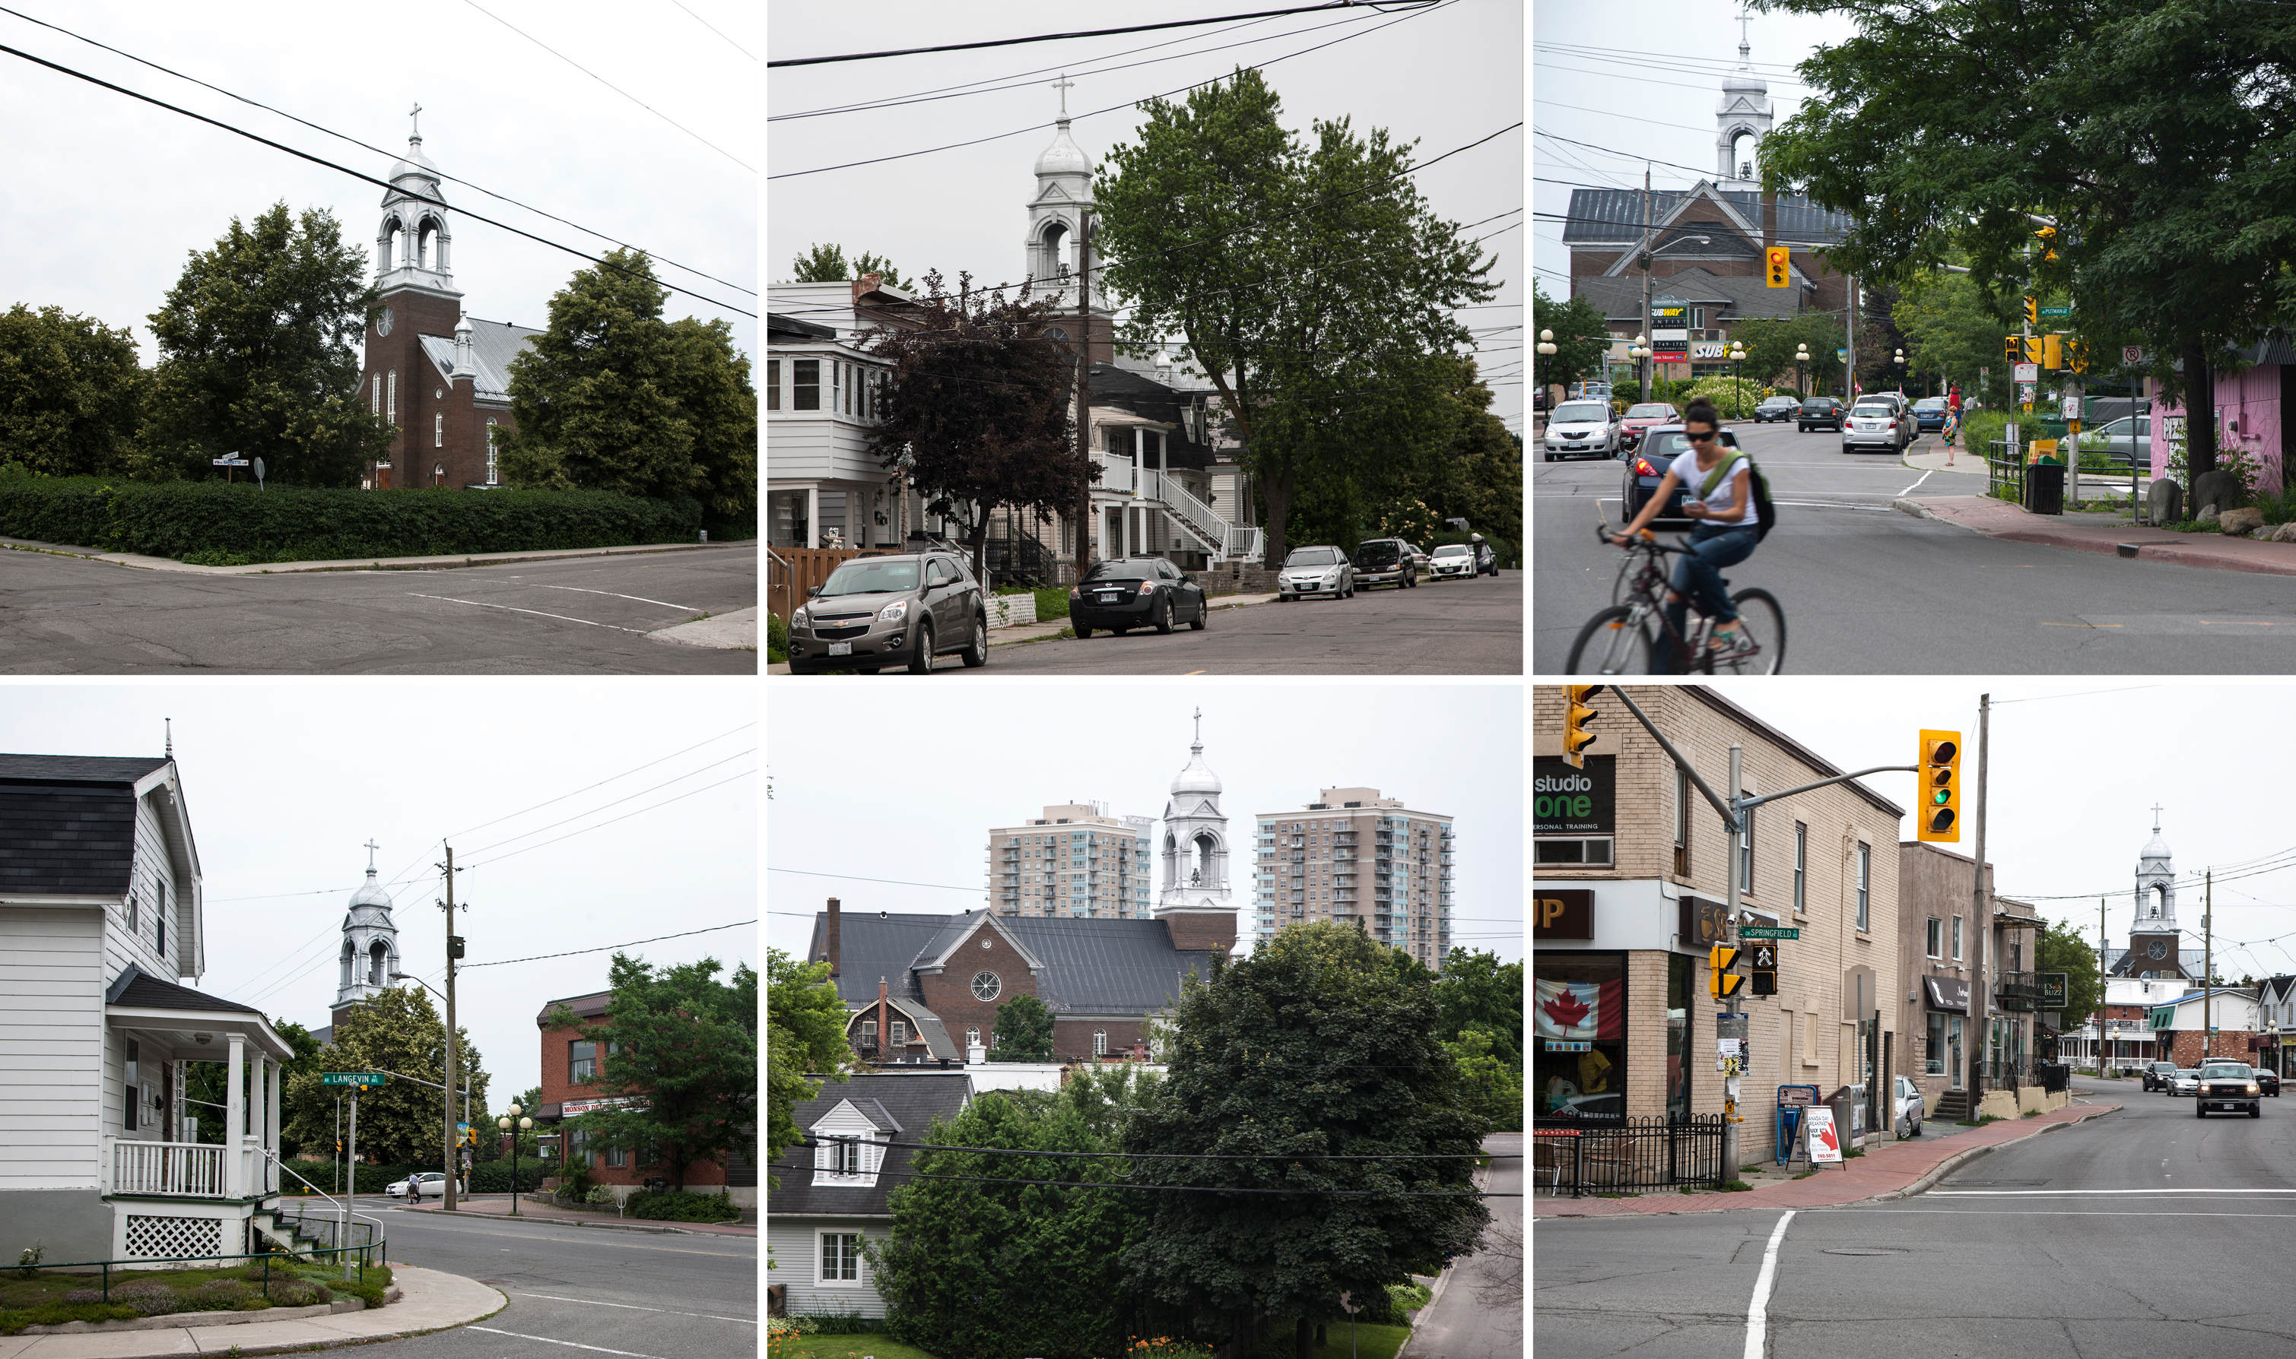

Photo: Mike Steinhauer. Saint-Charles Church
2:50 – Session 5: Emerging Professionals
2:55 – Defining Heritage:
Conservation Planning in the Post-Industrial City
Elena Lewis
Public Engagement Coordinator, Art Gallery of Algoma, Sault-St Marie ON
3:15 – Church of Santiago de Kuño Tambo
Jesslyn Granda
BA candidate, Carleton University Azrieli School of Architecture and Urbanism;
and Crystal Hanley
Research Assistant, Carleton Immersive Media Studio
3:35– Frozen Foods: Making the Leap from Harvest to Heritage
Shari Rutherford
MA candidate, Carleton University School of Canadian Studies
3:55 – Session 6: Disciplinary Fringes
On Conservation’s Edge:
The Call for a Social Science of Destruction Chris Wiebe
Manager, Heritage Policy and Government Relations, Heritage Canada National Trust; MA, Carleton University School of Canadian Studies
4:15 – Questions
4:30 – Closing Remarks Susan Ross Assistant Professor, Carleton University School of Canadian Studies
5:00 – Reception

6:00 – The School of Canadian Studies
Herb Stovel Memorial Lecture
Transitional Objects: Why Heritage Shapes the Future
Dr. Jorge Otero-Pailos
Graduate School of Architecture, Planning and Preservation (GSAPP),
Columbia University

This event is co-sponsored by the Office of the Dean of the Faculty of Arts and Social Sciences and the School of Canadian Studies.

Photo: Jorge Otero-Pailos. “The Ethics of Dust: Doge’s Palace, Venice, 2009,” as exhibited in the Corderie of the 53rd Venice Art Biennale. Collection of Thyssen-Bornemisza Art Contemporary Foundaton T-BA21

Herb Stovel
Arriving back in Ottawa following a distinguished national and international career, Herb Stovel was Associate Professor and the Coordinator of the Heritage Conservation Programme in the School of Canadian Studies at Carleton University from 2004 to 2012. His legacy at Carleton includes: the enthusiasm for and understanding of Canadian and international heritage ideas and conservation practices he instilled in dozens of students in his undergraduate and graduate courses; the comprehensive online resource list he developed as a study guide for heritage conservation; his essential support to building new streams in Conservation and Sustainability in the Schools of Architecture and Engineering; the creation of this annual graduate student-run Symposium on Heritage Conservation; the many community-based student projects he helped foster in Ottawa; and his development of greater connections between heritage and conservation disciplines within the university and outside. He also left the University the vast archives of his career’s work.
Jorge Otero-Pailos
Dr. Jorge Otero-Pailos is an architect, historian and theorist specialized in experimental forms of preservation. His research and work rethinks preservation as a powerful countercultural practice that creates alternative futures for our world heritage. He is Founder and Editor of Future Anterior, the first American peer-reviewed scholarly journal to be devoted to the history, theory and criticism of historic preservation. He is the author of Architecture's Historical Turn: Phenomenology and the Rise of the Postmodern (University of Minnesota Press, 2010). His work and articles have been featured in many international publications, and his installation work was exhibited in Manifesta 7: The European Contemporary Art Biennial and the 53rd Venice Art Biennial.
Professor Otero-Pailos is a graduate of Cornell University and has an architecture degree and Ph.D. from M.I.T. At Columbia University, Otero-Pailos teaches core courses in Historic Preservation and Architecture as well as seminars and workshops that critically explore topics in architectural history and theory such authenticity, phenomenology, and interpretation. He has served as vice-president of DoCoMoMo US. Prior to joining Columbia University, he was Assistant Professor of Architecture and a founding member of the New School of Architecture at the Polytechnic University of Puerto Rico.
2014 Presentation Abstracts
Nancy Oakley Heritage in the Borderlands: The Yukon Experience
Reflecting on my experience as the Executive Director of the Yukon Historical & Museums Association, in this presentation I will share the sights and stories of Yukon heritage and its conservation to explore how the Yukon approach is blurring borders and minding gaps. Home to a living heritage in a surprisingly complex landscape, the ‘Yukon approach’ is necessarily focused on overcoming gaps between disciplines and understandings, and is cross-border at its heart. I propose to explore this approach through three lenses:
A community-based approach. As a small community in a Territory with twelve self-governing First Nations, the ‘Yukon approach’ is collaborative and involves and accommodates people from a variety of disciplines and backgrounds. Given the predominance of ‘history from the ground up’ initiatives, the Yukon may represent a uniquely community-based approach to conservation.
A broad understanding of heritage. The Yukon embodies a cultural landscape approach that understands the implicit connections between the intangible and tangible, natural and cultural heritage elements and how work together to create and sustain a sense of place rooted in a strong relationship between people and the land.
Use of heritage for many purposes. Heritage is a central element of the Yukon tourism industry, from Dawson’s Gold Rush to paddling the Alsek River. Many First Nations are also actively reviving their languages, cultural traditions and practices. The result is a dynamic space where arts, culture and heritage practices blend to create and interpret a unique sense of place.
In conclusion, I will reflect on the Yukon’s approach in the Canadian context. We may do well to explore the ‘borderlands’ of our practice for new ways of framing approaches to conservation that incorporates multiple, sometimes conflicting perspectives, leverages the expertise of various disciplines and involves our communities in the care and celebration of our heritage.

Julie Harris What to do with what we know about conventional housing for Inuit
As the coordinator of research and writing for the Qikiqtani Truth Commission, I spent several years examining the relationship between government and Inuit in the Baffin region of present-day Nunavut. One of the many topics explored in our work was the history of housing programs imposed on Inuit by federal bureaucrats from the 1950s to the 1970s. Today, visitors regularly photograph these houses through a nostalgic lens that fails to capture the complicated history behind their construction, occupation and use. Nunavut townscapes and conventional houses are at the core of a difficult history, where ‘difficult’ refers to more than the ways in which the design and construction of the houses contributed to poor health and economic outcomes for Inuit families. This history necessarily raises issues related to gender, racism, internal colonialism and fiduciary failures, while simultaneously providing evidence about cultural resilience and family life. What might influence decisions to conserve some of these houses? And, for whose benefit? This presentation will explore the history as I understand it, and present responses from Inuit and Nunavut heritage specialists about the future of the region’s housing past.

Dr. Anne Trépanier A true trompe-l'oeil: la fresque des Quebecois in the context of Place Royale
In as much as Québec's Parliamentary facade serves as an illustrated secular bible for the XIXth century's capital, the Fresque des Québecois serves as a time capsule, inviting passers-by into the world of a trompe-l'oeil painting rich with life-sized national signs which play on the ambivalence of being and the sense of belonging.
Half way between National Performance of History and Patrimoine, this object is inviting the eye not only into a designed History but also in the well-known site of Place Royale, the heart of the World's Heritage city and the cradle of French America supported from its inception as a ‘Lieu de Mémoire’ by the Parti Québécois.
My presentation will study the mural as a national identity performance using the patrimonialized space of Place Royale to question the margins of the discipline of Heritage Conservation in a city that also plays the role of representing the National, as the Capital of the Quebec nation.
Victoria Edwards Heritage and Conservation in the Royal 22e Regiment's Centennial
My paper, "Mind the Gap: Heritage & Conservation at The Royal 22e Regiment's Centennial" would explore the gaps between 'heritage' and 'conservation', as well as the challenges and potentials of multidisciplinary approaches to heritage conservation in the context of the Royal 22e Regiment centennial. I would share the story and inspiration for a number of sculptural commemorations of the Royal 22e Regiment. I will consider works by LCol (Ret'd) Andre Gauthier, some of which were included in the recent Royal 22e Regiment on all Fronts Centennial Symposium, which I suggested and helped organize. I will also consider Royal 22e Regiment commemorative works by other artists e.g. stone shaft, offered by lieutenant-colonel L.J.A. Amyot, CD and erected at CMR 26 September 1964 by the Royal 22e Régiment on its 50th anniversary, commemorates the founding of the 22e Battalion (French-Canadian) which trained in Saint-Jean in 1914.
The memorial chamber at the Citadel, Quebec City was restored by the Royal 22e Régiment in honour of the regiment; it includes the memorial book for members of the regiment, regimental and queen's colours from the regiment and inscriptions of the battle honours of the regiment. There are also three bronze plaques naming the three Victoria Cross winners from the regiment (Kaeble, Brillant and Triquet). A bronze plaque in the officers' mess at the Citadel is dedicated to the members of the Royal 22e Régiment who have been killed on peacekeeping duties with the United Nations.
Timothy Di Leo Browne Debunking Nationalist Ideas of
Architectural Style
This discussion will use architectural evidence from the Loyalist period of Upper Canada to challenge claims that there is a Canadian "national style" in architecture. Although American Loyalists were, by definition, loyal to Britain and the Crown, they were rooted in the environmental and cultural heritage of North America. They brought with them practices that had already worked for them in the former colonies, including forms of local governance and architectural styles for both domestic and public buildings. After considering styles exemplified in such Loyalist communities as Thornhill, Ontario, and in notable Neo-Classical public architecture of the time, I will demonstrate how these examples contest later theorizing on what constitutes a Canadian style. Gothic Revival architecture gained widespread popularity in mid-19th-century Canada and has come to be associated with Canada’s “Britishness” and “distinctiveness” (the Parliament buildings being the style’s most obvious example). But in the decades following the American Revolution, Gothic motifs did not yet predominate; and some architectural theorists, in trying to identify a distinctly Canadian style, have tended to ignore this period since it does not fit the Gothic storyline (see, for example, Gowans 1968). Such attempts to pinpoint a national style will leave out examples that do not support a particular argument (Thomas 1997). A more complete picture of any nation's architectural heritage would consider multiple styles and storylines, as well as ongoing cross fertilization between countries and regions.
Peter Coffman Subverting the Disciplinary Silos: The role of architectural history in heritage conservation education
Most architectural historians would likely assume that a rigorous training in their discipline was a critical component of a good education in the field of heritage conservation. Historically, the heritage profession in Canada has tended to confirm this assumption: seminal institutions like Parks Canada have been staffed with architectural historians, and prolific private practitioners such as Harold Kalman have also been trained in the field.
Nevertheless, as the heritage profession has grown in academic and professional autonomy, architectural history seems to have moved further and further from its centre. Indeed at Carleton, one of the few institutions anywhere with rich expertise in both heritage conservation and architectural history, there is no formal mechanism at curriculum level that makes either discipline a mandatory part of the other.
Have heritage studies left architectural history behind? Have those who study the history of the built environment lost their relevance for those who work to preserve it? This paper will attempt to build a case for answering both questions in the negative. Using specific case studies, it will explore the contribution that architectural history makes to the field of heritage conservation, and argue for increased dialogue and integration between the two disciplines.

Dr. Kenza Benali L'évocation du patrimoine dans la défense de 3 quartiers menacés par la densification : Vanier, Basse-Ville, Les Plaines Lebreton
Le développement urbain durable est aujourd’hui au cœur des politiques d’aménagement des villes canadiennes. L’une des mesures prônées dans ce cadre est celle de la densification urbaine des quartiers centraux, qui permet de contrecarrer les effets néfastes de l’étalement urbain (limitation du gaspillage des terres, diminution de la pollution, déclin économique du centre, etc.). Le développement urbain durable partage plusieurs valeurs avec le discours sur le patrimoine: nécessité de léguer un héritage bâti et culturel de qualité, volonté de préservation des identités des communautés locales, positionnement des générations actuelles comme les dépositaires de biens qu’il convient de transmettre aux générations futures, affirmation d’une inquiétude vis-à-vis de ressources non-renouvelables, etc. Ainsi la ville durable, à l’opposé de la ville fonctionnaliste, privilégie le maintien et l’utilisation des héritages urbains dans le processus de reconstruction de la ville sur elle-même. Cependant, les aspirations à une densification urbaine d’une part et à une préservation patrimoniale d’autre part sont parfois difficilement compatibles, voire contradictoires : dans certains cas, la densification urbaine peut s’appuyer sur des bâtiments hérités d’une période révolue, profitant des infrastructures qu’ils fournissent, dans d’autres cas, elle nécessite la destruction d’un héritage bâti, ou ne prend pas en compte le patrimoine tangible et intangible de l’environnement urbain dans lequel elle s’inscrit. Dans cette communication, nous présenterons 3 quartiers d’Ottawa, dans lesquels les projets de densification urbaine se sont heurtés à l’acceptabilité sociale et suscités de véritables conflits urbains, largement manifestés dans l’espace médiatique. Nous évoquerons les différents argumentaires patrimoniaux mobilisés pour faire barrage à ces projets.
Mike Steinhauer St. Charles Church: Understanding the interrelationship between community, parish, place and space
The relationship between cultural memory and historical discourse has received increasing attention in recent decades. Using the case study of St. Charles Church (1908), the paper will explore this relationship by focusing on the church’s contextual and associate value – rather than its design or physical value – as it pertains to the heritage designation of the Ontario Heritage Act.

The paper will examine the church and church site as a place of memory or, in Pierre Nora’s conception, as a lieu de mémoire and will study the interrelationship between community, parish, place and space. In recent years, the future of St. Charles’ has been the focus of much discussion. The large property, situated on a winding main street, borders four Ottawa neighbourhoods: Vanier, New Edinburgh, Lindenlea and Rockcliffe Park. As such, the paper will examine arguments used to shape and deconstruct the church’s landmark value and will discuss the photographic material submitted as part of the heritage designation application.
With a focus on St. Charles, the paper will argue that archival material has the potential to generate new meaning once it is separated from the domestic or the liturgical domain and removed from family albums and institutional records.

James Maddigan When to Let Go
Heritage conservation is built on the concept of preserving the past, that has survived to the present, for the benefit future generations. Yet, there are times when we may need to decide to let go of our heritage and not conserve it. As heritage conservation practitioners, we eventually come across situations when we must decide if we must let go of a heritage object, from the smallest to largest scale. Discussion of when to let go has largely not been part of the dialogue in heritage conservation, creating a gap in conservation theory and erecting a taboo border that is not often crossed. Consequently, we lack a framework in which to make these decisions. Without a framework, the tendency is to decide and save everything, whether of lesser or greater importance. Such, may result in losing more than is saved. By trying to save everything, we become cultural hoarders, and hoarding is a growing societal disease. What should be the framework for making decisions on when to let go of our heritage? What are the factors/criteria? Who should be part of the process? How can we be sure we are at the point that we must let go? Who makes the final decision? To develop a framework within heritage conservation, we should look to, and borrow from other fields that have developed frameworks when dealing with situations in which a decision must be made on letting go. One field is the medical profession that deals with letting go when faced with trauma and end-of-life situations. By considering how other fields deal with letting go, it is hoped that this will start a dialogue that will lead to the development of a framework to make decisions on when to let go, and fill a perceived gap in heritage conservation.
Elena Lewis Defining Heritage: Conservation Planning in the Post-Industrial City
At one time Toronto’s Gooderham and Worts (G&W) Distillery founded in 1832 was one of the largest distilleries in the world, today, it is better known as “a pedestrians-only village entirely dedicated to arts, culture and entertainment”(Distillery District, 2013). This marked transformation parallels the overall decline of traditional industries and the rise of service ones and speaks, moreover, to the heightened importance of cultural spaces and creative clusters in the post-industrial city. This paper looks at the importance of built heritage within the creative city and argues that the Gooderham and Worts distillery district was redeveloped with this in mind. Although traditional industry is monumentalized and subsequently remembered through the conservation of the site’s built heritage, the dominance of cultural activities and the command they have taken of space allows for a very limited interpretation of the past. Heritage moreover has been approached much differently at the distillery district than it has at those former industrial sites turned museums or heritage interpretation centres. Visitors have found a way, nevertheless, to identify with the site’s authentic character and engage with heritage in a number of ways. This paper also looks at how different conservation value systems are intersecting at complex industrial redevelopments. It argues that the overlap is in part due to the diversity of the projects where environmental, economic and heritage concerns must equally be considered. Even more, this paper suggests that the intersection of different conservation value systems reveals a trend in heritage and conservation planning that reﬂects and is best understood in the social economic context of the post-industrial city.

Jesslyn Granda & Crystal Hanley Church of Santiago de Kuño Tambo
In this paper we will discuss the collaboration between the Carleton Immersive Media Studio and the Getty Conservation Institute for their Earthen Architecture Initiative’s - Seismic Retrofitting Project. Identified as a prototype building for this project, the Church of Santiago de Kuño Tambo, Perú was selected.
The Church of Kuño Tambo is a 17th century earthen structure located in a remote Andean village in Peru. Members of the Carleton Immersive Media Studio travelled to Peru in 2013 to take part in the project where the primary goal was to assess the historic wall paintings on the interior of the church.
We will discuss the phases of work that were carried out including orthographic photography, a deterioration glossary, and our graphic condition assessment. In addition we will discuss our collaboration efforts with the Getty Conservation Institute, wall painting specialists, and the Ministerio de Cultura del Perú. We will outline the technologies we used as well as the challenges of working in a secluded landscape. Finally, we will present our condition assessment of the church and speak of its value in Perú, Latin America, and for worldwide heritage conservation.

Shari Rutherford Frozen Foods: Making the Leap from Harvest to Heritage
Since the United Nations’ landmark decision in November 2010 to give foodways the “official heritage nod” it has become increasingly important that conservation practitioners and scholars - as well as those in related fields - begin to examine why and how foodways should be classified and safeguarded as heritage. My current Masters research seeks to contribute to that discourse by offering a preliminary exploration of the overall desirability and viability of culinary heritage conservation, grounding its discussion in a case study of Canada’s iconic maple products to help draw out impactful issues. Particularly relevant to the theme of this year’s Carleton University Heritage Conservation Symposium, “Mind the Gap,” a major challenge I highlight is the difficult-to-bridge distance between acknowledging foodways expressions as heritage on one hand, and actively working to safeguard that heritage on the other.
Primarily, that challenge derives from the ephemeral and mutable nature of culinary traditions. This not only complicates the process of identifying expressions for the purposes of heritage designation, but also forces us to ask whether designations can accomplish anything beyond recording for posterity dead or doomed practices and if this is enough. Some changes simply cannot or should not be averted or reversed: many food practices evolve for health reasons, key ingredients may become extinct, and even the ways in which we taste and experience cuisines transformed. The paper I will present at the Symposium will draw upon my Masters research to expand upon this topic in the burgeoning field of culinary heritage, and suggest that as our understanding of what may be defined as heritage broadens, so too might the gap between heritage and our ability to achieve the end goal of conservation.
Chris Wiebe On Conservation’s Edge: The Call for a Social Science of Destruction
In recent decades, heritage conservation as an academic field has been primarily concerned with understanding heritage value – physical or otherwise – and how to maintain/sustain it. Heritage conservation as a social movement, on the other hand, has been preoccupied with the questions of relevance and motivation: changing hearts and minds through better arguments and stories or with shaping the property marketplace via carrots and sticks.
We now know quite a bit about how to manage heritage on the level of process and technique. But how much do we know about the seemingly deep-seated impulse to destroy what one inherits rather than maintain it? American heritage scholars Randall Mason and Elizabeth S. Chilton obliquely pointed in this direction in their 2010 “NSF White Paper: Call for a Social Science of the Past.” While they laid out an ambitious program of research meant to deepen understandings of the value of the past in contemporary society, their program fails to explore the societal forces that threaten to undermine heritage conservation.
My proposed presentation will examine the fruitful intersections with social sciences and with evolutionary biology and suggest areas for further research. Why do new things give pleasure to many while old things provide satisfaction to the few? How does the challenges heritage conservation faces intersect with theories of risk-taking in Evolutionary Biology or habitual behavior in Behavioral Psychology? What can sociological understandings of western civilization’s culture of consumption tell us about the relevance of heritage in our society? This exploration of root causes presents a promising “new frontier” from both an academic and social movement perspective.

A warm thank you to our many supporters:
Thank you to our Volunteers! Without your time and energy, the 2014 Carleton University Heritage Conservation Symposium would not have been possible.
Thank you to Robert Tombs for his excellent poster designs.
Thank you to The Lord Elgin Hotel for a fantastic venue and enormous support during the planning processes of the Symposium.
Thank you to Cathy Schmueck for her immense knowledge and hard work throughout the organization of this event.
Thank you to Susan Ross for her tireless enthusiasm, her valuable insight and her guiding hand in encouraging us to take on the project of this Symposium.
Thank you!
To all of our speakers, guests, and supporters:
We would like to thank each of you for attending and participating in the ninth annual Carleton University Heritage Conservation Symposium. “Minding the gap” is a popular sentiment lately as cross-disciplinary work and holistic approaches become common goals. We are honoured to bring together so many brilliant minds discussing the subject. Carleton’s School of Canadian Studies is lucky to play host to so many of these voices and hopes to continue the interdisciplinary discussion throughout the year.

We hope you are coming away from today’s event inspired and ready to dive back into your various fields of research and practice. Thank you once again!

Margaret Caron-Vuotari, Stephanie Elliott, Victoria Ellis, Heather Leroux
Co-Chairs, Carleton Heritage Conservation Symposium 2014
MA Students, Canadian Studies – Heritage Conservation
March 2014

