Follow us on Twitter @CarletonHCon15 & use #UnsettlingHeritage

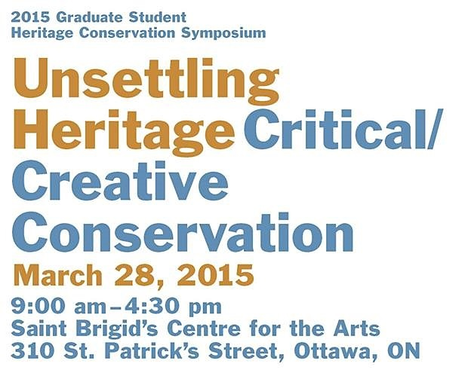
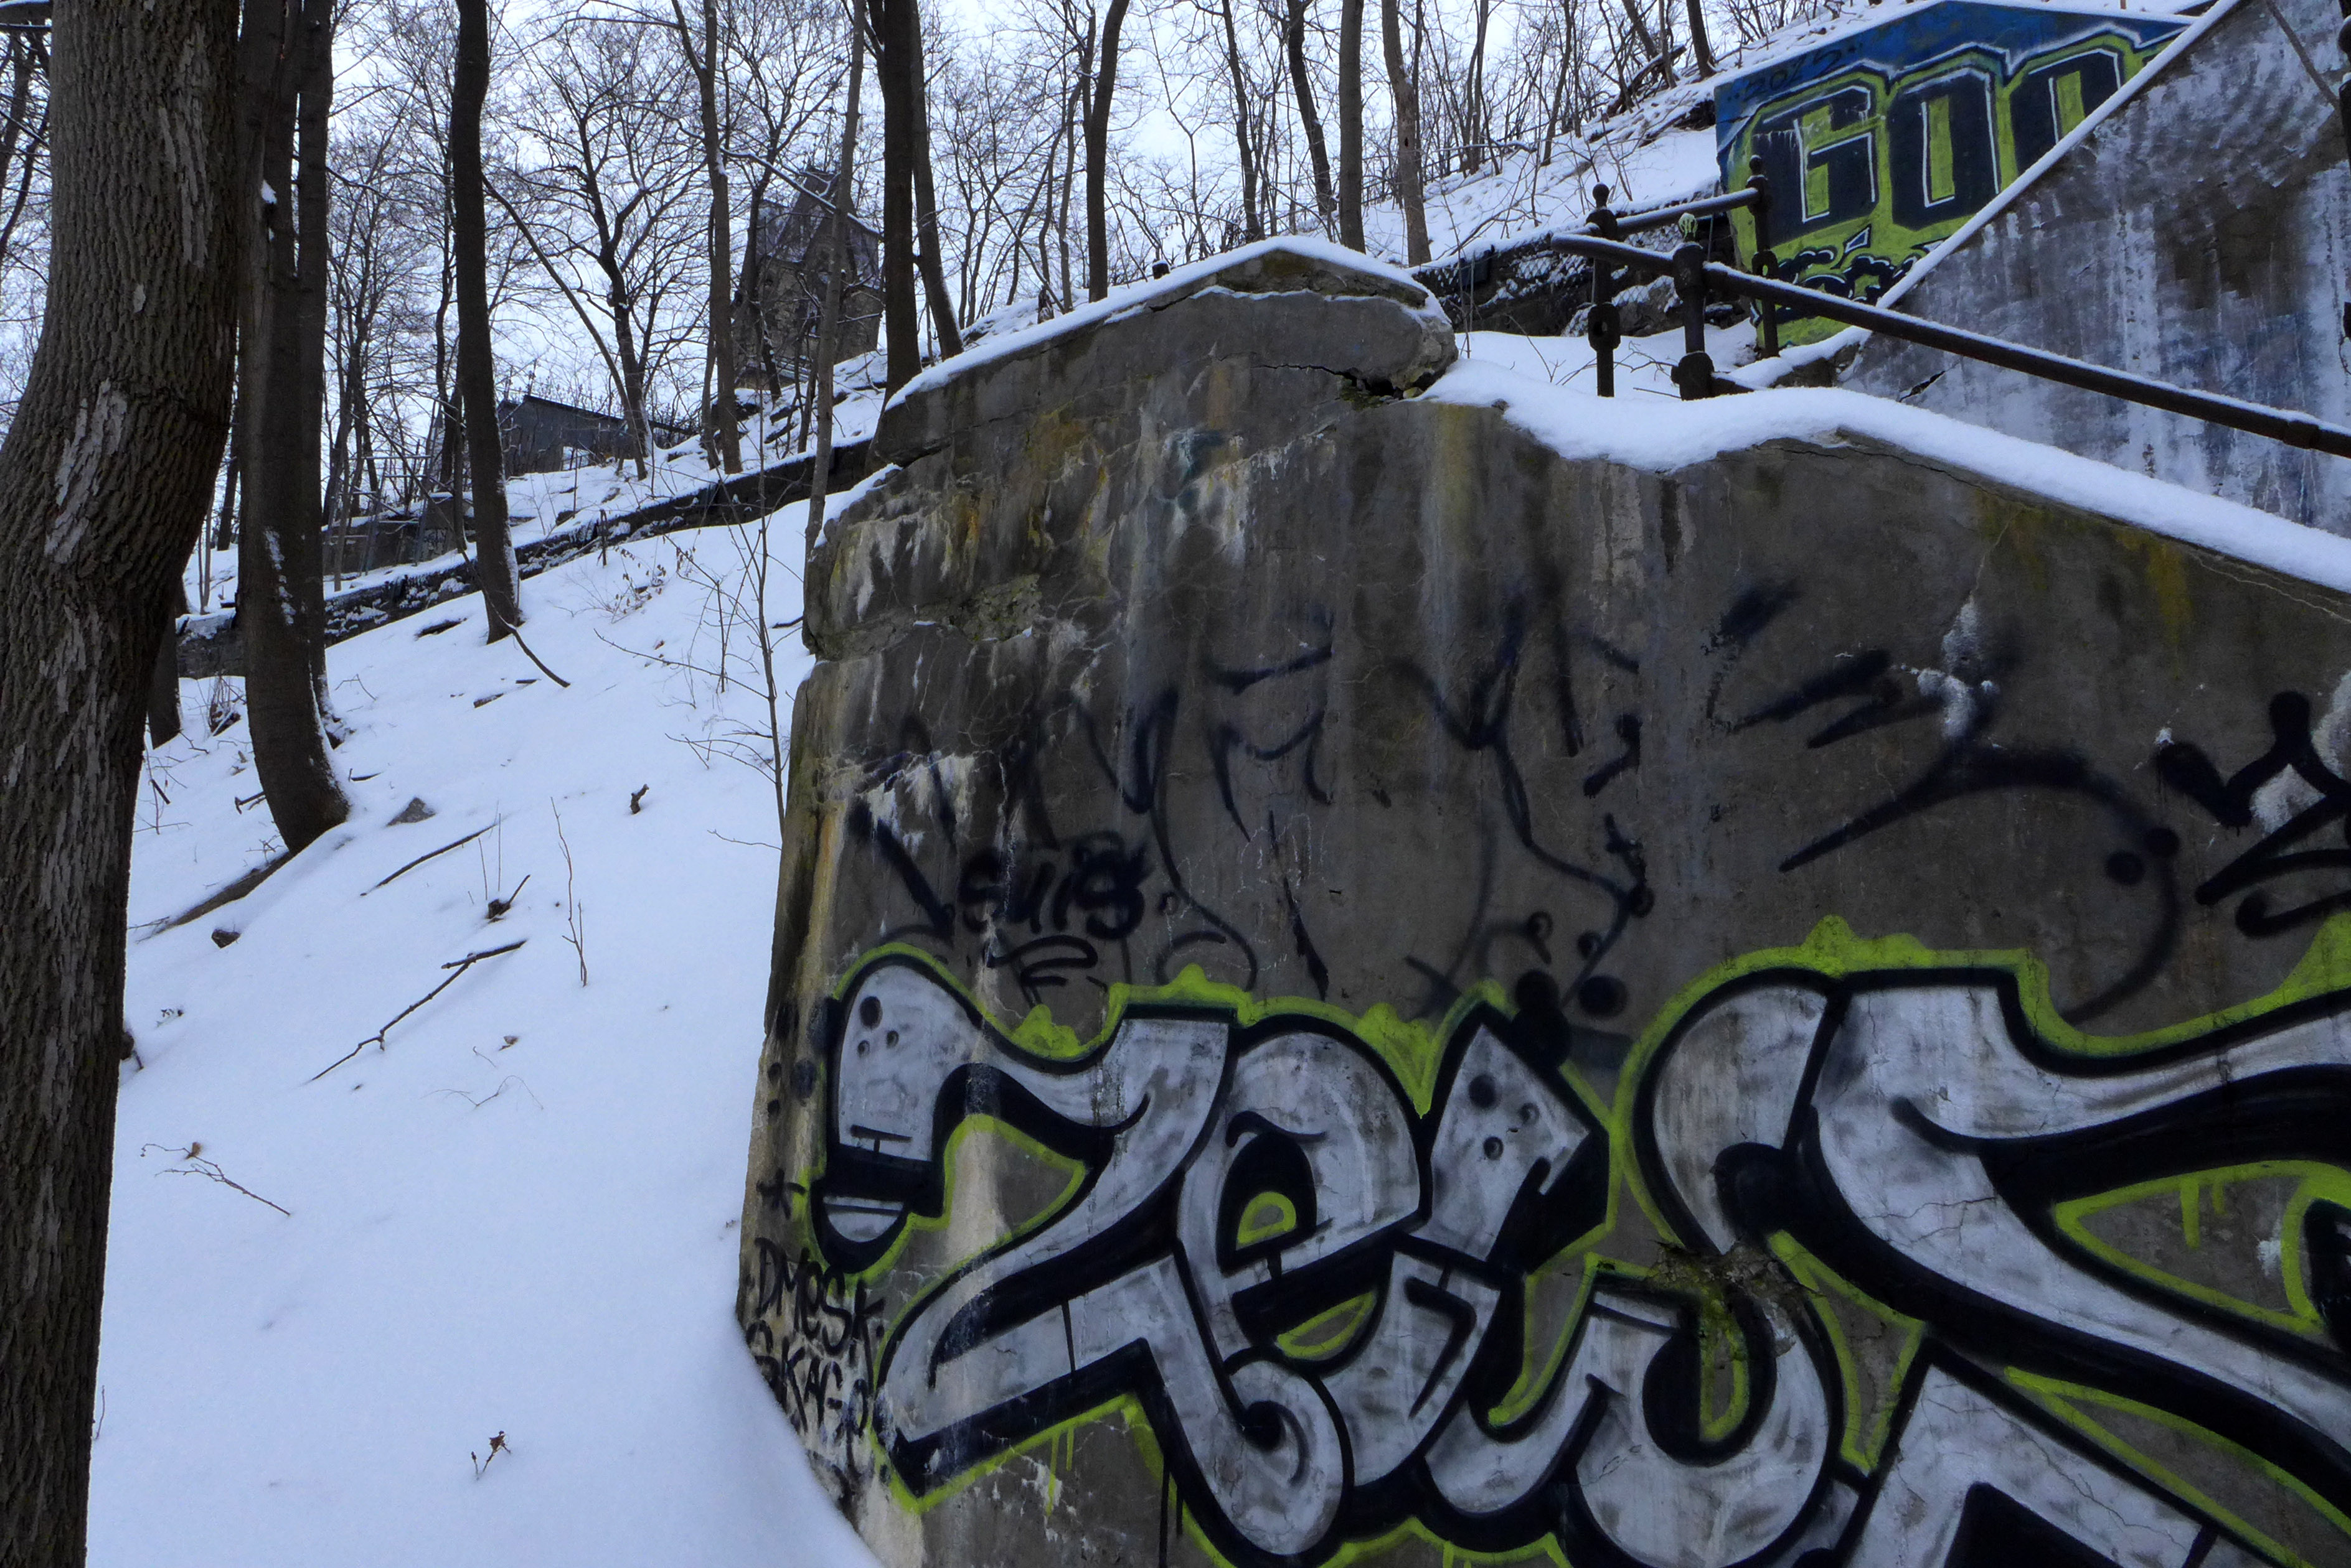

WELCOME to the 10th annual Carleton University Graduate Student Heritage Conservation Symposium, Unsettling Heritage: Critical / Creative Conservation!

In recent years, challenges arising from new ideas and technologies have unsettled heritage conservation. Traditional architectural approaches to conservation are sitting side by side with values-based community outreach and intangible heritage. Creative approaches are needed to adapt to the expanding field of heritage, including areas and projects not traditionally seen as ‘heritage.’
‘Unsettling’ also alludes to dissonant Canadian heritage, and to heritage that is difficult to confront. Critical perspectives on our work and methods can help us to deal with complex and/or contested types of heritage and methods of conservation.
For ten years this symposium has played a role in Ottawa’s heritage landscape, providing critical discussion on heritage and conservation. Today, on our tenth anniversary, we hope to take this experience and apply it to the future, asking necessary questions about how the discipline is changing and what it could become.
We hope you enjoy today’s thought-provoking and compelling speakers, and that you will be inspired to look critically and creatively at your own heritage and/or conservation work.
Enjoy!
James Arteaga, Stephanie Elliott, Victoria Ellis, Heather Leroux, Amber Polywkan
Co-Chairs, Carleton University Heritage Conservation Symposium
MA Students, Canadian Studies – Heritage Conservation
March 2015

To our generous 2015
Corporate Sponsors
– THANK YOU!

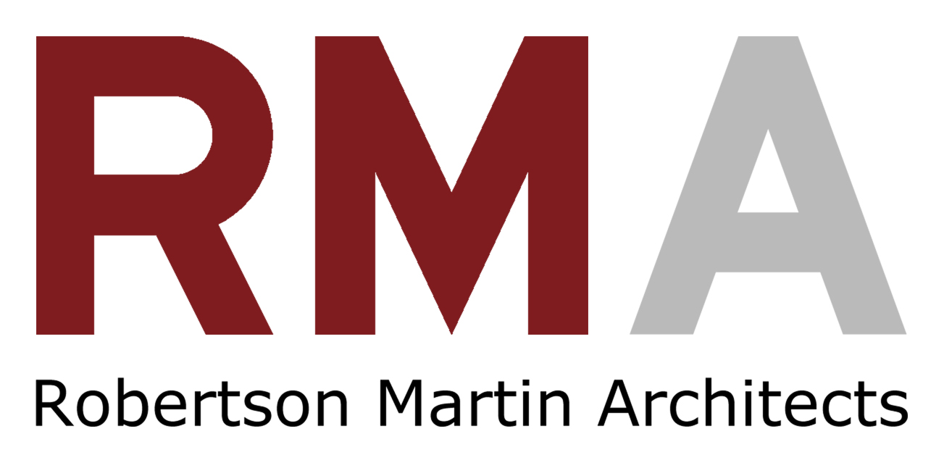

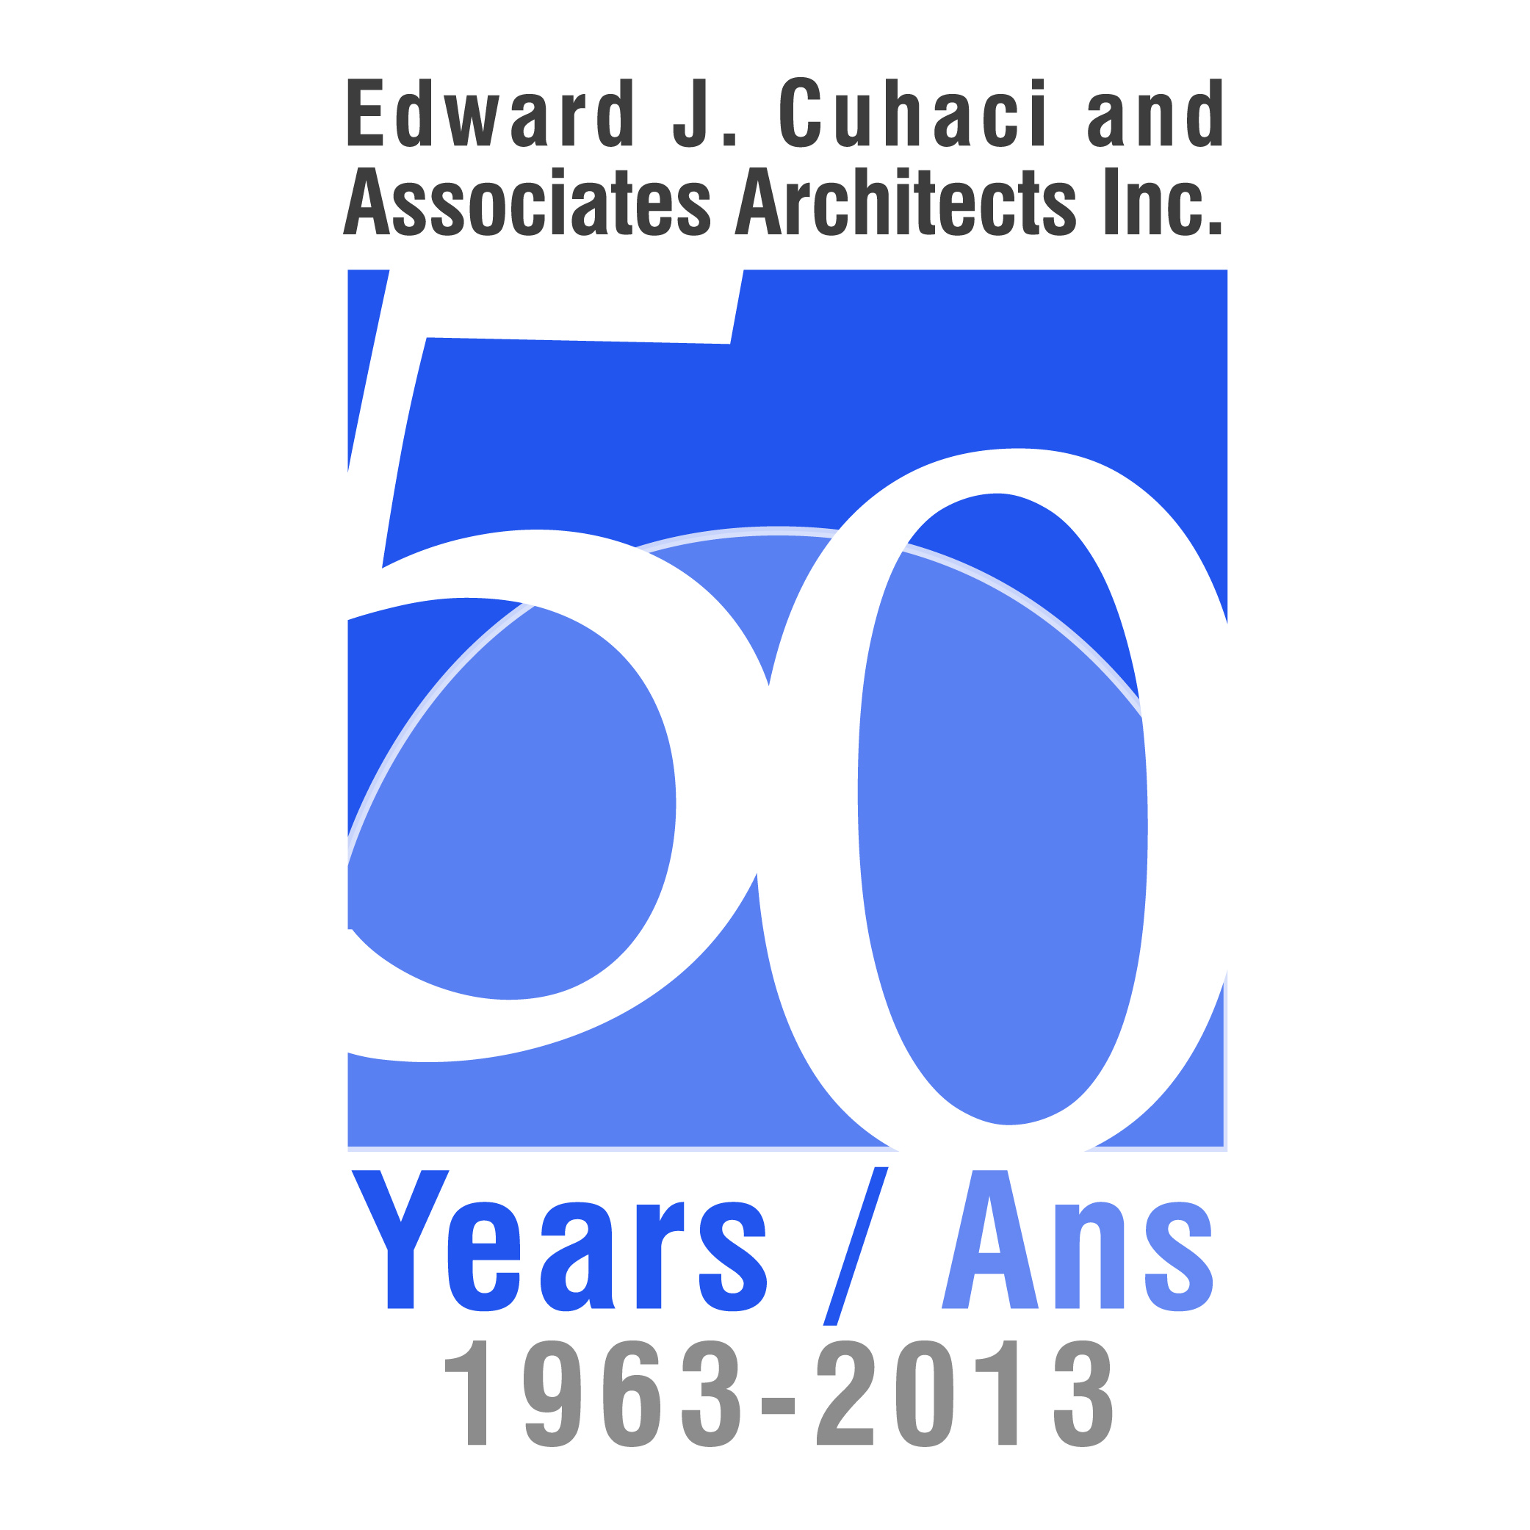

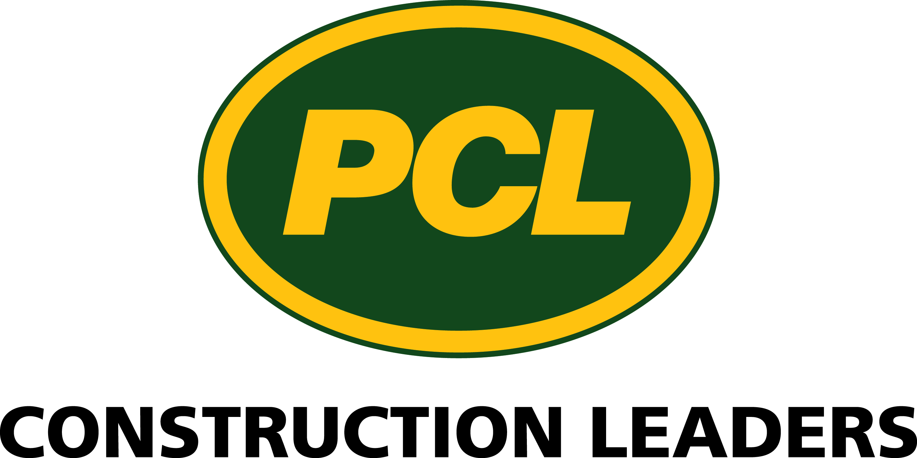

Thank you to our
Carleton University
Partners:

The School of Canadian Studies

The Department of History

The Azrieli School of Architecture

2015 Programme
8:00 – Registration opens
9:00 – Introductory Remarks Susan Ross, Jurek Elzanowski
Assistant Professors, School of Canadian Studies, Carleton University
Heather LeRoux
Co-Chair, 2015 Carleton University Heritage Symposium. M.A. Candidate, School of Canadian Studies - Heritage Conservation, Carleton University.

Session 1 : Abundance / Waste / Destruction
9:20 – Prairie ArchiCulture:
Adaptive Reuse of Wooden Crib Grain Elevators
in Saskatchewan Ali Piwowar
Master of Architecture Student, Azrieli School of Architecture and Urbanism, Carleton University.
9:40 – Heritage Has Left the Building Karen Prytula
Author, Director of Communications for the Lanark County Genealogy Society
10:00 – Heritage Hoarders?
Archaeological Cultural Heritage Resources in Ontario
Chris Uchiyama
Heritage Consultant and Archaeologist, Chris Uchiyama Consulting
10:20 – Questions
10:40 – 11:00 – Morning Break

Session 2: Community Approaches and Intangible Heritage
11:00 – Reimagining the Community Sound Archive:
Cultural Memory and the Case for “Slow” Archiving
on the Gaspé Coast Glenn Patterson
Ph.D. Candidate, Ethnomusicology, Memorial University, St. John’s, NL.
11:20 – the Suburbs as Transitional Space:
Mapping Edge City Heritage through Contemporary Art Tina Chu
Engagement Officer, Art Gallery of Mississauga
11:40 – Questions
12:00 - 1:30 – Lunch Break

Session 3: Dissonance and Difficult Heritage I
1:30 – Industrial Heritage in Northern Ontario:
Case Study of the Controversial Inco Superstack
Amanda Sherrington
M.Sc. Candidate, Conservation of Monuments and Sites, Raymond Lemaire International Centre for Conservation (KU Leuven, Belgium)
1:50 – Marginal Vernaculars and Place-Making Tactics
Sarah Gelbard
Ph.D. Candidate, School of Urban Planning, McGill University, Montreal, QC.
2:10 – Rebuilding Identity:
Architecture as Evidence in Forillon National Park
Desirée Valadares
M.A. Candidate, Urban Design and Housing, McGill University, Montreal, QC
2:30 – Questions
2:45 - 3:05 – Afternoon Break
Session 4: Dissonance and Difficult Heritage II
3:05 – Canadian Law as Heritage
Allister Morrison
M.A. Candidate, School of Canadian Studies, Carleton University
3:25 – Healing Heritage:
Commemorating Canada’s Indian Residential School System
Trina Bolam
Ph.D. Candidate, Carleton University
3:45 – Questions
4:00 – Closing Remarks Paul Litt Professor, School of Canadian Studies, Carleton University

2015 Presentation Abstracts
Ali Piwowar Prairie ArchiCulture: Adaptive Reuse of Wooden Crib Grain Elevators in Saskatchewan
This paper studies the tangible and intangible cultural heritage of the wooden grain elevators in Saskatchewan. As wooden elevators become obsolete as a result of changing agricultural technology, they are facing neglect, abandonment, and demolition. While these elevators were once purely functional structures, their unintentional monumentality has contributed to their relationship with prairie people fostering individual and communal identity.
The wooden elevators are explored in the context of the past, present, and future using archival research, site visits, and interviews. The town of Indian Head, SK is a case study. The micro history of Indian Head permits an understanding of the relationship between elevators and other prairie towns. Further, Indian Head is the selected site for an architectural adaptive reuse project of a wooden grain elevator.
The concept of living heritage is employed to investigate the tangible and intangible cultural heritage associated with grain elevators using a temporal framework. Living heritage is both an action and theory—a way of thinking and acting towards the past. This sets the stage for a multifaceted discourse concerning place, time, and people relating to the wooden grain elevators in Saskatchewan.
Though the demolition of some wooden grain elevators is inevitable, it is crucial that the cultural value of these historic structures be recognized through its living heritage and that adaptive reuses are considered in order to sustain their existence and usability of the elevators into the future. This thesis substantiates the importance of the wooden grain elevators to prairie people and prescribes an architectural response for adaptive reuse.
Karen Prytula Heritage Has Left the Building
The purpose of this paper is to highlight how heritage and history can become lost when an old house outlives the family it was built for, thereby changing the heritage landscape. The importance for this topic lies in an apparent trend accepted by land developers, municipalities, and private owners alike, where a building falls so far into disrepair it is not feasible to renovate and so the only option available is demolition.
This presentation will refer to a few cases, which will be familiar to many, but will focus on a particular stone home located on the Rideau Ferry Road, in Perth Ontario. It is has been destined for demolition for a few years, and is symbolic of many houses like it, from the Rideau Ferry Rd. all the way east to Ottawa. It, like the other houses in Ottawa and area, is host to a history that is not getting told, not being part of the heritage landscape, and therefore not being mentioned in the history books.
This house was built by one of the first pioneers who came to settle in this area. Originally built by Scottish immigrant Peter McPhearson ca. 1835, this stone home has been passed down through several generations. Yet for a number of reasons, to be outlined in this presentation, the house fell into disrepair. The townspeople urged the town council to do whatever they could to save the house. This presentation will outline examples of the different types of uses the townspeople came forward with, and the responses from the town.
The story of this old stone house has not ended yet. A new chapter in its history has begun. It is going to be repurposed: it will be torn down, but will be re-erected stone by stone, on a property closer to Smiths Falls to be used as a winery.
The conclusion to be drawn from this example is that although a building has outlived its purpose, it is not without history or cultural heritage. It does not mean that “history has left the building” because it is no longer capable of its original use.
Chris Uchiyama Heritage Hoarders? Archaeological Cultural Heritage Resources in Ontario
Archaeological assessments are routinely undertaken by licenced Archaeologists as a standard component of development projects in Ontario. These assessments often result in the excavation and recovery of large collections of artifacts. But what happens to these artifacts once they are collected, processed and analysed? In Ontario, it is the responsibility of licenced archaeologists to curate archaeological resources on behalf of the Crown, in perpetuity. With an increasing number of artifacts recovered each year, we are faced with a number of questions about the long-term curation of these, often undesirable, artifacts.
The goals of this paper are to:
- Present an overview of the framework under which archaeological resources are collected and curated in Ontario; and
- Identify some of the issues with the current policies and process, including:
  - The current process leaves the bulk of archaeological resources almost completely inaccessible to not only the public, but also researchers;
  - A large cohort of aging archaeologists are in the process of retiring (What will happen to the artifacts in their care?);
  - A growing number of licenced archaeologists are undertaking an increasing number of projects each year; and
  - Undiagnostic or undesirable artifacts generally account for a large proportion of artifacts recovered during excavation (i.e., rusty nails, window glass).
- Identify possible means to sustainable long-term curation of Ontario’s material cultural heritage and discuss associated opportunities and drawbacks for each of these options, some of which include:
  - Sustainable Archaeology – developing technologies and systems to manage and curate collections efficiently, often digitally (through catalogues, photographs, and, more recently, 3D renderings);
  - long term loans to museums and educational institutions;
  - repatriation of goods to interest groups, ancestors, First Nations; or
  - is it simply time to start returning some of these artifacts to land-fill?
Glenn Patterson Reimagining the Community Sound Archive: Cultural Memory and the Case for “Slow” Archiving on the Gaspé Coast
Theorizing why certain places are effective carriers of cultural memory, sociologist Paul Connerton points to the age before mechanical reproduction: The “handmade world, in which all things were made one by one, was a slow world … [where] … the term ‘building’ would apply as much to the memory of the continuing transitive activity of construction as to that of the eventual product” (Connerton 2009). During 2013 fieldwork in Douglastown, Quebec—an anglophone community on the province’s Gaspé Coast—I collaborated with the Douglas Community Centre and a colleague to begin developing a community sound archive featuring local home recordings made on reel-to-reel and cassette formats. We developed a proactive archival protocol (Edmonson 2004) that is inherently slow, leveraging community collaboration to procure recordings and produce digitized collections that are—contrary to traditional archival practices—highly contextualized at the item-level. This paper explores the materiality and temporalities of sonic archival media and considers how these might intersect with the social dimensions of our slow archival protocol to engender rich ethnographic encounters and cultural remembering. How did community collaborators remember during our archival protocol and how might digitization, by separating recorded sounds from their physical traces, engender cultural forgetting (Huyssen 2000; Van Dijck 2007)? Further, what are the implications of extensive community collaboration for cultural memory and sustainability? Through ethnographic exploration, I seek to broaden proactive archival practices (Landau 2012; Gray 1996) to suggest how researchers might incorporate collaboration not only through proactively engaged user access, but also while building digital and physical holdings, in this way creating a community resource that is at once effective and affective, itself a shared site of production for new cultural memories in dialogue with their audible past.
Tina Chu The Suburbs as Transitional Space: Mapping Edge City Heritage through Contemporary Art
This presentation reconsiders conservation approaches to suburban heritage by suggesting the use of contemporary art as a vehicle to present the lived experiences of Canadian suburbs. It begins by disrupting stereotypical notions of suburban homogeneity, advocating for the examination of edge cities beyond its built form to focus on the social dynamics situated within.
This approach reframes suburban spaces as transitional or in a constant state of becoming and suggests that the experience of space is a necessary consideration in the conservation of suburban heritage alongside current representations of space. The report goes on to suggest the use of contemporary art as a well-suited vehicle to document such experiences and cites examples from leading and emerging Canadian artists working in various media.
Select examples of artists and works include: Esmond Lee’s Between Us, a spatial portrait of his family set in his Scarborough home, Morris Lum’s The New Cultural Topographic: The Plaza, examining architectural hybridity in Toronto’s “ethnic enclaves”, and Camille Turner’s 5 & Dime Walking Tour, a social practice piece that repositions what heritage is in Cooksville, Mississauga’s original downtown currently under threat of gentrification.
In these works, artists, Lee, Lum and Turner navigate a range of private and public spaces by mapping a broad spectrum of experience and effectively employ art to more accurately preserve a nuanced and pluralistic narrative of suburban heritage.
Amanda Sherrington Industrial Heritage in Northern Ontario : Case Study of the Controversial Inco Superstack
The metropolitan area of Sudbury has been an important mining centre in northern Ontario for over 100 years. In order to resolve the alarming and growing threat of pollution and disappearance of the region’s native vegetation, Inco Ltd. resolved to build a 1,250 feet chimney at its nickel smelter complex in Copper Cliff, to reduce the amount of sulphur dioxide emitted in the region. Completed in 1972, Inco’s superstack is today the second highest free-standing structure in Canada, and second highest chimney in the world.
This presentation will aim to evaluate and illustrate the superstack’s historical significance and the community’s reaction to the November 2014 news exclaiming that the company was assessing whether or not the structure was finally obsolete. Any prospects for the preservation of such an immensely complicated and controversial landmark, in the event that it is no longer required, are not made without difficulty however. As illustrated by the community’s colourful response, the superstack is both a necessary evil of the region’s mining past and an ode to the near complete disaster of the area’s ecosystems, all the while being a beacon of hope toward changing tides in mining practices and a cultural landmark.
Sarah Gelbard Marginal Vernaculars and Place-Making Tactics
The re-appropriation of public space is an important practice for community place-making and identity formation. In recent years, tactical urbanism has captured popular imagination. Its hands-on and bottom-up alternative practice of urban place-making encourages citizens to respond to their environment directly with ad hoc and relatively minimal or temporary transformations—often as a form of protest to the expected function or design of public space. Though framed as a form of ‘participatory urbanism’, it is important to note that tactical urbanism often operates around, rather than in direct collaboration with, official and authoritative professional structures of urban planning. Furthermore, despite being described as the “Newest Urbanism”, alternative urban place-making practices have a long history that predate contemporary tactical urbanism. A marginal but growing interest in vernacular architecture presents an analogous challenge to mainstream and professionally-directed production of space. Vernacular architecture privileges a grass-roots sharing of knowledge and techniques that emerge in response to local conditions of place and culture. There is a shared disposition between vernacular traditions and contemporary urban tactics that challenges but potentially enriches our professional understanding of and approach to the built environment. These marginal practices, however, are often overlooked by mainstream studies and histories of the city—an oversight that perpetuates their exclusion. This paper links the place-making practices of tactical urbanism and the vernacular through Michel de Certeau’s theories of marginality and tactics. It further aims to distinguish between marginal and marginalized practices and how both relate to mainstream production and preservation of space.
Desirée Valadares Rebuilding Identity: Architecture as Evidence in Forillon National Park
This research examines changing attitudes toward national park management through the handling of vernacular architecture of expropriated communities. The study advocates for the conservation of the extant built traces as evidence to establish a historical record and counter denial of early expropriation practices in the founding and expansion of Canada's National Parks.
Forillon National Park, located in the eastern tip of the Gaspé Peninsula, was created in 1970 through expropriation of complete villages that resulted in the destructuring and dismantling of entire communities. Beginning in 1970, 225 families were forcibly displaced while one thousand individual lots lying within the boundaries of Forillon were expropriated. Though most signs of human occupation were erased from Forillon National Park, certain buildings and landscapes in the Grande-Grave area remain. This study, which is informed by archival research and participatory field work, supports the conservation of Forillon's vernacular architecture in Grande-Grave to reinforce the cultural landscape of the south shore of the Forillon Peninsula to evoke the former, traditional Gaspé coastal fishing village settlement.
This is significant in light of Parks Canada's current difficulty in documenting and preserving this built and landscape heritage in the Grande-Grave sector. Furthermore, reconciliation efforts spearheaded by two citizen committees: the Committee for the Commemoration of Persons Displaced by Expropriation and the Provisional Committee of the Expropriated People focus more on the interpretive value of exhibition displays, commemorative panels and interpretive trails. This study argues that these committees' mandate and commemorative policy directives should also take into account the built traces at Forillon, which have the potential to offer an equally compelling narrative and a powerful material reminder of the site's rich history of habitation.
Ultimately, this research continues to debate the importance of the relationship between memory and place. Results, in the form of recommendations, explore the feasibility and social acceptability of possible conservation, commemoration and appropriate repurposing techniques of the extant vernacular architecture and landscape in order to contribute to a new, evolving identity of the park.
Allister Morrison Defining Heritage: Conservation Planning in the Post-Industrial City
Arguably, section 35 of the Constitution Act, 1982, is the highest legal protection of heritage -- that being Aboriginal rights -- to exist in Canada. It set out to “recognize and affirm” the “existing Aboriginal and treaty rights of the Aboriginal peoples of Canada”. Over the past couple of decades since the inclusion of s.35, a number of legal cases have confronted, attempted to define and applied the notion of Aboriginal rights to questions around fishing, hunting and Aboriginal title. Calder (1973) and Guerin (1984) acknowledged and reinforced the existence of Aboriginal rights and title, while Sparrow constitutionally protected them. Van der Peet (1996) defined them and Delgamuukw (1997) accommodated for Aboriginal title. Yet, despite this relatively quick legal turnaround from simply recognizing Aboriginals rights in 1973 to them becoming constitutionally protected, there still exists a significant philosophical and epistemological misunderstanding between Canada and Indigenous communities. In some ways, s.35 has diverted Indigenous peoples away from fighting for their rights to assisting Canada in legally defining what Aboriginal rights are. Thus, the question arises as to whether Western notions of heritage -- which work to protect, restore or conserve -- are reconcilable with decolonization which brings forth Indigenous epistemologies, ontologies and aixologies.
Trina Bolam Healing Heritage: Commemorating Canada’s Indian Residential School System
My research anticipates the Final Report of the Truth and Reconciliation Commission of Canada, and both examines and critiques Canada’s federal place-based heritage infrastructure and in particular the policy and practice of the Historic Sites and Monuments Board of Canada (HSMBC) relative to its engagements with the history of Indian residential schools. Interpreting IRS Survivor-led commemoration and heritage practices as healing and decolonizing, and drawing on art-as-resistance and social activism-oriented models of commemoration and counter-commemoration, I examine alternative approaches to collective remembering and forgetting within the context of genocide, atrocity, and historic trauma. I argue for recognition of the potential and uses of heritage as a healing practice. I will speak about the apparent irreconcilability of current HSMBC policy and practice with heritage practices of Indigenous community-based groups relative to Indian residential schools, and ask where we go from here.

A warm thank you to our many supporters:
Thank you to our Volunteers! Without your time and energy, the 10th annual 2015 Carleton University Heritage Conservation Symposium would not have been possible.
Thank you to St. Brigid’s Centre for the Arts for a fantastic venue and enormous support during the planning processes of the Symposium.
Thank you to Epicuria Fine Food Store and Catering for the delicious lunch and to Bridgehead Coffee for sponsoring our reviving coffee breaks.
Thank you to Cathy Schmueck for her immense knowledge and hard work throughout the organization of this event.
Thank you to Robert Tombs for his lovely poster designs.
Thank you to Susan Ross and Jurek Elzanowski for their tireless enthusiasm, their commitment to excellence, their valuable insight and their guidance in organization of this year’s Symposium,
despite busy schedules and other duties.
Thank you!

To all of our speakers, guests, and supporters:

We would like to thank each of you for attending and participating in the tenth annual Carleton University Heritage Conservation Symposium. “Critical/Creative Approaches” is a new but expanding area of heritage conservation, with inspiring and innovative practices. We are honoured to bring together so many brilliant minds discussing the subject. Carleton’s School of Canadian Studies is lucky to play host to so many of these voices and hopes to continue being critical and creative throughout the year.

We hope today’s speakers have inspired you to look differently at your respective fields and imagine critical and/or creative approaches you can take in your own work!

James Arteaga, Stephanie Elliott, Victoria Ellis, Heather Leroux, Amber Polywkan
Co-Chairs, Carleton Heritage Conservation Symposium 2015
MA Students, Canadian Studies – Heritage Conservation
March 2015

