Title of the Honours Project

Student’s Name

An Honours Project submitted to
The School of Linguistics and Language Studies in partial fulfillment of
B. A. Honours in
Applied Linguistics and Discourse Studies

Carleton University
Date

Approved by:

Honours Project Supervisor: Name
ALDS Undergraduate Advisor: Name

ABSTRACT

Your abstract goes here, generally about 200 words. This is a summary of the entire project.

ACKNOWLEDGMENTS
Usually people want to thank their supervisors, other faculty members involved in the project, perhaps member of their families, and any other people the student wants to thank. Generally about half a page, double spaced.

TABLE OF CONTENTS
Use a word processor to generate a table of contents like the one below. In Microsoft Office Word, you should insert a table of contents in the Formal format. You can use up to five levels of headings as described in the APA Style Manual. Below is a sample table of contents.

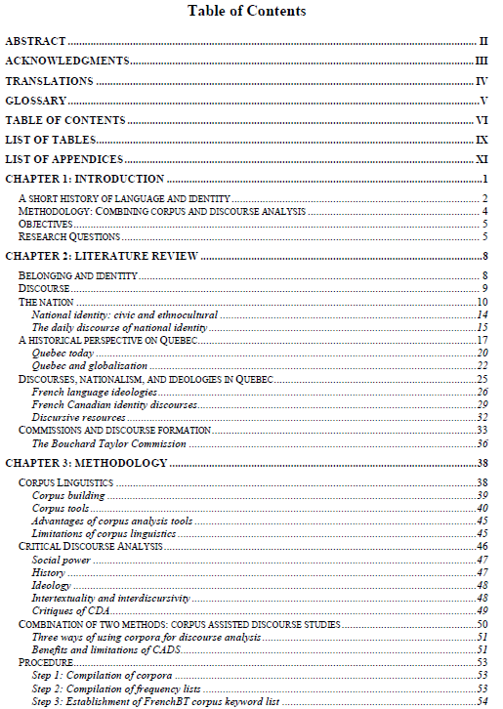
LIST OF TABLES/FIGURES

(Only include this section if you have tables, a list of maps, figures, etc. You should use a word processor to generate such lists. In Microsoft Office Word, you should use the Formal format.)

