QUMRAN FACT SHEET
The discovery of the Dead Sea Scrolls
The Qumran site is located on the west side of the Dead Sea and about 5 km inland, just where the arable land ends at the base of a rugged rocky cliff. It was here in 1947 that one of the most remarkable archaeological discoveries in all Israel took place. Two Bedouin shepherd lads were searching for a lost goat in the rocky interior when they stumbled upon clay jars hidden in a cave and containing a number of scrolls. After a series of adventures and misadventures, the scrolls finally made it into the hands of scholars who recognized their immense historical value.

Archaeological investigations were carried out under the leadership of Father R. de Vaux, a Dominican priest, between 1951 and 1956. Altogether 190 scrolls and thousands of fragments were found in 11 nearby caves. These delicate parchment scrolls were preserved for over 2000 years by the dry climate at Qumran. They contain, in whole or in part, every book of the Hebrew Bible except the book of Esther. The theology, daily practices and rules of the community are described in detail in several of its scrolls, for example, the Community Rule (or Manual of Discipline), the Damascus Rule, and the Messianic Rule.

The Qumran Community
Excavations carried out nearby have uncovered the ruins of the monastic community which produced the scrolls. The site was occupied from about 130 BCE but was completely abandoned after the Jewish War in 68 CE. It is conjectured that the community members hastily hid the scrolls in the caves as they were fleeing from the advancing Roman army.

Scholars generally identify the community as members of the Essene sect which Josephus mentions as the third major grouping within first-century Judaism after the Pharisees and Sadducees. The Essenes followed a strict monastic rule and practised communal living far from the established population centres. Most of the communities were celibate, consisting of men only. A high emphasis on purity and took daily ritual baths. The descriptions of the communal life of the Essenes as described by Josephus are close enough to those in the Dead Sea Scrolls to conclude that the Qumran community was most probably a group of Essenes.

From the scrolls we learn further that the community was governed by a priesthood claiming descent from Aaron and the Levites. The Law of Moses was supreme and members were held to a very standard of moral conduct. Stiff penalties were imposed, even for minor violations. There was no sacrifice of animals and members were forbidden to swear oaths.

The Qumran site visit
Upon our entrance to the site, we will first see a short multi-lingual film and view a small exhibit on the site. We will then proceed to the main archaeological site. From the watch tower we will view a number of features of the site, including the scriptorium where the scrolls were produced, the refectory and assembly hall, the potter’s kiln, and the mikvehs or baths. For the purpose of these baths water was brought into the site by aqueducts and was stored in cisterns.

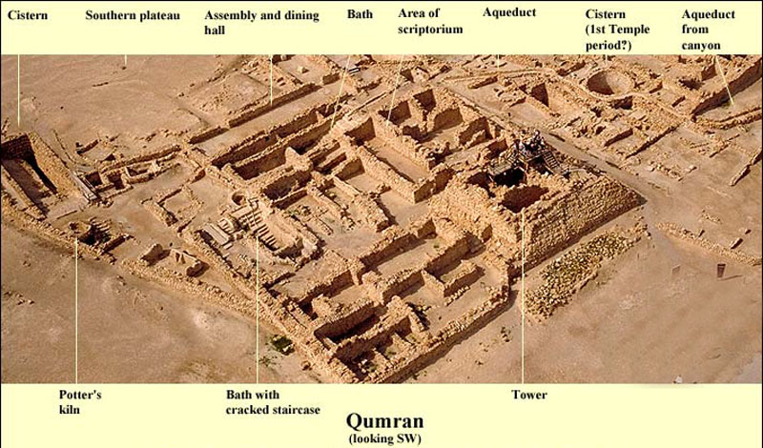
The Qumran site as it appears today.

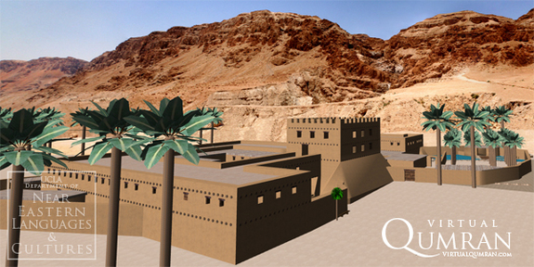
A reconstruction of how the site might have appeared in the first century.

References on the Qumran site and the Essenes.

“Archaeology in Israel:Qumran,” Jewish Virtual Library, https://www.jewishvirtuallibrary.org/jsource/Archaeology/Qumran.html

Flavius Josephus, The War of the Jews, Book II, Chapter 8.
http://www.ccel.org/j/josephus/works/war-2.htm

The Dead Sea Scrolls in English, ed. G. Vermes, London: Penquin Books, 1987.

