Dana Murray
May 20, 2014

Voluntary Associations and Judaean Identity Expressed in Synagogue Art

Sites: Beit She’an (c. 4-7th century), Beth Alpha (5-6th century CE), Ein Gedi (3-6th century CE) and Hamat Tiberias (4th century CE) synagogues

Readings:
Primary:
Judith; Josephus, Vita 276-81, 290-303; Matt 4:23; Luke 4:14-15; m. Ned. 5:5; m. Shebu. 4:10; m. Neg. 13:12; Josephus, B.J. 2.289; Beth Alpha Inscription; Ein Gedi Inscription.

Scholarly:
Hachlili, Rachel. “The Zodiac in Ancient Jewish Synagogal Art: A Review.” Jewish Studies Quarterly 9.3 (2002): 219-258.
Magness, Jodi. “Samson in the Synagogue.” Biblical Archaeology Review 39.1 (2013):
32–39, 66–67.

Fine, Steven. “Iconoclasm.” Bible Review 16.5 (2000): 32-43, 55.

Dvorjetski, Estee. “Healing Waters.” Biblical Archaeology Review 30.4 (2004): 16-27, 60.

Key Terms:

Aramaic: Script adapted from Phoenician alphabet during 8th century BCE, read right to left.

Bet ha-kneset: “synagogue,” may refer to the building or place of meeting for worship/religious instruction, or the congregation of people for the purpose of worship/religious instruction.

Bema/Bimah: Raised platform in the synagogue on which the Torah is read on the Sabbath and festivals.

Mosaic themes and images: Ancestors (i.e. Adar, Abraham, Isaac, Jacob, Hananiah, Mishael, and ‘Azariah), Ethrog (yellow citron), Helios (personification of the sun), Lulav (palm branch), Menorah, Odysseus, Quadriga (Chariot drawn by four horses), Shofar (ram’s horn), and Zodiac (derived from Greek ζῳδιακὸς κύκλος, or “circle of animals”).

Outside Research:

Magness, Jodi. “Heaven on Earth: Helios and the Zodiac Cycle in Ancient Palestinian Synagogues.” Dumbarton Oaks Papers 59 (2005): 1-52.

Rogoff, Mike. “The Hammat Tiberias' synagogue floor mosaic.” Haaretz.
Accessed on May 3, 2014. http://www.haaretz.com/travel-in-israel/tourist-tip-of- the-day/.premium-1.554419

Shanks, Hershel. “First Person: The Sun God in the Synagogue.” Biblical Archaeology Society. Accessed April 29, 2014. http://www.biblicalarchaeology.org/daily/ancient-cultures/ancient-israel/first- person- the-sun-god-in-the-synagogue/.

Zanger, Walter. “Jewish Worship, Pagan Symbols.” Biblical Archaeology Society. Accessed April 29, 2014. http://www.biblicalarchaeology.org/daily/ancient- cultures/ancient-israel/jewish-worship-pagan-symbols/.

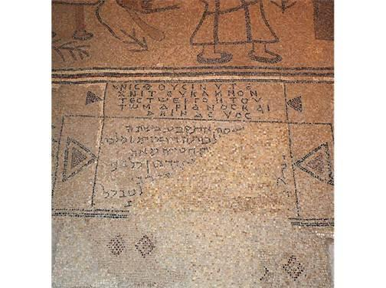
Images:
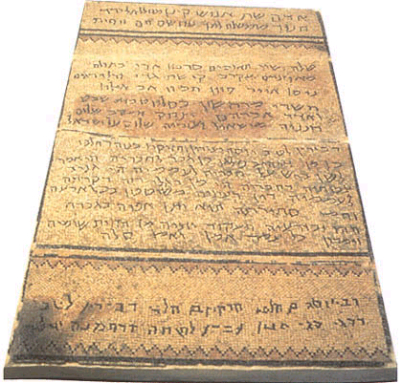

Ein Gedi inscription Beth Alpha inscription
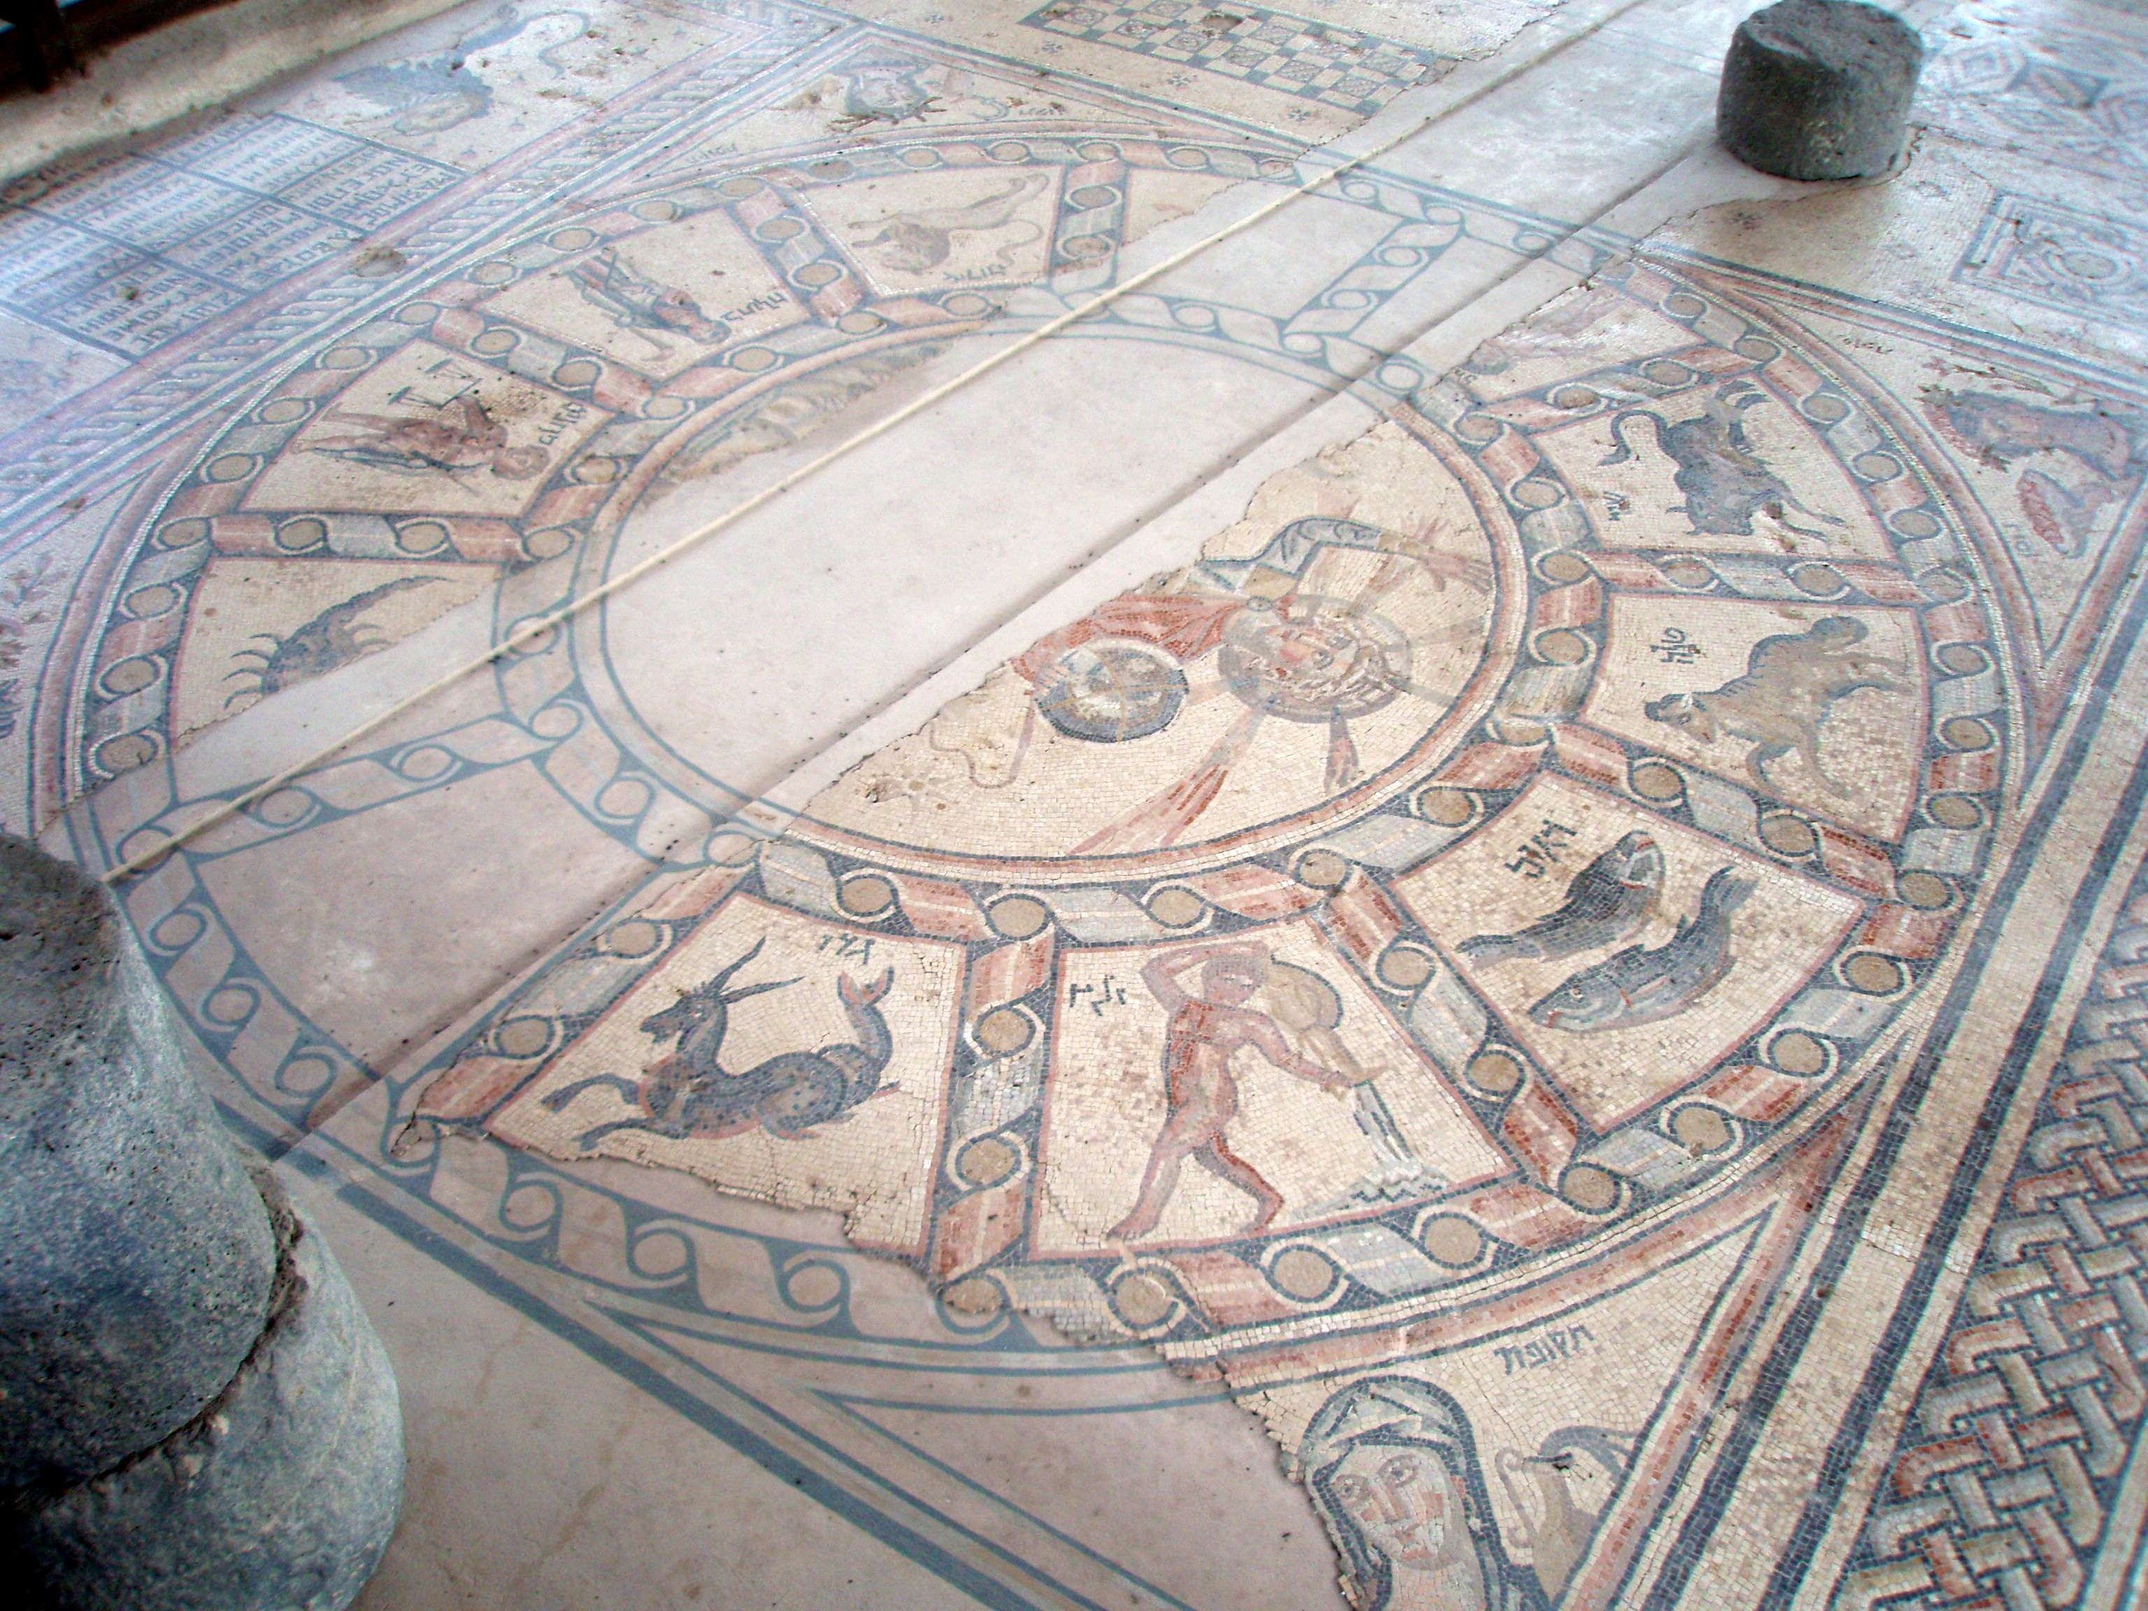

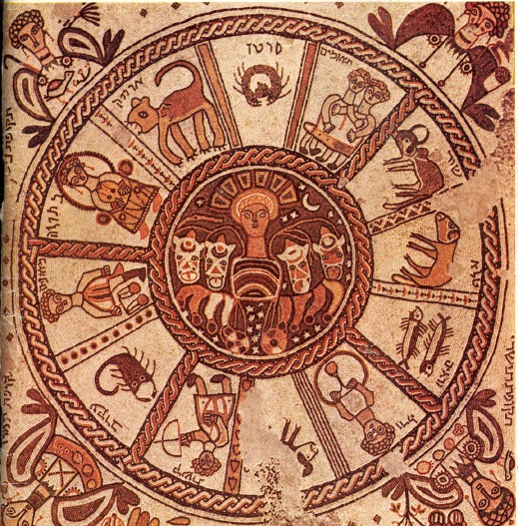

Beth Alpha mosaic Hamat Tiberias mosaic

