
Coordinated Accessibility Strategy
Annual Report 2025-2026

Contents
Algonquin Territory Acknowledgement 3
From the Coordinated Accessibility Strategy Implementation Team 4
Executive Summary 5
Context 6
Reporting Back 7
Cross-Campus Patterns 8
Highlights of Progress in the Areas of Focus 9
Area of Focus #1: Coordination and Leadership 10
Area of Focus #2: Education and Training 11
Area of Focus #3: Information and Communication 12
Area of Focus #4: Physical Campus 13
Area of Focus #5: Employment and Employee Support 14
Area of Focus #6: Student Support Services 15
Area of Focus #7: Research and Development 16
Evaluating Impact 17
What is Next? 17
Appendix 1: Areas of Focus and Recommendations Status 18
Area of Focus #1: Coordination and Leadership 19
Area of Focus #2: Education and Training 19
Area of Focus #3: Information and Communication 20
Area of Focus #4: Physical Campus 20
Area of Focus #5: Employment and Employee Support 21
Area of Focus #6: Student Support Services 21
Area of Focus #7: Research and Development 22

Algonquin Territory Acknowledgement
Carleton University acknowledges the location of its campus upon the traditional, unceded territories of the Algonquin nation. We recognize that the implementation of the Coordinated Accessibility Strategy must reflect the values of the Algonquin people. Accordingly, we must strive to further strengthen relationships between Carleton and the Algonquin communities and endeavor to accelerate the inclusion of Indigenous perspectives and knowledge in our campus practices.


From the Coordinated Accessibility Strategy Implementation Team
Carleton University strives to be an inclusive community, one that leads with care, accountability and a shared commitment to reducing barriers for students, staff, faculty and visitors.

This past year has been a significant one for accessibility at Carleton, as it marked the completion of the first five-year Coordinated Accessibility Strategy (2020–2025) and the development of its follow-up strategy. The renewed Coordinated Accessibility Strategy (2025–2030), released in June 2025, reflects the voices of our campus community. Throughout 2024–2025, our team engaged in extensive consultations with our campus, including those with living/lived experience of disability. These dialogues shaped the priorities and longer-term outcomes embedded in the new strategy. The refreshed CAS is not simply a continuation of past efforts. It is a deepening of our collective vision for what accessibility at Carleton must become.

As we continue our shared journey toward a more accessible and inclusive Carleton, we are energized by the commitment, creativity and collaboration reflected across this year’s reporting. Accessibility is not achieved through single actions, but through a culture of care, one that grows stronger when each of us contributes in meaningful ways.

Thank you to every unit, staff member, faculty member and student who has contributed to this progress. Your work helps shape a more accessible future for all members of our campus community.

To our continued success,



Cathy Malcolm Edwards
CAS Implementation Lead

Executive Summary
The 2025–2026 reporting period marks the first year of implementation of Carleton University’s renewed Coordinated Accessibility Strategy (CAS) 2025–2030. This refreshed strategy builds on extensive community consultation and reflects Carleton’s deepening commitment to accessibility, inclusion and barrier reduction across campus.

Early implementation shows strong engagement: 23 units reported activities aligned with the CAS between June 2025 and April 2026 spanning all seven areas of focus. Over the past year, four of the 25 CAS strategic actions are considered complete or continuous (meaning key activities have been accomplished, although there is no definitive end date); nine strategic actions are underway; three are in the planning phase; and nine are upcoming.

Several broad themes are emerging based on responses submitted through the 2025 Accessibility Activities Reporting Form (June 2025 to April 2026):
- Neuroinclusion is becoming a defining element of accessibility work, visible in programming, training and campus engagement.
- Accessibility is shifting toward accessible-by-design practices, reducing barriers for students, staff and faculty.
- Investment in improving accessibility of our physical campus.
Additionally, campus units often identified time, capacity, budget and accessibility mindsets as the most common challenges. Attitudes, dedicated staff expertise and targeted resources were cited as key facilitators. This duality reflects a culture in transition: momentum is building, but sustained reinforcement through continued awareness efforts, capacity building and leadership modeling will be essential to support lasting change.
Carleton is also advancing its multiyear evaluation approach through the CAS Logic Model, which integrates quantitative indicators (e.g., accessible spaces, training uptake) and qualitative measures (e.g., user experiences, cultural shifts). This supports evidence-informed planning, continuous improvement and accountability.
Carleton will continue strengthening accessibility through strategic investments, enhanced coordination and the scaling of successful initiatives across campus. Priorities include strengthening leadership capacity and accountability for accessibility and inclusive practices, improving tools and processes that support employees with disabilities, and advancing accessible-by-design digital and physical practices. Ongoing collaboration with senior leaders across portfolios will remain essential to sustaining momentum, aligning resources and supporting coordinated implementation.

Context
Carleton University’s second iteration of the Coordinated Accessibility Strategy (CAS) launched in June 2025. The CAS outlines seven areas of focus, comprising 14 objectives and 25 strategic actions which have been determined based on community consultation.
The CAS supports Carleton’s commitment to fostering a strong culture of accessibility across the campus by coordinating programs and initiatives related to accessibility, while prioritizing the creation of an inclusive environment for all students, employees and visitors. An Implementation Plan accompanies it. Through a coordinated structure and a multi‑year process, the Implementation Plan turns strategic actions into reality, helping create a more accessible Carleton for everyone. Overall, the implementation structure (Figure 1) will bring together members of the Carleton campus community interested in and committed to moving the dial on accessibility.
Figure 1: CAS Implementation Structure

A key contributor to this work is the CAS Advisory Group, which includes 22 volunteer members. Together, they represent students, staff, faculty, instructors, alumni and individuals with living/lived experience of disability. The Operations Group coordinates day-to-day implementation, monitoring progress and supporting other groups. Working Groups translate strategic actions into concrete projects and deliverables. The Vice-Presidents Group offers senior level oversight, aligns resources and addresses institutional risks. This structure ensures strategic direction, operational execution, community engagement and institutional accountability necessary to drive meaningful accessibility progress.

Reporting Back
While the refreshed strategy is still in its initial stages, 23 units reported delivering or planning at least one activity between June 1, 2025 – April 30, 2026, through the 2025 Accessibility Activities Reporting Form.
Figure 2: Number of people and units involved in planning and early implementation

The 50 activities reported represent a healthy distribution across portfolios and indicate that accessibility is being advanced through multiple levers (e.g., policy alignment, service design, digital accessibility and physical space modifications) rather than a single program stream (Figure 3).
Figure 3: Activities by primary area of focus

It is important to note that figure 3 reflects the number of activities undertaken, not their depth, scale or complexity. Some activities, particularly those within Student Support Services and Physical Campus, represent major, resource‑intensive initiatives with broad reach and long‑term impact (for example, residence retrofits or expanded neurodivergent support programming), while others may be smaller or more targeted in scope.
This distribution is also consistent with Carleton’s strong, long‑standing culture of accessibility within Student Support Services. These units work closely with students every day and have well‑established structures, practices and partnerships that naturally yield a high volume of activity. Their deeper culture of accessibility often leads to more continuous innovation, more frequent reporting of activities and more visible outcomes.

Cross-Campus Patterns

Neuroinclusion
A growing campus pattern is the expanding investment in neuroinclusive programming, training and environments. At least nine units now offer neurodiversity‑focused supports. Collectively, these initiatives reflect a broad institutional shift toward better understanding and supporting neurodivergent learners and colleagues.

Shifting to Accessible-By-Design
We are shifting toward an accessible‑by‑design mindset, particularly for digital experiences across campus. These resources reduce “How do I…?” moments for students and staff by making tasks clearer, more intuitive and accessible from the start.

Physical Campus Upgrades
More campus units are increasingly investing in accessible physical spaces, reflecting a growing commitment to removing barriers and improving the day-to-day experience for students, staff and visitors. This trend shows a clear shift toward proactive planning, with departments integrating accessibility considerations into renovations, infrastructure upgrades and service improvements.

Expected Campus Impacts
The most frequently expected outcomes are knowledge gains and easier access to information/services. This pattern is consistent with the shift to accessible‑by‑design practices (plain language, webforms, captions, predictable processes) and represents foundational change upon which physical and policy improvements can compound. Mentions of improved accommodations and accessible physical spaces indicate tangible benefits that directly impact daily usability of the campus including door timing adjustments, accessible group study rooms and barrier‑free residences.
Across departments, a range of operational conditions influenced the progress of accessibility-related initiatives. Many of these conditions were experienced both as supports and as challenges, depending on context and resource availability.
Time and budget emerged as the most frequently cited factors across all categories. These conditions functioned as everyday operational factors that could either accelerate or slow progress, depending on how effectively they were allocated and coordinated. Attitudes and mindsets were reported more often as enabling supports rather than constraining, indicating a strong collective willingness across units to advance accessibility work.
This dual pattern reflects a culture in transition. Accessibility mindsets were ranked among the top factors both enabling and constraining progress, underscoring the ongoing need for culture building, awareness initiatives and visible leadership modeling to reinforce and sustain momentum.

Highlights of Progress in the Areas of Focus
The following section outlines highlights and progress from the 2025-2026 year, mapped to the corresponding CAS area of focus. For a comprehensive list of all objectives and recommendations, along with their current statuses, please see Appendix 1.

Area of Focus #1: Coordination and Leadership
This area of focus aims to strengthen the effectiveness of accessibility initiatives, promote diverse representation and sustain Carleton’s reputation as a leader in accessibility.

Highlights:
- Two tabling events engaged approximately 70 community members and revealed both strong interest in accessibility and ongoing gaps in awareness of accessibility on campus. Overall, the feedback points to opportunities for clearer communication, stronger policy alignment and improved accessibility supports for students and employees. Area of Focus 1a
- The CAS Advisory Group, which includes 22 volunteer members, formed in Fall 2025. Collectively, they represent students, staff, faculty, instructors, alumni and individuals with living/lived experience of disability. Area of Focus 1b, 1d
- A two-week adaptive sport camp offered activities supported by a 3:1 camper-to-staff ratio and Attendant Services. The camp served 13 participants and increased awareness of parasport opportunities. Area of Focus 1
- Carleton hosted the 2025 Special Olympics Ontario School Championships, welcoming over 1,100 student athletes. The event strengthened Carleton’s reputation as an accessible and inclusive venue for major adaptive sport competitions. It also enhanced campus understanding of accessibility and highlighted physically accessible event spaces. Area of Focus 1
- The Office of Quality Initiatives (OQI) helped develop the updated Healthy Workplace Strategy, embedding accessibility as a core component of workplace well-being and aligning it with the Coordinated Accessibility Strategy. Expected benefits include easier navigation of processes, improved access to services and information and a more inclusive campus culture. Area of Focus 1c

Area of Focus #2: Education and Training
This area of focus supports the knowledge and skills needed to foster accessible and inclusive teaching, learning and research environments. It involves inclusive practices through academic programs, skills-based certification training and professional development initiatives.

Highlights:
- The Faculty of Engineering and Design and Teaching and Learning Services collaborated to create the “Accessible Design” Brightspace module. The project, which introduces disability, accessibility and inclusive design concepts to improve knowledge of accessibility in the student population, has been piloted to approximately 40 undergraduates in Winter 2026 Area of Focus 2d
- The Faculty of Science hosted an Awareness, Collaboration and Engagement event to advance Equity, Diversity and Inclusion (EDI). “Autistic in Academia” had approximately 50 attendees and boosted knowledge of neurodiversity and accommodations. Area of Focus 2d
- Graduate Studies included 43 professional development workshops for graduate students and postdocs via online delivery to improve access to services and information. The workshops helped to build essential skills in career planning, communication, research and networking. Area of Focus 2b
- There has been increased proactive engagement in professional development to pursue accessibility knowledge including at senior academic leaders in the Faculty of Public and Global Affairs and across the Admissions unit. Together, these initiatives enhanced shared understanding and improved the accessibility of campus services. Area of Focus 2
- The Department of Political Science created an Equity, Diversity, Inclusion and Reconciliation section on the website which gathers latest educational materials on EDIR debates and readings in Political Science that could be included in course outlines. Area of Focus 2

Area of Focus #3: Information and Communication
This area of focus supports digital accessibility, as well as how we share information across platforms and departments, including information technology, learning management systems and communication practices that go beyond compliance standards.

Highlights:
- Graduate Studies is transitioning longstanding static and fillable PDF academic forms into accessible webforms. This shift ensures forms work smoothly with assistive technologies, reflow on any device and eliminate the need for specialized software. The change makes information and services easier to access for a broader range of users. Area of Focus 3b
- Recruitment is adding an audio narration option to the virtual campus tour, launching this spring. This enhancement allows prospective students to listen to tour content rather than relying solely on text. It improves digital accessibility and supports different learning and engagement preferences. Area of Focus 3b
- Teaching and Learning Services shares regular accessibility-focused tips in its monthly newsletter to help instructors improve the usability of teaching materials and educational technology. These short, practical messages raise awareness about digital accessibility across the teaching community. The newsletter reaches roughly 1,500 faculty and contract instructors. Area of Focus 3b
- Accessible communication is crucial to ensuring that everyone can access information and participate fully. An accessible communication guide is in development and will be released in Spring 2026. The guide provides staff and faculty with an introductory understanding of accessible communication, including diverse types of accessibility considerations, creating accessible content, assistive technologies, good accessible communication practices and resources and tools. Area of Focus 3a
- A new set of considerations for accessible meetings and events is now available for the Carleton community. For a quick and easy format, new Quick Guides were developed for the updated full guide. Collectively, these guides aim to ensure all Carleton University meetings and events are as accessible and inclusive as possible. Area of Focus 3

Area of Focus #4: Physical Campus
This area of focus highlights the commitment to reduce accessibility barriers across the physical campus, including structural and sensory (e.g., visual, auditory) elements, to ensure people can access and navigate the campus.

Highlights:
- The Accessibility Institute, Department of University Communications, and Information and Technology Services collaborated to provide a comprehensive, campus-wide inventory of accessibility features per building. The project brought together detailed data on accessible parking, entrances, tunnel connections, elevators and washrooms for every academic and residence building, ensuring a consistent and centralized accessibility profile across the university. Area of Focus 4c
- The university completed comprehensive physical campus accessibility audits covering 40 buildings and requiring 2,000 people hours of work. This effort involved coordination across four departments and was made possible through dedicated support from university leadership. Area of Focus 4
- The campus invested in accessible physical spaces across several units. Carleton Dominion Chalmers Centre installed new accessible door operators at high-traffic entrances funded by the Audette Foundation Fund. The Library expanded its sensory-friendly study options by retrofitting four group rooms with powered doors, adjustable lighting and accessible furniture. Accessible rooms in the Library have seen 2,300+ bookings since Fall 2024. The Registrar’s Office and Academic Advising Centre also improved front office accessibility. Area of Focus 4c
- Rideau House added 60 Ontario Building Code–accessible rooms and eight barrier-free rooms as part of a new build. This expansion increases the university’s capacity to guarantee accessible housing for students who require it. It also supports accessible conference hosting. Area of Focus 4a
- A student working with the Accessibility Institute developed tools to support an annual review of all campus Para Transpo stops. In 2025, 100% of mapped stops (20/20) were reviewed and updated. This process ensures information accuracy and supports barrier removal across transportation routes. Area of Focus 4
- The counselling and medical areas of the Office of Student Health and Wellness added new sensory supportive features. Calm waiting area spaces and sound attenuation measures were created to reduce sensory overload. These changes make physical spaces more supportive for neurodivergent students seeking care. Area of Focus 4a

Area of Focus #5: Employment and Employee Support
This area of focus aims to enhance workplace inclusion for persons with disabilities by promoting representation, improving accessibility and fostering a supportive environment for all employees. It also involves including employees with disabilities in providing input into the implementation activities related to this area of focus.

Highlights:
- Human Resources (HR) led a comprehensive review of the professional services hiring framework, which was audited by an external agency through an inclusivity and accessibility lens. The resulting report identified strengths along with a small number of improvement areas, which have since been implemented. This work enhances transparency, accessibility and consistency across hiring practices. Area of Focus 5a
- HR updated its approach to collecting medical information by shifting from generic physician forms to condition-specific, individualized request letters. This change allows the university to receive clearer, more detailed information about employee restrictions, reducing back-and-forth communication. The result is more accurate accommodation planning and smoother navigation of the return-to-work and support processes. Area of Focus 5d
- An accessibility audit was completed for new employee orientation slides, and accessibility resources have been added to the content. Area of Focus 5

Area of Focus #6: Student Support Services
This area of focus includes services across the university and throughout the campus community. It aims to support the needs of students throughout their university journey and in fostering their personal, professional and academic potential. This includes continuing to provide accessible services and environments to help students thrive both inside and outside the classroom.

Highlights:
- A new system was developed by Strategic Initiatives (Students and Enrolment) to share timely updates about road closures, elevator outages and other infrastructure issues through the Carleton Mobile App and web platforms. This improves information sharing related to campus accessibility. It ensures students can better navigate physical barriers in real time. Area of Focus 6b
- A neurodiversity group offered by Health and Counselling Services (HCS), supports students through activities, discussion, and campus engagement that build social connection, communication skills and wellness. In Fall 2025, 145 students registered. HCS also offered a neurodivergent group that provides a neuroaffirming space for women and female-identified students, helping participants develop wellness strategies, coping tools and peer support; 104 students registered in Fall 2025. Area of Focus 6b
- The library expanded alternate format production for visually impaired students, ensuring course readings, library resources and media include proper tagging, alt text and accessible structures. In Fall 2025, 671 readings and six textbooks were remediated; in Winter 2026, 250 readings, 17 textbooks, and six videos were produced. This centralizes alternate format services and significantly improves the student experience. Area of Focus 6b
- The Wellness Desk hosted a spotlight event to introduce neurodivergent students to the Accessible Career Transitions program and related supports. Staff provided a welcoming orientation to the physical space and services. This reduces uncertainty and supports smoother access to wellness resources. Area of Focus 6b
- The Student Support Certificate provided foundational knowledge on neurodiversity and equipped participants with practical strategies. The “Introduction to Accessibility” workshop complements this by exploring accessibility-focused strategies within their departments. Area of Focus 6
- The Therapy Dog program introduced low sensory office hours for students who prefer quiet, predictable environments. This makes the program more accessible to students who avoid larger, busier drop-in sessions. Area of Focus 6b

Area of Focus #7: Research and Development
This area of focus seeks to cultivate a thriving, inclusive research community that leads the way in accessibility and disability research.

Highlights:
- Carleton Office for Research Initiatives and Services conducted an environmental scan using 35 faculty interviews, publication metrics, research funding data and input from the Accessibility Institute to identify Carleton’s strengths and opportunities in accessibility/disability research. The scan informs an internal report (Winter/Spring 2026), follow on workshops/info sessions and supports institutional funding pursuits with one major institutional proposal submitted in 2025 as a direct outcome. Expected impacts include stronger research culture and strategic recommendations to leverage accessibility/disability research across campus. Area of Focus 7b
- Carleton recruited a nominee for a Canada Excellence Research Chair (CERC) focused on accessibility. The accessibility area drew 11 of 27 applications (40.7%), and one candidate was chosen as one of Carleton’s two institutional nominees (submission targeted for March 2026). This strengthens Carleton’s leadership trajectory in accessibility research and raises visibility for disability-focused scholarship. Area of Focus 7
- In partnership with the Sinneave Family Foundation, the Accessibility Institute synthesized national and international evidence on neuroinclusive housing, combining ecosystem mapping, 48 in-depth interviews, Spotlights, webinars and Housing Harmonies webcasts. Findings were translated into The Bright Ideas Book and an accessible website, offering practical tools for practitioners, families and communities. The project expands access to evidence-informed strategies and supports broader adoption of neuroinclusion in housing ecosystems. Area of Focus 7c
- AVA (Accessibility Virtual Assistant) originated as a New Frontiers in Research Excellence Exploration (NFRFE) project and has now progressed into early implementation within the Paul Menton Centre’s service workflows. The tool provides a flexible, conversational way for students to share information about their accessibility needs and day-to-day activities that affect academic performance. By gathering this contextual detail in advance, AVA equips PMC coordinators with more relevant information ahead of meetings, supporting clearer discussions and more effective accommodation planning. Anticipated outcomes include improved accommodation quality and easier access to services. Area of Focus 7c; Area of Focus 6b

Evaluating Impact
A key component of evaluation is the CAS Logic Model, developed to guide our long-term vision and ensure alignment between day-to-day activities, intermediate outcomes and the broader institutional goals of accessibility. The logic model provides a structured framework for evaluating progress, supporting evidence-informed decision making and reinforcing accountability across all areas of focus. By integrating the logic model into ongoing planning and reporting cycles, we will enhance our ability to measure impact, identify gaps and support a culture of continuous improvement as we advance toward a barrier-free campus. The model includes monitoring quantitative indicators (e.g., the number of accessible rooms added, digital accessibility improvements and uptake of accessibility-related training) alongside qualitative indicators like user experience, cultural change and the living/lived experiences of students, staff and faculty with disabilities.

What is Next?
Carleton will continue strengthening accessibility through strategic investments, enhanced coordination and the scaling of successful initiatives across campus. A key priority will be deepening an institution-wide culture of accessibility by strengthening leadership capacity and accountability for accessibility and inclusive practices, improving tools and processes that support employees with disabilities and advancing accessible-by-design digital and physical practices. The CAS Advisory Group plays a central role in helping prioritize next steps, ensuring emerging needs and living/lived experience perspectives guide decision-making. Ongoing collaboration with senior leaders across portfolios will remain essential to sustaining momentum, aligning resources and supporting coordinated implementation. Continued integration of the CAS Logic Model will reinforce evidence-informed planning, measurement and accountability as the university moves toward its long-term vision of a barrier-free campus.
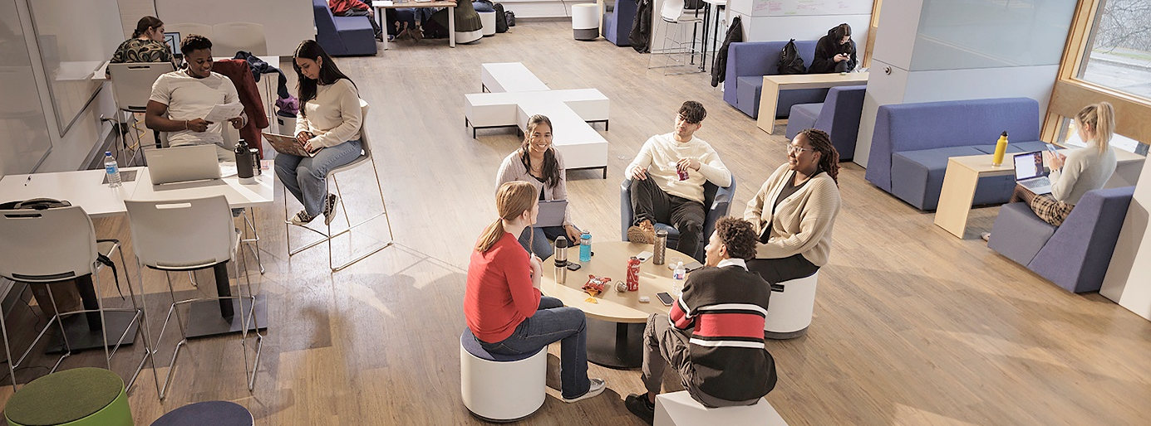

Appendix 1: Areas of Focus and Recommendations Status
This Appendix contains the Objectives and Strategic Actions directly outlined in the Coordinated Accessibility Strategy (CAS). A status column has been added with the following indicators:
- Complete: Activities are complete with no further implementation required.
- Continuous: Key activities have been completed, but implementation is an ongoing process with no definitive end date.
- Underway: Activities are currently underway and being implemented.
- Planning: Activities (e.g., planning, coordination) are initiated in the current reporting cycle.
- Upcoming: Activities are planned in the near-to-mid term.
The tables on the following pages can be summarized as follows:
- 1 strategic action is considered complete;
- 3 strategic actions are in a continuous state;
- 9 strategic actions are underway;
- 3 strategic actions are considered in the planning phase; and
- 9 strategic actions are in the upcoming phase.
As strategic actions are implemented, it is worth noting that the implementation is an ongoing process with no definitive end date. This is reflective of accessibility not being an end state but instead a continuous state of adaptation.

Area of Focus #1: Coordination and Leadership
Strategic Actions | Status
- Implement feedback mechanisms with the campus community as a way to support progress and identify new or evolving needs | Continuous
- Establish cross-functional working groups to address accessibility challenges and to ensure a coordinated approach | Underway
- Formalize institutional policies for accessibility as a priority at all levels, ensuring that accessibility is embedded in decisions, operational practices and long-term strategies | Underway
- Ensure persons with disabilities and other equity-denied groups are involved in decision-making processes related to the Coordinated Accessibility Strategy | Continuous

Area of Focus #2: Education and Training
Strategic Actions | Status
- Provide incentives, skills and resources for educators to consider universal design for learning (UDL) and digital accessibility in the creation and delivery of academic activities and experiential learning | Upcoming
- Explore and expand the availability of online courses to better meet the diverse needs of learners and educators | Planning
- Continually assess and improve accessibility across all aspects of the academic experience, including research environments | Upcoming
- Develop new academic and professional development programs and courses that have a focus on accessibility or disability | Underway

Area of Focus #3: Information and Communication
Strategic Actions | Status
- Create and provide training on communication accessibility standards, including course syllabi and university forms, so that people with disabilities can access, use and benefit from information | Underway
- Ensure all Carleton templates are accessible and continually improve based on user experiences and feedback | Planning
- Explore integrated accessibility evaluation tools for digital content | Upcoming

Area of Focus #4: Physical Campus
Strategic Actions | Status
- Adopt an accessible design standard that surpasses minimum requirements | Upcoming
- Prioritize and undertake accessibility retrofits, including in research spaces and those identified as part of the accessibility audit | Underway
- Enhance the clarity and consistency of wayfinding across campus to improve navigation, including signage, campus building pages and digital maps | Underway
- Ensure an inventory of accessible parking that is responsive to the needs of the community | Upcoming

Area of Focus #5: Employment and Employee Support
Strategic Actions | Status
- Identify and respond to gaps in employment-related policies, procedures and practices that support accessibility, accommodations and disability-competent inclusion across all stages of employment | Planning
- Build capacity, knowledge and resources for managers, department chairs and HR staff to support employees with disabilities, including specialized expertise on equitable workplace accommodations | Underway
- Provide training and guidance on disability inclusion across all work environments, including understanding the spectrum and diversity of visible- and non-visible disabilities | Upcoming
- Regularly review, improve and implement timely communication of clear, effective and consistent processes, including roles and responsibilities, for workplace accommodations, so that employees with disabilities feel supported in all work environments | Upcoming

Area of Focus #6: Student Support Services
Strategic Actions | Status
- Enhance communications in the accommodations process, ensuring clarity for students at all points | Upcoming
- Review standards and address gaps in service across student-facing departments and units and clearly outline roles, expectations and responsibilities regarding accommodations for students with disabilities | Underway
- Expand awareness and training for faculty, staff and student peers to better support the academic success of students with disabilities | Continuous

Area of Focus #7: Research and Development
Strategic Actions | Status
- Encourage researchers to foster research labs and lab processes that take accessibility into consideration and build knowledge by providing accessible, timely information, guidance and training | Upcoming
- Conduct an environmental scan at Carleton to inform strategic recommendations and actions that strengthen internal and external partnerships and community engagement in accessibility and disability research | Completed
- Promote the visibility and dissemination of research in accessibility and disability by developing and implementing strategies to share findings with both academic and non-academic audiences | Underway

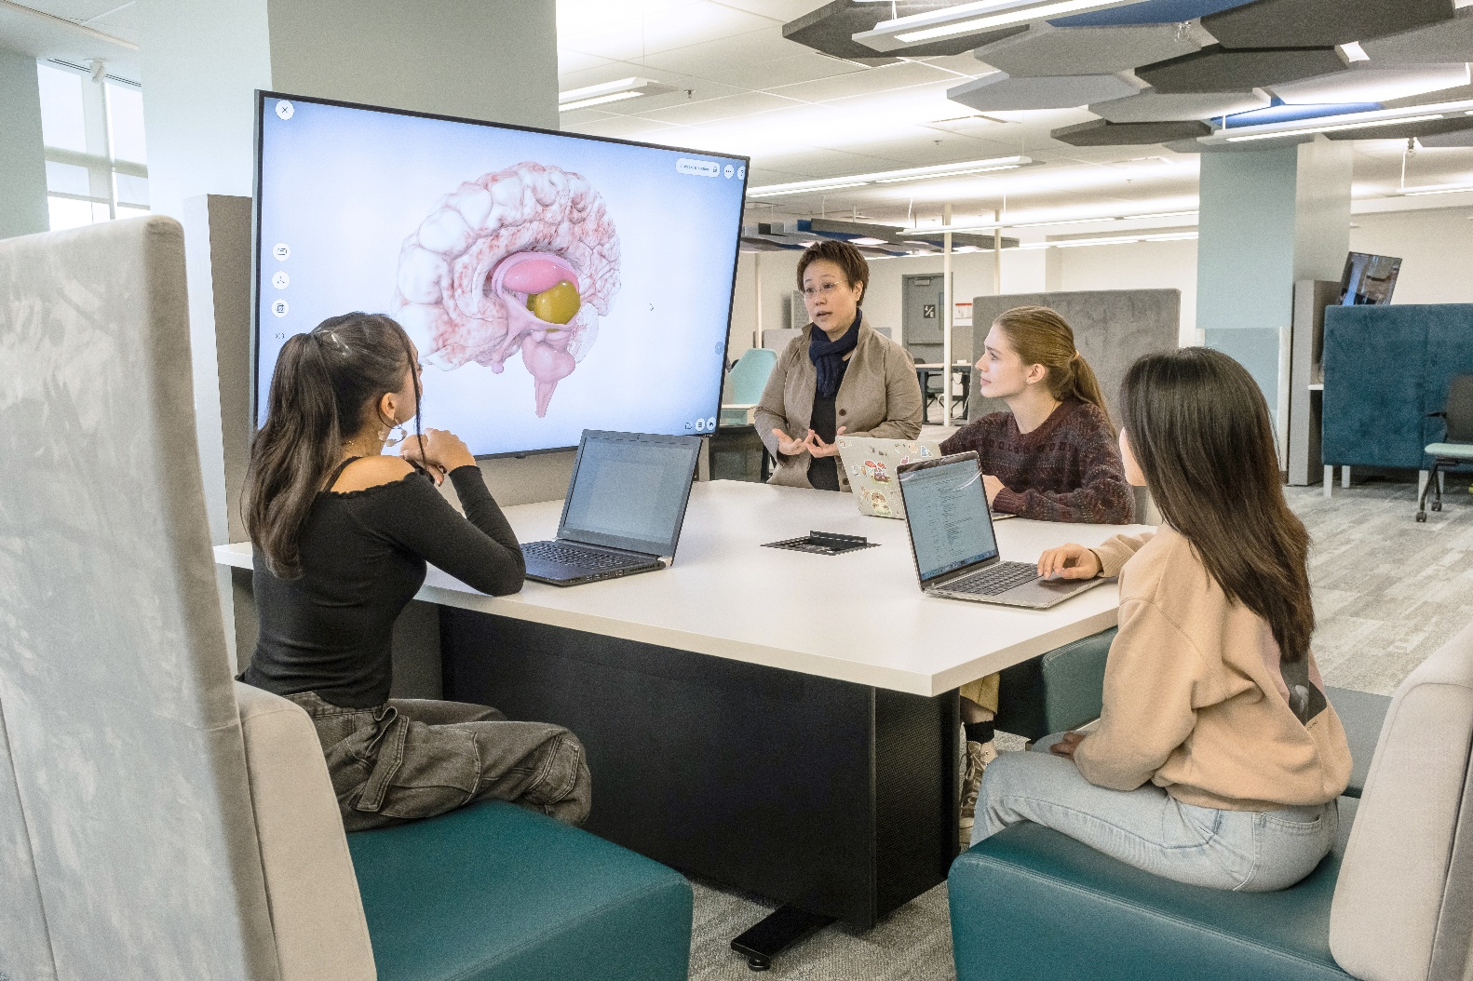



Accessibility Institute


3500 Carleton Technology and Training Centre (CTTC)
Carleton University
1125 Colonel By Drive, Ottawa, Ontario K1S 5B6

Email: accessibility.institute@carleton.ca
Phone: 613-520-2600 ext. 7323
carleton.ca/accessibility-institute

UDL is a framework that guides the development of flexible learning environments and materials to accommodate individual learning differences, ensuring all students have an equal opportunity to succeed.
Campus audits have been conducted using a national standard which surpasses existing building codes.

