Coordinated Accessibility Strategy Annual Report 2021-2022
Presented to the Board of Governors
Research, Education, Accessibility and Design (READ)
April 29, 2022

Table of Contents
From the Coordinated Accessibility Strategy Implementation Team 3
Executive Summary 4
A note about language 4
Context 5
Governance 6
Reporting Back – Highlights of Progress in the Areas of Focus 8
- Coordination and Leadership 8
- Education and Training 9
- Information and Communications 10
- Physical Campus 10
- Employment and Employee Support 11
- Student Support Services 12
- Research and Development 13
What is next? 14
Appendix 1: Objectives and Recommendations Status 16
Appendix 2: Theory of Change Development 21
Appendix 3: Office Acronyms 24

From the Coordinated Accessibility Strategy Implementation Team

I was not sure that we could have predicted the continuing toll of the pandemic and resulting civic unrest one year ago. While the spotlight continues to illuminate inequities for people with disabilities, much work is needed to ensure that inclusion and community remain at the heart of what we do. Carleton continues to lead from a place of service and commitment, encouraging us to acknowledge the humanity in all of us and, by doing so, make space for recognition, understanding and compassion.

We have successfully managed the implementation of the Coordinated Accessibility Strategy (CAS) with the acknowledgement of shifting priorities and pandemic fatigue. Over the past year, we have moved from planning the implementation of the CAS to action-based groups working on specific projects. Progress on this implementation is a direct result of a dedicated group of more than 30 people across all aspects of campus life whose creativity and innovative mindsets are advancing the needle on accessibility at Carleton. In the following pages, we share the highlights for each area of focus. It is important to recognize that while presented more linearly, the reality is that there are interrelated aspects across focus areas, creating ripples across the continuum of the strategy.

The CAS is approaching its second anniversary. We will continue to reflect, listen, and learn as a community what is working and what needs to be improved. We will also continue to engage the community as an essential step so that Carleton continues to be a place where people of all abilities have the choice and agency to engage fully in all aspects of campus life.

On behalf of the CAS implementation team and the teams advancing our strategy, thank you for your continued advocacy and leadership for a more accessible world.

To our continued success,



Cathy Malcolm Edwards
CAS Implementation Lead

Executive Summary

After an 18-month collaborative consultation process, Carleton’s Coordinated Accessibility Strategy (CAS) was officially launched in June 2020 under the guidance of the four Vice-Presidents. Through the cross-representational Steering Committee, the first phase of implementation brought together diverse voices and perspectives to draft proposed action plans. This past year, the CAS has moved into an action phase, with projects underway across the University. Each project ensures that the voices of lived/living experience guide the path forward. There is also an intention for equitable representation that reflects the diversity of our campus community.

Over the past year, 9 recommendations are in the planning phase, 14 recommendations are underway, 7 recommendations have the status of continuous, with 10 recommendations upcoming in the near-to-mid term (see Appendix 1). Since the launch of the CAS, definitive actions have been taken on 30 of the 40 recommendations. Through research and development, our partner offices brought in $3.3M in funding during this fiscal year, bringing the total to $15.8M since the development of the strategy.

The pandemic continues to present challenges and opportunities related to accessibility, both of which can be seen in the highlights contained in this report. A key focus of the implementation work this past year has been the creation of a theory of change framework and adapting to a more agile group to guide coordination and leadership; these elements combined have facilitated a hub and spoke model that supports a distributed team.

This annual report is respectfully presented to the Board of Governors as part of the CAS’s ongoing commitment to transparency within the Carleton community.

A note about language

It is essential to recognize the power of language. People self-determine how to express their identities. As such, some people identify with person-first language (e.g., people with disabilities), others use identity-first language (e.g., disabled person), and some may decide to use broader acknowledgement of the ability continuum (e.g., people with varying abilities). The emphasis on equity, diversity, and inclusion (EDI) continues to evolve for the representation of those who have been marginalized by society. This acknowledgement is often expressed through language such as lived/living experience, which can acknowledge the multiple social identities any given person may have (e.g., gender, ethnicity/race, ability) and the intersection of them. While the Coordinated Accessibility Strategy has adopted ‘persons with disabilities’ as our language, we have used a variety of the language above to create space where people feel seen and represented.

Context

Carleton strives to be an inclusive community. This aspiration allows us to form deeper connections with one another as we work through barriers of language, stigma, and biases. We are grateful to the land, which supports us in this pursuit, the traditional and unsurrendered territory of the Algonquin people.

The following guiding principles continue to anchor implementation efforts for the strategy:

- We collectively support accessibility for those with visible and non-visible disabilities, including cognitive, developmental, intellectual, medical, mental, physical, and sensory disabilities.

- We commit to being flexible to support each individual's fullest participation in activities and society in any place, space, item or service, whether physical or virtual.

- We recognize and work to address attitudinal and systemic barriers to inclusion.

In 2018, Carleton undertook a collaborative process to develop its first Coordinated Accessibility Strategy (CAS) to strengthen our commitment further and build on our culture of accessibility while working towards a more accessible and inclusive world. After extensive consultations with the community, where an emphasis was placed on listening to and reflecting on experiences, seven areas of focus emerged, each with a set of objectives and recommendations. Collectively, these serve as pathways to a more accessible campus for all.
“I decided to use my voice to speak up to the pressing need to consider accessibility in terms of diversity and not as a defined checklist to simply be checked off.”
Patricia Bérubé, Student Accessibility Champion, 2021

Continuing with a human-centred approach for the implementation of the CAS, the first year (2020-2021) centred on activities and efforts in planning the implementation of the strategy. We established an initial governance plan to support teams working on analyzing and synthesizing data points as they brought forward proposed action plans for consideration. This year (2021-2022), more than 30 people in 19 units are actively engaged in action projects that will address elements in the overall system that require improvement. Figure 1 provides an account of the major activities and the units on campus that are part of the Action Teams. More details can be found in Reporting Back.

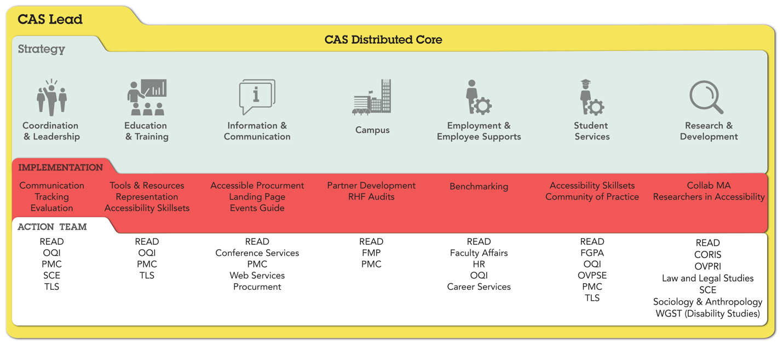
Figure 1: Coordinated Accessibility Strategy Implementation 2021-2022. Please see Appendix 3 for a description of office acronyms.

The impact of the COVID-19 pandemic continues to present a significant challenge as organizational and personal needs in our community shift the focus to recovery and resiliency during these exceptional times. Those leading the implementation of the CAS recognize the impacts of the pandemic and, as such, are managing a delicate balance to continue to advocate for progress while the state of normalcy seems ever shifting.

Governance

One significant change occurred in the governance approach for the Coordinated Accessibility Strategy (CAS). The CAS Council was initially formed to ensure adequate representation of equitable voices and functional units key to leading accessibility on campus. The result was a Council with more than 30 representatives and continued engagement from stakeholders during the pandemic presented a challenge. While quarterly communications are shared with members as well as the Vice-President (Students and Enrolment), a decision was made to support the various Action Teams and maintain an agile, central responsive team central for overall coordination and leadership. Figure 2 represents the current membership of this central team. The CAS Lead continues to interface with Executive Champions to ensure accessibility remains a priority and to coordinate cross-functional initiatives.

Figure 2: Team supporting coordination and leadership
¹ Coordinated Accessibility Strategy (CAS) co-chairs
² Part-time resources and alum
³ Paul Menton Centre CAS Liaison (on loan)

Reporting Back - Highlights of Progress in the Areas of Focus

The following section provides an overview of the exceptional work led by more than 30 people on campus who are directly involved, spanning 19 units. Note that each highlight and next step is mapped to a recommendation from the CAS. Please see Appendix 1, which contains a table of all of the objectives and recommendations as outlined in the CAS per area and related status.

Area of Focus #1: Coordination and Leadership

The Research, Education, Accessibility and Design (READ) Initiative was launched ten years ago as a campus-wide leadership initiative dedicated to accessibility and inclusion of persons with disabilities at Carleton and in the local, national, and global community. The initiative is just one way that Carleton continues to promote an increased emphasis on areas of disability, design, accessibility, and inclusion.

Highlights:
- In Fall 2021, a provincial committee sought feedback on proposed standards for AODA, specific to postsecondary institutions, to help make education more accessible for students with disabilities. As part of Carleton’s response, a team collected feedback from across Carleton on more than 150 of the 179 recommendations and submitted a detailed summary through Carleton’s President and its Vice-President (Students and Enrolment) to the Chair of the Postsecondary Education Standards Development Committee. Overall, the feedback received indicates that the CAS positions the University to be compliant with the majority of the proposed recommendations. Members of the CAS team are reviewing the feedback in detail to look at gaps that we can easily address.
- Strategic communications are core to increasing visibility and awareness and also have potential for educational tips on how others can engage in more accessible practices. A strategic communications team has formed a partnership between READ and the PMC. This team is tackling the reimagining of Carleton’s accessibility landing page in partnership with Web Services. Additionally, a new campaign is being launched to highlight accessibility moments on campus, encouraging all members of our community to submit (in a form that works for them) how they bring accessibility to their day. These moments will be celebrated during National AccessAbility Week (NAAW) in June. (Recommendation 1.R.e; Recommendation 2.R.b)
- As outlined in the Theory of Change (Appendix 2), a major deliverable this year was the creation of a guiding framework that is supported by activities and outputs. This directly links to the development of an excel sheet to track the CAS activities and initiatives. Both of these efforts anchor the work of the Coordination and Leadership group and, ultimately, the whole strategy. The next steps include more feedback on the evaluation model and creating a visual representation to include on the website. The team is also working on the possibility of transferring the tracking sheet into a project management tool such as Eclipse, for which Carleton has a license. (Recommendation 1.R.a)
- Other areas where we are showing leadership include the continued growth of the Canadian Accessibility Network (CAN) with its national office at Carleton’s READ Initiative, being the only university in Canada that has committed to a full audit of all buildings on campus and the continued work to develop a first-of-its-kind collaborative master’s specialization in Accessibility.

Area of Focus #2: Education and Training

Over the years, Carleton has committed to better practices as well as mobilizing knowledge, skills, and attitudes. In both formal academic programs and professional development training environments, the goal remains to educate instructors and the student population on how to make campus and campus life more accessible. Efforts in this focus area build on established practices on campus (e.g., Accessibility for Ontarians with Disabilities Act (AODA) training, Universal Design for Learning, and web accessibility workshops). Advancements on several fronts are attributable to increased collaborations between Teaching and Learning Services (TLS), the Paul Menton Centre (PMC), and READ.

Highlights:
- TLS and PMC have deepened their collaborations to curate spaces where instructors can participate in panel discussions and workshops to support more accessible classroom experiences. TLS continues to host digital classroom accessibility sessions in an effort to demystify accessibility for instructors. Efforts are concentrated on learning management system (Brightspace) support, skills development, and instructional design. (Recommendation 2.R, 2.R.c, 2.R.e, 2.R.f)
- READ and TLS partnered together with the READi Action Team to guide a team of graduate students conducting research to help understand barriers to student experience in virtual environments. The project resulted in a proposal to co-create an accessibility lab that will mobilize tools and resources co-created by those with living experiences. Funding sources will be pursued later this year. (Recommendation 2.R.c)
- The Accessibility and Wellness series arose directly from the community. It represents an opportunity to link accessibility in the workplace as a vital part of our personal, collective, and organizational wellness. The CAS Lead also touches base regularly with the Director of the Mental Health and Well-being Research and Training Hub (MeWeRTH) regarding the Lived Experience series. Collectively these forums provide a platform for living experiences, increasing awareness, and creating space for important dialogue. (Recommendations 2.R.a, 2.R.b, 2.R.e; 1.R.e; 6.R.c, 6.R.d)

Area of Focus #3: Information and Communications

For many, the COVID-19 pandemic illuminates the reality that Carleton operates in two environments, one which is physical and one that is virtual. Below, we have captured several highlights that speak to leadership in this focus area.

Highlights:
- A new collaboration emerged in early 2022 between Conference Services, READ, and the Paul Menton Centre (PMC). As part of the overall strategic communications and as a recommendation within the strategy, the team has drafted up a beta version of an Accessible Events Guide. Over the coming months, they will engage a larger stakeholder group to revise as needed prior to sharing it with the full community. Conference Services will take the lead for future iterations and communications about the guide. (Recommendation 3.R.b)
- The strategic communications group is collaborating with Web Services to revamp the accessibility landing page for Carleton. There have been some initial setbacks, but with renewed commitment and additional team resources, the project is taking shape. The Phase 1 site is live as of April 8, 2022 with Phase 2 work underway. (Recommendation 3.R.d; Recommendation 1)
- Procurement is demonstrating leadership in reaching out to resources on campus (e.g., READ) and the external community (e.g., Accessible Procurement Resource Centre (APRC). The team is actively seeking to understand important aspects of accessibility and disability to inform the development of accessible practices. Building on their collective learning experiences, the team is developing tools and a statement of commitment that will be core to its own communication plan to educate its clients. Knowledge and collaborations for procurement continue to be strengthened through a budding community as part of the Canadian Accessibility Network (CAN), which is led by READ. (Recommendation 3.R.e)

Area of Focus #4: Physical Campus

For most people, we do not really notice the built environment until it gets in our way. Carleton is fortunate to have a team of dedicated professionals working towards making campus as accessible as possible. By adopting the Rick Hansen Foundation's Accessibility Standard, Carleton has created its new standard of excellence that far exceeds compliance with codes and regulations.

Highlights:
- Facilities Management and Planning (FMP) continues to build its strategic engagement with the Rick Hansen Foundation (RHF). The team was able to negotiate a significantly reduced rate to adjudicate all buildings on campus formally. This is in addition to the four-building audits awarded in the previous year. The audit team at Carleton, a partnership between FMP, READ, and the Paul Mention Centre (PMC), will submit five building assessments per quarter for adjudication by the RHF. At present, Carleton is the only University in Canada that has committed to a full audit of all buildings. (Recommendation 4.R.b)
- The Physical Campus team continues to pursue innovative solutions to test and possibly implement on campus. One such partnership is with Key2Access. While not new to the Carleton ecosystem, Keys2Access is exploring innovation opportunities as part of the Sprott Innovation Hub. (Recommendation 4.R.a)

Area of Focus #5: Employment and Employee Support

While Carleton University is well known for being a leader in accessibility, the Coordinated Accessibility Strategy (CAS) highlights the need for further attention to services and supports for Carleton employees with visible and non-visible disabilities. More needs to be done for employees, though, to address structural inequities that may exist inherently in our practices and processes particularly.

Highlights:
- Under the guidance of the Assistant Vice-President, Human Resources, an extensive benchmarking project was completed over the past year. The objective of this project was to identify best practices that improve the experiences and increase inclusion of persons with disabilities throughout the employee lifecycle at Carleton. From this research, the Benchmarking Team identified 10 recommendations aimed at growing a culture of accessibility for Carleton employees. These recommendations suggest a multi-pronged, holistic approach to creating a more accessible workplace for Carleton employees that includes changes to policies and processes, additional human and monetary resources, better collaboration and communication, and more opportunities for our community to learn about accessibility. (Recommendation 5)
Recommendations:
Growing a Stronger Culture of Accessibility for Employees
- Consistently signal Carleton’s dedication to accessibility through a statement of commitment.
- Create an Accessibility Resource Connector position.
- Revise the Accessibility at Carleton website.
- Create a cross-functional group committed to accessibility within employee and employment support at Carleton.
- Develop a network of employees who navigate disability-related barriers.

Accommodation Infrastructure
- Update Carleton’s workplace accommodation policies and procedures in accordance with best practices.
- Create a central accommodation fund.
Recruitment and hiring
- Embed accessibility in the Human Resources, Faculty Affairs, and Career Services websites.
- Ensure accessibility in all recruitment and hiring practices.
Training and Resources
- Revise existing training and resources to embed accessibility. Create additional training and resources related to accessibility in employment and employee support.

Area of Focus #6: Student Support Services

Over the past two years, significant strides have been made to develop tools and resources for non-visible disabilities, including mental health. This is evidenced in the increased support at the graduate and undergraduate level as well as the launch of the curated mental health and well-being resources through the Office of Student Affairs and Health and Counselling Services and new support programming in the Paul Menton Centre (PMC). The teams behind both the implementation of the Coordinated Accessibility Strategy (CAS) and the recently updated Student Mental Health Framework continue to collaborate to support the mutual goal of a more inclusive campus.

Highlights:
- The PMC, the Faculty of Graduate and Postdoctoral Affairs (FGPA), and READ are working on increasing awareness and support for graduate students and post-doctoral fellows with disabilities. The group has regular touchpoints to look at how processes and practice can be improved so that graduate students are aware of the support and services available through FGPA and the PMC. This includes awareness-building sessions for all graduate students as well as more central communication channels as part of registration and orientation. (Recommendations 6.R.b, 6.R.d)
- As a result of the initial work of the CAS Action Plan teams, a strong need was identified in two areas of focus (Student Support Services and Education and Training) around improving training and awareness related to accessibility. These also exist as deliverables within the CAS itself. An action team has been designing a questionnaire proposed to be piloted in Teaching and Learning Services and the Students and Enrolment division. Responses will help inform future learning and professional development experiences on campus. It will also help us better understand the diverse set of skills associated with accessibility professionals. There is a proposed output of the development of a directory and communities of practice to encourage peer-to-peer learning. After the pilot, the intent is to roll out the questionnaire more broadly. (Recommendations 6.R.b, 6.R.d; Recommendation 2.R.e)
- The Housing and Residence Life team is committed to more inclusive and accessible environments. A working team with representatives from Conference Services, Housing, Residence Life, PMC, and READ are working on a series of workshops to Challenge Ableism. The first session will launch in May 2022. (Recommendations 6.R.c, 6.R.d)

Area of Focus #7: Research and Development

Research plays a vital role in advancing inclusion in society. Carleton’s research reputation continues to grow in parallel to its ongoing commitment to accessibility. In READ alone, $3.3M in research funding was awarded since the last CAS report, April 2021, representing areas such as employment, transportation, neurodiversity, and acoustics. It is worth noting that many of the opportunities came from outreach to Carleton based on its reputation.

A key element for competitive graduate programs is the ability to attract research funding to support leading-edge, socially relevant projects. Over the past four years, the University has attracted a minimum of $3-$5M per year in research revenue for accessibility research. The ability to bring in consistent funding year over year demonstrates ongoing capacity in Carleton’s research enterprise to support the training of students interested in accessibility-related research. This understanding is at the forefront of the continued work to develop the first-of-its-kind collaborative masters' specialization in Accessibility. The team is represented by members from READ, Systems and Computer Engineering, Sociology/Anthropology, Women and Gender Studies (including Disability Studies), and Law and Legal Studies.

Highlights:
- In September 2021, the Office of the Vice-President (Research and International) (OVPRI), the Carleton Office for Research Initiatives and Services (CORIS) and READ held an OVPRI-sponsored REALISE event with the goal of developing greater accessibility research at the University. It brought together researchers and practitioners from Carleton University, Bruyère Research Institute and The Ottawa Hospital. Research professionals and research teams expressed a strong interest in accessibility, but they require greater resources, training, and expertise in order to effectively utilize research methodologies and recruit individuals with lived experience. In the coming year, a working group will explore the expressed needs and develop program supports and communications for researchers. (Recommendations 7.R.b, 7.R.c)
- Carleton University is leading the second phase of the David C. Onley Initiative (DCOI 2.0). The $3M project will deliberately focus on Postsecondary Institutions as one of the key stakeholders in the collective effort to improve employment outcomes for postsecondary students with disabilities in Ontario. Implementation of the DCOI Collective Impact Strategy aims to improve employability and employment outcomes for postsecondary students with disabilities and support their transition into quality employment. (Recommendation 7.R.c)

What is next?

Over the next 12-18 months, the Coordinated Accessibility Strategy (CAS) implementation team will focus on progress towards intermediary outcomes that resulted from the continued consultations and feedback from the Carleton community. The outcomes are outlined in Figure 3. It is critical that we collectively create opportunities for the campus community to identify with and recognize our culture of accessibility. We will continue to see accessibility embedded more formally in roles and in the policies that guide the institution.

Figure 3: Intermediary outcomes within the Coordinated Accessibility Strategy

Some specific activities that will support the outcomes include:

- Prioritization and implementation of the recommendations from the benchmarking report for employee support. (Recommendation 5)

- Working with leadership to explore ways to have accessibility embedded in roles and resources as a priority at all levels (Recommendation 1.R.c)

- Completing an Audit of AODA and Beyond (using eCampus ON) to inform upgrades to Carleton’s AODA training. (Recommendation 2)

- Work with Learning and Professional Development on building accessibility into the offerings (Recommendation 2.R.e)

- Review Carleton policies using the lens of accessibility, beginning with Physical Campus. (Recommendation 4.R.f)

- Launch user experience and testing groups for web templates. (Recommendation 3.R.d)

“It is validation that my voice I cultivated matters, and not only have I left behind ripples in my community, but it gives me the confidence to take my voice out into the world around me.”
Rebecca Andre, Student Accessibility Champion, 2021

Appendix 1: Areas of Focus and Recommendations Status

This Appendix contains the Objectives and Recommendations directly outlined in the Coordinated Accessibility Strategy (CAS). A status column has been added with the following indicators:
- Planning: Activities (e.g., planning, coordination) have been initiated in the current reporting cycle
- Underway: Activities are currently underway and being implemented
- Continuous: Activities are complete, but implementation is an ongoing process with no definitive end date.
- Upcoming: Activities that are planned in the near-to-mid term.

The table below can be summarized as follows:
- 9 recommendations are in the planning phase,
- 14 recommendations are underway,
- 7 recommendations are considered in a continuous phase, and
- 10 recommendations are upcoming.

It is worth noting that as recommendations are actioned, the implementation is an ongoing process with no definitive end date. This is reflective of accessibility not being an end state but instead a continuous state of adaptation. Since the original launch of the CAS, definitive actions have been taken on 30 of the 40 recommendations.

Area of Focus #1. Coordination and Leadership

Recommendations | Status
A. Conduct a thorough environmental scan and create a living document of all accessibility initiatives at Carleton. | Underway
B. Establish an interdisciplinary Centre of Excellence in Accessibility that provides leadership, coordination, best practices, research, support, training, and knowledge mobilization. | Underway
C. Formalize the senior leadership responsibility for accessibility across the University’s portfolios. | Upcoming
D. Increase depth of accessibility training of people in leadership positions. | Upcoming
E. Expand University-wide and community events and campaigns to increase awareness and foster a culture of accessibility. | Underway
F. Develop membership and contributions to accessibility partnerships, organizations, and consortium, partnering at the local, provincial, national, and global level. | Continuous
G. Establish a central resource to disseminate and receive information on accessibility. | Continuous

Area of Focus #2: Education and Training

Recommendations | Status
A. Increase the number of in-depth training opportunities in accessibility on campus that are relevant to different settings and exceed minimum requirements. | Underway
B. Increase the number of community activities that build greater awareness and understanding of accessibility and disabilities, barriers, and exclusion, as well as opportunities for change. | Continuous
C. Provide educators on campus with incentives, skills, and resources to consider accessibility in the design of academic activities and experiential learning, including the principles of universal design. | Underway
D. Include persons with disabilities and value their lived experiences as a source of knowledge in the design of teaching and learning. | Planning
E. Expand interdisciplinary academic programming and professional development in accessibility and disabilities for members of the internal and external community. | Underway
F. Address issues of accessibility and disabilities within the Faculties and Departments and encourage faculty to utilize relevant teaching and learning services. | Planning

Area of Focus #3: Information and Communications

Recommendations | Status
A. Perform system audits for accessibility, driven by individual units. | Upcoming
B. Establish process for support for providing accommodations, and adaptive and assistive devices for Carleton events. | Underway
C. Establish a reporting protocol to identify information and communication related accessibility barriers and areas for improvement. | Planning
D. Establish best practices for accessibility in all knowledge creation and sharing (e.g., documents, presentation, websites, social media, conferences), which are shared internally and externally. | Underway
E. Provide guidelines and training opportunities on accessibility in knowledge creation and sharing for faculty and staff. | Underway
F. Ensure accessibility to be part of the procurement requirements. | Planning

Area of Focus #4: Physical Campus

Recommendations | Status
A. Create a Carleton University standard for accessibility of physical spaces based on best practice guidelines and certifications that surpass minimum requirements. | Continuous
B. Perform a full accessibility audit of the physical campus with input from the campus community, particularly persons with disabilities. | Underway
C. Undertake systematic retrofitting to address current problems and meet the new standards for the physical campus. | Planning
D. Establish a reporting protocol to identify accessibility barriers and areas for improvement. | Planning
E. Establish a permanent University budget and related supporting resources for accessibility of physical spaces. | Upcoming
F. Review University policies and practices to consider accessibility where relevant to the physical campus. | Upcoming
Area of Focus #5: Employment and Employee Support

Recommendations | Status
A. Institute effective processes and go-to resources on campus for disability-related accommodations and supports for employees across all levels and stages of employment. | Upcoming
B. Review and identify gaps in employment-related policies, practices, and training that support accessibility, accommodations, and disability-competent inclusion. | Continuous
C. Provide targeted opportunities across campus that promote career development and training for Carleton employees with disabilities. | Upcoming
D. Include employees with disabilities for input and participation to improve accessibility in employment for persons with disabilities. | Planning
E. Review Carleton’s rates of employment of persons with disabilities and address gaps in representation where they exist. | Upcoming

Area of Focus #6: Student Support Services

Recommendations | Status
A. Optimize resources through accessibility lens to be responsive to the growing needs for accommodation and support of students with disabilities. | Underway
B. Review and identify gaps in student services programming and delivery with consideration of both undergraduate and graduate students with disabilities. | Planning
C. Provide accessibility and disability-related training specific to different student services programs. | Underway
D. Build knowledge, awareness, and attitudes in accessibility and accommodations across all student-facing services and points of contact on campus. | Continuous
E. Establish formal student feedback and program evaluation protocols for disability-related student services for continuous quality improvement. | Underway
Area of Focus #7: Research and Development

Recommendations | Status
A. Develop a strategic plan for accessibility and disability research and knowledge mobilization (e.g., research informed campus initiatives). | Upcoming
B. Create a university-wide network of researchers in accessibility and disability. | Continuous
C. Grow the research capacity in accessibility and disability, including increasing the number and retention of researchers, research funding, research infrastructure, and community partnerships. | Planning
D. Pursue research chair(s) in accessibility and disability. | Upcoming
E. Establish academic programming to support research in accessibility and disability. | Underway

Appendix 2: Theory of Change Development

A small working group met over the past six months to develop a theory of change for the Coordinated Accessibility Strategy (CAS). A theory of change can be a valuable tool to guide the evaluation of complex, interwoven and interdependent outcomes, including leadership and cultural change. Represented as a logical process, the theory of change starts with desired change and then applies backwards design to determine what are the outcomes, outputs, and activities needed to achieve the desired change. Figure 1 shares the impact statement of the CAS, namely, that our community fully supports the inclusion and participation of all its members, regardless of ability. This commitment is the heartbeat of why the CAS exists and is supported by the intended outcomes of representation and engagement of living/lived experiences of disability that act as a catalyst for change both on campus and more broadly in society. An active community will create more fulsome, accessible experiences that collectively authenticate Carleton’s position as a national and global leader.

Figure 1: Coordinated Accessibility Strategy impact and higher-order outcomes

Central to the theory of change is an acknowledgement of the pre-conditions needed for success and any assumptions being made. As per Figure 2, the assumptions carry over from the development of CAS, namely that:
- the approach continues to recognize the vital need for promotion of agency, co-design;
- acceptance that change is possible;
- representation of disabled people (also referred to as living/lived experience) is essential; and,
- The CAS implementation team recognizes the intersectionality of our identities.

The implementation of the CAS requires pre-conditions such as relationships and people, financial investment, accountability to commit and deliver, and lastly, strength in our community to be successful.
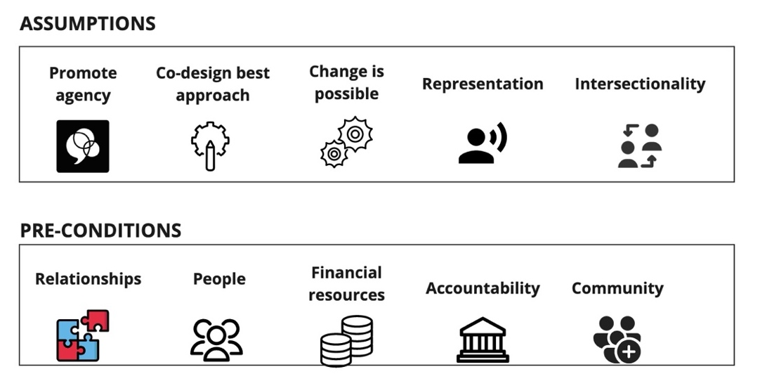
Figure 2: Theory of Change Assumptions and Pre-conditions

It is also important to acknowledge the barriers and enablers to accomplishing our goals and objectives with the CAS, as expressed in Figure 1. Doing so helps set and manage expectations. Figure 3 represents some of the barriers to more accessible environments, both systemic in society and also specific to the Carleton environment. It is worth noting that impacts of the COVID-19 pandemic and organization priorities are strongly interrelated; that is to say that the pandemic has played a heavy role in the capacity of units to prioritize activities and efforts for the CAS, though the commitment to accessibility has not diminished. This commitment is key to the enablers listed. Continually, the strength of our community is evident through collaborations, innovative thinking, and co-design approaches.

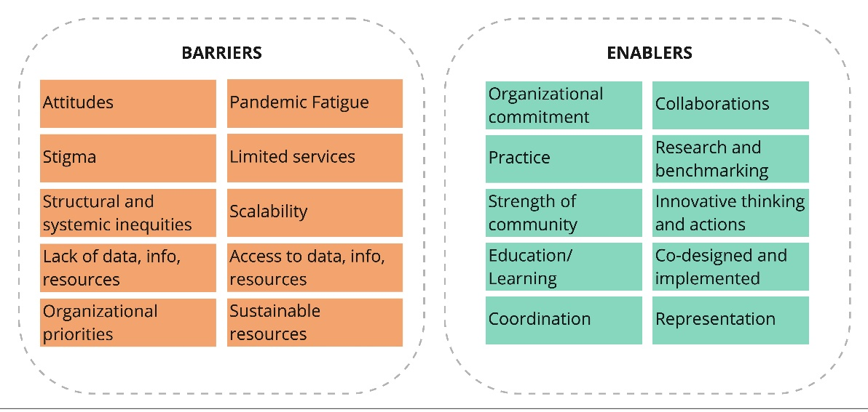
Figure 3: Barriers and Enablers for Theory of Change

The primary activities and nearer-term outputs act as the progress measures to meet the intermediary and longer-term outcomes associated with the CAS. These elements are documented in Reporting Back.

Appendix 3: Office Acronyms

CORIS: Carleton Office for Research Initiatives and Services
FMP: Facilities, Management and Planning
HR: Human Resources
OQI: Office of Quality Initiatives
PMC: Paul Menton Centre for Students with Disabilities
READ: Research, Education, Accessibility and Design Initiative
SCE: Systems and Computer Engineering
TLS: Teaching and Learning Services
OVPRI: Office of the Vice-President (Research and International)
OVPSE: Office of the Vice-President (Students and Enrolment)
WGST: Women’s and Gender Studies

