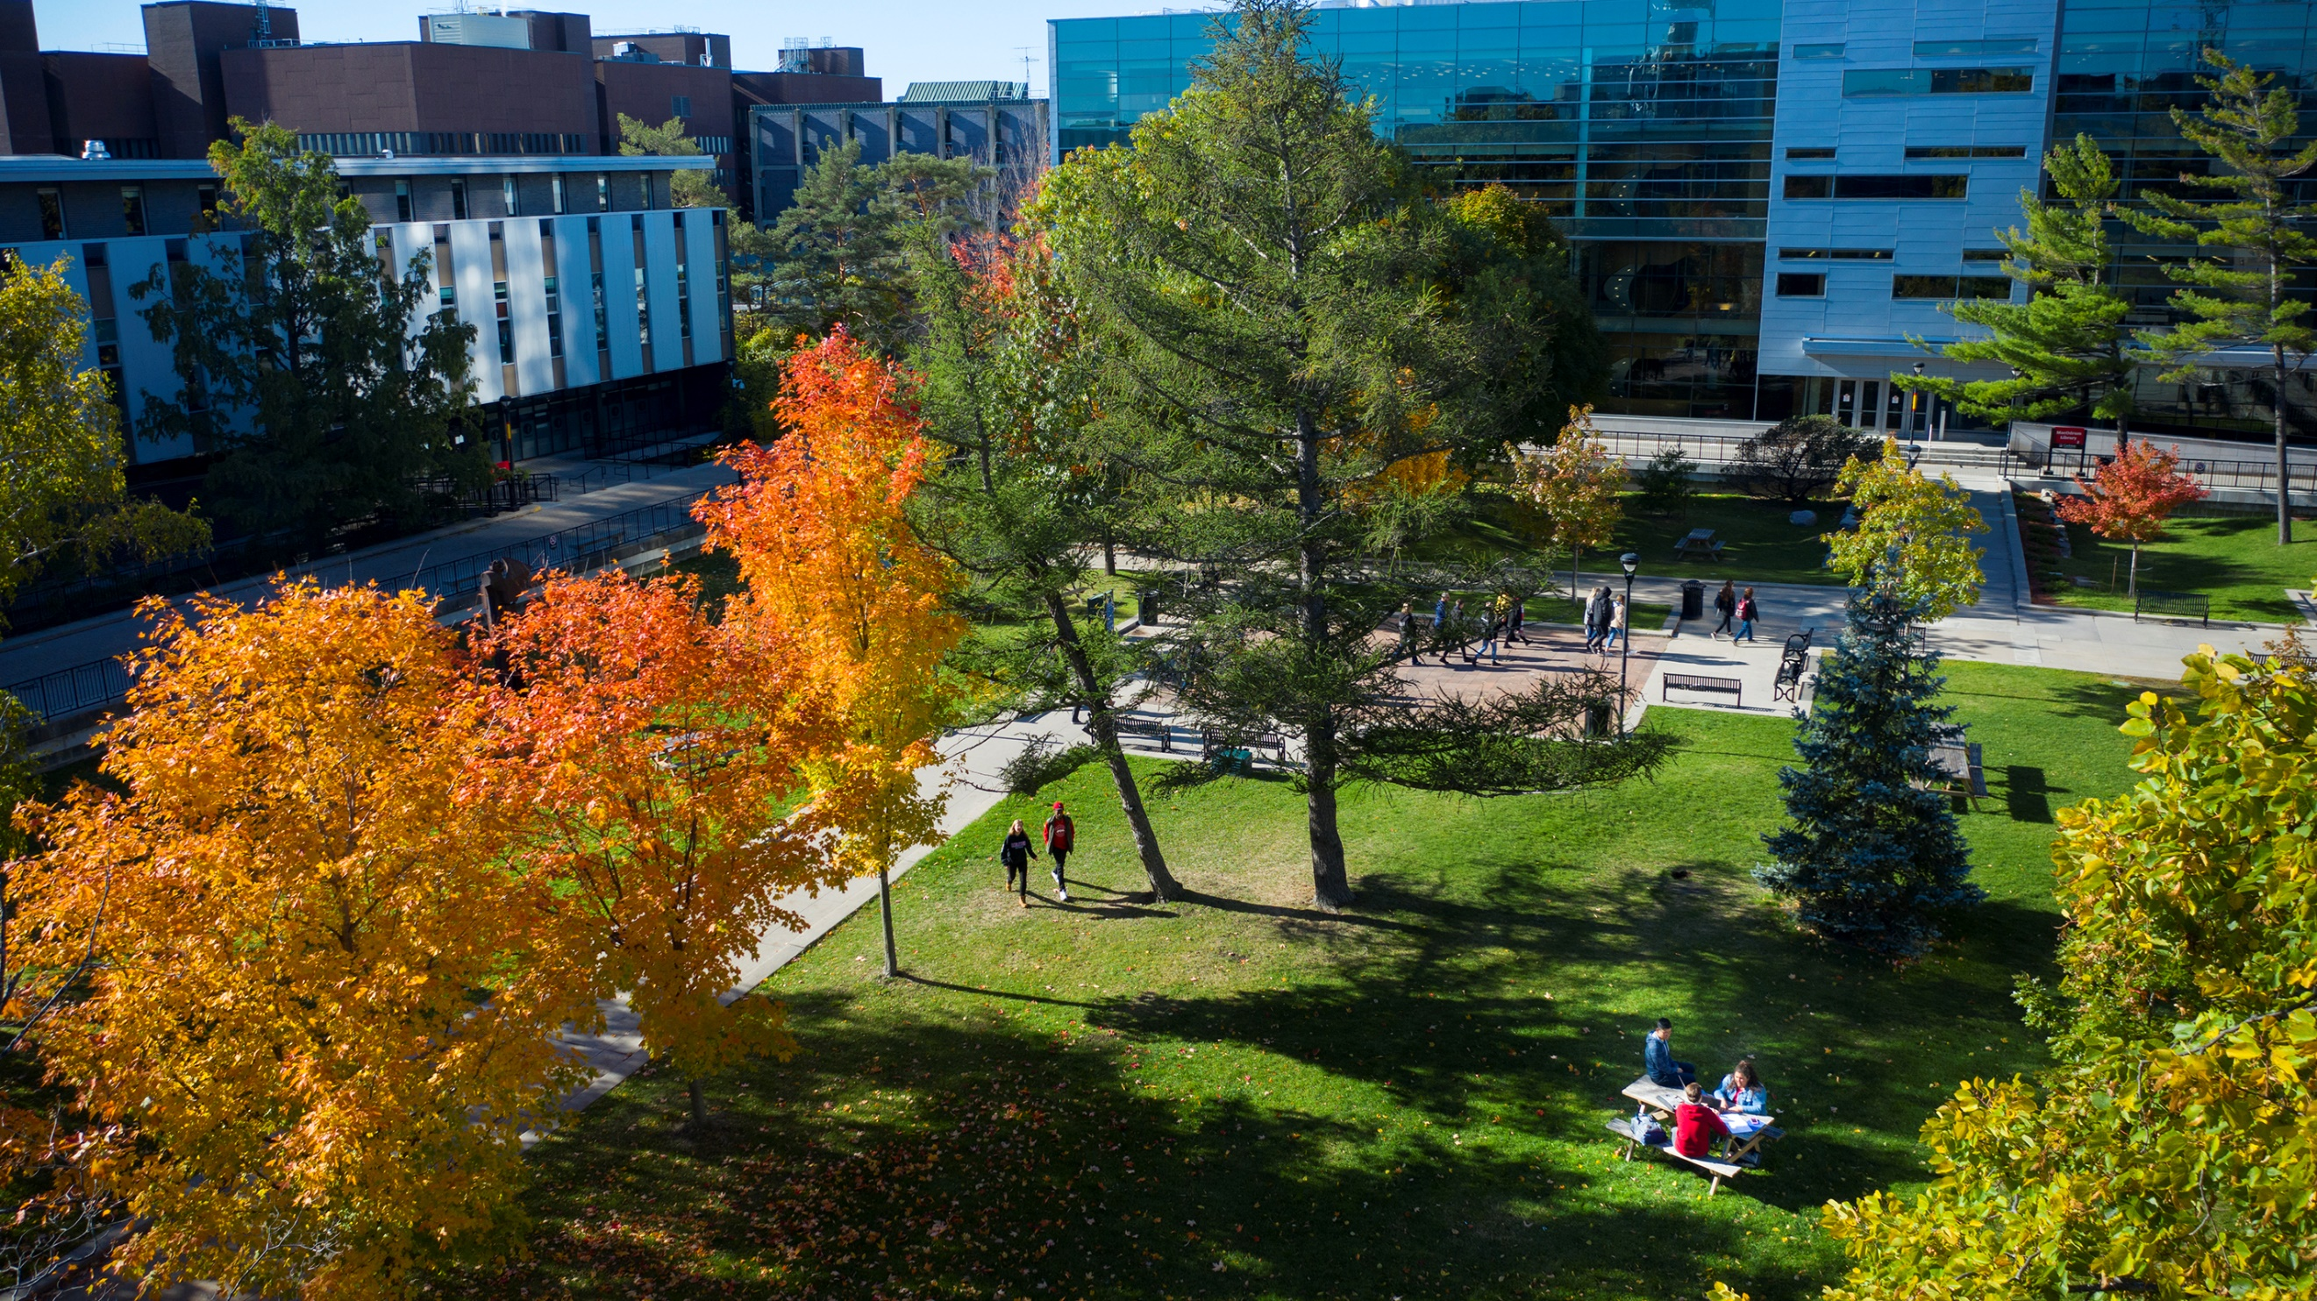
Coordinated Accessibility Strategy
Annual Report 2025

Contents
Algonquin Territory Acknowledgement 3
From the Coordinated Accessibility Strategy Implementation Team 4
Executive Summary 5
Context 7
Reporting Back – Highlights of Progress in the Areas of Focus 8
Area of Focus #1: Coordination and Leadership 10
Area of Focus #2: Education and Training 11
Area of Focus #3: Information and Communication 12
Area of Focus #4: Physical Campus 13
Area of Focus #5: Employment and Employee Support 14
Area of Focus #6: Student Support Services 15
Area of Focus #7: Research and Development 16
What is next? 17
Appendix 1: Areas of Focus and Recommendations Status 18
Area of Focus #1: Coordination and Leadership 19
Area of Focus #2: Education and Training 19
Area of Focus #3: Information and Communication 20
Area of Focus #4: Physical Campus 20
Area of Focus #5: Employment and Employee Support 21
Area of Focus #6: Student Support Services 21
Area of Focus #7: Research and Development 22

Algonquin Territory Acknowledgement
Carleton University acknowledges the location of its campus upon the traditional, unceded territories of the Algonquin nation. We recognize that the implementation of the Coordinated Accessibility Strategy must reflect the values of the Algonquin people. Accordingly, we must strive to further strengthen relationships between Carleton and the Algonquin communities and endeavor to accelerate the inclusion of Indigenous perspectives and knowledge in our campus practices.

From the Coordinated Accessibility Strategy Implementation Team
Carleton University strives to be an inclusive community; one that leads from a place of service and commitment.
Our dedicated community working on the implementation of the Coordinated Accessibility Strategy (CAS) continues to evolve even as the post-secondary education sector faces ongoing resource constraints. The continued success of our collective efforts is reflected in the commitment from senior-level management and our community at large. This commitment is evidenced by the efforts reflected in this year’s annual report.
2025 represents the final year of the initial five-year strategic plan, with the CAS set to renew in May 2025. Over the past five years, we have seen successes such as the Collaborative Specialization in Accessibility, Web Accessibility Training Modules, the allocation of Canada Research Chair positions in accessibility and disability, the launch of extensive audits of the physical campus in accordance with a national standard, the creation of the Canadian Accessibility Network and the acclamation of the Accessibility Institute.
In addition to the accessibility initiatives that are underway, since fall 2024, efforts have focused on looking forward to what is next for the CAS. We have listened to our community and have incorporated their feedback into a new strategy to guide us from 2025 to 2030. There is still work to do. What is most apparent is that the CAS must reflect the values of our community, a community that strives to be equitable for persons with disabilities.
On behalf of the CAS implementation team and the teams advancing our strategy, thank you for your continued advocacy and leadership for a more accessible campus and a more inclusive world.

To our continued success,



Cathy Malcolm Edwards
CAS Implementation Lead

Executive Summary
Carleton University’s Coordinated Accessibility Strategy (CAS) was officially launched in June 2020 under the guidance of the university’s four vice-presidents. Through the cross-representational Steering Committee, the first phase of implementation brought together diverse voices and perspectives to draft proposed action plans. The CAS is now wrapping up its first five-year term, with projects underway across the university. There is intention in the activities shared for equitable representation that reflects the diversity of our campus community.
The CAS implementation team continues to make progress towards its longer-term outcomes, such as internal and external recognition of accessibility as part of our culture, standards that go beyond compliance and world-class accessibility and disability research. The team is also working with units on campus to support coordination and leadership and build competencies and capacity in accessibility. These outcomes are the result of continued consultations and feedback from the Carleton community. This report outlines specific actions taken in service of these outcomes in each of the CAS areas of focus from May 2024 to April 2025.
In 2025, 33 of the 40 recommendations in the CAS are considered complete or have the status of continuous, meaning that key activities have been accomplished although there is no definitive end date; 3 recommendations are underway; 3 recommendations are in the planning phase; and 1 recommendation is upcoming (Figure 1). Since the launch of the CAS, clear actions have been taken on 39 of the 40 recommendations.
Since its inception, the CAS has inspired more than 175 initiatives across seven areas of focus, with several activities spanning multiple areas and recommendations (Figure 2). This impressive commitment to action across all areas of focus highlights our community’s dedication to advancing accessibility on our campus, nationally and globally.
This annual report is respectfully presented to the Board of Governors and the Carleton University community as part of the CAS’s ongoing commitment to transparency and accountability.
Figure 1: Status of projects in 2024-2025

Figure 2: Activities by area of focus of the CAS from 2020-2025

Context
Carleton University strives to be an inclusive community. This aspiration allows us to form deeper connections with one another as we work through barriers of language, stigma and biases.
In 2020, Carleton launched its first Coordinated Accessibility Strategy (CAS). After extensive consultations with the community, seven areas of focus emerged, each with a set of objectives and recommendations. Collectively, these serve as pathways to a more accessible campus for all.
The CAS is governed by a distributed leadership team that is responsible for the overall coordination and leadership (Figure 3). The CAS Lead interfaces with the distributed team and executive champions to ensure access and support for coordinating cross-functional initiatives. Activities are informed by a theory of change that was developed in 2021-2022.

Figure 3: Team supporting coordination and leadership

¹ CAS co-chairs
² Part-time CAS coordinator and student resources
³ Access to staff members at the Accessibility Institute for coordination and communications

Reporting Back – Highlights of Progress in the Areas of Focus
Since 2020, engagement in accessibility activities has continued to grow steadily (Figure 4), with 90+ people across more than 35 units on campus contributing to the CAS. Approximately 40% of the people involved were in leadership roles, guiding and influencing the state of accessibility on campus. The following section provides an overview of the exceptional work being done in our community.

Figure 4: Capacity and growth of the CAS since inception

Through the accessibility champions across campus, the implementation team has learned about the many types of accessibility initiatives happening in our community over the past year. In 2024-2025, the majority of reported activities include Information and Communication and Student Support Services, followed by Education and Training and Physical Campus (Figure 5). These efforts across the campus not only build capacity but strengthen our culture of accessibility.
Figure 5: Active projects by area of focus (2024-2025)

The following section outlines highlights and progress from the 2024-2025 year, mapped to the corresponding CAS area of focus. For a comprehensive list of all objectives and recommendations, along with their current statuses, please see Appendix 1.

Area of Focus #1: Coordination and Leadership
The Accessibility Institute plays a strong leadership role at Carleton by emphasizing the confluence of disability, accessibility and inclusion. Carleton’s commitment is also exemplified in the CAS reporting to the vice-presidents of the university, with the Vice-President (Students and Enrolment) as the primary executive champion. Having accountability for accessibility entrenched at the senior levels of leadership promotes a culture of service, commitment and innovative thinking.

Highlights:
- Carleton is actively engaged on several of the Council of Ontario Universities Post-Secondary Education Accessibility Standards Implementation (ASI) Working Groups, aiding universities in implementing potential new accessibility standards for students with disabilities. Overall, the groups aim to provide recommendations, assess the impact of standards and create sector-wide resources. (Area of Focus 1, R.f)
- An advisory committee was tasked with guiding the renewal of the CAS for 2025 to 2030. Comprising a diverse, cross-functional group of individuals from various departments and roles, the committee collaborated to identify key accessibility challenges and opportunities across campus. The committee provided ongoing recommendations and insights throughout the strategy’s development and implementation, supporting the launch of the refreshed CAS in spring 2025. (Area of Focus 1, R.e)
- The Library's Accessibility Committee put on a book display for International Day of Persons with Disabilities in collaboration with the Carleton Disability Awareness Centre (CDAC). CDAC is a student peer support group, advocacy organization and community space for students who experience disability, chronic illness, neurodiversity or inaccessibility. (Area of Focus 1, R.e; Area of Focus 2, R.b; Area of Focus 6, R.d)
- The Canadian Accessibility Network (CAN), with its national office at Carleton’s Accessibility Institute, continues to grow. CAN engages over 130 CAN Collaborator Organizations and more than 250 individual members, with the Communities of Practice actively leading six projects aimed at addressing key issues and advancing the cause of accessibility. The bi-monthly newsletter has grown to a readership of over 1,400 individuals and there were over 1,500 registrations by participants to attend five CAN Connect Forums over the past year. (Area of Focus 1, R.f)

Area of Focus #2: Education and Training
Over the years, Carleton has committed to better practices in Education and Training as well as mobilizing knowledge, skills and attitudes. In both formal academic programs and professional development training environments, the goal remains to educate our community about how to make campus and campus life more accessible by learning with and from one another.

Highlights:
- Teaching and Learning Services (TLS) worked with students and instructors to make virtual reality/augmented reality (VR/AR) events accessible. This includes the development of a VR lab with adjustable furniture and alternative solutions for VR headsets. (Area of Focus 2, R.a; Area of Focus 2, R.c)
- A Carleton researcher developed and produced a written guide and associated poster, providing guidance to research-group leaders to make their groups more inclusive for Autistic trainees. The guide and poster are available for free. (Area of Focus 2, R.b)
- The Department of Equity and Inclusive Communities took a training on accessible design to ensure that their trainings and workshops would be as accessible as possible. (Area of Focus 2, R.a; Area of Focus 2, R.c)
- Introductory training in accessibility and accessibility competencies was delivered through Learning and Development. The training provided foundational knowledge and practical skills to explore the importance of accessibility, identify ableism, reflect on personal biases and develop inclusive communication strategies. Two new accessibility-focused workshops were also launched as part of the refreshed Student Support Certificate: “Supporting Neurodivergent Students in Higher Education” and “Introduction to Accessibility.” (Area of Focus 2, R.a; Area of Focus 2, R.b; Area of Focus 2, R.d; Area of Focus 2, R.e)
- The Professional Education for Accessibility Competence (PEAC) [pronounced peek] program is designed to bridge the gap between accessibility awareness and workplace operations. Focusing on upskilling professionals, PEAC emphasizes key competencies in workplace accessibility, empowering participants and their organizations to implement practices and move beyond compliance to inclusion. (Area of Focus 2, R.a; Area of Focus 2, R.e; Area of Focus 1, R.d)

Area of Focus #3: Information and Communication
Information and communication content and technologies, including websites, documents and events, are critical to the accessibility of our university community. They are essential tools for learning, teaching, research and administration.

Highlights:
- TLS unveiled a set of comprehensive resources designed to help instructors make their courses more accessible, including creating accessible documents, leveraging educational technologies and improving web content. (Area of Focus 3, R.d; Area of Focus 2, R.c)
- The Awards and Financial Aid Office tested all existing pdf-based scholarship and bursary applications to identify and correct accessibility barriers, both technical and informational. This was done in collaboration with the Paul Menton Centre for Students with Disabilities (PMC) to ensure that the forms follow a logical reading order and are written in plain language. (Area of Focus 3, R.d; Area of Focus 6, R.a; Area of Focus 6, R.d)
- Carleton Mobile's Service Alerts function is in the final stage of development. This feature enables push notifications about campus outages affecting accessibility, as well as emails to internal stakeholders and information displayed on key websites. This streamlined approach ensures effective communication and compliance with legislative requirements. (Area of Focus 3; Area of Focus 6)
- Web Services has introduced a new template, cuTheme, which incorporates accessibility into its design. It also provides some checks which alert site owners if they are about to publish less accessible content. Sites that use cuTheme will not only be more accessible for individuals with disabilities, but more user-friendly for all users. (Area of Focus 3, R.d)

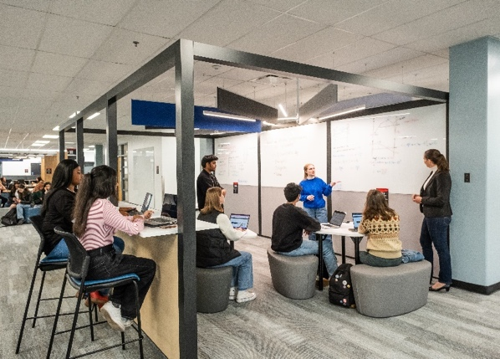

Area of Focus #4: Physical Campus
Carleton continues to challenge its standard of excellence in physical accessibility, which exceeds compliance with codes and regulations. Leadership in this space ensures Carleton remains an inviting and inclusive community.

Highlights:
- Completed the Key2Access project, which aimed to install 90 door openers across campus with the innovative OpenUp system. This project was designed to improve accessibility for individuals with vision and mobility impairments by providing an easier way to navigate doors. The system enables users to open doors through their smartphones, eliminating the traditional barriers of hard-to-reach or hard-to-find door openers. The project was funded by the Employment and Social Development Canada (ESDC) Enabling Accessibility Fund and supported by the Paul Menton Centre for Students with Disabilities (PMC). (Area of Focus 4, R.c; Area of Focus 4, R.e)
- The Dedicated Access Fund (a student-driven fund that is matched by university contributions) funded a project to install 25 new door automators on campus. (Area of Focus 4, R.c; Area of Focus 4, R.e)
- The Department of Recreation and Athletics fabricated a customized steel removal ramp for an activity room used for adaptive programs. The ramp was built in response to feedback from a participant regarding the accessibility of the room for mobility device users. It can be easily added or removed in the doorway by program supervisors, allowing for greater flexibility and inclusivity in the space. (Area of Focus 4, R.c)

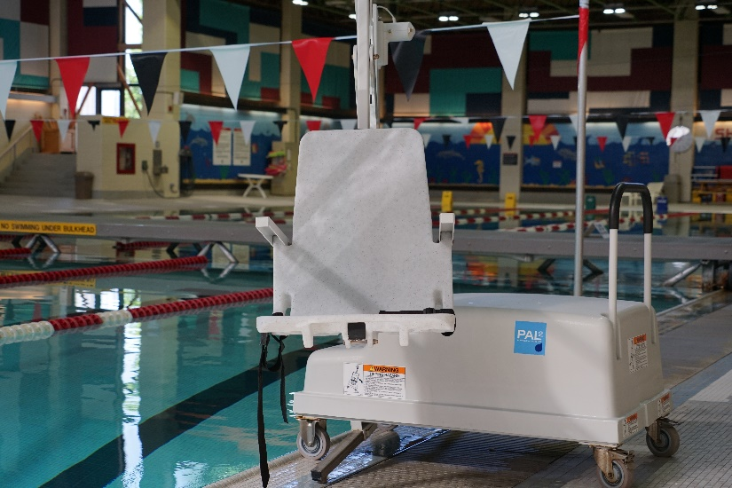

Area of Focus #5: Employment and Employee Support
The CAS highlights the need for further attention to services and support for Carleton employees with disabilities. We continue to take steps toward addressing structural inequities that may exist inherently, particularly in our practices and processes.

Highlights:
- A new initiative is being introduced to develop a standardized approach to employee recruitment. This initiative aims to create a transparent, clear and consistent recruitment experience for all candidates, ensuring that individuals with disabilities have equitable opportunities to apply and succeed. (Area of Focus 5, R.b)
- The Office of Risk Management has embedded accessibility within the Joint Health and Safety Committee (JHSC) as well as during legislated JHSC inspections. Additionally, accidents and incidents are investigated using many lenses, including accessibility. The overall approach aims to identify and remove potential barriers and implement solutions that improve both safety and accessibility for every member of the campus community. (Area of Focus 5, R.b)
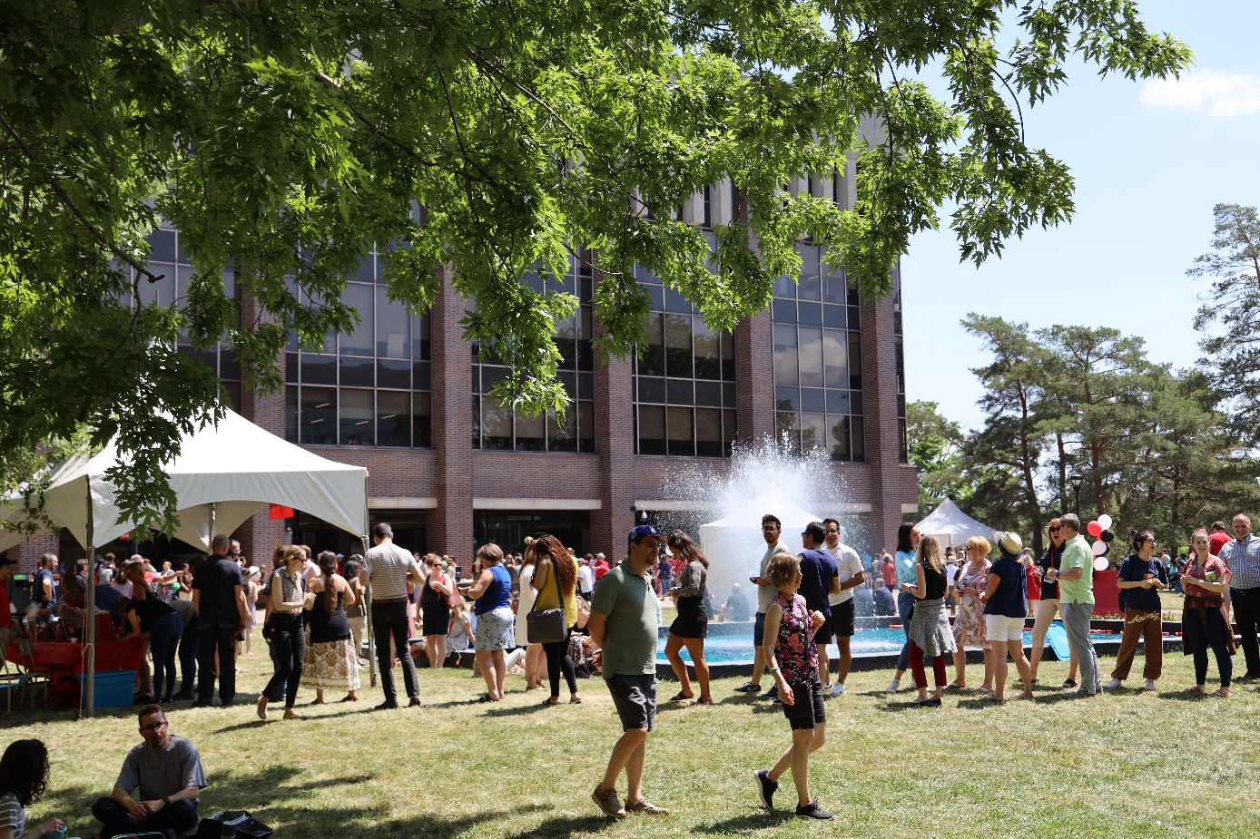

Area of Focus #6: Student Support Services
Carleton strives for excellence in services for students with disabilities across all units to support success in every aspect of campus life. By striving for excellence, space is created for innovative thinking.

Highlights:
- The Awards and Financial Aid Office worked with the Paul Menton Centre for Students with Disabilities (PMC) and Information and Technology Services (ITS) to add functionality to a software platform to allow efficient administration of funding to purchase equipment and services to address disability-related barriers to learning. (Area of Focus 6, R.a; Area of Focus 6, R.d)
- Health and Counselling Services (HCS) developed several counselling group sessions for students with disabilities, including an open group for neurodivergent students, a therapeutic Dungeon and Dragons group and cognitive behavioural therapy for anxiety. (Area of Focus 6, R.a; Area of Focus 6, R.b)
- The Department of Recreation and Athletics provides free, accessible opportunities for Carleton students to participate in sports and activities, including Adaptive Boccia and Para Swim, in partnership with Swim Ontario. They also introduced the Adaptive Strength & Flexibility program. (Area of Focus 6, R.a; Area of Focus 6, R.b; Area of Focus 6, R.d)
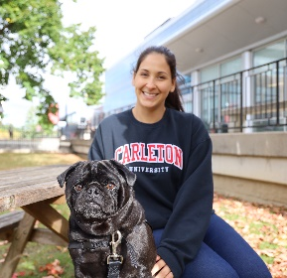
- Recruitment teams participate in training with the PMC prior to beginning the recruitment cycle. Recruiters learn detailed information about various disability supports and about the accommodation process. (Area of Focus 6, R.a; Area of Focus 6, R.c; Area of Focus 6, R.d; Area of Focus 2, R.a; Area of Focus 2, R.b)

Area of Focus #7: Research and Development
Research plays a vital role in advancing inclusion of persons with disabilities. In the last calendar year, more than $845K in funding was awarded for projects, including evaluating the accessibility of emergency management measures in Canada and the accessibility of safe and affordable housing. While newly approved research funding in accessibility decreased in the past calendar year, the amount does not reflect the multi-year funding secured in previous years.

Highlights:
- The AI for Assessment of Functional Limitations in Disability Services for Postsecondary Education Project (funded by the New Frontiers in Research Fund) researched the viability and effectiveness of artificial intelligence (AI) in assessing disability-related needs. A prototype system was trained by disability experts (including those with lived experience and/or professionals in the field) to (a) collect information about self-reported strengths and limitations in functioning, and (b) produce recommendations for disability-related supports. (Area of Focus 7, R.c)
- An environmental scan and network map have been initiated to identify areas of expertise in accessibility and critical disability studies at Carleton. The information collected will help identify key resources and may also serve as the foundation for organizing future events, activities and supporting research in these areas. (Area of Focus 7, R.b; Area of Focus 7, R.c)
- Four applications have been submitted for Canada Research Chairs in research areas related to accessibility and disability. (Area of Focus 7, R.d)

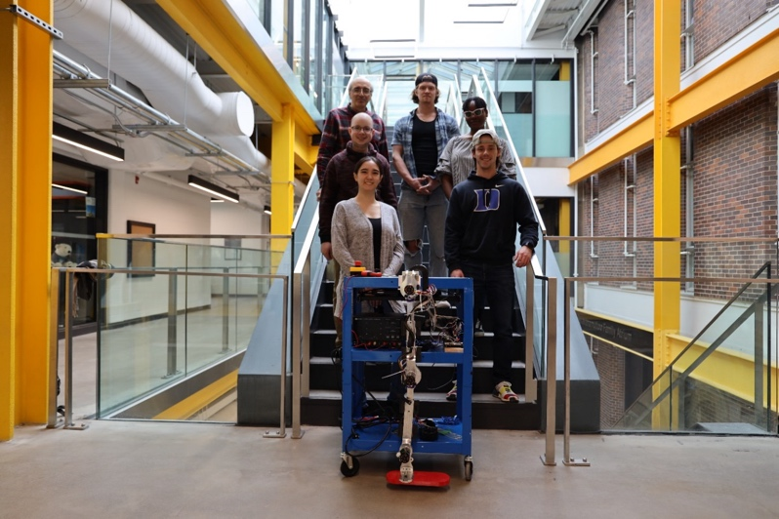

What is next?
Carleton University's Coordinated Accessibility Strategy (CAS), launched in 2020, is a comprehensive commitment to building a more inclusive and accessible community. It focuses on ensuring that all members, particularly those with disabilities, can fully participate in university life. The strategy emphasizes identifying and addressing barriers to inclusion while promoting an accessibility culture across campus.
Significant progress has been made toward our goals, with strong leadership, increased awareness and resource allocation to reduce barriers. We are attracting research funding, forming international collaborations and leading national initiatives. However, to maintain our leadership, we must continue growing and innovating, reinforcing that accessibility is not just necessary, but the right path forward.
Despite our progress, more work remains. The next iteration of the CAS, launching in spring 2025, will guide us toward 2030 and reflects Carleton's ongoing dedication to accessibility. Through individual and community-driven actions, we will continue fostering an inclusive environment, ensuring accessibility remains central to Carleton University's future. Together, we will continue building an inclusive campus where all members can thrive.


Appendix 1: Areas of Focus and Recommendations Status
This Appendix contains the Objectives and Recommendations directly outlined in the Coordinated Accessibility Strategy (CAS). A status column has been added with the following indicators:
- Complete: Activities are complete with no further implementation required.
- Continuous: Key activities have been completed, but implementation is an ongoing process with no definitive end date.
- Underway: Activities are currently underway and being implemented.
- Planning: Activities (e.g., planning, coordination) are initiated in the current reporting cycle.
- Upcoming: Activities are planned in the near-to-mid term.

The table below can be summarized as follows:
- 11 recommendations are considered complete;
- 22 recommendations are in a continuous state;
- 3 recommendations are underway;
- 3 recommendations are considered in the planning phase; and
- 1 recommendation is in the upcoming phase.

As recommendations are actioned, it is worth noting that the implementation is an ongoing process with no definitive end date. This is reflective of accessibility not being an end state but instead a continuous state of adaptation. Since the original launch of the CAS, definitive actions have been taken on 39 of the 40 recommendations.

Area of Focus #1: Coordination and Leadership
Recommendations | Status
a. Conduct a thorough environmental scan and create a living document of all accessibility initiatives at Carleton. | Continuous
b. Establish an interdisciplinary Centre of Excellence in Accessibility that provides leadership, coordination, best practices, research, support training and knowledge mobilization. | Complete
c. Formalize the senior leadership responsibility for accessibility across the university’s portfolios. | Complete
d. Increase depth of accessibility training of people in leadership positions. | Underway
e. Expand university-wide and community events and campaigns to increase awareness and foster a culture of accessibility. | Continuous
f. Develop membership and contributions to accessibility partnerships, organizations and consortium, partnering at the local, provincial, national and global level. | Continuous
g. Establish a central resource to disseminate and receive information on accessibility. | Complete

Area of Focus #2: Education and Training
Recommendations | Status
a. Increase the number of in-depth training opportunities in accessibility on campus that are relevant to different settings and exceed minimum requirements. | Continuous
b. Increase the number of community activities that build greater awareness and understanding of accessibility and disabilities, barriers and exclusion, as well as opportunities for change. | Continuous
c. Provide educators on campus with incentives, skills and resources to consider accessibility in the design of academic activities and experiential learning, including the principles of universal design. | Continuous
d. Include persons with disabilities and value their lived experiences as a source of knowledge in the design of teaching and learning. | Continuous
e. Expand interdisciplinary academic programming and professional development in accessibility and disabilities for members of the internal and external community. | Complete
f. Address issues of accessibility and disabilities within the Faculties and Departments and encourage faculty to utilize relevant teaching and learning services. | Planning

Area of Focus #3: Information and Communication
Recommendations | Status
a. Perform system audits for accessibility, driven by individual units. | Continuous
b. Establish a process for support for providing accommodations and adaptive and assistive devices for Carleton events. | Underway
c. Establish a reporting protocol to identify information- and communication-related accessibility barriers and areas for improvement. | Complete
d. Establish best practices for accessibility in all knowledge creation and sharing (e.g., documents, presentation, websites, social media, conferences), which are shared internally and externally. | Continuous
e. Provide guidelines and training opportunities on accessibility in knowledge creation and sharing for faculty and staff. | Continuous
f. Ensure accessibility to be part of the procurement requirements. | Complete

Area of Focus #4: Physical Campus
Recommendations | Status
a. Create a Carleton University standard for accessibility of physical spaces based on best practice guidelines and certifications that surpass minimum requirements. | Complete
b. Perform a full accessibility audit of the physical campus with input from the campus community, particularly persons with disabilities. | Continuous
c. Undertake systematic retrofitting to address current problems and meet the new standards for the physical campus. | Continuous
d. Establish a reporting protocol to identify accessibility barriers and areas for improvement. | Continuous
e. Establish a permanent university budget and related supporting resources for accessibility of physical spaces. | Complete
f. Review university policies and practices to consider accessibility where relevant to the physical campus. | Continuous

Area of Focus #5: Employment and Employee Support
Recommendations | Status
a. Institute effective processes and go-to resources on campus for disability-related accommodations and supports for employees across all levels and stages of employment. | Underway
b. Review and identify gaps in employment-related policies, practices and training that support accessibility, accommodations and disability-competent inclusion. | Continuous
c. Provide targeted opportunities across campus that promote career development and training for Carleton employees with disabilities. | Upcoming
d. Include employees with disabilities for input and participation to improve accessibility in employment for persons with disabilities. | Planning
e. Review Carleton’s rates of employment of persons with disabilities and address gaps in representation where they exist. | Planning

Area of Focus #6: Student Support Services
Recommendations | Status
a. Optimize resources through an accessibility lens to be responsive to the growing needs for accommodation and support of students with disabilities. | Continuous
b. Review and identify gaps in student services programming and delivery with consideration of both undergraduate and graduate students with disabilities. | Continuous
c. Provide accessibility- and disability-related training specific to different student services programs. | Continuous
d. Build knowledge, awareness and attitudes in accessibility and accommodations across all student-facing services and points of contact on campus. | Continuous
e. Establish formal student feedback and program evaluation protocols for disability-related student services for continuous quality improvement. | Continuous

Area of Focus #7: Research and Development
Recommendations | Status
a. Develop a strategic plan for accessibility and disability research and knowledge mobilization (e.g., research informed campus initiatives). | Continuous
b. Create a university-wide network of researchers in accessibility and disability. | Complete
c. Grow the research capacity in accessibility and disability, including increasing the number and retention of researchers, research funding, research infrastructure and community partnerships. | Continuous
d. Pursue research chair(s) in accessibility and disability. | Complete
e. Establish academic programming to support research in accessibility and disability. | Complete





Accessibility Institute


3500 Carleton Technology and Training Centre (CTTC)
Carleton University
1125 Colonel By Drive, Ottawa, Ontario K1S 5B6

Email: accessibility.institute@carleton.ca
Phone: 613-520-2600 ext. 7323
carleton.ca/accessibility-institute

