the Institute of African Studies Presents

“The 2017 shooting of Kuki Gallmann and the whiteness of conservation in Kenya.”
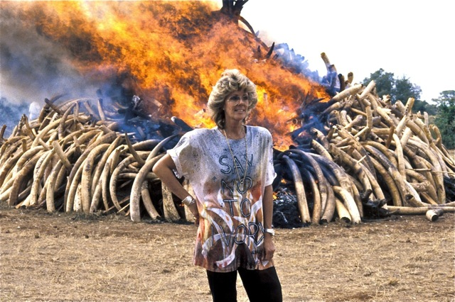

With

Graham R. Fox, PhD Candidate, Anthropology McGill University

Wednesday, April 18th, 1:00- 2:30 pm
MacOdrum Library Discovery Centre Room 482, Carleton University*

Graham R. Fox: Recent conflict between pastoralists and white landowners in northern Kenya has reignited concerns about land inequality and the anti-social impacts of wildlife conservation in the country. This presentation explores the racial underpinnings of Kenya’s safari industry, and its relationship with the gentrification of nature, more globally. The talk highlights how some white landowners have styled themselves as conservation icons, while masking the whiteness of Kenya’s safari industry. In the process, I draw attention to the challenges pastoral communities face in making conservation and tourism work for them.

This is part of the African Studies Brownbag Seminar Series
(http://www.carleton.ca/africanstudies/)
For more information, please contact the Institute of African Studies at
613-520-2600 ext. 2220 or African_Studies@carleton.ca
*For a campus map, please see: http://carleton.ca/campus/map/

