the Institute of African Studies Presents:
“Bottom-up Change in a Top-down Government: Changing Policy and Law in Ethiopia”

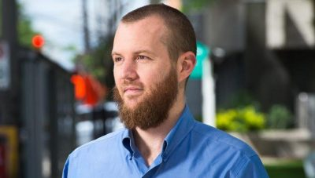

With
Logan Cochrane, Banting Fellow, Global and International Studies, Carleton University

Wednesday, March 28th, 1:00- 2:30 pm
MacOdrum Library Discovery Centre Room 482, Carleton University*

Logan Cochrane is a Banting Fellow at Carleton University in Global and International Studies. His research includes diverse geographic and disciplinary foci, covering broad thematic areas of food security, climate change, social justice, governance and collective action. Before joining Carleton University, Logan worked for twelve years with non-governmental organizations, including in Afghanistan, Benin, Burundi, the Democratic Republic of the Congo, Ethiopia, Tanzania and Uganda. Logan has served as a Director for two non-governmental organizations, and worked as a consultant with clients that have included Save the Children, Management Sciences for Health, The Liaison Office, UNICEF and UNAIDS. Awards he has been given include: Banting Postdoctoral Award (2017), Professional Development Awards by IDRC (2016-2017, 2017), SSHRC Storyteller finalist (2016), Vanier Canada Graduate Doctoral Award (2015), Robert M. Netting Award (2015), Mitacs Fellowship (2014), and he was Nominated for a YMCA Peace Medal, as an Emerging Leader (2009).

This is part of the African Studies Brownbag Seminar Series
(http://www.carleton.ca/africanstudies/)
For more information, please contact the Institute of African Studies at
613-520-2600 ext. 2220 or African_Studies@carleton.ca
*For a campus map, please see: http://carleton.ca/campus/map/

