the Institute of African Studies Presents:

“A powerful effect on their minds”: British Exhibitions of Technology in Abyssinia and Ashanti, 1868-74.
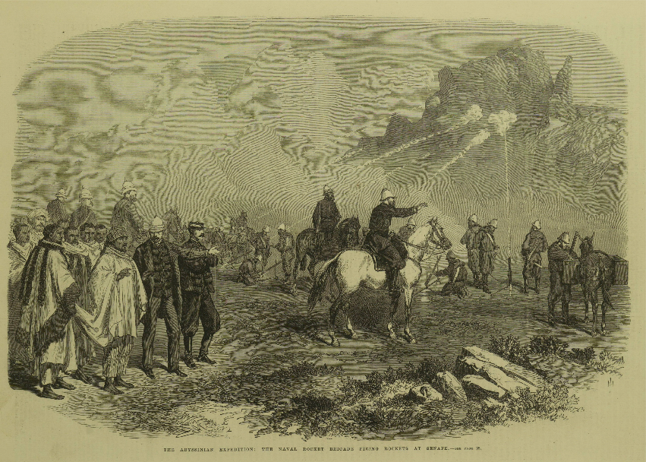

Photo: “The Abyssinian Expedition, The Naval Rocket Brigade Firing Rockets at Senafe”, Illustrated London News, 11 July 1868, p. 28.
With
Dr. Ryan Patterson, Early-career researcher and contract editor, Independent, previously at University of Bristol, UK.

Wednesday, November 1st, 1:00- 2:30 pm
MacOdrum Library Discovery Centre Room 482, Carleton University*

Ryan Patterson: I am an historian of 19th century British science, technology, and culture in colonial and imperial settings. I focus on the media coverage of expeditions into Africa during the 1860s and ‘70s, charting the influence of Victorian techno-centric ideals and views of race on the re-imagining of Africa as a colonial space. I did undergrads in Biology and in History at Carleton University, my MA at York University, and my PhD at the University of Exeter, UK. I have taught at the Universities of Exeter and Bristol. In this talk, I explore the highly publicized display of “novel” technology in the British Abyssinian (1868) and Ashanti (1873–74) expeditions. British commanders in Abyssinia and Ashanti went to considerable effort to dazzle local populations with the spectacle of modern technology. With these staged performances, they hoped to generate reverence in their allies and morale-breaking fear in their enemies. These motivations tinted the filter through which British observers interpreted and selectively represented the actual African responses to those performances. The result, I argue, was a strengthening of stereotypes.

This is part of the African Studies Brownbag Seminar Series
(http://www.carleton.ca/africanstudies/)
For more information, please contact the Institute of African Studies at
613-520-2600 ext. 2220 or African_Studies@carleton.ca
*For a campus map, please see: http://carleton.ca/campus/map/

