­

|  |  |
| --- | --- |
| Morgan RooneyTeaching and Learning Services | Andy Thompson Office of the Vice-Provost and Associate Vice-President (Academic) |

### October 2021

## **Participant Toolkit**

# **Putting Your Course on the Map:**

## Designing courses that Align with your Program’s Learning Outcomes

**Part 1: Reflecting on learning Outcomes**

**Instructions**: Take 7-8 mins to reflect on the relationship between your course’s learning outcomes (CLOs) and your program’s learning outcomes (PLOs):

|  |  |
| --- | --- |
| **Questions** | **Responses** |
| *What are the learning outcomes for your course?* |  |
| *Which of these relate to* ***program-level*** *goals?* |  |

**Part 2: Situating your Course in the Program**

**Instructions**: Take 20 mins to examine your course’s relationship to the program learning outcomes (PLOs) and the program’s curriculum map. You will need to:

1. Locate your course on your program’s curriculum map.
2. Consider the courses that precede it. What have your students learned prior to the course?
3. Consider the courses that will follow. What will your students need to be able to do after it?

|  |  |
| --- | --- |
| **Questions** | **Responses** |
| *Which PLOs are especially relevant to your course?* |  |
| *Prior to your course, what have your students learned? What are they able to do?* |  |
| *After your course, what will students learn? What will they have to do?* |  |

**Part 3: Designing assessments**

**Instructions**: Take 20 mins design teaching and assessment activities that will help your student achieve the course and program goals.

You will need to:

1. Identify 2-3 **program-level** learning outcomes you will address in your course
2. Consider what level of achievement is required by the end of that course AND what that will look like (e.g., *able to locate and summarize journal articles relevant to a topic of interest*)
3. Select assessments and learning activities will help your students achieve the expected outcomes

|  |  |  |
| --- | --- | --- |
| Learning outcomes to focus on in this course | Level of achievement expected | Assessments required to meet expectations |
|  |  |  |
|  |  |  |
|  |  |  |
|  |  |  |
|  |  |  |

**Part 4: Moving Forward**

**Instructions**: Take 5 mins to reflect on where your course sits in within the programs offered by your unit.

What questions to you have about:

* The relationship between your course and the program?
* The assessments and learning activities used in other, related courses?
* The appropriateness of the learning outcomes or curriculum to meet student/disciplinary goals?

|  |  |  |
| --- | --- | --- |
| **Questions I have about my course or program** | **People I can contact to find the answer** | **What I found out** |
|  |  |  |
|  |  |  |
|  |  |  |

**Part 5: Additional reading**

Bégin-Caouette, O. (2018). Le processus d’internationalisation des cégeps : Une analyse historique et géopolitique. Canadian Journal of Higher Education / Revue canadienne d'enseignement supérieur, 48(1), 99–117. https://doi.org/10.7202/1050844ar

Matthew L. Bergbower (2017) When are Students Ready for Research Methods? A Curriculum Mapping Argument for the Political Science Major, Journal of Political Science Education, 13:2, 200-210, DOI: [10.1080/15512169.2017.1292917](https://doi.org/10.1080/15512169.2017.1292917)

Rawle, F., Bowen, T., Murck, B., & Hong, R. (2017). Curriculum Mapping Across the Disciplines: Differences, Approaches, and Strategies. Collected Essays on Learning and Teaching, 10(0), 75-88. https://doi.org/10.22329/celt.v10i0.4765

Willans, Fiona (2021*)* Mapping the curriculum or doing curriculum mapping? A view from Linguistics and Language programmes. Directions: Journal of Educational Studies, 35 (1). pp. 29-37. ISSN 1011-5846

**Part 5: Example Curriculum Maps**

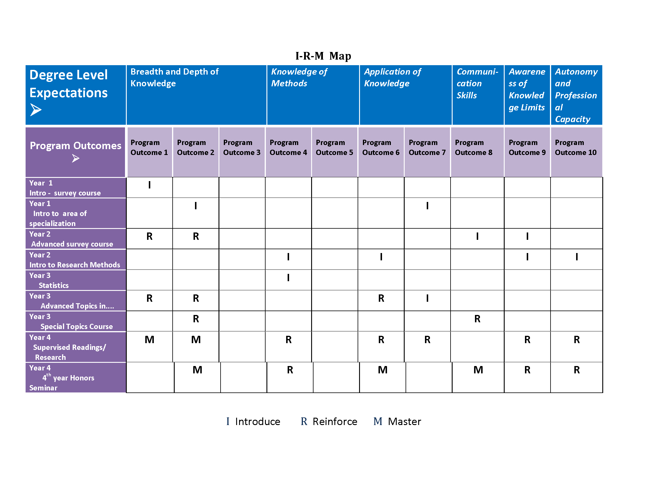

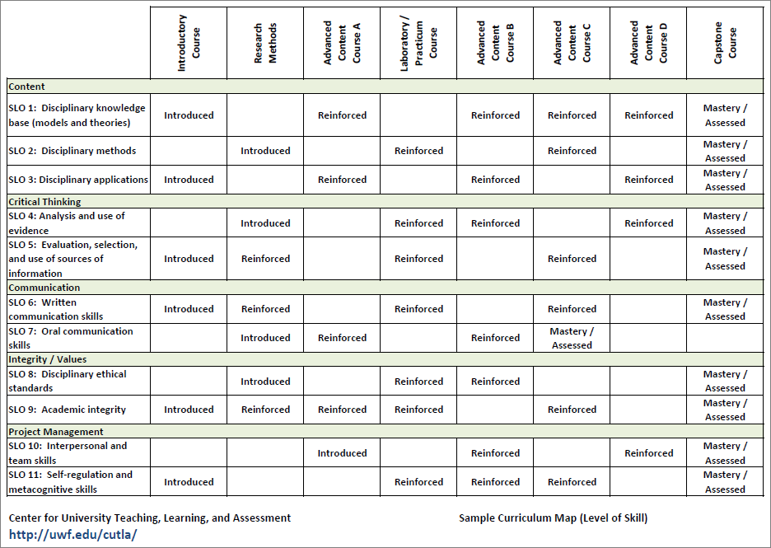

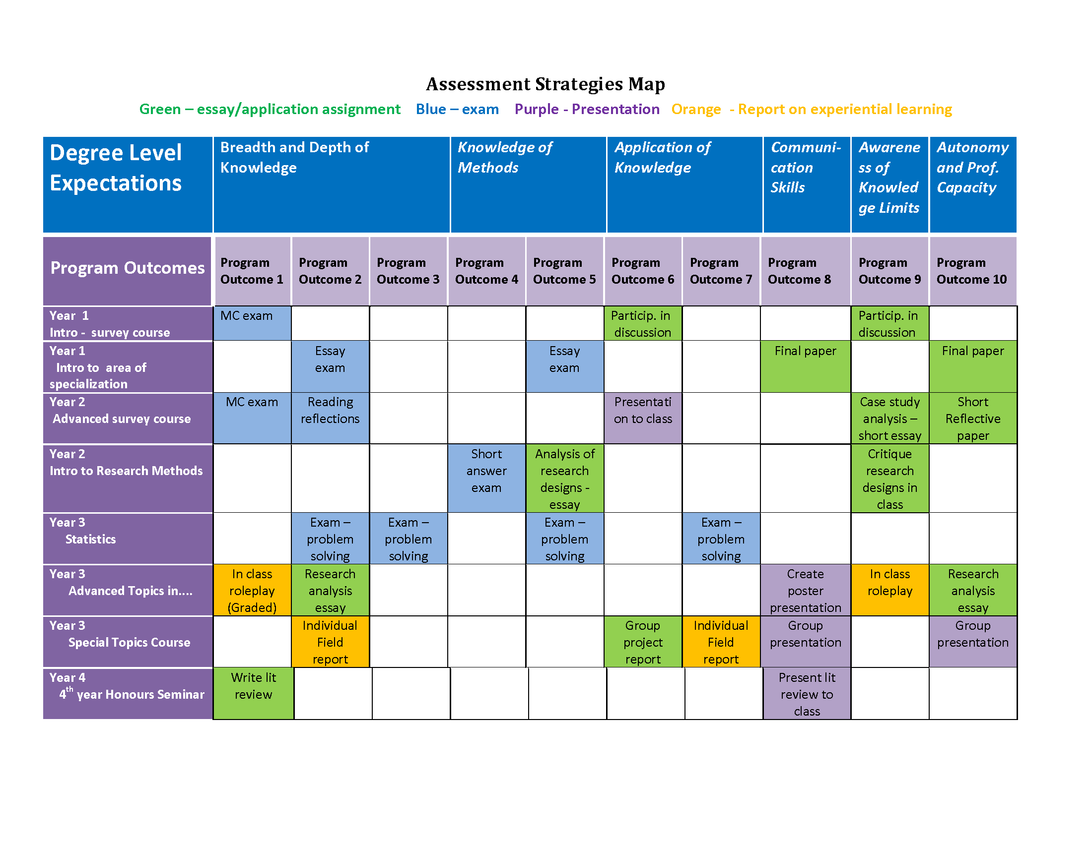

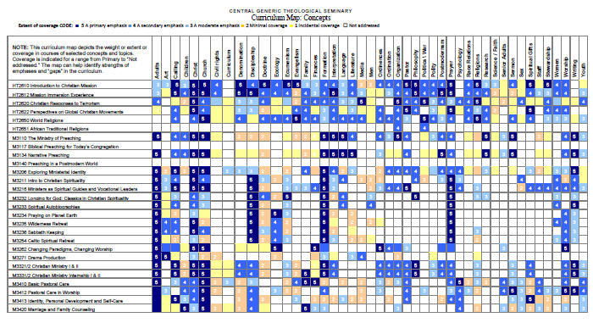

## Part 5: Selecting Evidence for Assessment of Learning

The following table outlines different skills and abilities, and the types of evidence that are most appropriate for their assessment.

| Skill or Ability | Appropriate Evidence | |
| --- | --- | --- |
| 1. Thinking critically and making judgments  *Developing arguments, reflecting, evaluating, assessing, judging* | * Essay * Report * Journal * Letter of advice to … (about policy, public health matters … ) * Present a case for an interest group | * Prepare a committee briefing paper for a specific meeting * Book review (or article) for a particular journal * Write a newspaper article for a foreign newspaper * Comment on an article's theoretical perspective |
| 2. Solving problems and developing plans  *Identifying problems, posing problems, defining problems, analysing data, reviewing, designing experiments, planning, applying information* | * Problem scenario * Group work * Work-based problem * Draft a research bid to a realistic brief | * Analyse a case * Conference paper (or notes for a conference paper plus annotated bibliography) |
| 3. Performing procedures and demonstrating techniques  *Computation, taking readings, using equipment, following laboratory procedures, following protocols, carrying out instructions* | * Demonstration * Role play * Make a video (write script and produce/make a video) * Produce a poster | * Lab report * Prepare an illustrated manual on using the equipment for a particular audience * Observation of real or simulated professional practice |
| 4. Managing and developing oneself  *Working cooperatively, working independently, learning independently, being self-directed, managing time, managing tasks, organising* | * Journal * Portfolio | * Learning contract * Group work |
| 5. Accessing and managing information  *Researching, investigating, interpreting, organising information, reviewing and paraphrasing information, collecting data, searching and managing information sources, observing and interpreting* | * Annotated bibliography * Project * Dissertation | * Applied task * Applied problem |
| 6. Demonstrating knowledge and understanding  *Recalling, describing, reporting, recounting, recognising, identifying, relating and interrelating* | * Written examination * Oral examination * Essay * Report * Comment on the accuracy of a set of records | * Devise an encyclopaedia entry * Produce an A–Z of … * Write an answer to a client’s question * Short-answer questions: true/false/ multiple-choice questions (paper-based or computer-aided assessment) |
| 7. Designing, creating, performing  *Imagining, visualising, designing, producing, creating, innovating, performing* | * Portfolio * Performance | * Presentation * Projects |
| 8. Communicating  *One and two-way communication; communication within a group, verbal, written and non-verbal communication. Arguing, describing, advocating, interviewing, negotiating, presenting; using specific written forms.* | * Written presentation (essay, report, reflective paper etc.) * Oral presentation * Group work * Discussion/debate/role play | * Participate in a ‘Court of Inquiry’ * Presentation to camera * Observation of real or simulated professional practice |

Excerpted from [*Guide to Writing Learning Outcomes for Units of Study in Higher Education*](http://tls.vu.edu.au/portal/site/design/resources/Learning_Outcomes_Guide.pdf). Published by the University of Victoria University of Victoria, Melbourne, Australia.