GINS 4090 B Winter 2024
Imperialism and Resistance in the 20th Century

CARLETON UNIVERSITY
Kroeger College of Public Affairs
Bachelor of Global and International Studies

Seminar: Wednesdays | 2:35-5:25 pm
Instructor: Candace Sobers | Office: 2115 Dunton
E-mail: candace.sobers@carleton.ca | Office Hours: see Brightspace for details

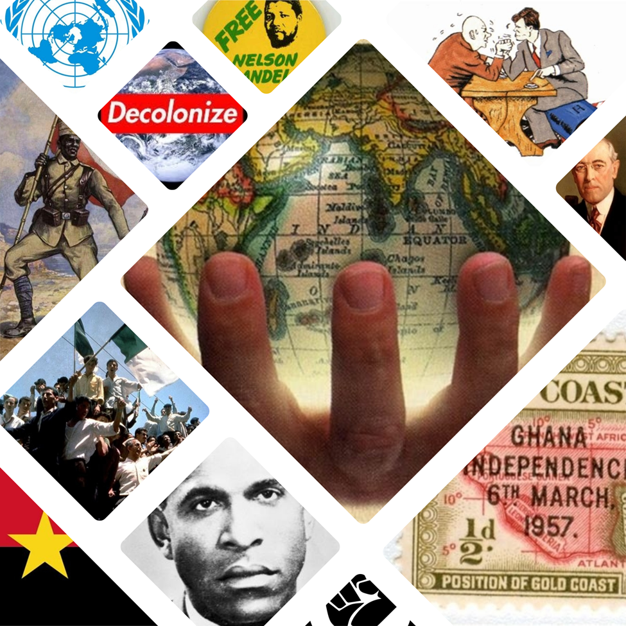
Algonquin Territory Acknowledgement

Carleton University acknowledges the location of its campus on the traditional, unceded territories of the Algonquin nation. In doing so, Carleton acknowledges it has a responsibility to the Algonquin people and a responsibility to adhere to Algonquin cultural protocols.

For further information: Carleton Centre for Indigenous Initiatives

Course Description

This course provides a detailed investigation of processes and consequences of empire and resistance in the 20th century, including imperial repertoires, colonization, decolonization as politics and metaphor, anticolonial nationalisms, revolution and counterrevolution, and what it means to be “after empire”? This course uses historical sources and methods and critical scholarships to better understand key elements of the contemporary world, including the borders and partitions, the persistence of the state, and postimperial imaginaries and intangibles, and neocolonial legacies. Note: a familiarity with 20th century international history is an asset.

Format: Meetings will take place once/week for a three-hour block. The majority of the time will be spent in class presentations and discussion based on examinations of historical documents, images, and films. Occasionally, students may be asked to watch a film, listen to a podcast, or visit a local exhibition.

Objectives: This course aims to re-consider the twentieth century from a global and international perspective, questioning the western-centred triumphalist narratives of the so-called “end of empires.” Students in this course will demonstrate an understanding of the field, will research and interpret primary sources, will engage in critical historical discussions, and will complete a high-quality research project. Familiarity with twentieth century history and questions of imperialism and colonization is an asset.

By the end of the course students will be able to:
- Describe the historical development of imperialism and modes of resistance in the 20th century;
- Identify and explain several influential theories, institutions, events, processes, and agents in the historical development of imperialism and modes of resistance in the 20th century;
- Explain key events through multiple disciplinary perspectives, including historical methods, memory studies, post- and decolonial thinking, and international relations (IR);
- Demonstrate enhanced critical and historical thinking and research skills through the writing of an original research paper or project.

Readings and Texts

- Core readings will be posted on the course website (Brightspace), available though ARES, or as chapters in electronic books (eBooks). EBooks can be purchased from the publisher’s website or from major online retailers. Note: the eBook provider may require an account or free third-party software.

- If you are unclear on the general trajectory of 20th century international history you should read the following: William R. Keylor, Jerry Bannister, and Tracey J. Kinney, The Twentieth-Century World and Beyond: An International History since 1900, Second Canadian Edition, Oxford University Press, 2011 (available online).

- You are responsible for checking the course website regularly and reading, watching, and/or listening to all material listed for each week. Occasionally, I will post additional articles or links that are course-related and informative. For the intellectually adventurous I will happily provide more challenging readings – just ask.

Assignments, Evaluation, and Grading

Your grade in this course is comprised of two main components: a) participation/discussion and b) written assignments.

- Participation (15%) – ongoing
- Seminar attendance is expected and attendance will be taken. The participation grade will reflect the extent to which students contribute to class discussions in an informed and critical manner, not only attendance. Participants are expected to arrive each week having completed the readings, prepared or answered the discussion questions (as applicable), and equipped to discuss the material.

- Students are expected to be in attendance for the duration of class (3 hours) each week. Arriving late/leaving at the break/leaving early does not count as ‘attendance for the duration’ and will be noted. Absences and weak and/or limited participation will result in a diminished final grade.

- If you are unavoidably prevented from attending class, please let the Instructor know as soon as possible (note: official documentation is required). If you would like to request an alternative participation arrangement, please see the Instructor no later than week 3. Alternative arrangements are at the discretion of the Instructor.

- Seminar Leader (30%) - ongoing
- In groups of no more than 2-3, each participant will co-lead the seminar. This includes giving a 20-30-minute presentation on the week’s reading and themes, preparing 2-3 discussion questions to distribute to the class two (2) days ahead of seminar (by Monday at 5:00 pm), preparing an engaging teaching activity, and writing a 3-5 page reflection to be submitted by the Friday. Each student will lead the seminar a minimum of twice/course.

- Document Analysis (15%) – due week 6
- Primary sources (remember these?) are an essential source of information, especially if we are serious about destabilizing intellectual hierarchies (i.e. letting people from the past ‘speak’ for themselves). Choose a primary source from one of the listed online archives or an example of cultural production (artistic work, performance, sonic work, etc.) that reflects the themes of 20th century imperialism and resistance. Write an 8-10 page explanation/justification for your choice. Points for creativity, clarity, and historical specificity.

- Research Paper or Project Proposal (10%) – due Week 9
- Students will write a 1-3 page proposal and abstract in anticipation of the main research paper or project. Points for creativity, clarity, and historical specificity. The proposal should contain a short description, a tentative thesis, and a bibliography.

- Research Paper or Project (30%) – final paper due Week 13
- Students will write an 15–18-page research paper or project on one element/episode/aspect of 20th century imperialism and resistance. Primary sources are imperative.
Grading: Final standing in courses will be shown by alphabetical grades. The system of grades used, with corresponding grade points is:
Percentage | Letter grade | 12-point scale | Percentage | Letter grade | 12-point scale
90-100 | A+ | 12 | 67-69 | C+ | 6
85-89 | A | 11 | 63-66 | C | 5
80-84 | A- | 10 | 60-62 | C- | 4
77-79 | B+ | 9 | 57-59 | D+ | 3
73-76 | B | 8 | 53-56 | D | 2
70-72 | B- | 7 | 50-52 | D- | 1

Approval of final grades: Standing in a course is determined by the Course Instructor subject to the approval of the Faculty Dean. This means that grades submitted by an Instructor may be subject to revision. No grades are final until they have been approved by the Dean.

Submitting Term Work

Always keep a copy of all essays, term papers, written assignments, or take-home tests submitted in your courses. You can be asked to submit drafts and rough notes, or to re-submit work for evaluation or for extension requests.

- Submission of Term Work: Upload assignments to Brightspace. No hardcopies will be accepted. All assignments are due by 5:00 pm. If the assignment portal has closed the assignment is late and late penalties of 5%/day will be applied.

- Late penalties: Late assignments will receive a -5% deduction for the first day, -5%/day thereafter, weekends count as one day. Barring exceptional circumstances, assignments will not be accepted more than three (3) days after the original deadline.

- Policy on Extensions: Extensions are granted solely at the discretion of the Instructor. While medical notes, appeals from the Registrar, etc., may be considered, please note that extensions are not guaranteed and will only be granted in the most exceptional circumstances. Please be prepared to submit notes, drafts, and other examples of work in progress.

Academic Accommodations
- Students with Disabilities: The Paul Menton Centre for Students with Disabilities (PMC) provides services to students with Learning Disabilities (LD), psychiatric/mental health disabilities, Attention Deficit Hyperactivity Disorder (ADHD), Autism Spectrum Disorders (ASD), chronic medical conditions, and impairments in mobility, hearing, and vision. If you have a disability requiring academic accommodations in this course, please contact PMC at 613-520-6608 or pmc@carleton.ca for a formal evaluation. If you are already registered with the PMC, contact your PMC coordinator to send me your Letter of Accommodation at the beginning of the term, and no later than two weeks before the first in-class scheduled test or exam requiring accommodation (if applicable). After requesting accommodation from PMC, meet with me to ensure accommodation arrangements are made. Please consult the PMC website for the deadline to request accommodations for the formally-scheduled exam (if applicable).

- Illness or Injury: In the unfortunate case of illness or injury, students are advised to complete this Self-Declaration form to request deferrals for any missed coursework due to the COVID-19 situation. Requests dealing with midterm exams, assignments or other term work should be sent to your Instructor. Requests dealing with final exams should be sent to the Registrar’s Office with a deferral application (carleton.ca/registrar/specialrequests/deferral). Note that in signing the Self-Declaration form students “acknowledge that providing false or misleading information in order to avoid or delay the submission of work or to avoid an exam is a violation of section VI.4 of the Academic Integrity Policy and a formal Academic Integrity investigation will be launched,” and that “deferring the course components listed above may result in a negative impact to my academic performance. I will consult with an academic advisor as needed and be sure that I am aware of the academic withdrawal deadline and, as always, assess my continuation in my courses before that deadline.”

- Pregnancy: Pregnant students requiring academic accommodations are encouraged to contact an Equity Services Advisor in Equity Services to complete a Letter of Accommodation. Then, make an appointment to discuss your needs with the instructor at least two weeks prior to the first academic event in which it is anticipated the accommodation will be required.

- Religious Observance: Students requesting accommodation for religious observances should apply in writing to their instructor for alternate dates and/or means of satisfying academic requirements. Such requests should be made during the first two weeks of class, or as soon as possible after the need for accommodation is known to exist, but no later than two weeks before the compulsory academic event. Accommodation is to be worked out directly and on an individual basis between the student and the instructor(s) involved. Instructors will make accommodations in a way that avoids academic disadvantage to the student. Instructors and students may contact an Equity Services Advisor for assistance (www.carleton.ca/equity).

- Survivors of Sexual Violence: As a community, Carleton University is committed to maintaining a positive learning, working and living environment where sexual violence will not be tolerated, and is survivors are supported through academic accommodations as per Carleton's Sexual Violence Policy. For more information about the services available at the university and to obtain information about sexual violence and/or support, visit: https://carleton.ca/sexual-violence-support/wp-content/uploads/Sexual-Violence-Policy-December-1-2016.pdf

Academic Integrity

- The University Academic Integrity Policy defines plagiarism as “presenting, whether intentionally or not, the ideas, expression of ideas or work of others as one’s own.” This includes reproducing or paraphrasing portions of someone else’s published or unpublished material, regardless of the source, and presenting these as one’s own without proper citation or reference to the original source. Examples of sources from which the ideas, expressions of ideas or works of others may be drawn from include but are not limited to: books, articles, papers, literary compositions and phrases, performance compositions, chemical compounds, art works, laboratory reports, research results, calculations and the results of calculations, diagrams, constructions, computer reports, computer code/software, material on the internet and/or conversations. Examples of plagiarism include, but are not limited to:
- any submission prepared in whole or in part, by someone else, including the unauthorized use of generative AI tools (e.g., ChatGPT);
- using ideas or direct, verbatim quotations, paraphrased material, algorithms, formulae, scientific or mathematical concepts, or ideas without appropriate acknowledgment in any academic assignment;
- using another’s data or research findings without appropriate acknowledgement;
- submitting a computer program developed in whole or in part by someone else, with or without modifications, as one’s own; and
- failing to acknowledge sources through the use of proper citations when using another’s work and/or failing to use quotations marks.

- Plagiarism is a serious offence that cannot be resolved directly by the course’s instructor. The Associate Dean of the Faculty conducts a rigorous investigation, including an interview with the student, when an instructor suspects a piece of work has been plagiarized. Penalties are not trivial. They can include a final grade of “F” for the course or even suspension or expulsion from the University.

Course Policy on the use of Generative Artificial Intelligence tools (e.g. ChatGPT)

- In this course any use of generative AI tools to produce assessed content is considered a violation of academic integrity standards.

Course Policy on Re-Using and Re-Submitting Course Work

- In this course students may not submit substantially the same piece of work for academic credit more than once, that is, students may not re-use and/or re-submit their own work from a different course or from the same course if they are repeating. Re-using and/or re-submitting substantially the same piece of work for academic credit more than once will result in a lowered grade or the student may be asked to re-do the assignment, at the Instructor’s discretion.

Intellectual Property

- Student or professor materials created for this course (including presentations and posted notes, labs, case studies, assignments and exams) remain the intellectual property of the author(s). They are intended for personal use and may not be reproduced or redistributed without prior written consent of the author(s). I maintain the copyright to all course materials; they may not be posted, uploaded, transferred, or sold without my express written consent in advance.

Course Communications

- All email communication to students from BGInS will be via official Carleton university e-mail accounts and/or Brightspace. As important course and University information is distributed this way, it is the student’s responsibility to monitor their Carleton and Brightspace accounts. Please note that “I didn’t check my email” will never be a valid excuse. A respectful tone is expected in all e-communication. Students can generally expect an e-mail response within 48 hours, weekends and holidays excepted.

Course Conduct

- In this course informed and critical discussion of complex and contentious issues is the central component of the learning experience. Thus, all participants are expected to arrive on-time, prepared to conduct themselves with decorum and civility, and to actively contribute to an atmosphere of scholarly inquiry and mutual respect. While spirited discussion and disagreement are encouraged, rudeness, combativeness, and disruption are not.

GINS 4090 B 2023: Discussion Schedule

Each week we will discuss a selection of works related to issues of imperialism and resistance in the 20th century. Representative readings are listed below; however, this list is not final and is subject to change and revision as our discussion progress.

Week 1 (January 10) Welcome & Introduction

- Class Policy Work: due to the nature of this course and its subject matter, certain readings and films will contain disturbing images, ideas, and/or offensive language. As a community of inquiry (i.e., as a class) we will work together to determine the class policy on contentious languages and images.

- *Burbank, Jane, and Frederick Cooper. Empires in World History: Power and the Politics of Difference. Princeton: Princeton University Press, 2010. “Introduction.”
- *Seth, Sanjay. Beyond Reason: Postcolonial Theory and the Social Sciences. Oxford: Oxford University Press, 2021. “Unsettling the Modern Knowledge Sentiment.”

- Watch: Edward Said’s “The Idea of Empire” feat. Eqbal Ahmad - Arena Series UK (February 1993) https://vimeo.com/414226354
- Watch by week 11: “The Battle of Algiers,” Gillo Pontecorvo (1966) (121 mins) https://carletonca.kanopy.com/product/battle-algiers-0
NB: these films contain disturbing images and offensive language. You are free to decline to watch or to watch on your own time if you prefer.

Week 2 (January 17) Imperialism and Internationalism

- *Burbank, Jane, and Frederick Cooper. “Empires after 1919: old, new, transformed.” International Affairs 95:1 (January 2019): 81-100
- Thomas, Martin and Andrew Thompson. “Empire and Globalisation: from ‘High Imperialism’ to Decolonisation.” The International History Review 36:1: 142-170

- Blog: Imperial & Global Forum, University of Exeter https://imperialglobalexeter.com/

Really, really recommended
- Jahn, Beate. “Liberal Internationalism: Historical Trajectory and Current Prospects.” International Affairs 94:1 (2018): 43-61.

Week 3 (January 24) Settler Colonialism

- Cavanagh, Edward, and Veracini, Lorenzo, eds. The Routledge Handbook of the History of Settler Colonialism. London: Taylor & Francis Group, 2016. “Introduction.”
- *Wolfe, Patrick. “Settler Colonialism and the Elimination of the Native.” Journal of Genocide Research 8:4 (December 1, 2006): 387–409
- Pithouse, Richard. “Being Human After 1492.” The Con. November 16, 2016.
http://www.theconmag.co.za/2016/11/16/being-human-after-1492/

- Database: Empire Online
https://www.empire.amdigital.co.uk/

Week 4 (January 31) The Challenge of Self-Determination

- Document Collection: Self-Determination {Brightspace}
- *Manela, Erez. The Wilsonian Moment: Self-Determination and the International Origins of Anticolonial Nationalism, New York: Oxford, 2007. “Introduction” and “Part I.”
- Briffa, Hillary. “1919: Repression, Riots and Revolution.” June 9, 2020, CIGH Exeter
https://imperialglobalexeter.com/2020/06/09/1919-repression-riots-and-revolution/#more-7019

Recommended
- Pedersen, Susan. The Guardians: The League of Nations and the Crisis of Empire, “Introduction” and Ch. 12

Week 5 (February 7) Thinking New Worlds: Anticolonial Intellectuals

- *Elam, J. Daniel. “Anticolonialism.” Global South Studies: A Collective Publication
with The Global South. December 27, 2017. https://globalsouthstudies.as.virginia.edu/key-concepts/anticolonialism
- Prashad, Vijay. The Darker Nations: A People’s History of the Third World, pp. 1-50
- Césaire, Aimé. Excerpt from Discourse on Colonialism, 1950
https://libcom.org/files/zz_aime_cesaire_robin_d.g._kelley_discourse_on_colbook4me.org_.pdf

Week 6 (February 14) Colonization and Cold War

- Document Collection: The United Nations and Decolonization {Brightspace}
- *Westad, Odd Arne. The Global Cold War: Third World Interventions and the Making of our Times. Cambridge 2006, Chapters 1-3
- Lewis, Su Lin, and Carolien Stolte. “Other Bandungs: Afro-Asian Internationalisms in the Early Cold War.” Journal of World History 30:1 (2019): 1–19

Winter Break – February 19-23 – No Classes

Week 7 (February 28) How to Hide an Empire? The United States as Empire

- Document Collection American Empire {Brightspace}
- Immerwahr, Daniel. How to Hide an Empire: A History of the Greater United States. New York: Farrar, Straus and Giroux, 2019. “Introduction.”
- *Heiss, Mary Ann, “The Evolution of the Imperial Idea and U.S. National Identity.” Diplomatic History, 26:4 (Fall 2002): 511-530

Week 8 (March 6) “Seek Ye First the Political Kingdom”: Independence as Resistance

- Document Collection: The Rise of ‘New’ Nations {Brightspace}
- *Kalter, Christoph. “A Shared Space of Imagination, Communication, and Action: Perspectives on the History of the ‘Third World’” in The Third World in the Global 1960s. Samathan Christiensen and Zachary Scarlett, eds. London: Berghan, 2012.
https://ebookcentral-proquest-com.proxy.library.carleton.ca/lib/oculcarleton-ebooks/reader.action?docID=1094715&ppg=37

Really, really recommended
- Craib, Raymond B. “Chapter One – Cartography and Decolonization,’ in Decolonizing the Map: Cartography From Colony to Nation. James R. Akerman, ed. Chicago: University of Chicago Press, 2017, pp. 11-71
NB: yes, this chapter is very, very long. Too long. But it is also one of the most thought-provoking approaches that I have read in a while. Perhaps just give it a try?

Recommended
- Ndlovu-Gatsheni, Sabelo J. “Fiftieth Anniversary of Decolonisation in Africa: A Moment of Celebration or Critical Reflection?” Third World Quarterly 33: 1 (2012), 71-89

Week 9 (March 13) The Global Sixties: Solidarity as Resistance

- WATCH: Savio, Mario. “Sit-in Address on the Steps of Sproul Hall.” December 1964, Berkeley (07:10)
https://www.americanrhetoric.com/speeches/mariosaviosproulhallsitin.htm

- *Chamberlin, Paul. “The Struggle Against Oppression Everywhere: The Global Politics of Palestinian Liberation,” Middle Eastern Studies 47:1 (2011), 25-41
- Elbaum, Max. “What Legacy from the Radical Internationalism of 1968?” Radical History Review 82 (Winter 2002), 37–64

Recommended
- Matthew Stibbe and Zbigniew Wojnowski, “The East European '1968' and its Legacies,” August 21, 2018. https://www.wilsoncenter.org/blog-post/the-east-european-1968-and-its-legacies

Week 10 (March 20) By Any Means Necessary? Violence as Resistance

- Document Collection: Calls to Action, Calls to Violence? {Brightspace}
- *Ruíz, Elena Flores. “The Secret Life of Violence,” in Frantz Fanon and Emancipatory Social Theory. London: Brill, 2019: 231-250. https://doi-org.proxy.library.carleton.ca/10.1163/9789004409200_013
- Meyer, Matt. “Rebuilding Revolutionary Nonviolence in an Anti-Imperialist
Era.” Peace Review 26:1 (2014), 69-77

Week 11 (March 27) “This is What Anti-Imperialism Looks Like”? Art as Resistance

- *Reed, T.V. “Introduction” in Art of Protest: Culture and Activism from the Civil Rights Movements to the Streets of Seattle. Minneapolis: University of Minnesota Press, 2005
- Activity: Critically reading the “Strike Moma Manifesto” (2020)
https://www.strikemoma.org/

Recommended
- Reed, T.V. Chapter 10 in Art of Protest: Culture and Activism from the Civil Rights Movements to the Streets of Seattle. Minneapolis: University of Minnesota Press, 2005
NB: Long, theory-heavy, and US-centric. But very useful. Maybe skip to the middle?

Week 12 (April 3) A Savage War of Peace?: Algeria

- By now you have watched all of “The Battle of Algiers”

- Watch: “Charles de Gaulle Returns to Power During the Algerian War of Independence ca. 1958,” (01:37) Newsreel. British Pathé. Films On Demand, Films Media Group
http://proxy.library.carleton.ca/login?url=https://fod.infobase.com/PortalPlaylists.aspx?wID=104730&xtid=38273
- *Sajed, Alina. “How We Fight: Anticolonial Imaginaries and the Question of National Liberation in the Algerian War.” Interventions 21, no. 5 (July 4, 2019): 635–51
- Perego, Elizabeth. “The veil or a brother’s life: French manipulations of Muslim women’s images during the Algerian War, 1954–62.” The Journal of North African Studies 20:3 (2015), 349-373

Week 13 (April 10) “After Empire?” 21st Century Empire and Resistance
The final essay is due Friday, April 12th by 5:00pm

- Course wrap-up. Be prepared to share findings from your research. Readings TBD.

