Station 1: Declaration of Military Intervention in Ukraine
Background Information
On February 24, 2022, Vladimir Putin announced ‘a special military operation’ to ‘demilitarize and denazify Ukraine’ given the ongoing threat of North Atlantic Treaty Organization (NATO) expansion. In his address, he enumerates several reasons to justify his decision. The following passage is an excerpt from Putin’s speech. Examine the excerpt and answer the corresponding questions.

Address by the President of the Russian Federation
“Citizens of Russia, friends,

[…] I will begin with what I said in my address on February 21, 2022. I spoke about our biggest concerns and worries […] I am referring to the eastward expansion of NATO, which is moving its military infrastructure ever closer to the Russian border.

[…] In the late 1980s, the Soviet Union grew weaker and subsequently broke apart. […] The collapse of the Soviet Union led to a redivision of the world, and the norms of international law that developed by that time… came in the way of those who declared themselves the winners of the Cold War.

[…] The illegal use of military power against Libya and the distortion of all the (United Nations) UN Security Council decisions on Libya ruined the state, created a huge seat of international terrorism, and pushed the country towards a humanitarian catastrophe, into the vortex of a civil war, which has continued there for years. The tragedy, which was created for hundreds of thousands and even millions of people not only in Libya but in the whole region, has led to a large-scale exodus from the Middle East and North Africa to Europe. A similar fate was also prepared for Syria. The combat operations conducted by the Western coalition in that country without the Syrian government’s approval or UN Security Council’s sanction can only be defined as aggression and intervention.

But the example that stands apart from the above events is, of course, the invasion of Iraq without any legal grounds. They used the pretext of allegedly reliable information available in the United States about the presence of weapons of mass destruction in Iraq… It later turned out that all of that was a fake and a sham, and that Iraq did not have any chemical weapons. Incredible and shocking but true. We witnessed lies made at the highest state level and voiced from the high UN rostrum. As a result, we see a tremendous loss in human life, damage, destruction, and a colossal upsurge of terrorism.

Overall, it appears that nearly everywhere, in many regions of the world where the United States brought its law and order, this created bloody, non-healing wounds and the curse of international terrorism and extremism. […] To reiterate: they have deceived us, or, to put it simply, they have played us.

[…] Any further expansion of the North Atlantic alliance’s infrastructure or the ongoing efforts to gain a military foothold of the Ukrainian territory are unacceptable for us. Of course, the question is not about NATO itself. It merely serves as a tool of US foreign policy. […] For our country, it is a matter of life and death, a matter of our historical future as a nation […] It is the red line which we have spoken about on numerous occasions. They have crossed it.

[…] In this context, in accordance with Article 51 (Chapter VII) of the UN Charter, with permission of Russia’s Federation Council, and in execution of the treaties of friendship and mutual assistance with the Donetsk People’s Republic and the Lugansk People’s Republic, ratified by the Federal Assembly on February 22, I made a decision to carry out a special military operation. The purpose of this operation is to protect people who, for eight years now, have been facing humiliation and genocide perpetrated by the Kiev regime. To this end, we will seek to demilitarise and denazify Ukraine, as well as bring to trial those who perpetrated numerous bloody crimes against civilians, including against citizens of the Russian Federation.

It is not our plan to occupy the Ukrainian territory. We do not intend to impose anything on anyone by force. […] The current events have nothing to do with a desire to infringe on the interests of Ukraine and the Ukrainian people. They are connected with the defending Russia from those who have taken Ukraine hostage and are trying to use it against our country and our people.”

––– Vladimir Putin
February 24, 2022
Station 1: Declaration of Military Intervention in Ukraine – Questions
- What is the purpose of this text and to whom is it addressed? How does this text contribute to our understanding of the war in Ukraine?
- Why does Vladimir Putin perceive NATO as a threat to Russian security and sovereignty? What examples does he give with regards to past events in Libya, Syria, and Iraq?
- How does Putin characterize Russia’s relationship with Western powers such as NATO, the United States and the United Nations (UN)?
- How does Putin justify the ‘special military operation’ in Ukraine? What are his goals and how does he use history, memory, and appeal to public sentiment to support his invasion of Ukraine?
- Develop two questions to ask regarding this text that would further enhance your understanding of the subject.

Putin, Vladimir. “Address by the President of the Russian Federation.” Speech, The Kremlin, Moscow, February
24, 2022. http://en.kremlin.ru/events/president/news/67843

Station 2: EU Support to Ukraine
Background Information
Since the start of the war, members of the European Union have banded together to support Ukraine. Together, they have made united and concentrated efforts to curtail Russian influence and provide financial and humanitarian assistance to Ukraine. Analyze the following infographic prepared by the European Council outlines key contributions made by the European Union to aid Ukraine and answer the corresponding questions.

EU Action to Support Ukraine

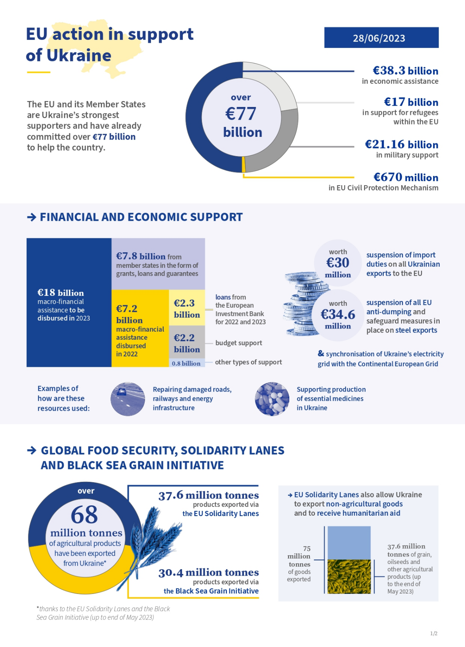
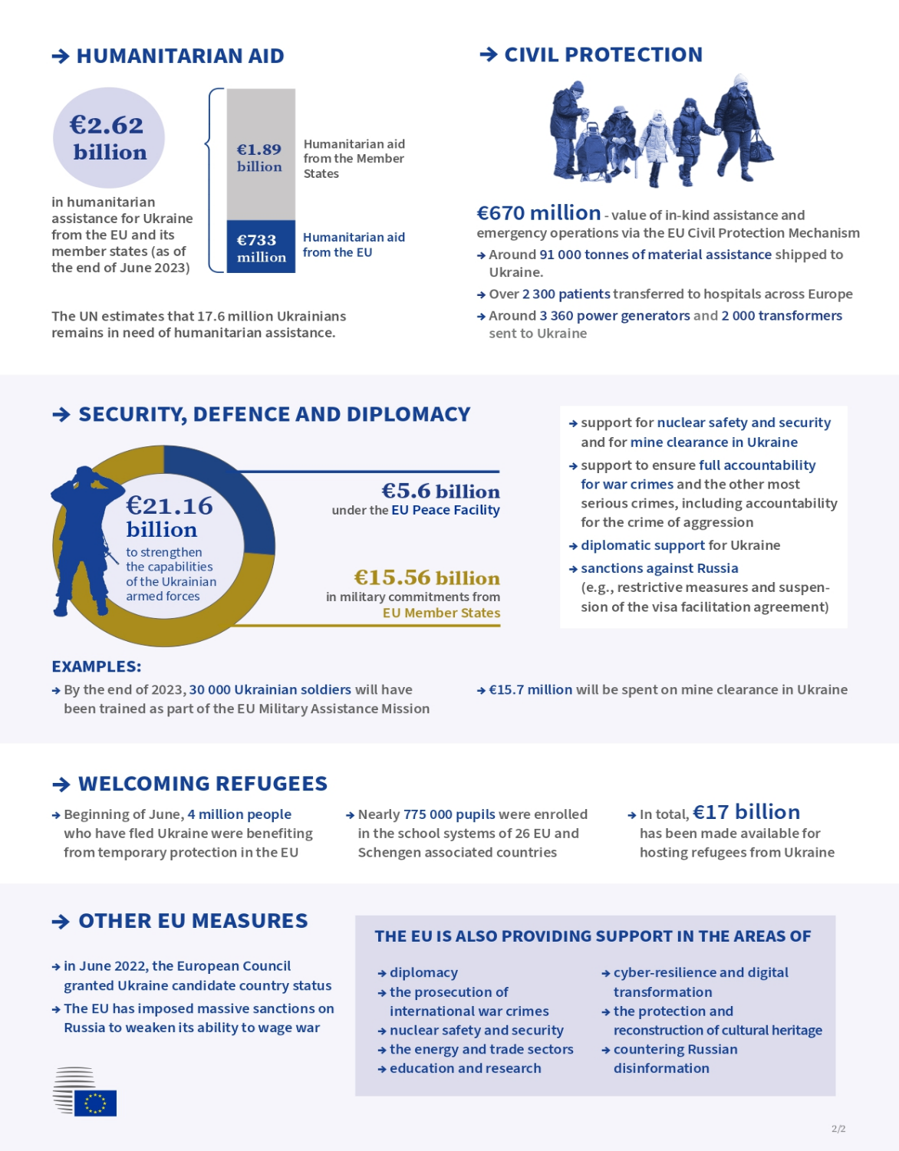

Station 2: EU Support to Ukraine - Questions
- What is the purpose of this infographic and who is the intended audience? How does this infographic contribute to our understanding of the war in Ukraine?
- What kind of financial, security and economic support has the EU provided to Ukraine and how will these measures help Ukraine fight the war?
- What kind of humanitarian, migration and civil support has the EU provided to Ukraine and how will these measures help Ukraine fight the war?
- Critically assess the infographic. What kind of challenges would the EU have had to face in order to develop these policies to assist Ukraine? How would the support provided to Ukraine impact the European Union’s economy and relations between the member states?
- Develop two questions to ask regarding this text that would further enhance your understanding of the subject.
European Council. “EU Action in Support of Ukraine.” European Union. June 28, 2023.
https://www.consilium.europa.eu/media/65478/eu-action-in-support-of-ukraine-factsheet.pdf
Station 3: EU Sanctions Against Russia
Background Information
Following Russia’s invasion of Ukraine, the European Union imposed several sanctions against Russia in order to weaken its economy, limit access to the global market and ultimately curtail its ability to wage war. According to the Encyclopedia Britannica Dictionary, a sanction is “an action that is taken or an order that is given to force a country to obey international laws by limiting or stopping trade with that country.” As of June 26, 2023, the European Union has imposed eleven sanction packages against Russia. Analyze the following infographic prepared by the European Union detailing the sanctions and answer the corresponding questions.

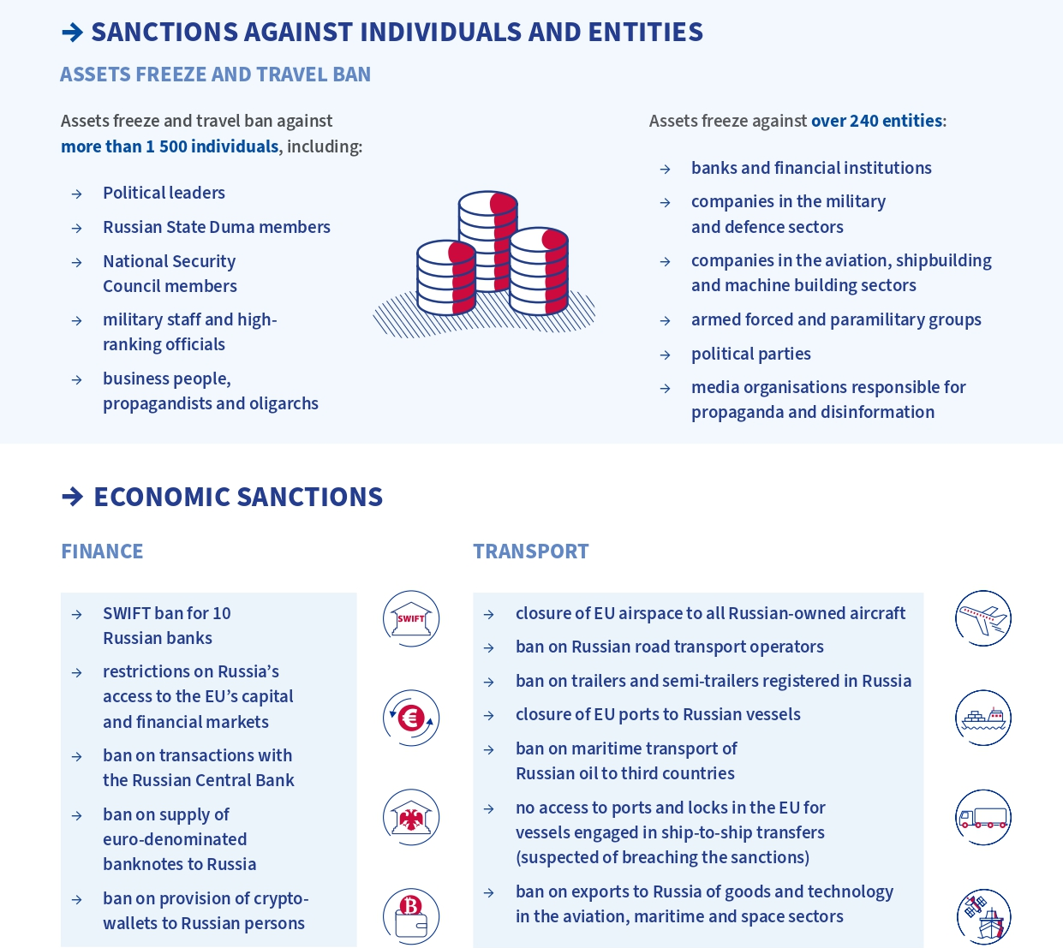
EU Sanctions Against Russia over Ukraine
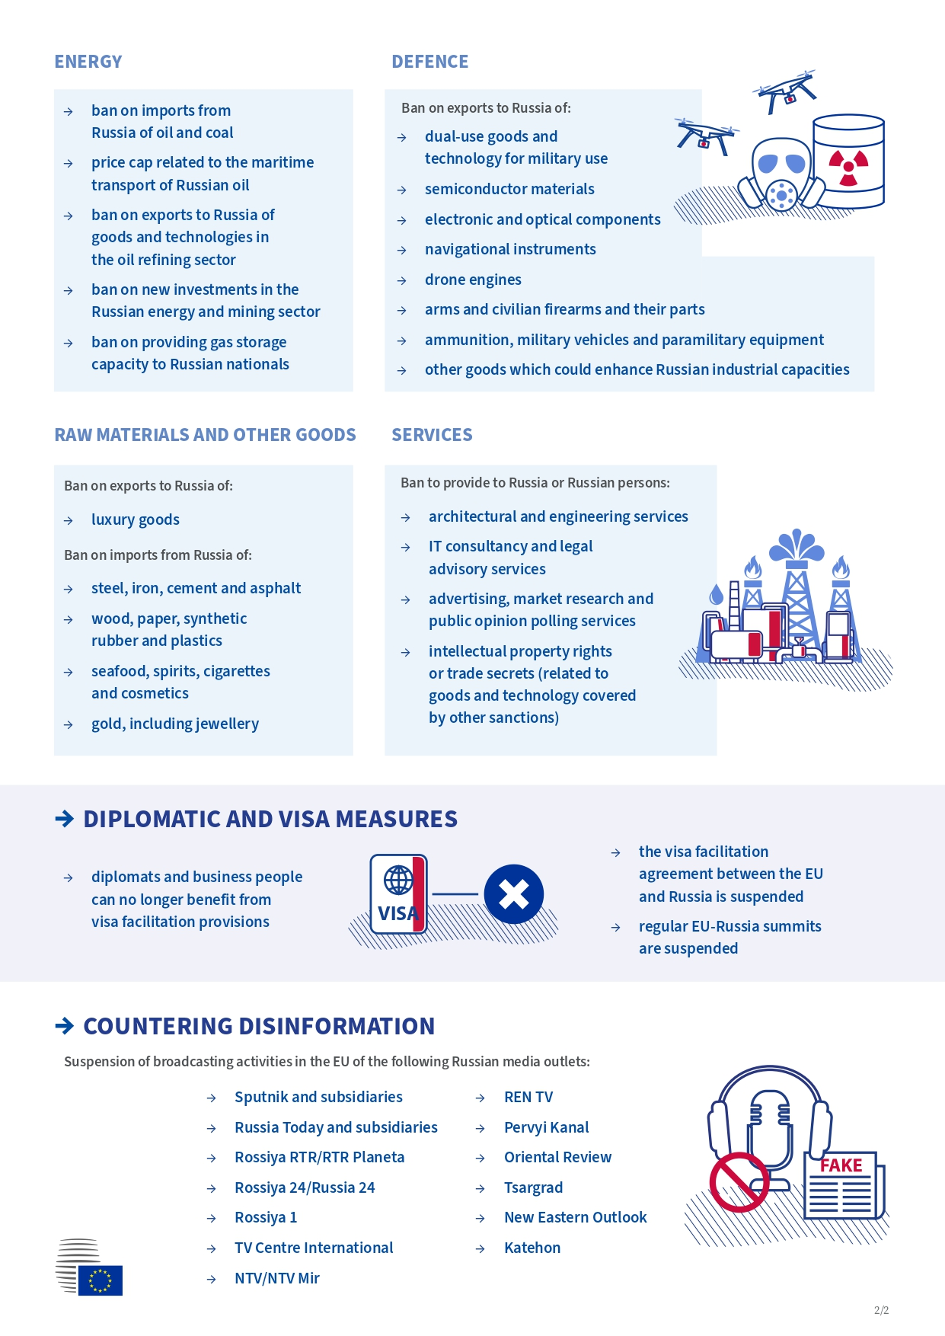
European Council. “Infographic – Eu Sanctions in Response to Russia’s Invasion of Ukraine.” European Union. June 26,
Station 3: EU Sanctions Against Russia - Questions
- What is the purpose of this infographic and who is the intended audience? How does this infographic contribute to our understanding of the war in Ukraine?
- What categories have the EU chosen to sanction? Given these targets, what are Russia’s strengths with regards to financial, economic and natural resources and how will the sanctions influence Russia’s power and influence in the war with Ukraine?
- Regarding the final section, ‘Countering Disinformation,’ describe the role that disinformation, fake news and propaganda play in war. How can Russia use these tools to strengthen their influence in war?
- Identify three sanctions that surprised you. Why do you think these sanctions have been put into place and how will they affect Russia’s economy, access to the market, and ability to wage war?
- Develop two questions to ask regarding this text that would further enhance your understanding of the subject.
2023. https://www.consilium.europa.eu/en/infographics/eu-sanctions-russia-ukraine-invasion/
Station 4: Global Food Security
Background Information
Known as the ‘breadbasket’ of Europe, Ukraine is one of the top agricultural exporters in the world. During the invasion of Ukraine, Russia blocked the Black Sea ports, thereby preventing Ukrainian exports, causing Ukraine to find alternative routes to distribute its products, and inciting global food prices to surge. The resulting food insecurity has severely exacerbated the food crisis around the world and has caused tension within the European Union to support Ukraine while upholding national interests. Analyze the following infographic prepared by the European Council detailing the sanctions and answer the corresponding questions.

Station 4: Global Food Security - Questions
- What is the purpose of this infographic and who is the intended audience? How does this infographic contribute to our understanding of the war in Ukraine?
- What are Ukraine’s most significant exports and what countries rely on these exports? How does the prevention of exports impact these countries?
- Examine the graph regarding Ukraine’s wheat exports. Describe the patterns you see. What are the causes for the rise and fall of Ukrainian exports?
- How does transportation play a role in the global food crisis? What measures have the EU put in place to facilitate transport, access to food and support farmers during this time?
- Develop two questions to ask regarding this text that would further enhance your understanding of the subject.

General Secretariat, Council of the European Union. “Infographic – How Eu Countries are Addressing the Global Food
Crisis.” European Union, 2022. https://www.consilium.europa.eu/en/infographics/how-eu-countries-are-addressing-the-global-food-crisis/

European Council. “Infographic – How the Russian Invasion of Ukraine has Further Aggravated the Global Food Crisis.”
European Union, October 23, 2022. https://www.consilium.europa.eu/en/infographics/how-the-russian-invasion-of-ukraine-has-further-aggravated-the-global-food-crisis/

Station 5: Migration and Displacement
Background Information
As a result of the war, many Ukrainians have fled their country and become refugees around the world, especially in neighbouring countries within the European Union. The following data are excerpts from the Thematic Fact Sheet of the European Union Agency for Asylum’s “Surveys with Arriving Migrants from Ukraine” SAM-UKR project report. This fact sheet is based on information collected between February 9 and May 17, 2023, and subsequently published on June 14, 2023. Analyze the following data regarding Ukrainian experiences in their new country and answer the questions below.

Station 5: Migration and Displacement
- What is the purpose of collecting this survey data and who is the intended audience? How does this infographic contribute to our understanding of the war in Ukraine?
- Take a look at Figure 1. What are the most popular locations for Ukrainian respondents in this survey and what factors may have contributed to Ukrainians taking refuge in these countries?
- Take a look at Figure 4. What factors may have contributed to the highest number of respondents answering ‘somewhat satisfied’ on their survey? How can the information provided in this survey be used to improve living conditions for refugees?
- Take a look at Figure 5. What are the top three most urgent concerns shared by respondents? How do these barriers impact refugees with regards to their quality of life, access to services and ability to integrate into their new country?
- Develop two questions to ask regarding this text that would further enhance your understanding of the subject.
EUAA’s Situational Awareness Unit. “SAM-UKR Project: Surveys with Arriving Migrants from Ukraine,” European Union
Agency for Asylum. June 14, 2023. https://euaa.europa.eu/publications/surveys-arriving-migrants-ukraine-thematic-fact-sheet-june-2023

