Promotional Toolkit – Stars in Reproductive, Maternal, Newborn and Child Health (Round 9)

For use from June 7 to August 3, 2017

On June 7, 2017, Grand Challenges Canada (funded by the Government of Canada) launched the ninth Request for Proposals of Stars in Global Health: Stars in Reproductive, Maternal, Newborn, and Child Health.
We encourage you to use this toolkit to share the new Request for Proposals widely across your networks. In this toolkit, you will find the following:
- Suggested social media messages
- A draft email to include in your organization’s eBulletin or Newsletter
- Images to include in your messaging.

For more information, please visit www.grandchallenges.ca. If you have questions about this toolkit or Grand Challenges Canada, please contact Liam Brown, Press Officer, at: liam.brown@grandchallenges.ca.

Background
Grand Challenges Canada is dedicated to supporting Bold Ideas with Big Impact® in global health. We are funded by the Government of Canada and we fund innovators in low- and middle-income countries and Canada. The bold ideas we support integrate science and technology, social and business innovation – we call this Integrated Innovation®. We focus on bringing successful innovation to scale, catalyzing sustainability and impact. We have a determined focus on results, and on saving and improving lives.
Grand Challenges Canada has launched a new open funding opportunity open to applicants in low- and middle-income countries and Canada: Stars in Reproductive, Maternal, Newborn, and Child Health.
Stars in Reproductive, Maternal, Newborn and Child Health seeks bold ideas for products, services and implementation models that could transform how persistent challenges in reproductive, maternal, newborn and child health are addressed in low- and middle-income countries. Successful proposals will be awarded seed grants of up to $100,000 CAD over a maximum of 12 to 18 months.
Application deadline: August 3, 2017, at 3:00PM EDT
Social Media Platforms
Follow us: Twitter, Facebook, LinkedIn, YouTube, Flickr
Suggested Messages - Twitter
- .@gchallenges seeks Bold Ideas with Big Impact in reproductive, maternal, newborn and child health → www.bit.ly/gccfunding #StarsInRMNCH (+Image)
- Do you have a Bold Idea in reproductive, maternal, newborn and child health? Apply to #StarsInRMNCH → www.bit.ly/gccfunding (+Image)
- New funding opportunity from @gchallenges: Stars In Reproductive, Maternal, Newborn and Child Health → www.bit.ly/gccfunding #StarsInRMNCH (+Image)
- Have a bold idea to improve #RMNCH in humanitarian settings? Apply to #StarsInRMNCH → www.bit.ly/gccfunding (+Image)
- #StarsInRMNCH seeks Bold Ideas to save and improve lives in low- and middle-income countries. Apply → www.bit.ly/gccfunding (+Image)
- Are you looking for #globalhealth funding? Apply to #StarsInRMNCH by August 3, 2017 → www.bit.ly/gccfunding (+Image)
- Have a bold idea to improve the sexual & reproductive health & rights of women & adolescent girls? → www.bit.ly/gccfunding #StarsInRMNCH (+Image)
Date-Specific
July 1 – July 7
- One month left to submit an application to Stars In Reproductive, Maternal, Newborn and Child Health → www.bit.ly/gccfunding #StarsInRMNCH (+Image)
- Do you have a Bold Idea in reproductive, maternal, newborn & child health? One month left to apply to #StarsInRMNCH: www.bit.ly/gccfunding (+Image)
July 27
- Last week to submit an application to Stars In Reproductive, Maternal, Newborn and Child Health → www.bit.ly/gccfunding #StarsInRMNCH (+Image)
August 2
- Tomorrow is the deadline to apply to Stars In Reproductive, Maternal, Newborn and Child Health → www.bit.ly/gccfunding #StarsInRMNCH (+Image)
Suggested Messages - Facebook / LinkedIn
- Grand Challenges Canada seeks Bold Ideas that could transform how persistent challenges in reproductive, maternal, newborn and child health are addressed in low- and middle-income countries. Apply to Stars in Reproductive, Maternal, Newborn and Child Health: www.bit.ly/gccfunding
- Do you have a Bold Idea for improving reproductive, maternal, newborn and/or child health? Grand Challenges Canada has launched a new funding opportunity: Stars in Reproductive, Maternal, Newborn and Child Health. Apply: www.bit.ly/gccfunding
Suggested Message – eBulletin / Newsletter
New Funding Opportunities from Grand Challenges Canada
Do you have a bold idea for improving reproductive, maternal, newborn and/or child health?
Grand Challenges Canada, funded by the Government of Canada, has launched a new open funding opportunity open to applicants in low- and middle-income countries and Canada: Stars in Reproductive, Maternal, Newborn, and Child Health (RMNCH).
Stars in Reproductive, Maternal, Newborn and Child Health seeks bold ideas for products, services and implementation models that could transform how persistent challenges in reproductive, maternal, newborn and child health are addressed in low- and middle-income countries. Successful proposals will be awarded seed grants of up to $100,000 CAD over a maximum of 12 to 18 months.
Of particular interest to Grand Challenges Canada are innovations to improve reproductive, maternal, newborn and child health in humanitarian contexts, notably among internally displaced and refugee populations, as well as innovations that improve the sexual and reproductive health and rights of women and girls, so that they are empowered and have greater influence over their lives and futures.
APPLICATION DEADLINE: August 3, 2017, at 3:00PM EDT
Find out more at www.grandchallenges.ca/funding-opportunities.

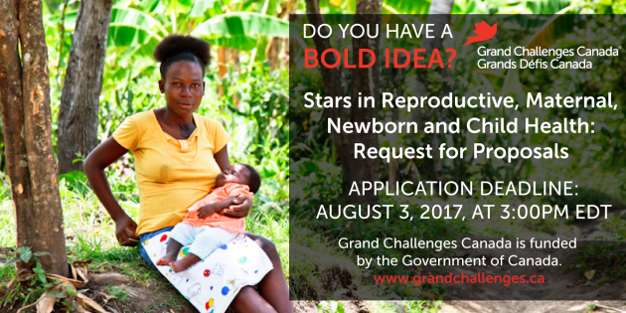
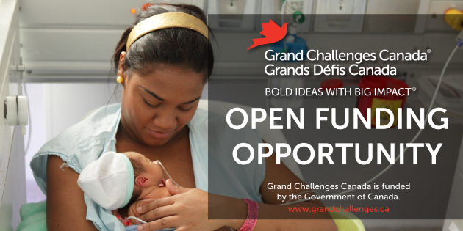
Images (Right click> “Save as Picture”)

