Facilitator Guide:
  - Social Media

Table of Contents
Module Overview 5
Lesson Plan 6
Learning Outcomes 6
Topics and Subtopics 6
Part i – what is social media? 6
Part ii – use of social media 8
Teaching and Learning Activities (Online Delivery) 9
Teaching and Learning Activities (Face-to-Face Delivery) 10
Appendix A: Module Slides and Notes (Face-to-Face) 12

About the Guide
This guide is meant for facilitators who will be leading the Social Media module in online, face-to-face, or blended learning environments.
The guide includes suggested teaching and learning activities for both online and face-to-face delivery. The activities may be mixed or modified for a blended learning experience.
All activities and content in this module are customizable and may be modified for your purposes. All materials are licensed under Creative Commons license: Attribution-NonCommercial-ShareAlike 4.0 International (CC BY-NC-SA 4.0).

ACCESSIBILITY
Module components have been designed to be fully navigable by keyboard and assistive technologies. Participants are provided with a way to skip repetitive navigation links and information. All audio and video components include synchronized text captions and descriptive tags where appropriate.

Module Overview
The goal of this module is for participants to identify the benefits of using and/or developing open educational resources for higher educational purposes, and to locate appropriate materials for specific subject matter.
The open resource model proposed here allows for instructors to reuse, repurpose, and redesign any number of different open-license educational materials that are deemed appropriate for the use in a course. This is a departure from the traditional copyright model which restricts usage based on a paid model. This module will help instructors recognize how these resources can be implemented in their courses, and they should be aware of how open copyrights work and can be put to use on their own materials. If you are delivering a full program in blended and online teaching and learning, it is recommended that you include this module with the open access and open data modules.

Lesson Plan

Learning Outcomes
By the end of this module, participants should be able to:
- Identify the current uses of social media in teaching and learning
- Discuss the potential impact of using social media in a course
- Set out guidelines for the ethical use of social media in education
- Develop effective strategies for using social media
- Identify issues to consider when integrating social media in a course
- Design a learning activity that uses social media in a course

Topics and Subtopics

Part i – what is social media?
- Defining Social Media
  - What is Social Media?
    - “Social media are technologies that facilitate social interaction, make possible collaboration, and enable deliberation across stakeholders. These technologies include blogs, wikis, media (audio, photo, video, text) sharing tools, networking platforms (including Facebook), and virtual worlds.” - Bryer and Zavatarro (2011)
- What does Social Media do?
  - Allows students to self-select study groups and organize based on interests;
  - Provides easy access to resources from around the world, and
  - Provides access to learning beyond the classroom.
- Using Social Media to Develop Professional Skills
  - Digital literacy
  - Independent and self-directed learning
  - Collaboration and teamwork
  - Development of global citizens
  - Inter-personal skills and networking
  - Knowledge management
  - Decision making
- Key Social Media Platforms
  - Personal
  - Interest-based
  - Discussion forums
  - Media sharing
  - Bookmarking
  - Social publishing
- Benefits of Using Social Media
- Increased level of communication (collaboration and participation)
- Privacy: private space for free and open discussion
- Facilitates team projects implementation and review
- Considerations for Adoption
- Undetermined possibilities
- Controversial opinions
- Technical issues
- Institutional factors

Part ii – use of social media
- Faculty use of Social Media
  - Personal
  - Professional
  - Teaching
- Best practices
  - Expectations
  - Presence
  - Audience
  - Quality
  - Privacy
  - Netiquette

Teaching and Learning Activities (Online Delivery)
1. Content Delivery: Participants open Social Media Introduction to read module goals and learning outcomes.
2. Read: Ask participants to read “Why educators need social media.” - https://www.jisc.ac.uk/news/why-educators-need-social-media-07-jul-2015
3. Content Delivery: Participants view “What is Social Media?”, which includes the following components:
- Quick definition & explanation of what social media is for.
- Slides: Types of social media platforms
- Slide: Benefits of using social media
- Video: Interviews with different instructors about their experiences using social media and how they integrated them into their course.
- Slides: Challenges of using social media
- Video: Challenges and considerations for adoption
Approximate run time: 30 minutes
4. Discussion Board: Ask participants to share how they might use some of the social media platforms shared in their courses.
5. Content Delivery: Participants view “Use of Social Media”, which includes the following components:
- Slides: Description of faculty use of social media
- Video: Instructors share how and why they use social media in their classes
- Slides: Sharing of best practices
- Video: Instructors share their own best practices for using social media
Approximate run time: 25 minutes
6. Assignment submission*: Based on the discussion board, ask participants to sign up for a social media platform that they have not used before. Add followers or contacts and explore interaction possibilities.
Based on this experience, design a learning activity for students using this platform.
*Participants may use the assignment submission tool in your LMS.

Teaching and Learning Activities (Face-to-Face Delivery)
Approximate Duration: 3 hours with 15 min break
Recommended Materials: Flipchart or whiteboard, markers or whiteboard markers, laptop with projector and speakers
1. Pre-read: Prior to attending, ask participants to read “Why educators need social media.” - https://www.jisc.ac.uk/news/why-educators-need-social-media-07-jul-2015
2. Introduction to Module & Agenda (5 mins):
Introduce yourself and explain your role at the school. You may edit slide to insert name, position, contact info. Lead participants through goal and learning outcomes of module. Provide an overview of how session will be divided.
3. Content Delivery: What are OER? (15 mins)
View presentation “What is Social Media?”, which discusses different types of social media platforms.
4. Group Activity: Think – Pair – Share (15 mins)
Ask participants to think about and share how they would use some of the platforms in their course, and how they use them personally.
5. Content delivery: Video (10 mins)
Watch interviews with different instructors about the benefits of using social media in courses.
6. Group discussion (15 mins)
Discuss some of the ideas that were presented in the video and how they could be adapted for different situations relevant to participants.
7. Content delivery: Video (10 mins)
Watch interviews with different instructors about the challenges of using social media in courses.
8. Group discussion (15 mins)
Discuss some of the ideas that were presented in the video and how they could be adapted for different situations relevant to participants.
9. Content delivery: Use of Social Media (15 mins)
Present faculty use of social media.
10. Content delivery: Video (10 mins)
Watch interviews with different instructors about how and why they use social media in courses.
11. Discussion: Why use Social Media? (10 mins)
Discussion on why participants think using social media in a social would be beneficial.
11. Content delivery: Best practices (25 mins)
Share best practices for using social media in your course from six different categories
12. Content delivery: Video (10 mins)
Watch interviews with different instructors about their best practices for using social media in courses.
13. Assignment * (10 mins): Explain assignment. Participants must sign up for a social media platform that they have not used before. Add followers or contacts and explore interaction possibilities.
Based on this experience, design a learning activity for students using this platform.
*Participants may use the assignment submission tool in your LMS.

Additional Resources and References
Anderson, S. (2012, May 7). How to create social media guidelines for your school. Retrieved January 15, 2017, from Edutopia, https://www.edutopia.org/how-to-create-social-media-guidelines-school
Dabbagh, N., & Kitsantas, A. (2012). Personal Learning Environments, social media, and self-regulated learning: A natural formula for connecting formal and informal learning. The Internet and Higher Education, 15(1), 3–8. Retrieved from http://anitacrawley.net/Articles/DabbaughPLE.pdf
Daer, A., & Potts, L. (2014). Teaching and learning with social media tools, cultures, and best practices. Programmatic Perspectives, 6(2), 21–40. Retrieved from https://www.academia.edu/8241386/Teaching_and_Learning_with_Social_Media_Tools_Cultures_and_Best_Practices
Definition of SOCIAL MEDIA. Retrieved January 15, 2017, from Merriam-Webster Dictionary, https://www.merriam-webster.com/dictionary/social%20media
Dron, J., & Anderson, T. (2014). Teaching Crowds. Retrieved from http://www.aupress.ca/books/120235/ebook/99Z_Dron_Anderson-Teaching_Crowds.pdf
Griesemer, J. A. (2012). Using Social Media to Enhance Students’ Learning Experience. Quality Approaches in Higher Education, 3(1), 8–11. Retrieved from http://rube.asq.org/edu/2014/03/best-practices/using-social-media-to-enhance-students-learning-experiences.pdf
Gupta, P. (2015, July 24). Importance of social media in higher education. Retrieved January 15, 2017, from Ed Tech Review, http://edtechreview.in/trends-insights/insights/2041-social-media-in-higher-education
How to use social media as a learning tool. (2015, January 12). Retrieved January 15, 2017, from Edudemic, http://www.edudemic.com/how-to-use-social-media-as-a-learning-tool-in-the-classroom/
Miller, J., Gilkerson, S., & Pignotti, L. (2015, May 21). Hey, @students! #Letschat: Using Social Media to Facilitate Research and Public Engagement. Retrieved January 15, 2017, from PraxisWiki, http://kairos.technorhetoric.net/praxis/tiki-index.php?page=PraxisWiki%3A_%3ASocial+Media+for+Digital+Engagement
Seaman, J., & Tinti-Kane, H. (2013, October ). Social Media for Teaching and Learning. Retrieved January 15, 2017, from Online Learning Survey, http://www.onlinelearningsurvey.com/reports/social-media-for-teaching-and-learning-2013-report.pdf
Stoller, E. (2015, July 20). Why educators can’t live without social media. Retrieved January 15, 2017, from JISC, https://www.jisc.ac.uk/news/why-educators-need-social-media-07-jul-2015
Rourke, L., Anderson, T., Garrison, D. R., & Archer, W. (2001). Assessing Social Presence In Asynchronous Text-based Computer Conferencing. Journal of Distance Education, 14(3), 51–70. Retrieved from http://auspace.athabascau.ca:8080/bitstream/2149/732/1/Assessing%20Social%20Presence%20In%20Asynchronous%20Text-based%20Computer%20Conferencing.pdf

Appendix A: Module Slides and Notes (Face-to-Face)
Slide 1

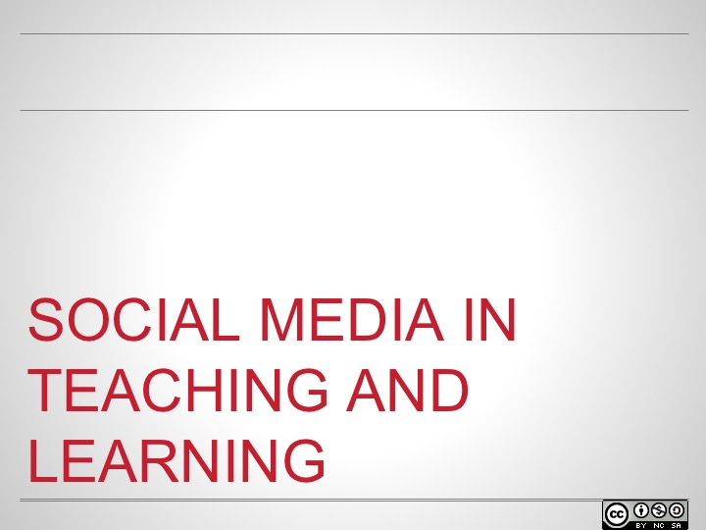

Slide 2

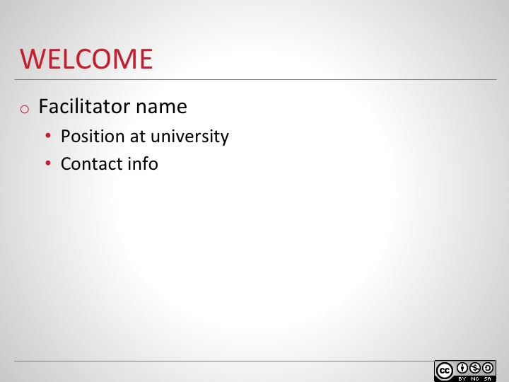
Introduce yourself and explain your role at the school. You may edit slide to insert name, position, contact info.
If this is the first of a series of modules, spend a little bit of time giving overview of the program. You may wish to insert a slide or two with that information.

Slide 3
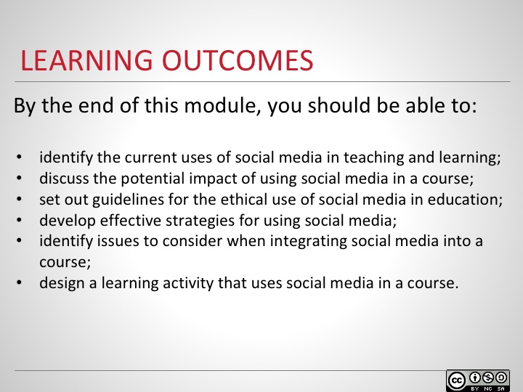
The goals of this module are to recognize the benefits and challenges of using social media in teaching and learning, and to develop design strategies for assignments involving social media.
After introducing the goal, lead participants through learning outcomes.

Slide 4
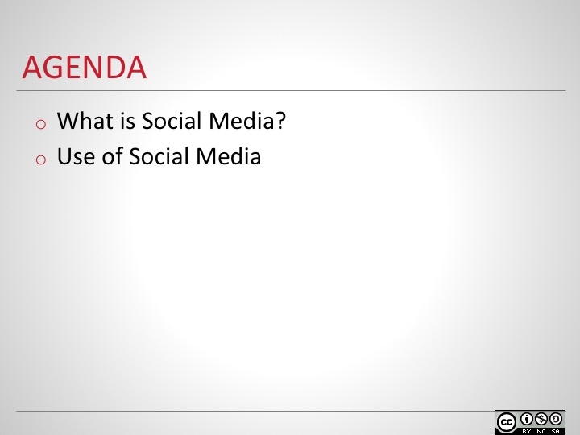
Provide an overview of how the session will be divided (if a different order makes more sense for your context, please feel free to reorder the slides and include additional materials).

Slide 5
SECTION OUTLINE
What is social media?
Key social media platforms
Benefits of using social media in education
Challenges of using social media in education
Considerations for adoption of social media in education
Using social media to develop professional skills

Slide 6
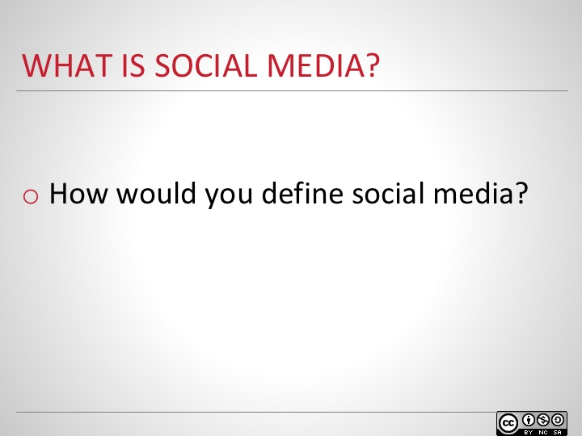
Give participants a moment to think on their own. Elicit a few responses before moving to the next slide.

Slide 7
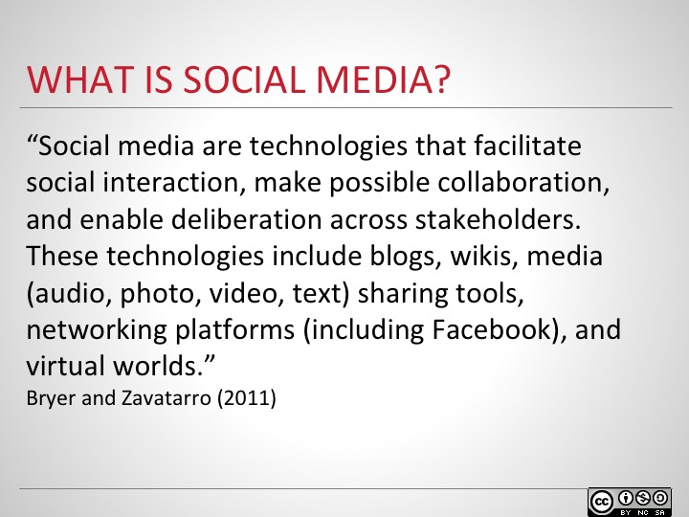
Social media has been defined in many ways. For the purposes of this module, we will be using Bryer and Zavatarro’s 2011 definition.
Ask participants whether their responses from the previous slide are included in this definition.
Next, we will examine the purposes or values, and the challenges of using of social media in education.

Slide 8
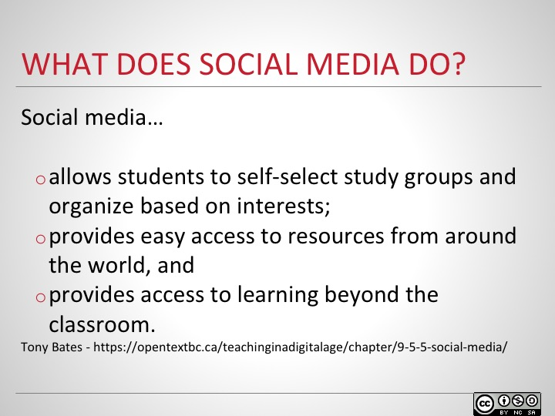
Elicit any other ideas from the class about what social media does to aid learning.

Slide 9
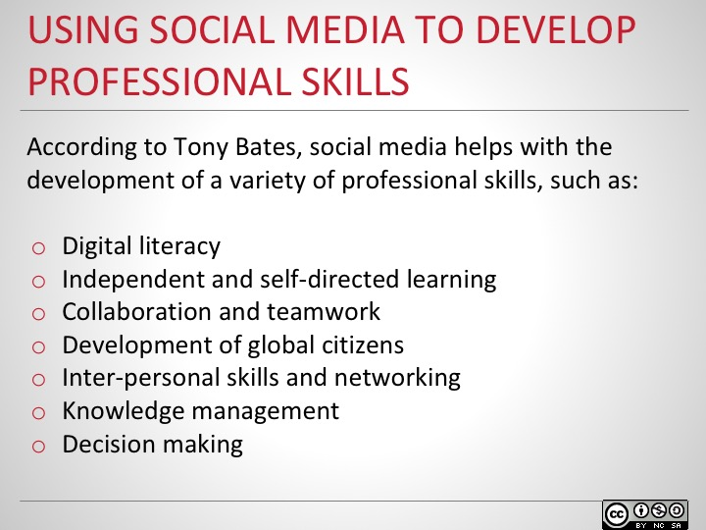
Ask participants how they think social media can help develop the skills listed.
For example, digital literacy can be developed by looking critically at links shared to determine whether they are from a reputable source.

Slide 10
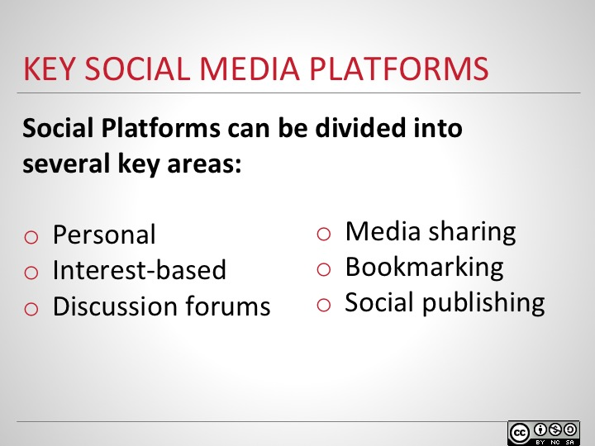
Social Media platforms are among the most accessed websites. There are hundreds of different platforms that are used for either personal or business reasons. We will explore some different social media platforms and see how they are used. Please take a look at the different types of social media, and investigate how they can be leveraged for educational needs.
The next slides will go into more detail for each area

Slide 11
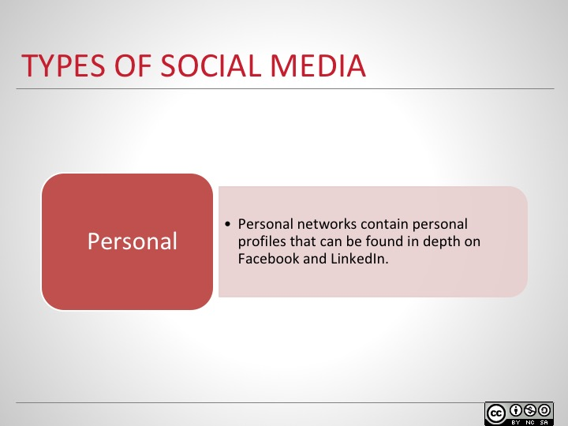
Personal networking tools like Facebook and LinkedIn contain personal profiles such as pictures, videos, biographies, academic achievements and professional experience, discussions of profession-related topics, job postings, etc.
Both platforms are social networks that connect people and professionals in the online environment. Facebook connects old friends, family, co-workers and acquaintances, whereas Linkedin connects professionals and is more business and career oriented. In a class setting, these tools can be useful for reaching out to students, or checking their bios for potential research interests and collaborations.

Slide 12
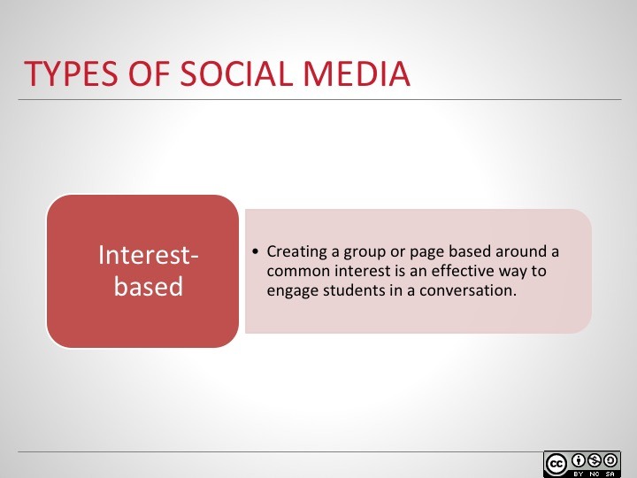
Creating groups or pages based around common interests is an effective way to engage students in conversations. Creating conversations on the open web can potentially draw in the viewpoints and opinions of experts from around the world. This can be done with Facebook groups, Google + Communities, Pinterest, or LinkedIn groups, as well. Each of the interest-based platforms mentioned operate in a similar manner in that users can post comments and replies to create discussions, as well as share pictures, videos and other media. Facebook, Google + and Pinterest are usually created via personal networks. LinkedIn is focused on professional groups and interests. Pinterest is somewhat different in that it involves ‘pinning’ items (usually photos) to your board for comments and sharing, whereas Facebook, Google + and LinkedIn are primarily discussion based.

Slide 13
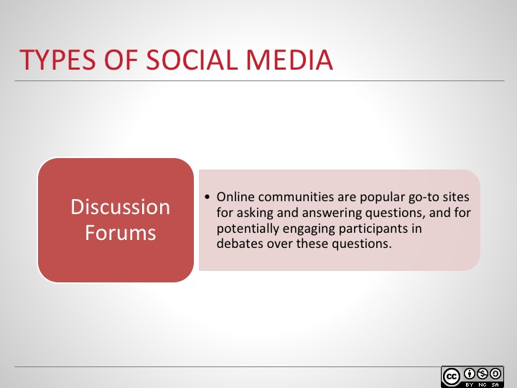
Online communities like Reddit and Quora are popular go-to sites for asking and answering questions, and for potentially engaging participants in debates over these questions. Reddit has many sub-reddits or sub-communities which are focused on specific topic areas. Quora allows you to direct questions to many different ‘experts’ who then weigh in and provide different answers. These communities are usually well moderated with clear rules. Active moderators keep the group discussion on topic and on task.

Slide 14
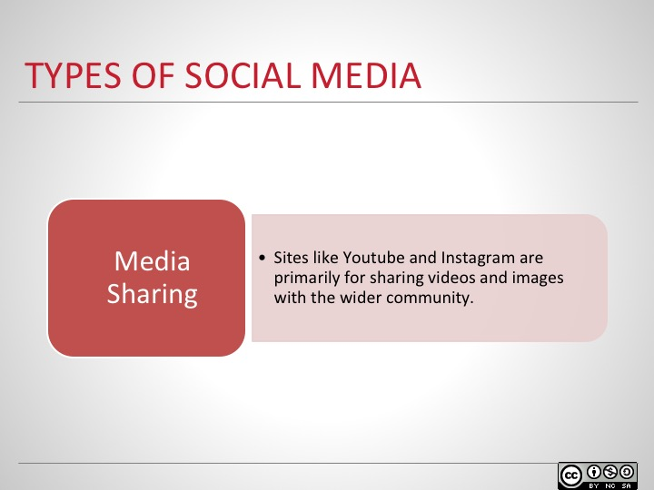
Personal networking tools like Facebook and LinkedIn contain personal profiles such as pictures, videos, biographies, academic achievements and professional experience, discussions of profession-related topics, job postings, etc.
Both platforms are social networks that connect people and professionals in the online environment. Facebook connects old friends, family, co-workers and acquaintances, whereas Linkedin connects professionals and is more business and career oriented. In a class setting, these tools can be useful for reaching out to students, or checking their bios for potential research interests and collaborations.

Slide 15
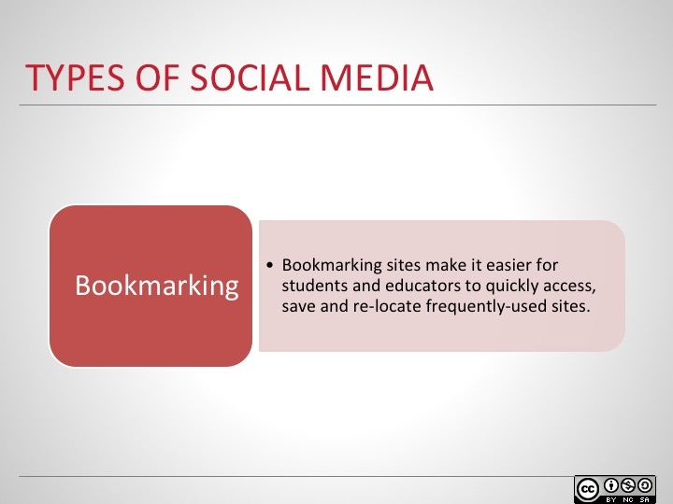
Personal networking tools like Facebook and LinkedIn contain personal profiles such as pictures, videos, biographies, academic achievements and professional experience, discussions of profession-related topics, job postings, etc.
Both platforms are social networks that connect people and professionals in the online environment. Facebook connects old friends, family, co-workers and acquaintances, whereas Linkedin connects professionals and is more business and career oriented. In a class setting, these tools can be useful for reaching out to students, or checking their bios for potential research interests and collaborations.

Slide 16
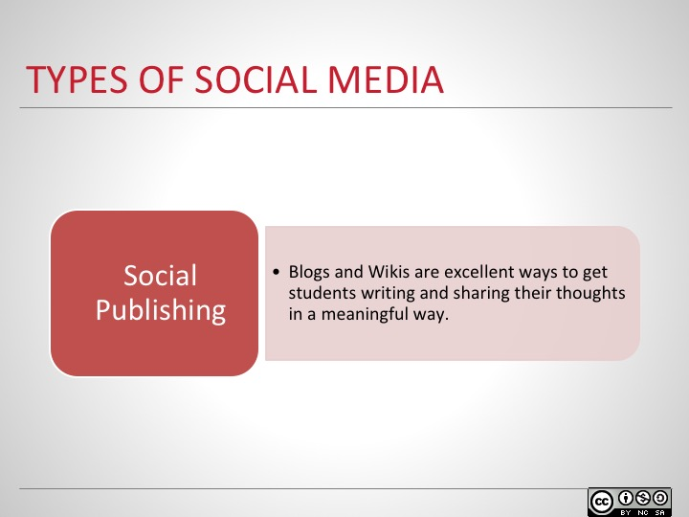
Blogs and wikis are excellent ways to get students writing and sharing their thoughts in a meaningful way. Tumblr and Medium are platforms that allow users to share their thoughts via online journals or blogs. Having students chronicle certain events throughout a semester or reflect on their work can be excellent activities. Wikis can be used in classes to generate shared knowledge of course content. You can also have students edit existing wiki articles, such as on Wikipedia, and study the effects of their edits.

Slide 17
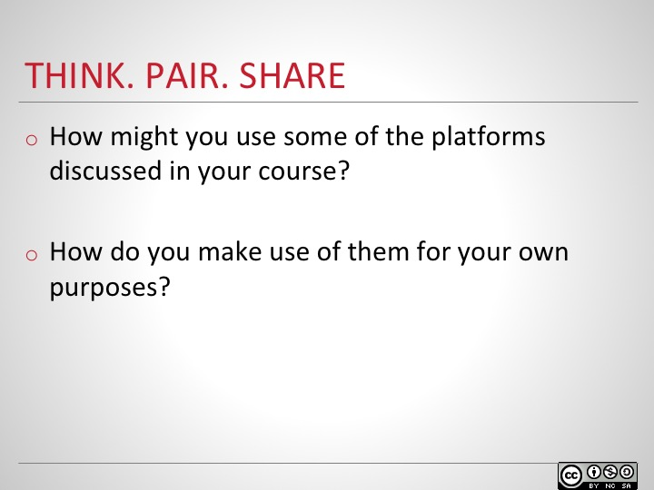
Ask participants to spend 2-3 minutes individually answering the questions, then spend 2-3 minutes discussing with a partner. Ask pairs to share their thoughts with the larger group. List participants’ answers on a whiteboard or flipchart to refer back to later.

Slide 18
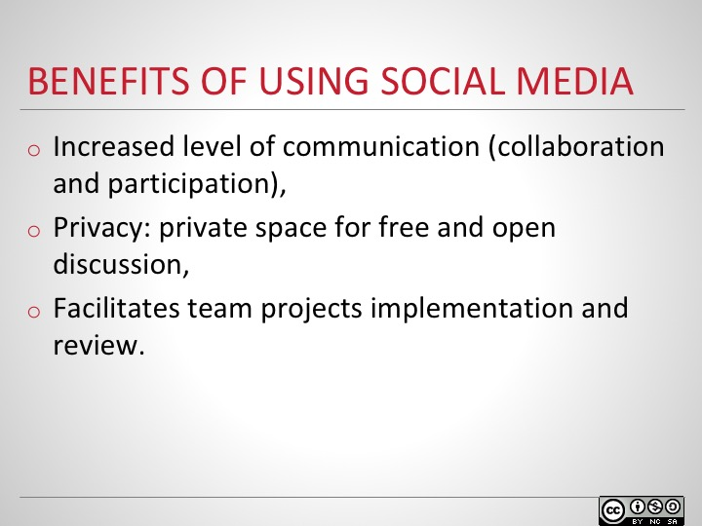

Slide 19
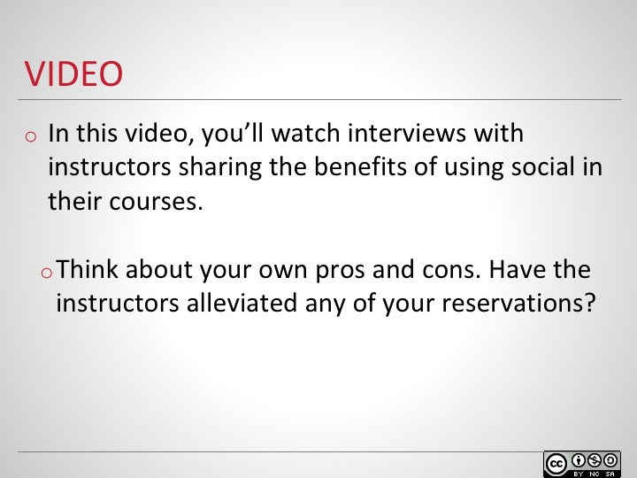
Watch this video of instructors sharing the benefits and challenges of using social media in their courses, and think about your own pros and cons. Have the instructors alleviated any of your reservations? Can you think of some challenges the instructors in the video had which we have not touched on, or think of potential challenges that the instructors didn’t mention in the video?

Slide 20
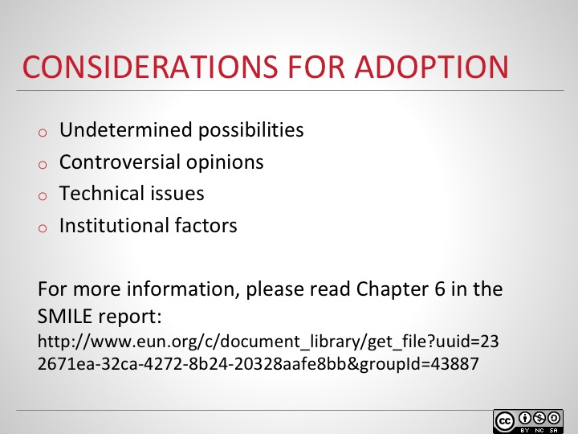
In order to successfully incorporate social media into your teaching, there are some factors to consider:
Social media is a relatively new phenomenon, with undetermined possibilities. Discovering the potential uses of social media is both an inspiring prospect and a daunting task. It is important to understand your audience when choosing the platforms you will use and to consider the pros and cons of each platform in order to decide on the best option for your particular scenario.
Using social media in classes allows for different opinions to be expressed, creating lively discussions. It’s important to actively facilitate these discussions to avoid possible conflicts. Be sure to set clear rules for communication before implementing social media in your course.
Not all students have equal access to all forms of social media. Restrictions on use due to institutional technical infrastructure and policy may also pose problems. Before adopting any type of social media into your classroom, understand the limitations that your students may face and consider potential ways to circumvent any potential problems.
Institutional hurdles and roadblocks can be formidable. The implications of introducing any new tool into the classroom must be carefully considered. Potential institutional issues include decisions to ban social media in the classroom or restrictions on what can or cannot be shared, policies regarding the use of one platform over another, and so on.
Slide 21
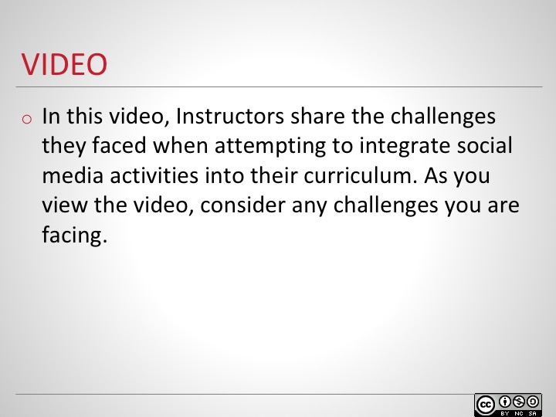

Slide 22
SECTION OUTLINE
Faculty use of social media
Social media in the class
Experience using social media
Best Practices and Guidelines

Slide 23
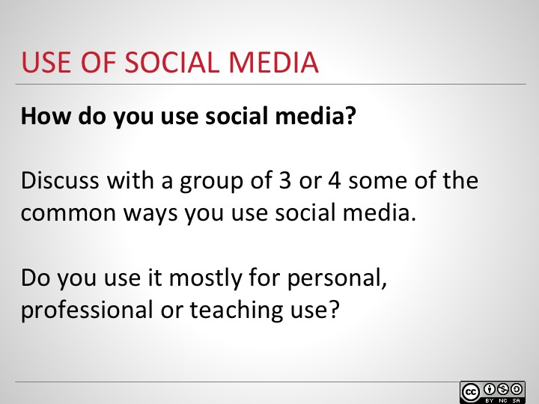
Ask participants to join a group of 3 or 4 to discuss the ways they use social media and ask them to discuss whether they use it for personal, professional or teaching use?

Slide 24
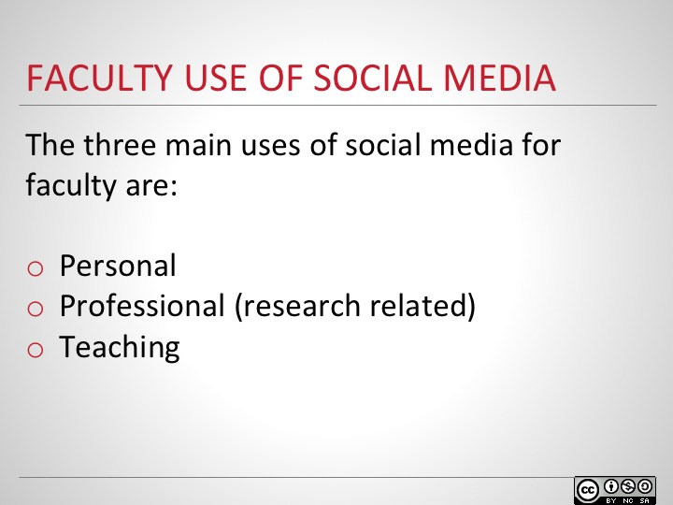
According to a study conducted by Seaman and Tinti-Kane (2013), faculty use social media for three main reasons: for professional use, for teaching, and for personal use. Each of these areas serves a distinct purpose. Seaman and Tinti-Kane define personal use as use not related to research or teaching pursuits, but rather connecting with friends or for other informal uses. Professional use is defined as any use that focuses on the individual’s research or area of study. And finally, using social media for teaching is use within a course that the faculty member is leading.

Slide 25
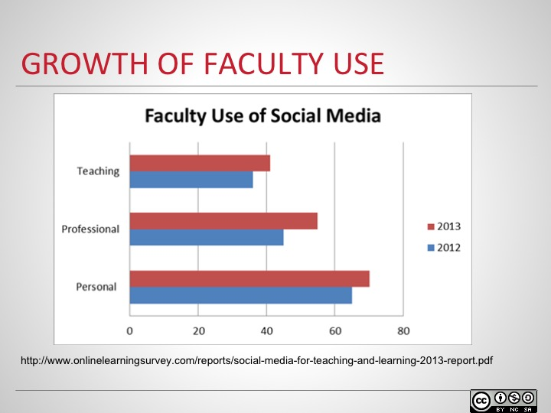
The study showed growth in the use of social media by North American faculty in all three areas. Each type of use maintained their rank: personal use was the highest, followed by professional use, and finally teaching with the lowest usage. Although there was continued growth in all three areas, professional use saw the largest increase with a growth of more than 10% in one year.

Slide 26
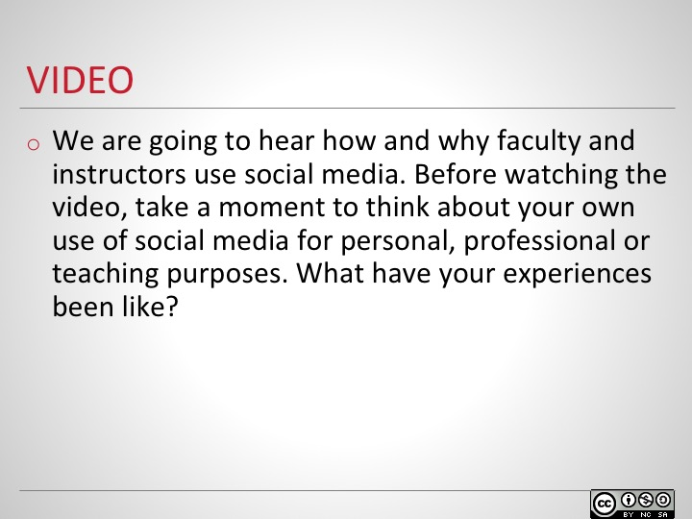

Slide 27
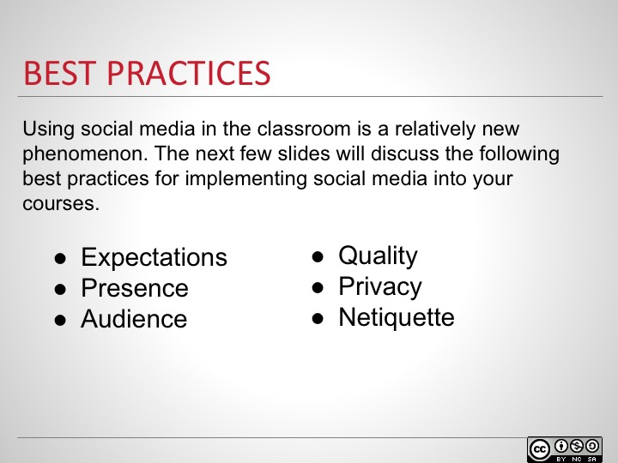
Using social media in the classroom is a relatively new phenomenon. Although there are many ways to incorporate social media into learning, a few best practices have emerged.

Slide 28
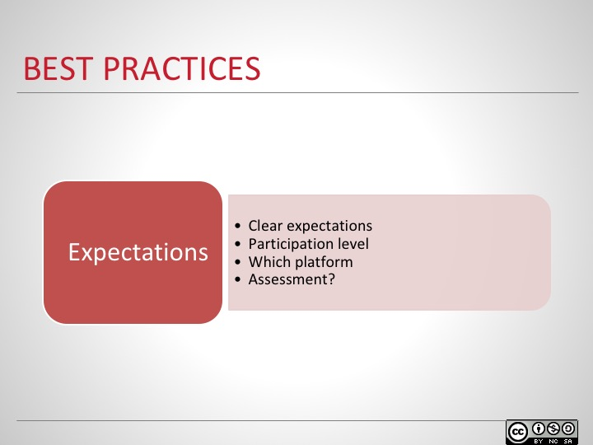
If you plan to use social media in your course, students should be clearly informed of what is expected from them at the outset of the course. Outline the level of participation required, which social media platforms they’ll need to use, and how, if at all, they will be assessed.

Slide 29
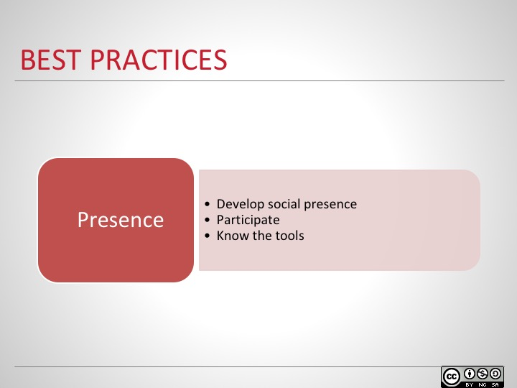
In order for any online learning community to be successful, social presence must be developed. According to Rourke, Anderson, Garrison & Archer (2001) social presence is “the ability of learners to project themselves socially and effectively in a community of inquiry.” To facilitate social presence, instructors must also participate in the community. Instructors should be familiar with social media tools and understand the effects they can have on learning (Daer & Potts, 2014).

Slide 30
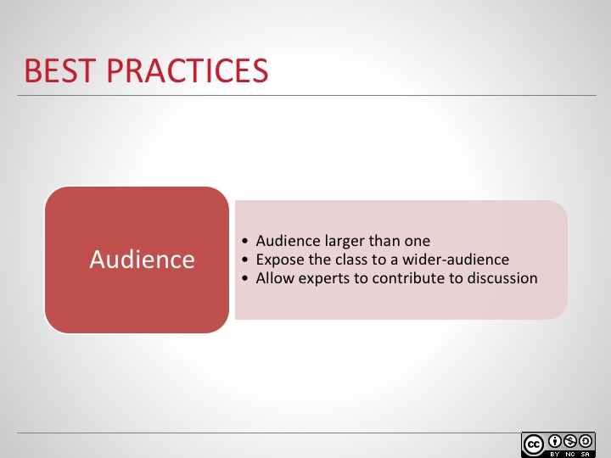
Opening up the classroom to social media exposes students to writing for more than just themselves and the instructor. They are lending their voice to the class as a whole and in the broader arena of the open web. As well, experts from outside the class can contribute to discussions and add their thoughts to students’ contributions. This can further enhance the learning experience and open up new topics of study to the students (Griesemer, 2012).

Slide 31
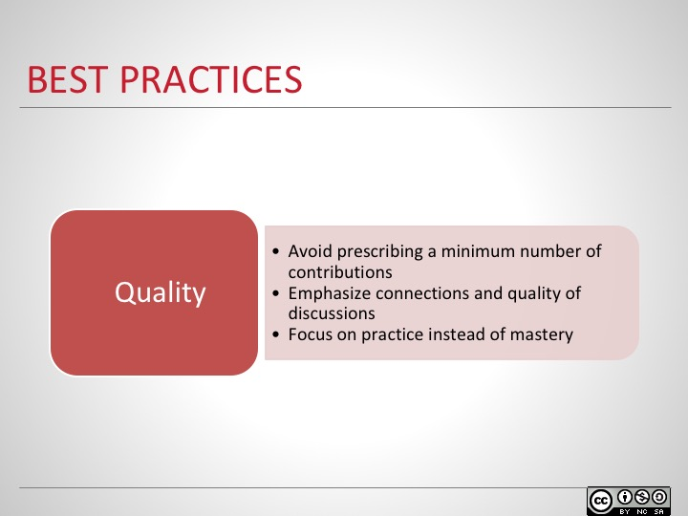
According to Daer and Potts (2014), telling students to contribute a minimum number of communications to a discussion can result in students putting in a minimum amount of effort. In order to cultivate a strong learning community, it’s important to emphasize connections, to focus on the quality of the discussions, and to encourage practice rather than mastery.

Slide 32
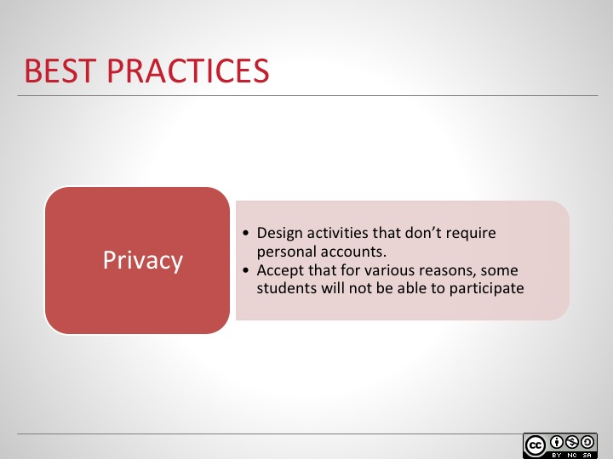
Some students may choose not to participate due to privacy issues, or for other reasons. In these situations, an alternative participation option should be made available for these students to share and express themselves. One option is for all students to use ‘throwaway accounts’ which will not be tied to them personally, but will still allow them to participate and contribute to the community (Daer & Potts, 2014).

Slide 33
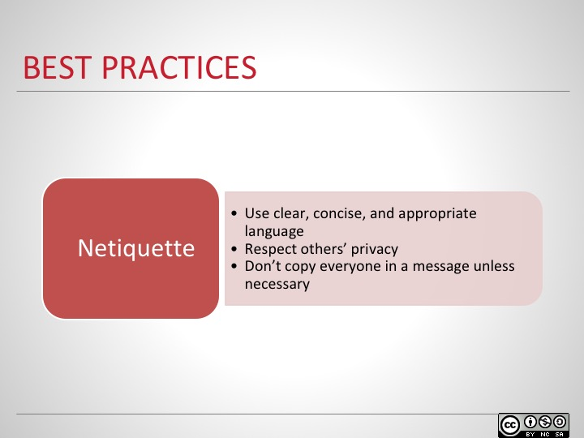
When communicating online, it is important to use clear, concise, and appropriate language. Avoid sarcasm and any other type of communication which could easily be misconstrued. Also, avoid lengthy descriptions which involve too much scrolling; this could discourage the reader from continuing. As well, appropriate language rules should be set at the outset to ensure rude or other potentially offensive words are not included.
It should be made very clear that the messages of others are not to be shared, distributed or forwarded in any way without their consent. If a message was sent privately, it should stay that way unless it has been discussed with each party involved.
Finally, avoid unnecessary emails by only copying others when the information included in the message is pertinent to the recipients or their studies. This includes soliciting others for non-course related activities or “spamming.”

Slide 34
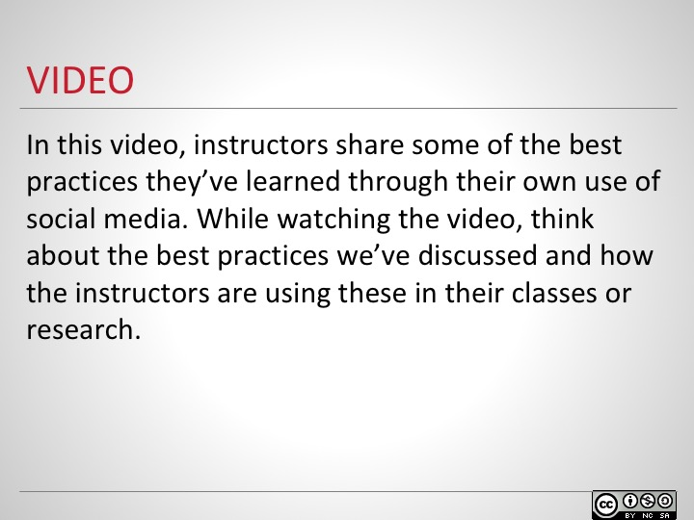

Slide 35
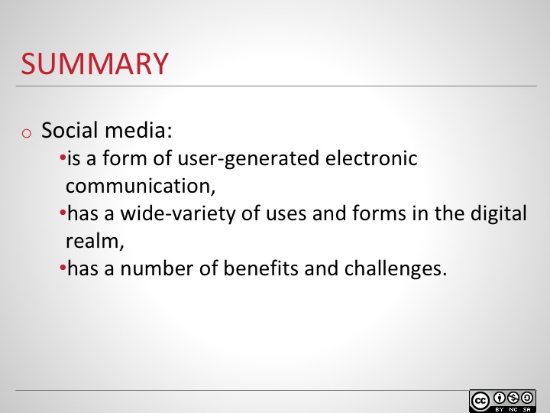

Slide 36
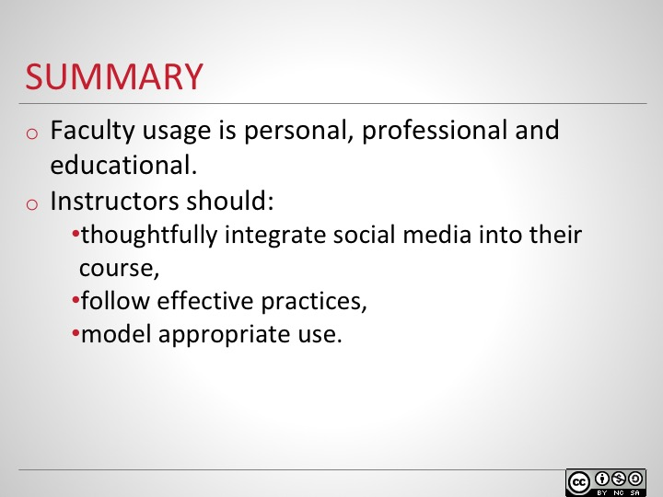

Slide 37
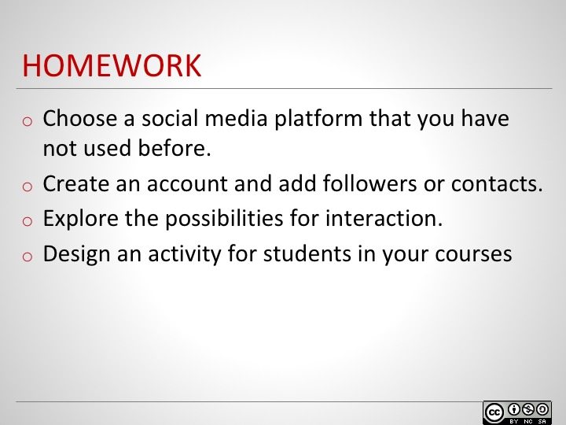

Slide 38
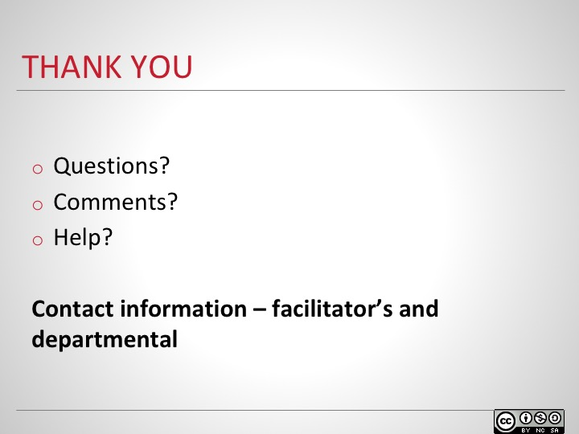

Slide 39
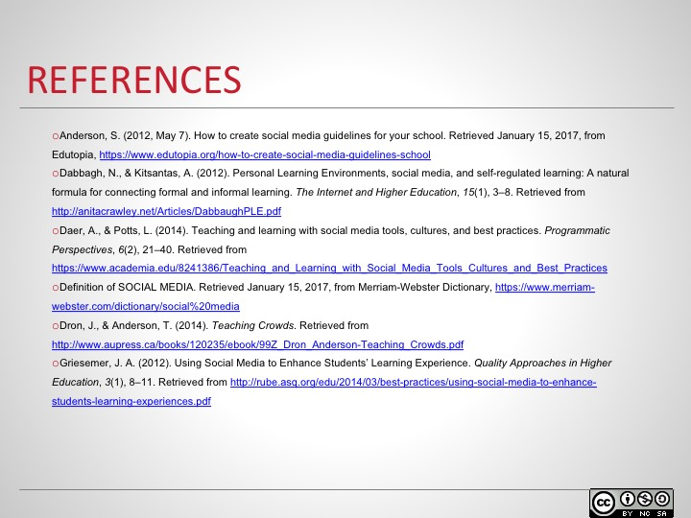

Slide 40
