NEWSLETTER
Updates from the Project director
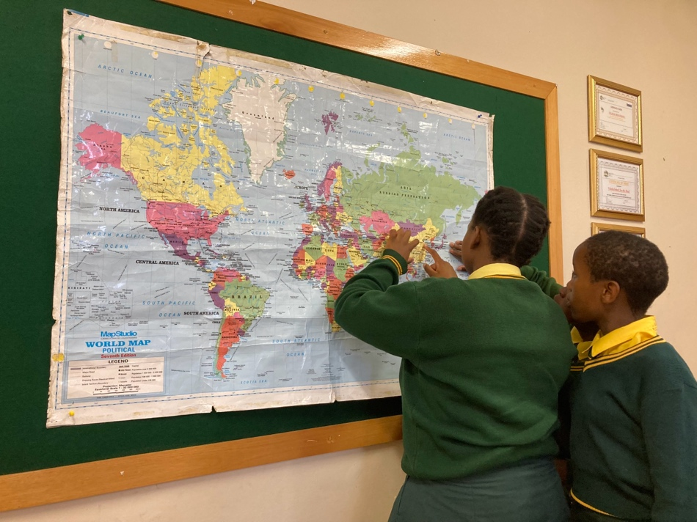
Photo 1: Girls with disabilities identifying South Africa, India, and Vietnam on the world map.
In 2023, I had an opportunity to engage with our local research teams and participants from the three different sites of the project. My trip to South Africa in February 2023 provided me with some important learning and insight about the challenges and opportunities that our partners and participants are facing in a “post”-pandemic context. More importantly, it was also an opportunity to learn about the deep roots of social inequalities which young people, including women and girls with disabilities, face in this global neoliberal time and space, through such forms as “load-shedding,” resource scarcity, and the challenges of transitioning from school to work. And yet, our South African partner’s deep commitment and interest in the project reminds us that, as my colleague from Blind South Africa shared, there is immense hope and optimism that the ENGAGE project may foster social change in such spaces. And, while not everyone involved was able to fully engage in this space in an equal manner (due to competing needs and responsibilities), the participants’ hopes and desire for change set them up for action. Perhaps the “decolonial” knowledge and praxis which the ENGAGE project has attempted to foster have simply started from there – from and across cultural spaces in the Global South.
Over the second year of the ENGAGE project, our team has been able to create several spaces and opportunities for young women and girls with disabilities to create knowledge and praxis through a variety of learning and engagement platforms – from local workshops organized at each project site, to the transnational Youth Leadership Circle (YLC) workshop in Hue City, Vietnam (with the participation of 12 young women and girls with disabilities in South Africa, India, and Vietnam), and monthly and bimonthly zoom meetings with the girls, young women, researchers and research assistants, and partners in each context. What’s more, the actions that our participants have undertaken beyond the formal ENGAGE workshop space, such as a public theatre performance in a market in Kolkata, India on the International Day of People with Disabilities, or the collective and continued efforts to mobilize the participation of other women and girls with disabilities in A Luoi, Vietnam, are part of the forms of knowledge and actions born out of struggles (de Soussa Santos, 2018) that we encourage and take on as a team.
In this newsletter, we are pleased to share some aspects of our collective work and knowledge emerging from each site, as well as from the transnational spaces in which we have co-organized with our partners. We thank the ENGAGE partners, UNICEF Vietnam, DP Hanoi, and related government and non-governmental organizations, for co-organizing these spaces with us. Most importantly, however, this newsletter brings together the connections and solidarity between young women and girls with disabilities across spaces – a key message that our participants sought to amplify through their engagements and actions.

Xuan Thuy Nguyen
ENGAGE Project Director

Updates from our local partners
Updates from India
By Suchandra Bhaduri
Starting October 3, 2023, 4 girls and 12 women with disabilities participated in our second workshop of the year in India. This three-day workshop was dedicated to creating a play to be performed on the International Day of Persons with Disabilities (December 3). During the workshop, the participants played several theatre games to facilitate coordination and to learn to role-play as a medium of activism, and they also wrote a script for the play. In addition, they shared their learning experiences from the Youth Leadership Circle event and devised ideas through which they could continue to build a network of girls and young women with disabilities in their villages in the district of South 24 Parganas, West Bengal, India.
Then, the participants from the ENGAGE Project presented their street play named “Aar Koto din?” (For How Long?) during the awareness programme organized by Disability Activists Forum West Bengal (DAFWB) in a busy market in Kolkata on the International Day of Persons with Disabilities (December 3, 2023). With a diverse audience and several disability activists present, this play, developed and presented by 13 girls and women with disabilities, aimed to convey the message that sex determination of fetuses for killing the female fetuses before birth is a crime. The session also emphasized the role of education in creating opportunities for progress and growth for disabled women.
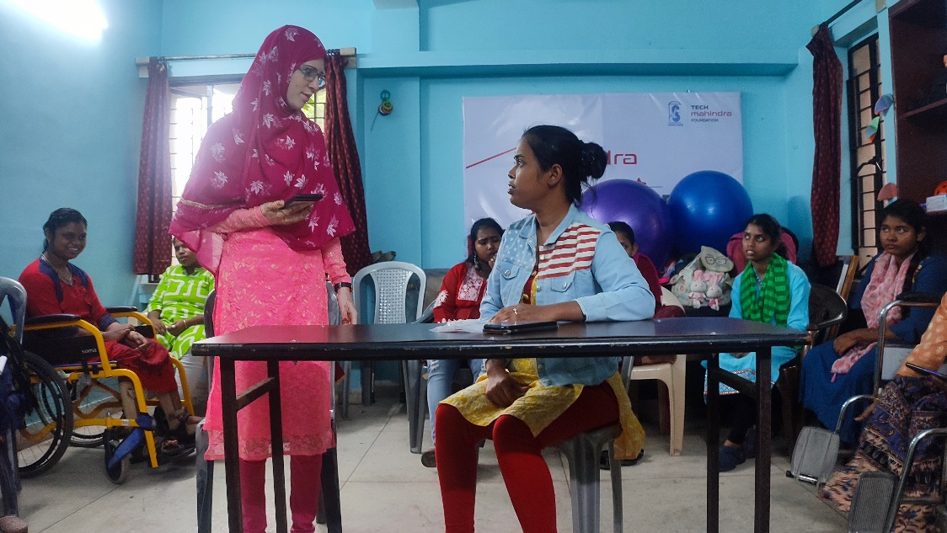
Photo 2: The rehearsal in preparation for the final performance on the International Day of Persons with Disabilities.
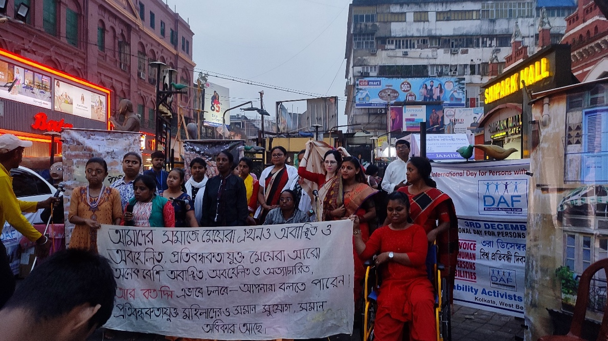
Photo 3: The participants at the end of the performance, conveying the message that disabled women and girls have equal rights.

Updates from Vietnam
The ENGAGE team in Vietnam has had a busy year, conducting several sessions of fieldwork in A Luoi, Vietnam, including those on February 11-13th, from June 7-9th, and again on October 28th and 29th, 2023. The workshops held during the first two sessions of the year included various participatory arts-based methods and reflexive discussions aimed at building knowledge about disabilities, leadership, and the role of girls and young women with disabilities; better understanding the community stakeholders’ cultural, historical, and traditional context; and preparing for the international Youth Leadership Circle event held in Vietnam in June.

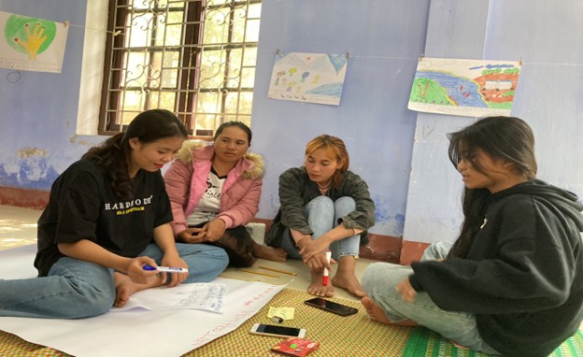
Photo 4: A group discussion on leadership model building
During the October fieldwork sessions, youth leaders shared their experiences and insights gained from the YLC workshop with other participants in A Luoi. They provided details about the activities and discussions from the event and reflected on the lessons learned. Then, all the participants discussed how they could apply the knowledge they gained from the workshop in their local context.
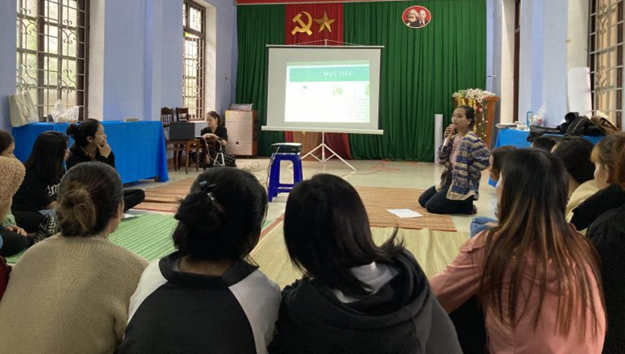
Photo 5: A youth leader presenting her learning experiences from the YLC to the rest of the participants from Vietnam.
Drawing on the manifestos developed at the YLC event (that proposed the establishment of a club for women and girls with disabilities), the participants collectively developed plans and activities to advance this goal. More specifically, they focused on promoting the roles and effective participation of girls with disabilities in the club’s future activities. We look forward to following and supporting the participants’ continued work towards these goals.
Updates from South Africa
The South African team held a 3-day workshop from November 22nd to 24th, 2023, in which 11 girls and 1 young woman with disabilities gathered to share and reflect on what had happened since their last meeting. The elected participant from the Youth Leadership Circle event in Vietnam talked about her experiences travelling to Vietnam and about learning and working with girls and young women from other cultural contexts. One meaningful take away for the group was the realization that girls and young women with disabilities from other parts of the world face many of the same challenges and barriers that they do, and they can all learn from one another and work together to call for and create solutions.
As a group, the participants also revisited the artwork and cellphilms produced during their previous workshop, and they reflected on how their views about disability, bullying and exclusion have evolved. Most of the girls stated that, by meeting other girls with different disabilities, they gained resiliency and, though the stigmas in their communities were still there, they were now better able to cope with bullying. Another important topic of discussion was intimate relationships and teenage pregnancy. These subjects brought on a lot of lively discussions and reflections from the girls and young woman, and we hope to continue to build on these discussions in future workshops.
Youth Leadership Circle (YLC): Reimagining leadership and activism together
In early 2023, the participants elected as leaders and representatives at each of the project sites came together to form the Youth Leadership Circle. Initially, 2 – 3 girls and young women from each location met online using the Zoom platform, with the support of the local research assistants or their teachers, to get to know one another and begin their collaboration. Three online meetings were held prior to the in-person international workshop in Hue, Vietnam in June 2023, providing participants with opportunities to connect, share their experiences and perspectives, and work together to actively shape the agenda for the forthcoming event.
The workshops in Vietnam took place between June 12th and 14th, 2023, and brought together 12 young women and girls with disabilities and their personal assistants from Empangeni, Kwa Zulu-Natal province, South Africa; West Bengal, India; and A Luoi district, Vietnam. Disability and youth activists from different provinces in Vietnam, along with the UNICEF staff and the ENGAGE research team, also attended, creating a transnational space for knowledge production and collective activism for young people with disabilities in the Global South.
Throughout the three-day event, participants took part in a variety of arts-based activities, such as collage-making and zine-making, to identify specific issues which they encountered in each context. Following this creative process, an exhibition was held to showcase this artwork and to engage local community members, thus facilitate dialogues within and beyond these communities.
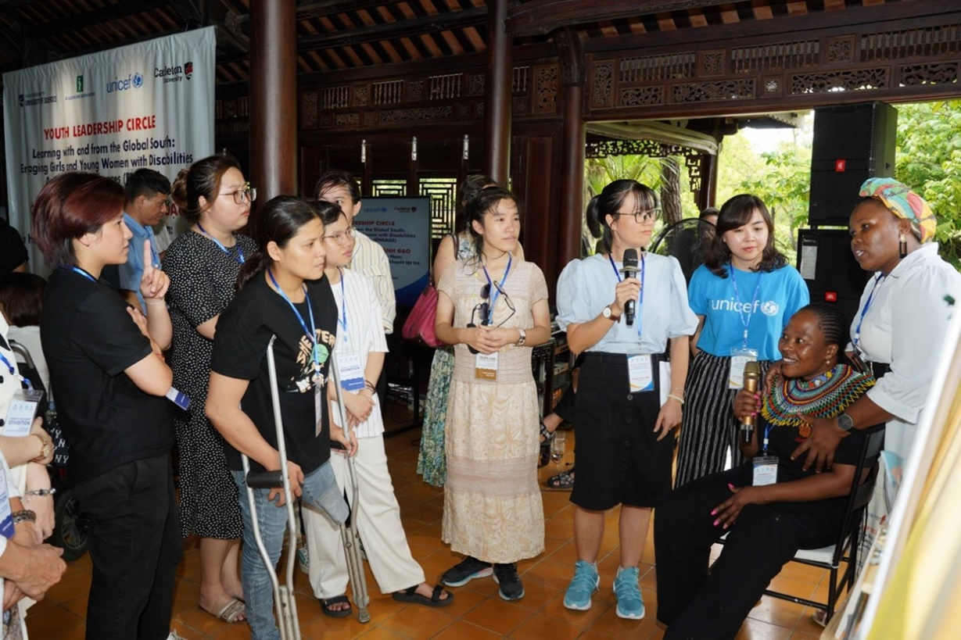
Photo 6: Young women with disabilities from South Africa present their collages at ENGAGE's Youth Leadership Circle in 2023.
The event also featured talks delivered by disability activists and advocates, and the opportunity for participants to build their activist agendas through the development of a Disabled Girls’ Manifesto. During this final activity, participants created a declaration in the form of a short video or a written statement, which they then shared with others.
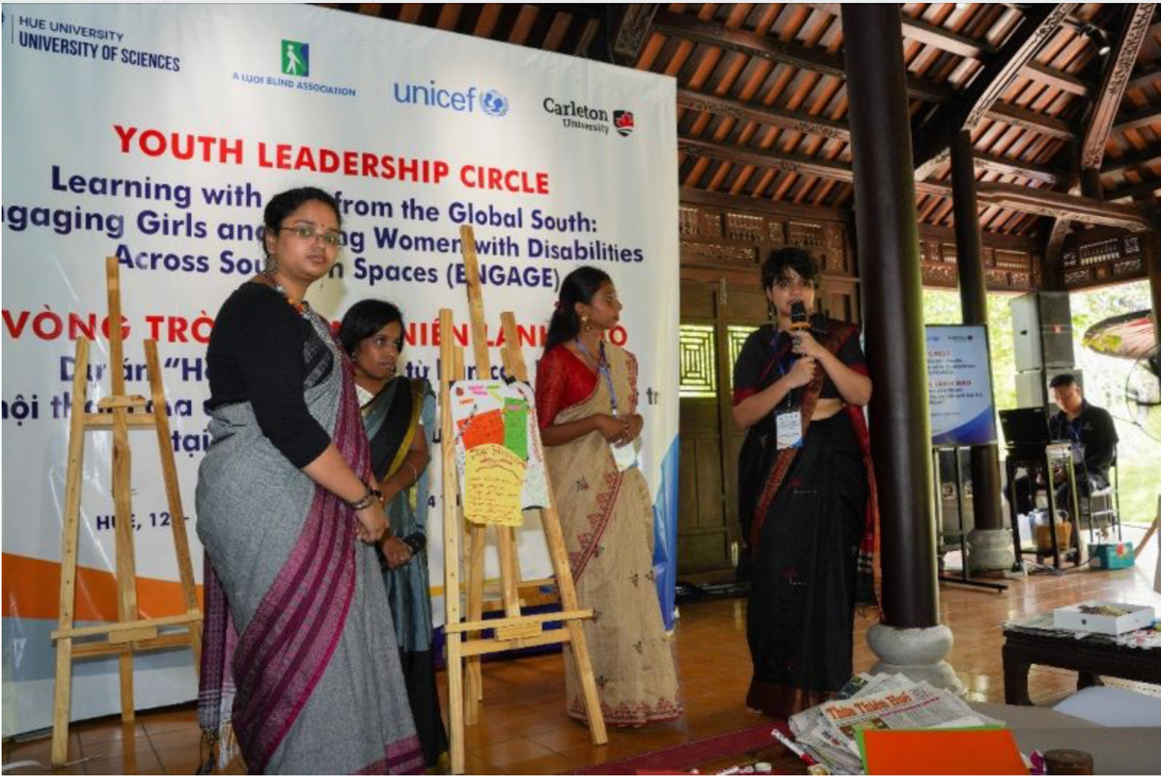
Photo 7: Young women with disabilities from India presented their manifesto at ENGAGE's Youth Leadership Circle in 2023.
Since the in-person workshops, we have held several additional virtual meetings to follow up and to continue to support this group as they further develop their action plans. Such meetings will continue throughout our third year of the project, as participants continue to grow their networks and relationships and as they implement their action plans within their local contexts.

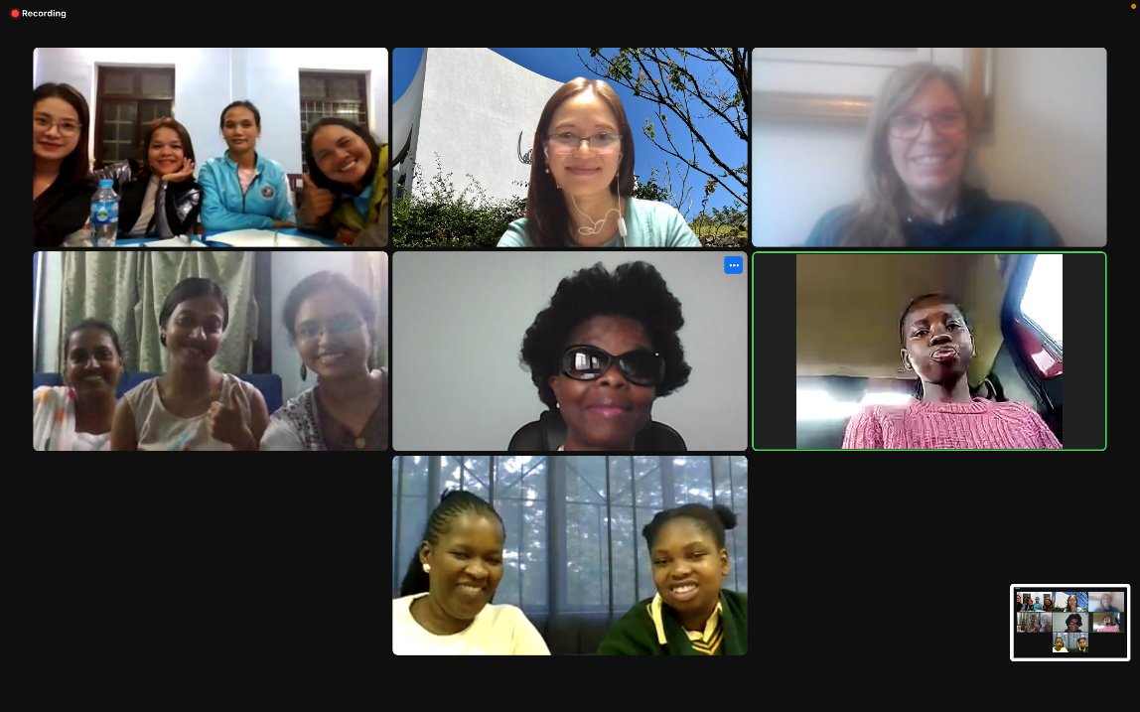
Photo 8: A screenshot of our YLC October virtual meeting, including participants and their support persons from South Africa, India and Vietnam, as well as Project Director Thuy Nguyen and Project Coordinator Dana Corfield.
For more detailed information about the Youth Leadership Circle events, please visit - https://carleton.ca/fass/2023/06/learning-with-and-from-the-global-south/ or https://carleton.ca/ddsc/category/youth-leadership-circle-engage/

OTHER NEWS
Review of Disability Studies: Contribution to RDS’ Special Edition from the ENGAGE team
Building on DDSC’s panel discussion about decolonial disability work within the Global South at the April 2022 Society for Disability Studies conference, ENGAGE Project Director Xuan Thuy Nguyen and colleagues Shilpaa Anand and Alexis Padilla are guest editing a special issue of the Review of Disability Studies journal, titled ‘Conversations with/across the Global South: Towards Decolonial Disability Futurities’. This themed issue aims to create a decolonial platform for researchers and activists across the Global North and South to revisit, reclaim, and re-imagine their stories through the lens of decolonial and anti-ableist futures.
ENGAGE team members Xuan Thuy Nguyen (Project Director), Nhi Truong (Research Assistant, Vietnam) and Dana Corfield (Project Coordinator) have also submitted an article for the special issue. Titled ‘Organizing the Youth Leadership Circle: Lessons Learned across Southern Spaces’, this article offers a critical reflection on the experiences gained working with the Youth Leadership Circle participants in the ENGAGE project.
DDSC Webinar
On October 23, 2023, the DDSC held its first webinar, “Developing Decolonial Partnerships with Disability Communities in the Global South: Perspectives from the South” using the Zoom platform.
This engaging event brought together three panelists - Jace Nair (CEO of Blind South Africa), Dr. Shilpaa Anand (Associate Professor, Birla Institute of Technology and Science Pilani), and Dr. Alexis Padilla (disabled Latinx lawyer, sociologist and visiting professor at the University of MO St. Louis) - in a dialogue to explore the challenges and opportunities of fostering inclusive, decolonial partnerships with disability communities in the Global South. Approximately 45 participants from around the world attended the webinar and learned from the lively discussion. We hope that this will be the beginning of an ongoing conversation and continued network building for all those who participated.

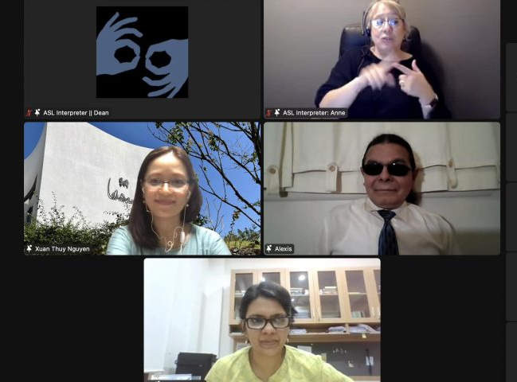
Photo 9: A screenshot from the webinar including the images of speakers Alexis Padilla and Shilpaa Anand, Project Director Thuy Nguyen, and two sign language interpreters.
ENGAGE Meetings
Throughout the year we have continued to hold regular research stream meetings, country-based partnership meetings, as well as a full partnership meeting and regular coordination meetings with our research assistants.
For example, in August 2023, we held our annual full partnership meeting, during which we reviewed our progress and future direction, and we held in-depth discussions about our experiences so far.
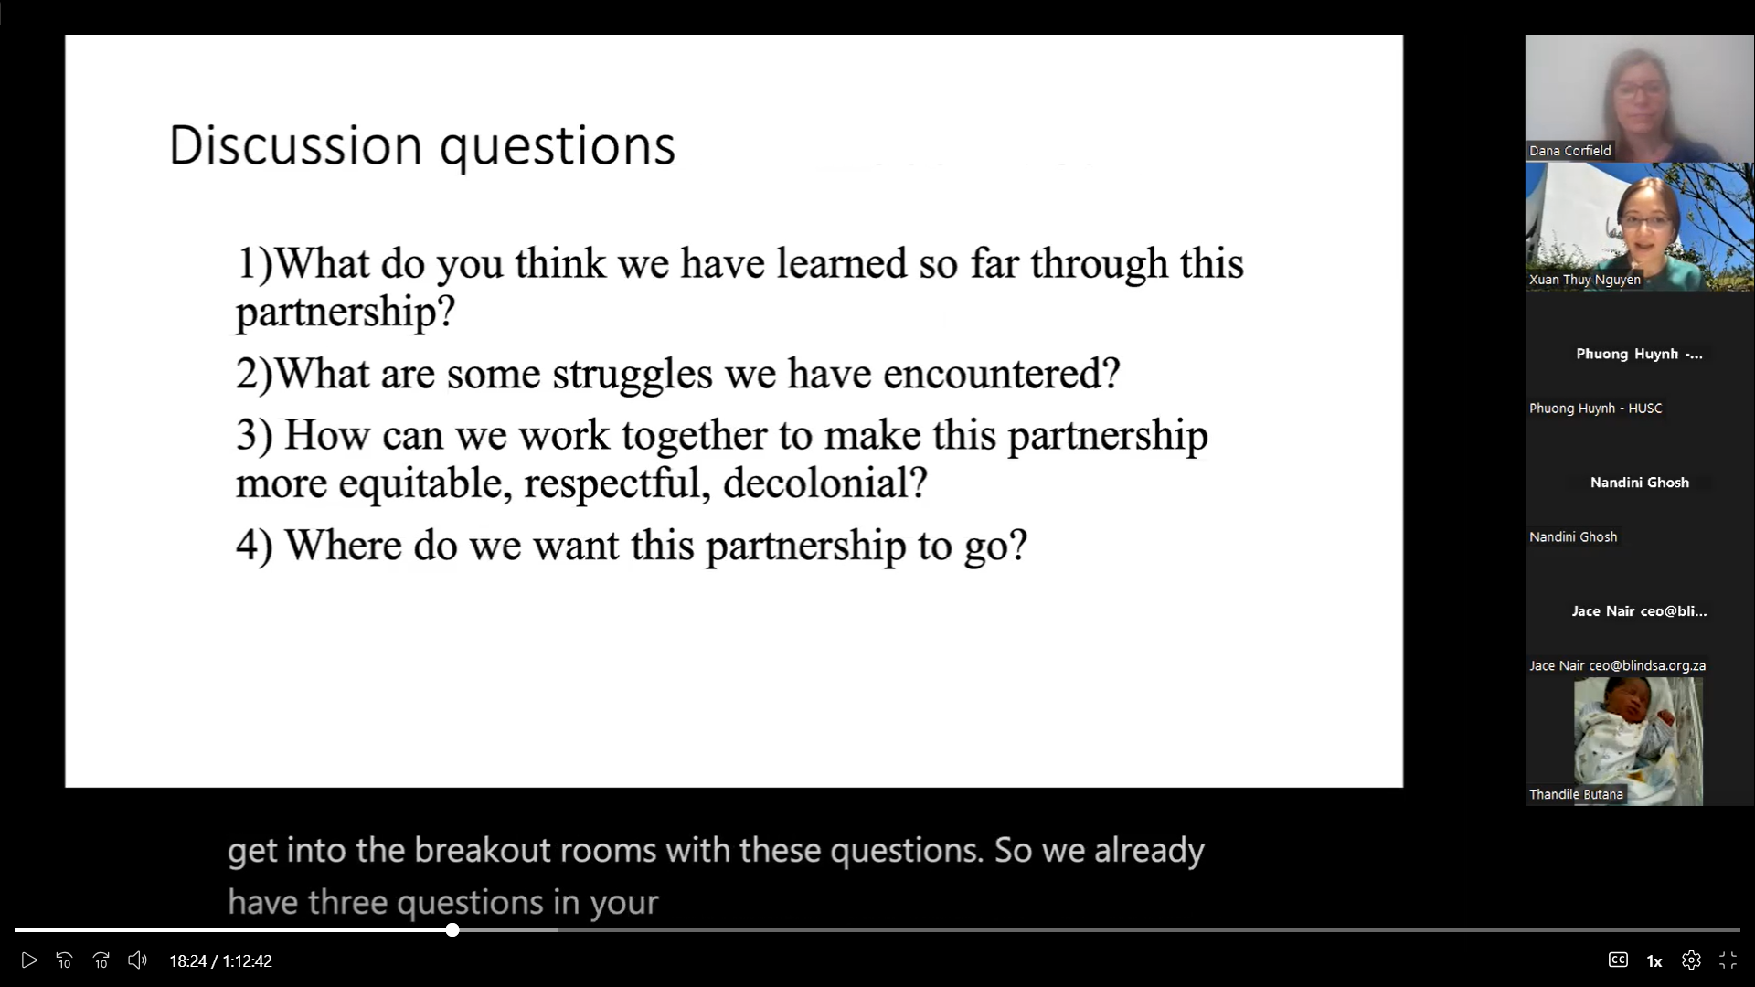
Photo 10: A screenshot from our August partnership meeting, including a list of discussion questions for breakout groups to reflect on.
Welcome and Thanks
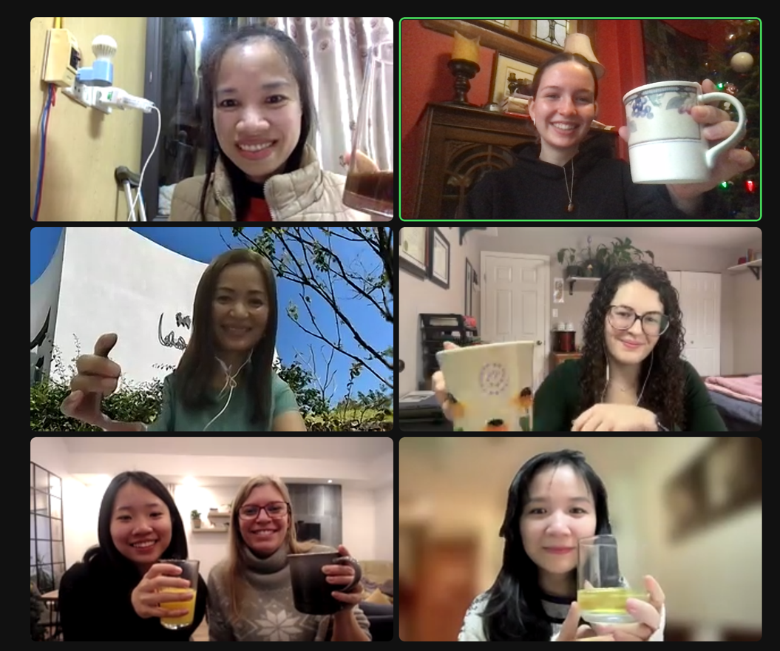
Photo 11: A screenshot of our virtual year-end party for ENGAGE Carleton staff and research assistants
We are pleased to introduce two new members of our team, Jessica McCarthy from Carleton University and Phuong Mai Anh Tran from the University of Ottawa. Jessica and and Phuong join us as research assistants based in Ottawa.
We would also like to express our gratitude to Asaki Perera and Martha Roblin for their great work and support this year, and we wish them the best with their future endeavors.
Summary of Supplementary Data on Issues in relation to the Initial Report of Vietnam on the Implementation of the Convention on The Rights of Persons with Disabilities
The DDSC has released a Summary of Supplementary Data on Issues in Relation to the Initial Report of Vietnam on the Implementation of the Convention on The Rights of Persons with Disabilities (CRPD). This report addresses the inquiries of the Committee on the CRPD for additional information regarding the Vietnamese government’s progress in implementing the CRPD. The report draws data from the Engendering Disability-Inclusive Development (EDID Vietnam) project and our previous research. The findings highlight that women and girls with disabilities in Vietnam face multiple barriers in education, public transport, employment, and social services. Despite the assumption of their inclusion in national programs and policies, our research indicates that the intersections of disability, gender, ethnicity, age, and geographical locations continue to create significant obstacles for their participation in these programs.
The English and Vietnamese versions of the report are available at:
[English] Summary of The Supplementary Report on CRPD Implementation https://carleton.ca/ddsc/wp-content/uploads/English-Summary-of-The-Supplementary-Report-on-CRPD-Implementation.pdf
[Vietnamese] Supplementary Report on CRPD Implementation: https://carleton.ca/ddsc/wp-content/uploads/Vietnamese-Supplementary-Report-on-CRPD-Implementation.pdf
Partner News
Breaking barriers to amplify the voices of visually impaired youth – Blind SA, South Africa
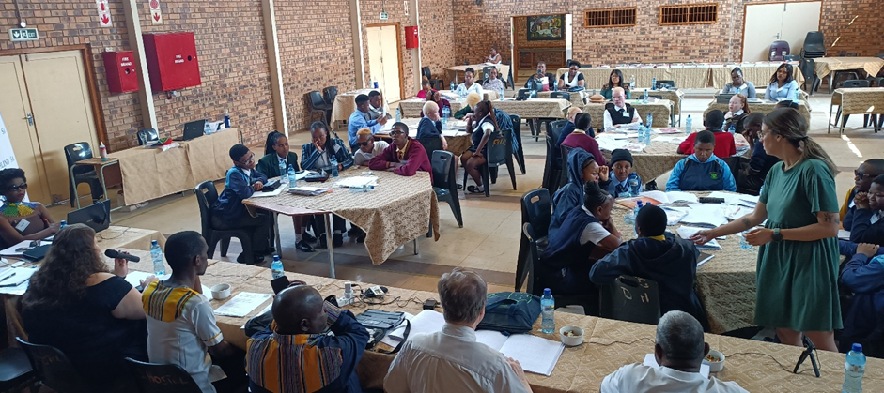
Photo 12: Visually impaired youth at the National Youth Parliament.
History unfolded when Blind SA commenced the first-ever National Youth Parliament on 23 September 2023 in South Africa. 14 schools from 7 provinces came together to robustly debate issues that affect the lives of visually impaired youth, socially, politically, academically, and otherwise.
The students were divided into commissions to discuss key issues, which they then debated with the larger group. The inaccessibility of economic opportunities for blind youth, the lack of competency of educators to teach blind learners, stigma and discrimination against blind youth when accessing job opportunities all emerged as important topics. Parliamentarians also highlighted issues related to mental health and the impact of COVID-19 on accessing sexual reproductive and other healthcare services.
Many thanks to the educators and other support staff who were very proactive and supportive to the Blind SA team, ensuring that parliamentarians were emotionally calm and prepared to debate issues affecting their lives and to interact with others throughout the programme.
__________________________________________________________________
What’s coming in 2024?
- Additional fieldwork and reflective workshops at each site to strengthen and support the participants’ agendas, leadership skills and networking.
- Community engagement and film screening at each site.
- Outputs such as policy briefs and a project report.
Acknowledgements
Our partners and collaborators
A Luoi Blind Association (Vietnam)
Blind South Africa (South Africa)
Disabled Women’s Network of Canada (DAWN; Canada)
Shanta Memorial Rehabilitation Centre (SMRC; India)
University of Sciences, Hue University (Vietnam)
Carleton University (Canada)
Western Sydney University (Australia)
Our team members
Xuan Thuy Nguyen
Nandini Ghosh
Deborah Stienstra
Claudia Mitchell
Bonnie Brayton
Reena Mohanty
Asha Hans
Nilika Mehrotra
Jace Nair
Thandile Bhutana
Duy Van Nguyen
Phuong Huynh
Vo T. Hoang Yen
Katie Aubrecht
Karen Soldatic
Hannah Dyer
Valérie Grand'Maison
Suchandra Bhaduri
Mayurika Chakravorty
Dana Corfield
Linh Dang
Hoa Bui
Nhi Truong
Jessica McCarthy
Phuong Mai Anh Tran
Contact us
For more information, please contact Dr. Xuan Thuy Nguyen (Project Director) at
xuanthuynguyen@cunet.carleton.ca, or Dana Corfield (Project Coordinator) at
danacorfield@cunet.carleton.ca

Reference
de Sousa Santos, B. (2018). The End of the Cognitive Empire: The Coming of Age of
Epistemologies of the South. Duke University Press. http://www.jstor.org/stable/j.ctv125jqvn

