Field worK_ ENGAGE 2023

Date: 28.10.2023-29.10.2023

# OBJECTIVES

* To create a space for disabled youth leaders to share knowledge and experiences about the Youth Leadership Circle (YLC) with the local women and girls in their community.
* To build and mobilize leadership and activist skills with young women and girls with disabilities through collective organizing and knowledge-sharing.
* To engage the participants in taking action in community organizing through the process of network building.

# main activities

* The youth leaders reported on their participation into and the results of the YLC workshop with other young women and girls with disabilities in A Luoi. They shared information about the activities organized and the issues discussed at the YLC. They also shared lessons learned from their participation. Furthermore, young women and girls with disabilities in A Luoi discussed the effective application of knowledge gained from the workshop in their local context.

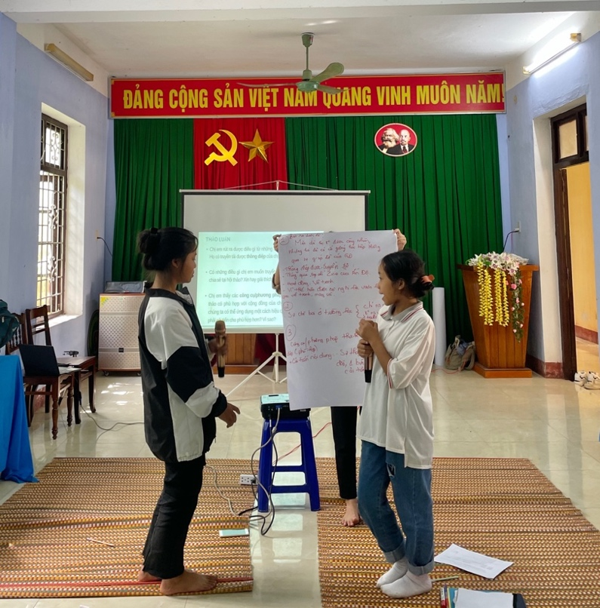

Figure 1: Two girls presented their reflection on the lessons learned from the YLC workshop.

* Zine making: Through a topic titled “Bringing about changes,” young women and girls with disabilities in A Luoi discussed the issues that need to be addressed through the creative production of a magazine, covering topics such as employment, verbal violence, school, and community inclusion. Participants envisioned their roles in collaborating to create a better world for women and young girls with disabilities.

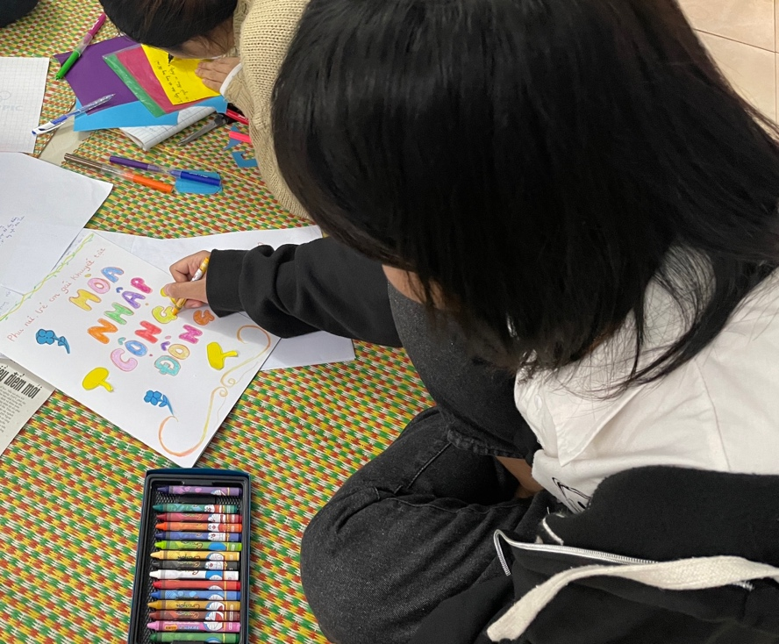

Figure 2: A girl with disabilities was making a zine titled “Community inclusion”.

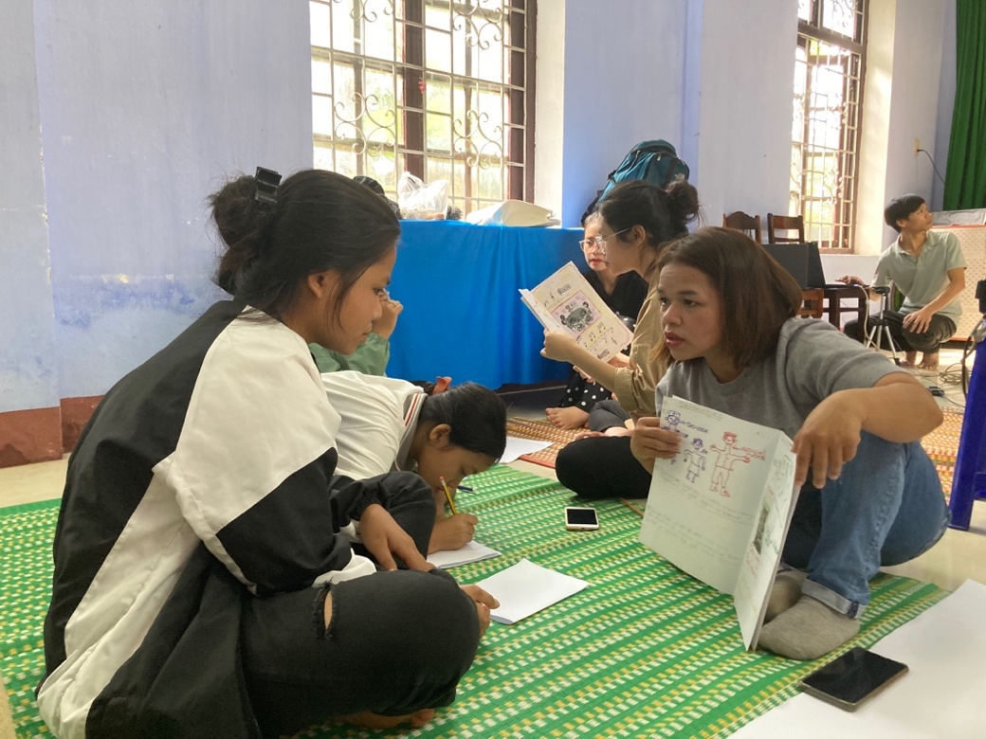

Figure 3: A girl and a woman with disabilities sharing their stories through zine-making*.*

* Drawing on the manifesto of the representative group from the YLC workshop regarding the establishment of a Club for women and girls with disabilities, all the participants collectively developed specific plans and activities. In particular, they focused on promoting the roles and effective participation of girls with disabilities in the club's activities.

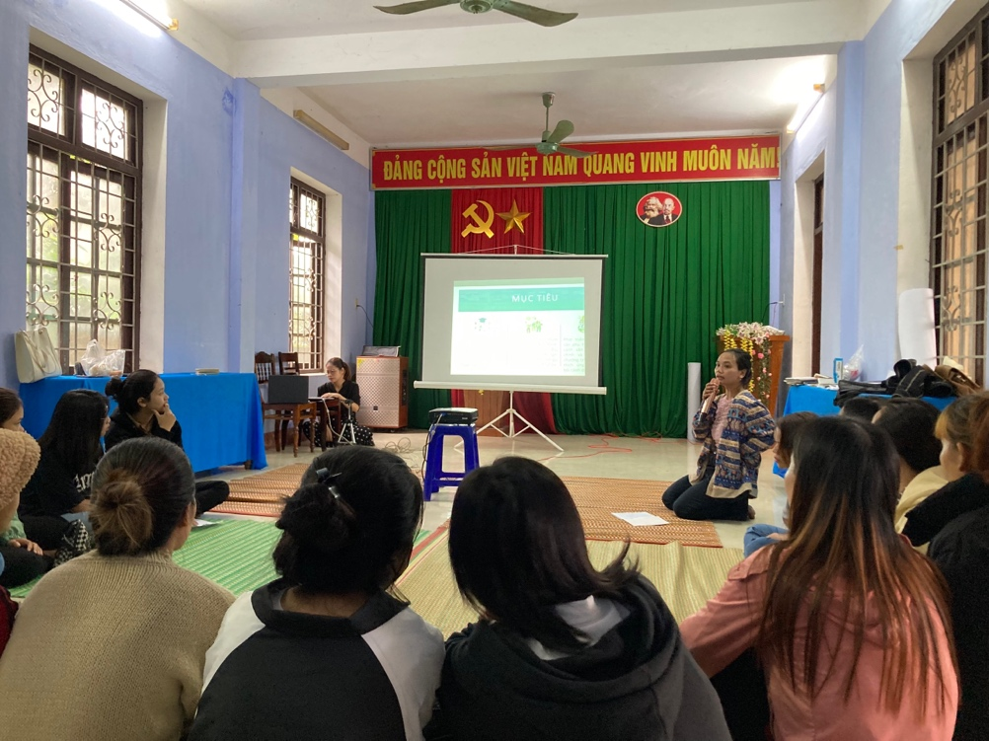

Figure 4: A youth leader presenting her learning experiences from the YLC.

# outcomes

Through their active engagement in collective organizing, the youth leaders gradually took on a leadership role, transitioning from their primary role as participants to organizers of their own community activities. This leadership development approach not only empowered the youth leaders but also enhanced their leadership responsibilities within the team. This reflects a process of building trust and relationship between researchers and community members, contributing to the development of the effective learning environment.

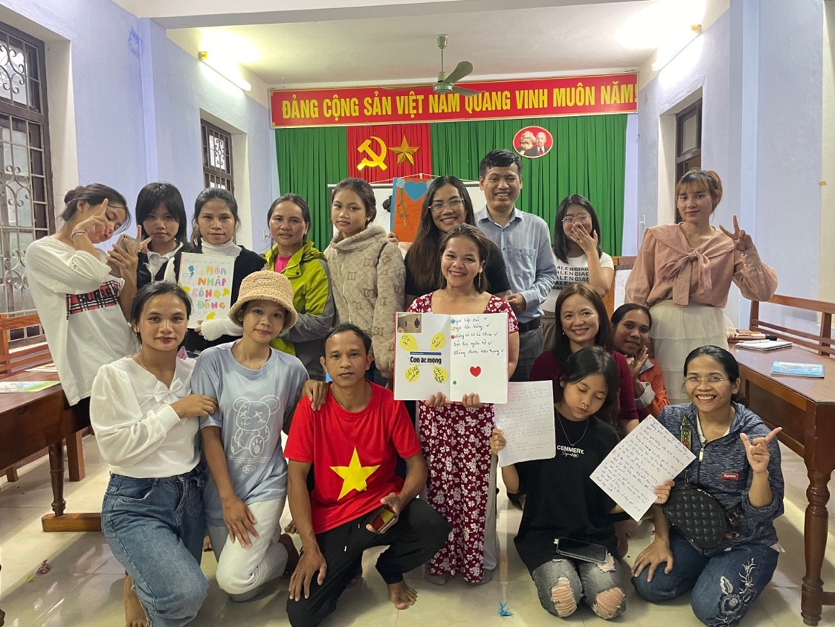

Figure 5: A group photo of the women and girls with disabilities, the representatives of A Luoi Blind Association, and the research team.