An Automated External Defibrillator (AED) is a device that automatically analyzes heart rhythms and advises the operator to deliver an electric current if the heart is in ventricular fibrillation, an otherwise fatal rhythm. No special training is required to operate an AED.
As part of the Ottawa Paramedic Service’s Public Access Defibrillator (PAD) program, Carleton University has acquired 40 AEDs. Their locations are indicated below.

AEDs On Campus
Building | Location
Architecture Building | 2nd Floor  Located up one flight of stairs from the main entrance. | 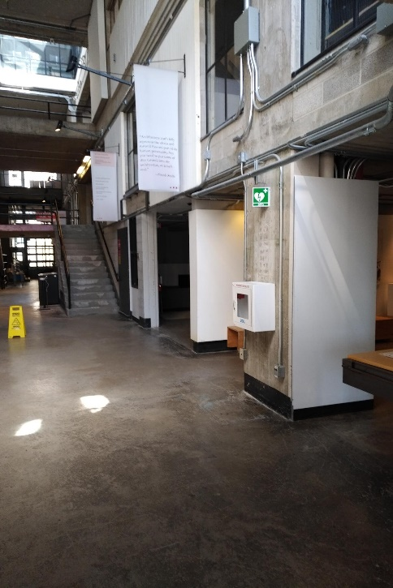
ARISE  Building | Main L4 Entrance  Located next to ARISE 4002 near the main L4 entrance for the building. | 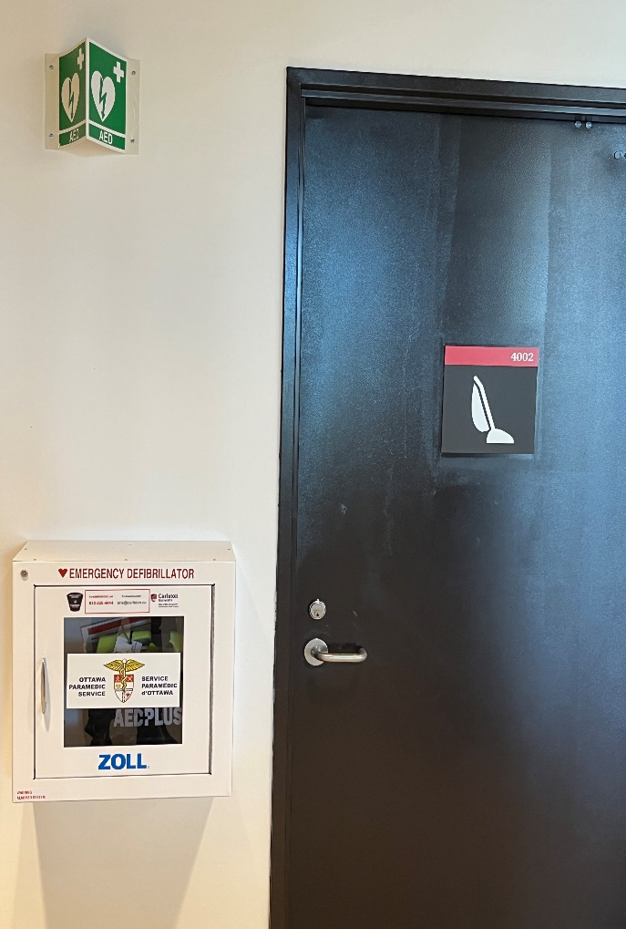
Athletics  Fitness Centre | 2nd Floor  Located near the front desk. | 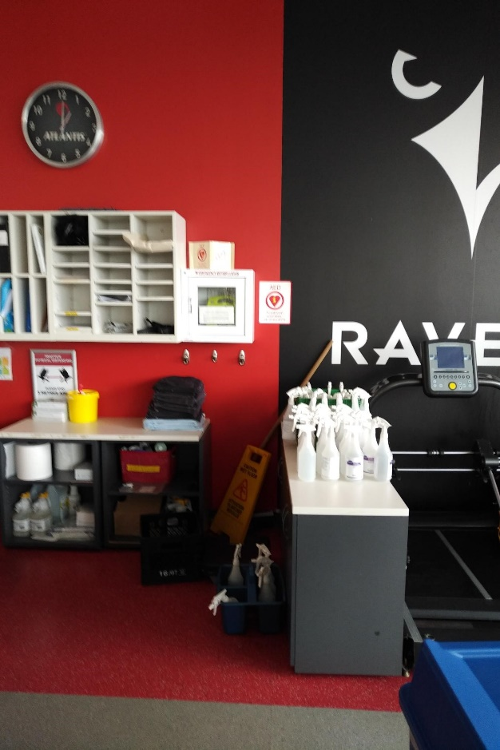
Athletics  Pool | 2nd Floor  Located  outside of the pool area. | 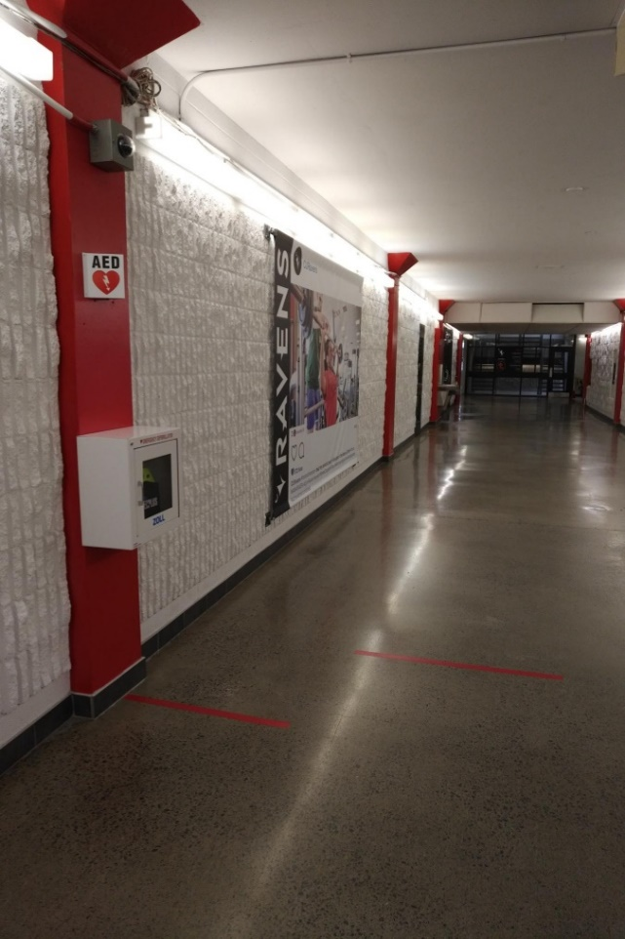
Athletics  Welcome Centre | 1st Floor  Located immediately inside the  doors leading from the Welcome  Centre to the main facility | 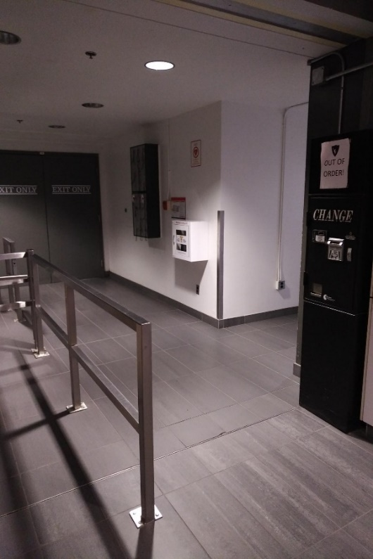
Azrieli  Pavilion | 2nd Floor  Located in the hallway near  the elevators. | 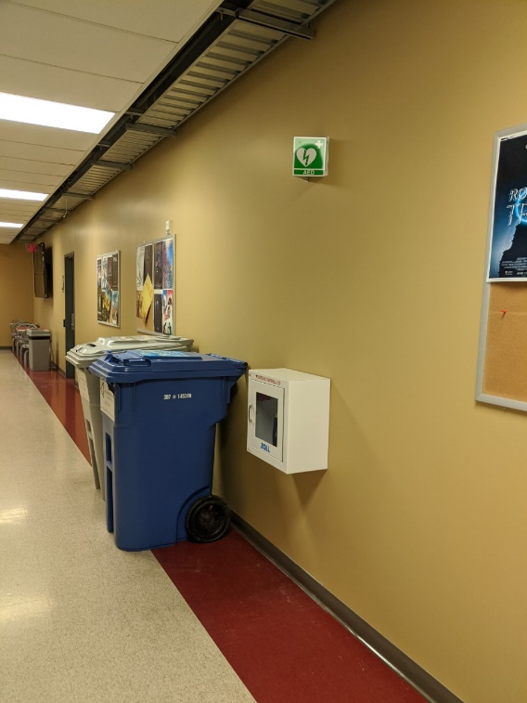
3Azrieli  Theatre | 1st Floor  Located in the hallway  between theatres 101 and 102. | 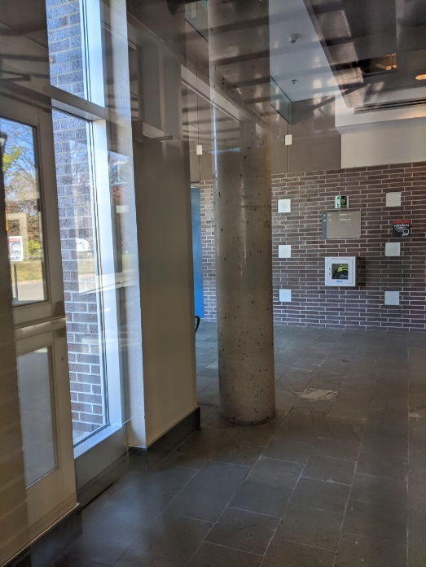
Canal  Building | 2nd Floor  Located  directly inside  of the  entryway  facing the University Centre. | 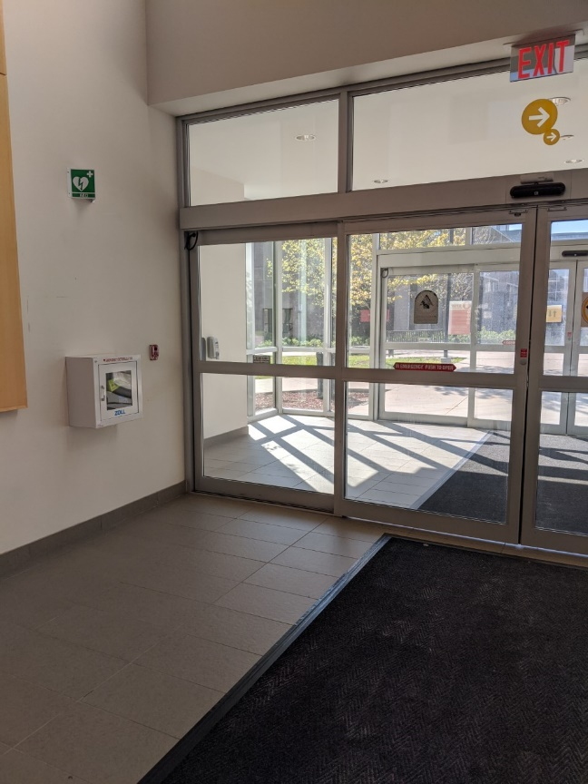
Carleton Dominion Chalmers Centre | 2nd Floor  Located in the lobby near the parking lot entrance on Lisgar Street. |   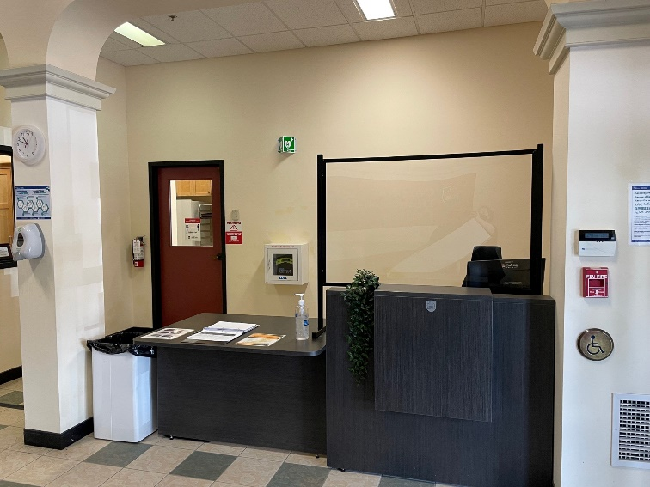
CTTC  Building | 2nd Floor  Located  directly outside of Health Services,  beside the fire hose cabinet. | 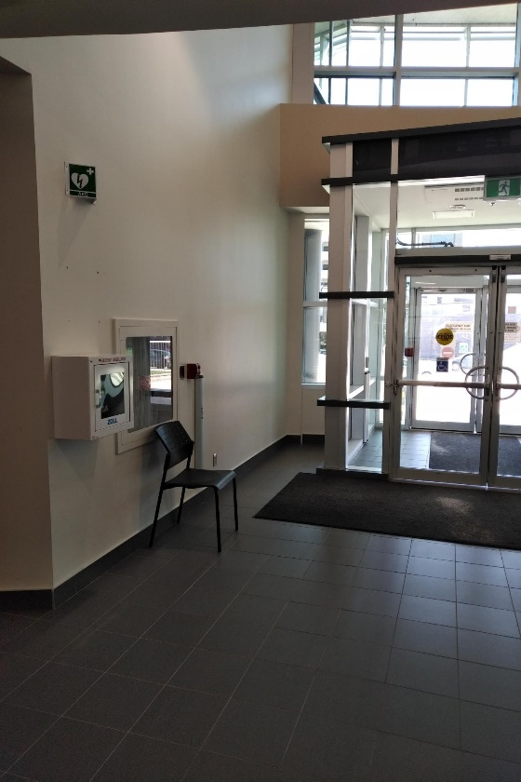
Dunton  Tower | 2nd Floor  Located near the elevators. | 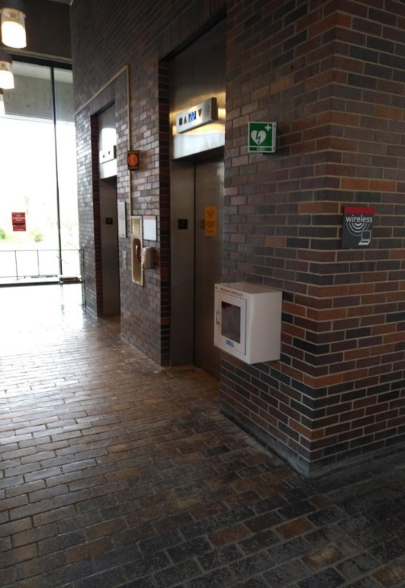
Dunton  Tower | 20th Floor  Outside DT 2017 | 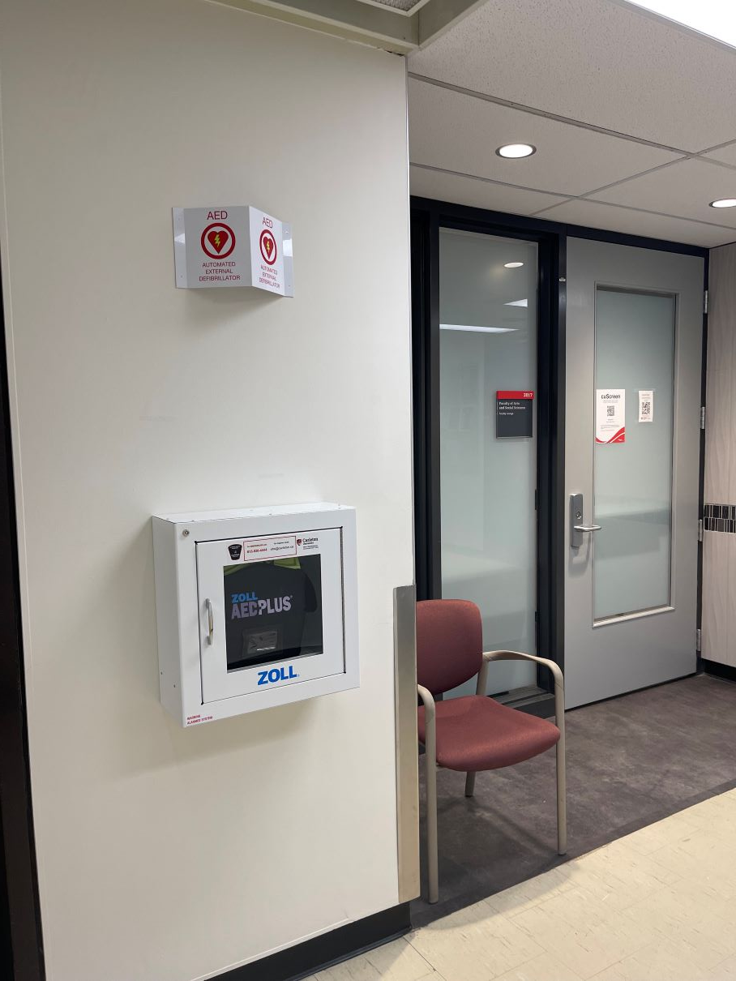
Tennis Bubble | Inside Main Door | 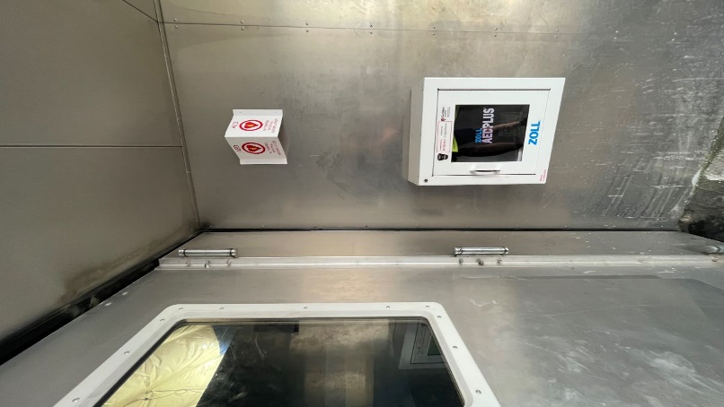
Fieldhouse | Main Level  Located near the entrance, beside emergency phone line. | 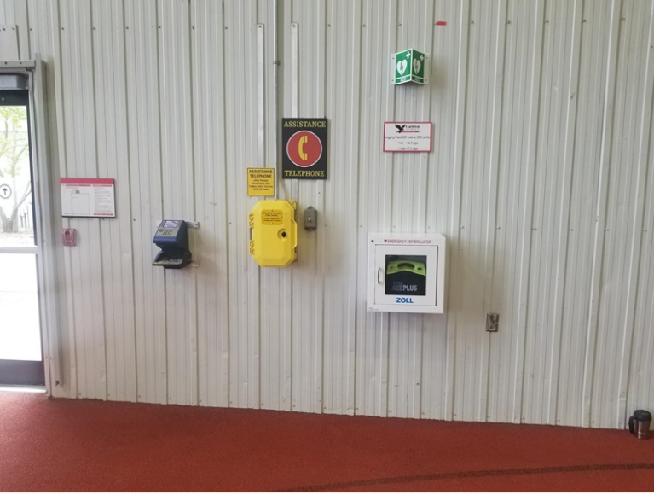
HCI – VSIM | Located in the hallway connecting HCI to VSIM near Stairwell 2C. | 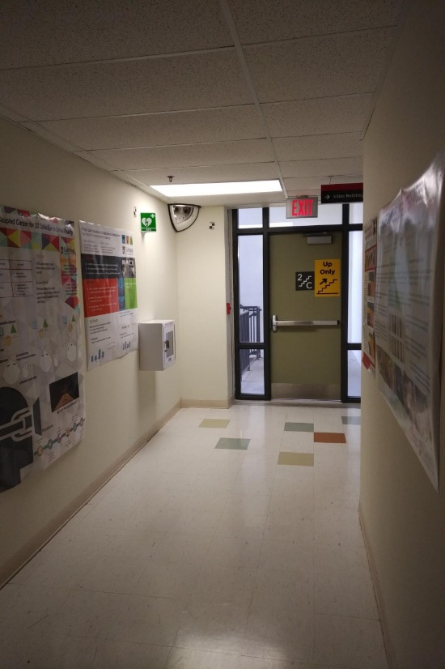
Health  Science Building | 1st Floor  Located in the main lobby  area, next to  the fire hose cabinet. | 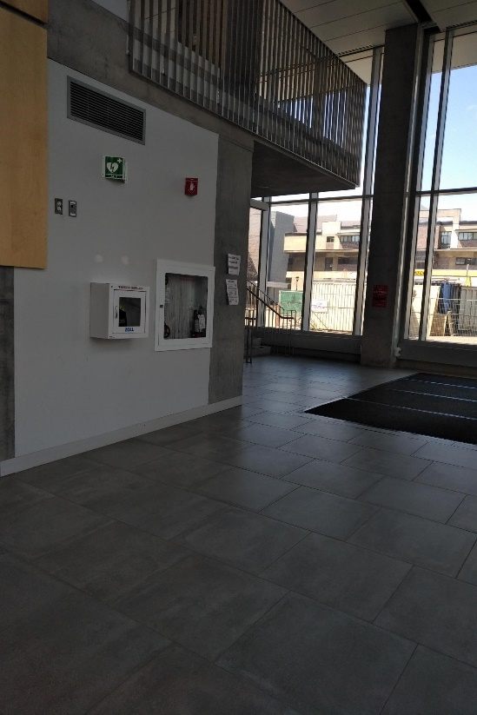
Herzberg  Building | Main Floor  Located to the right of the entrance near the washrooms. | 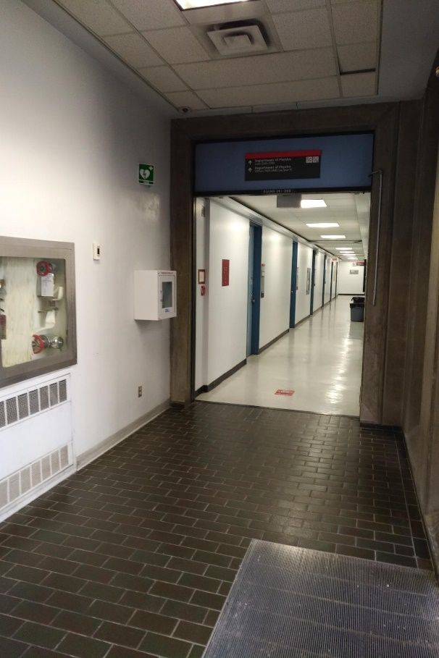
Ice House  Lobby | 1st Floor  Located on the wall near the emergency phone line. | 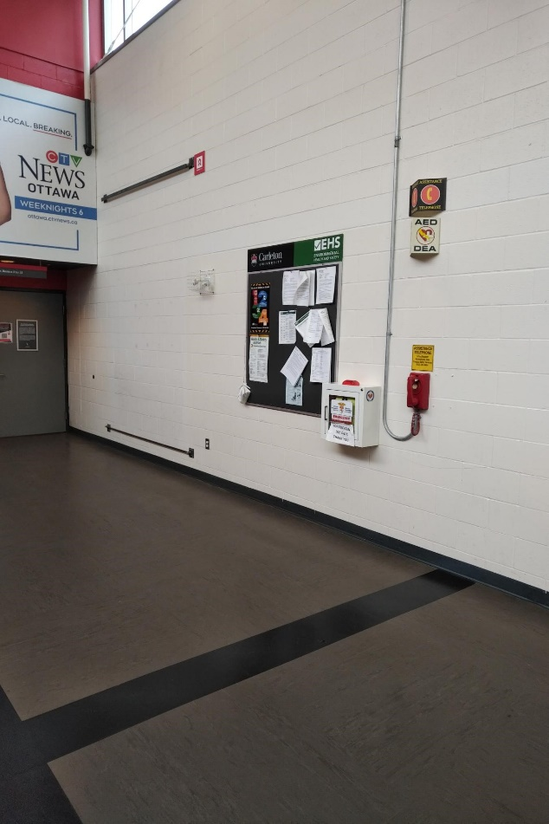
Ice House  Rink A | 1st Floor  Located near the tunnel to  the locker rooms. | 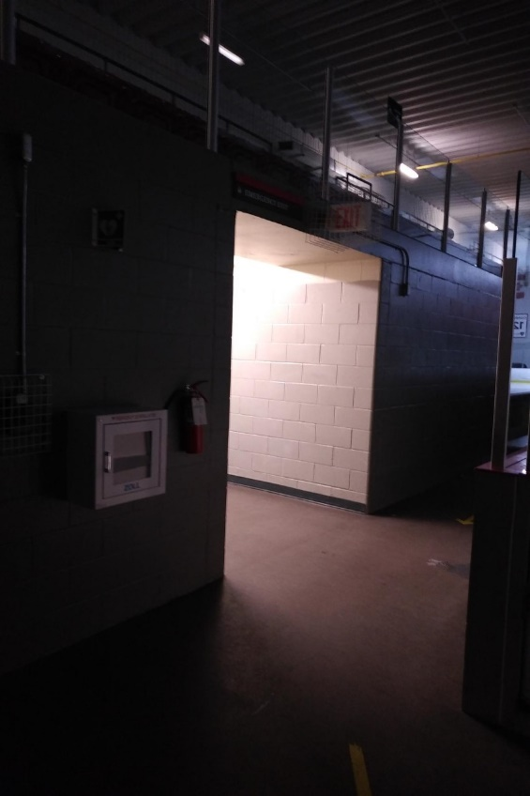
Ice House  Rink B | 1st Floor  Located between the home and  away benches. | 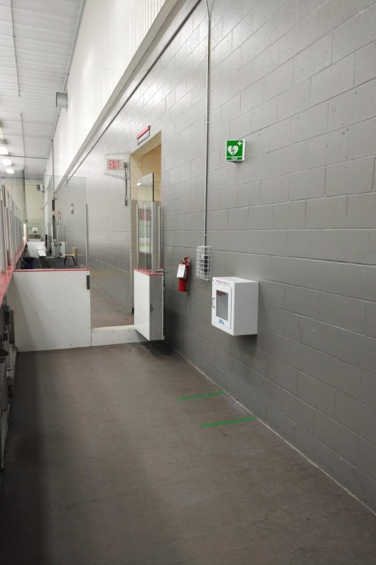
Leeds Residence | 2nd Floor  Located in the foyer across from the elevators. | 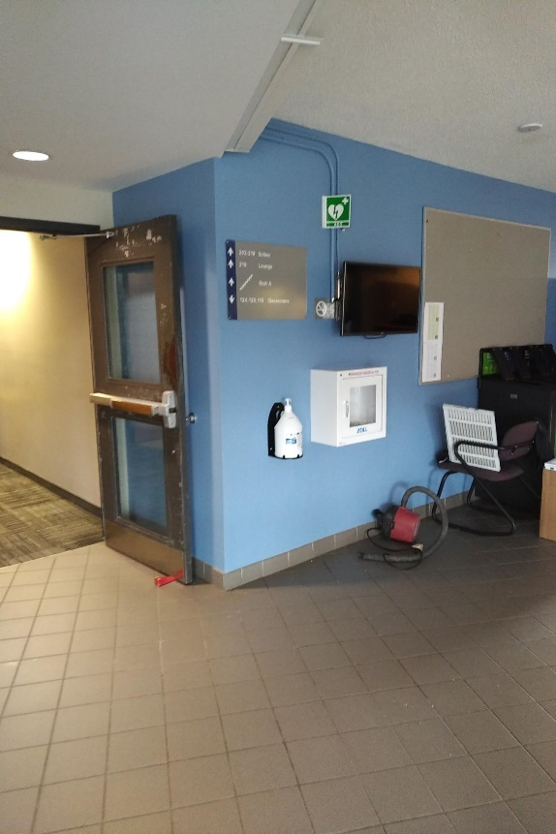
Loeb  Building | 2nd Floor  Located near the elevators and universal washroom. | 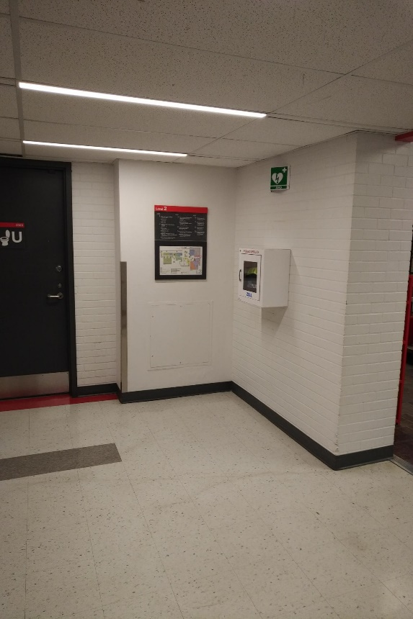
Mackenzie  Building | 2nd Floor  Located immediately adjacent to  the recycling station at the entry to  section  2420-2499. | 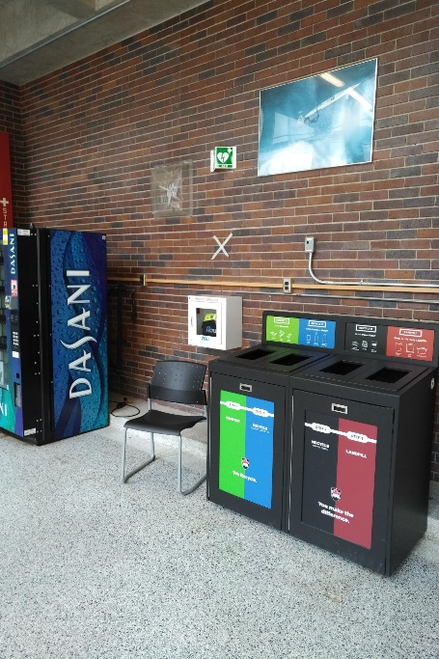
Mackenzie  Building (EDC Wing) | Main Entrance Doors to EDC  Across from the elevator (ME 2nd Level) | 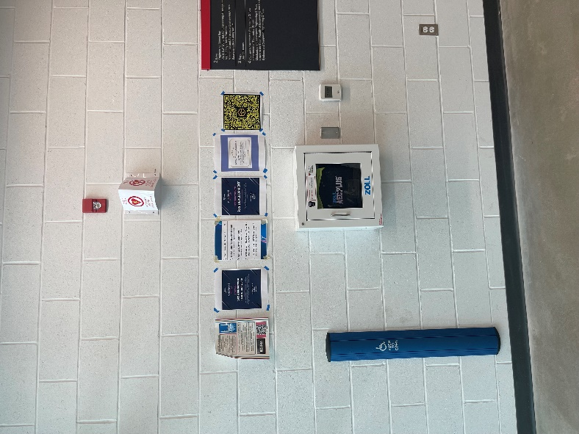
MacOdrum Library | 2nd Floor  Located between Stairwell A and the Help Desk. | 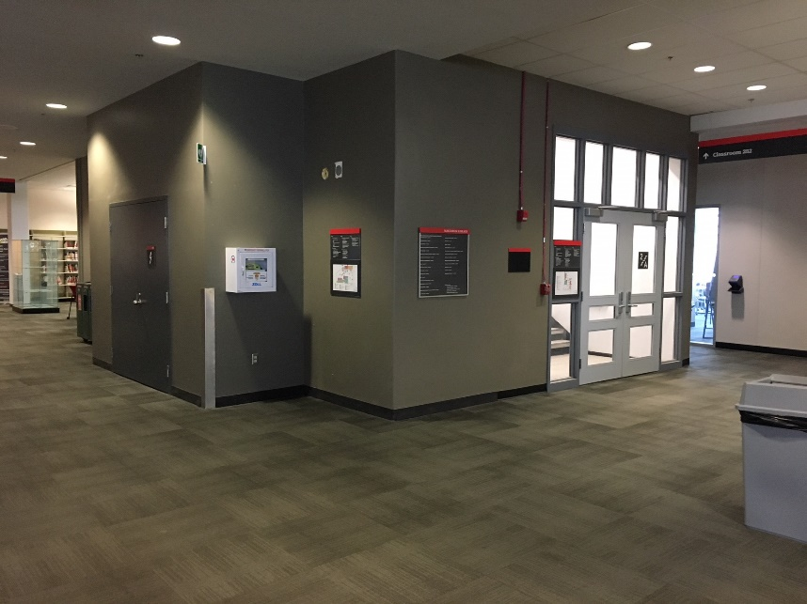
Maintenance Building | 1st Floor  Located  outside of the Central  Heating Plant, across from  the street entrance. | 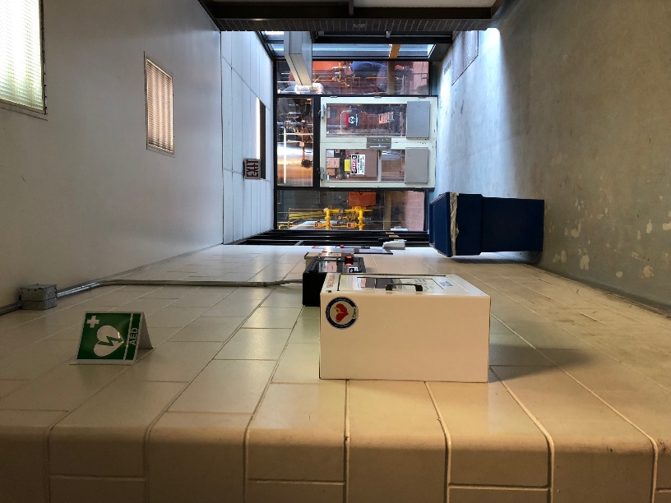
Maintenance Building  Minto Case | 2nd Floor  Across from main stairwell on the green wall.  2nd Floor  Located beside the elevators. | 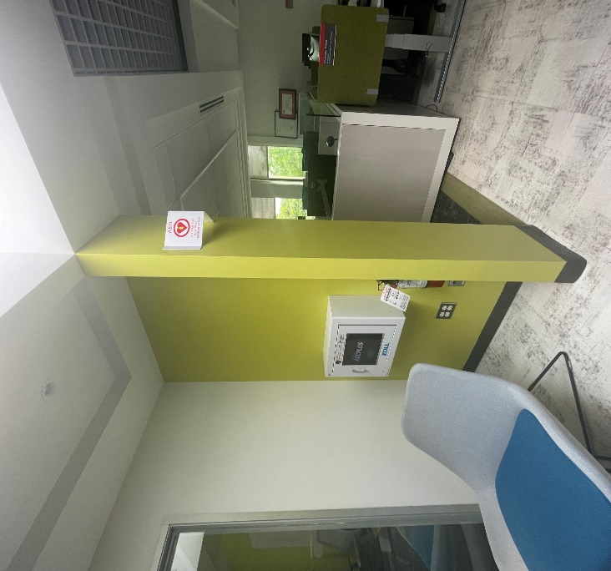  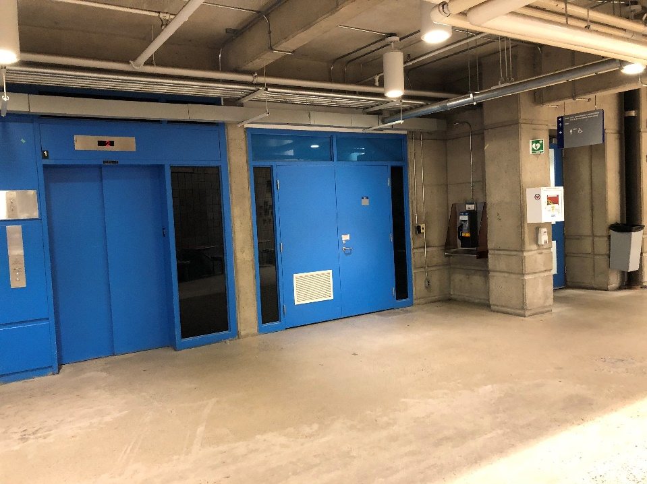
Nesbitt  Biology Building | 2nd Floor  Located near the Greenhouses directly outside of Stairwell B. | 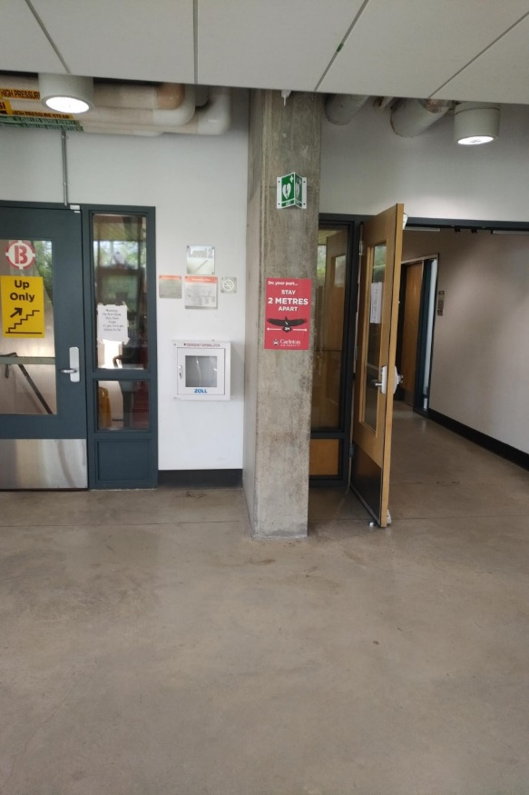
Nicol  Building | 1st Floor  Located beside Bridgehead, next to  the fire hose cabinet | 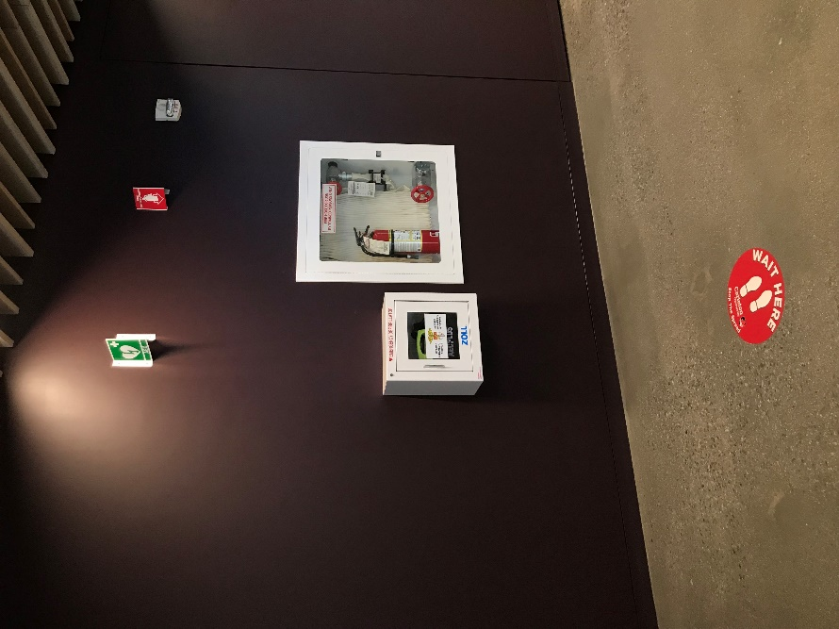
Paterson Hall | 2nd Floor  Located facing the Academic Quad near the Ojigkwanong Indigenous Student Centre. | 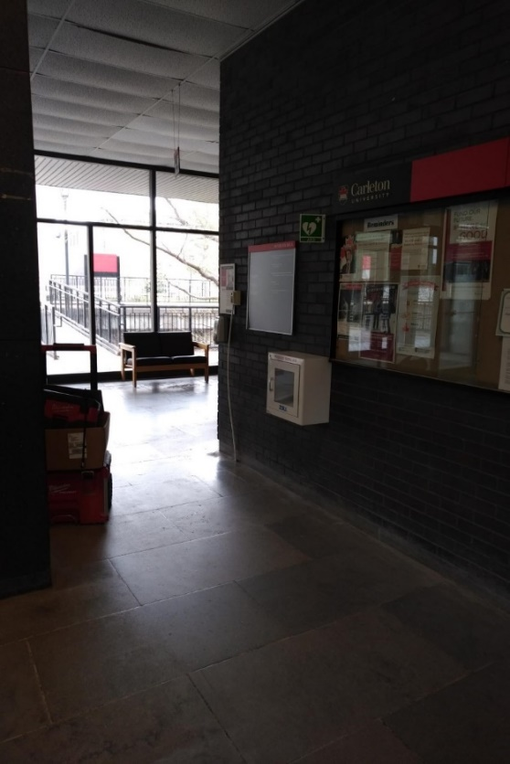
Prescott Residence | 2nd Floor  Located  outside of the entrance to the multipurpose room  (residence  gym). | 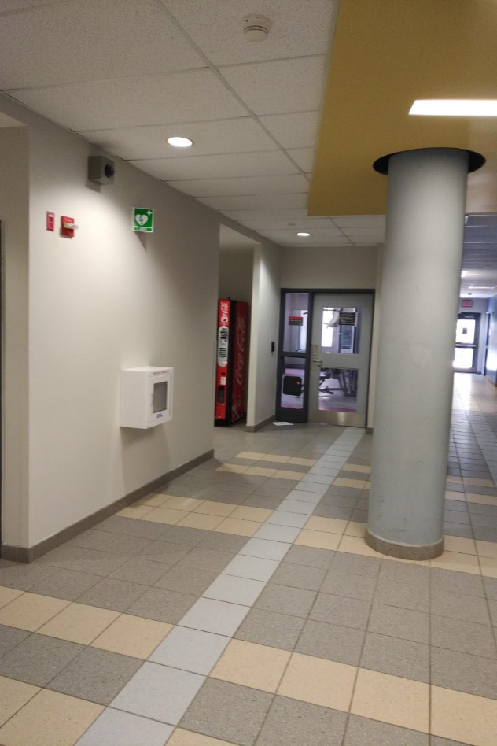
Raven’s  Roost | Located near the main entrance by the washrooms. | 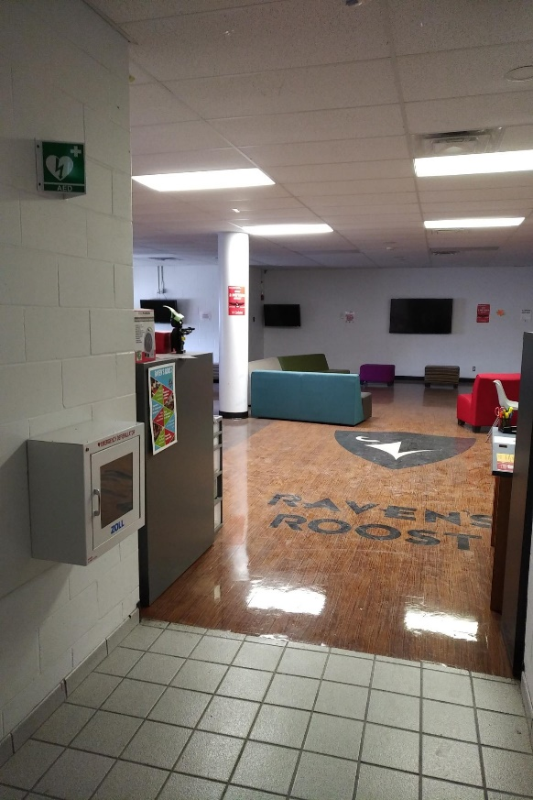
Renfrew Residence | 1st Floor  Located outside of the nurses’ station near Stairwell 1B. | 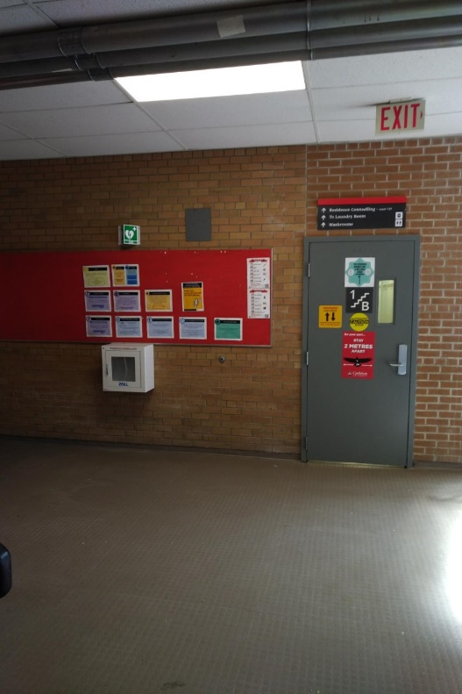
Teraanga Commons | 2nd Floor  Located near the reception desk, beside Fenn Lounge and Starbucks. | 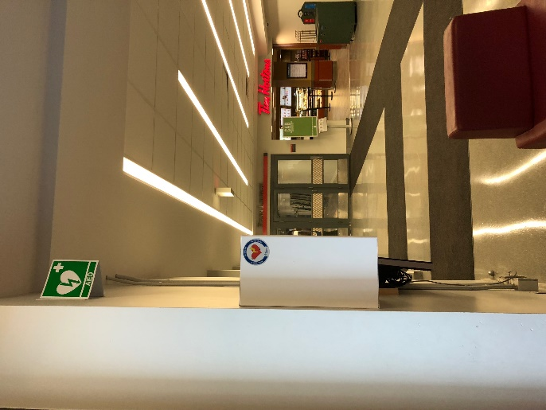
Teraanga Commons | 2nd Floor  Located directly outside of room 270. | 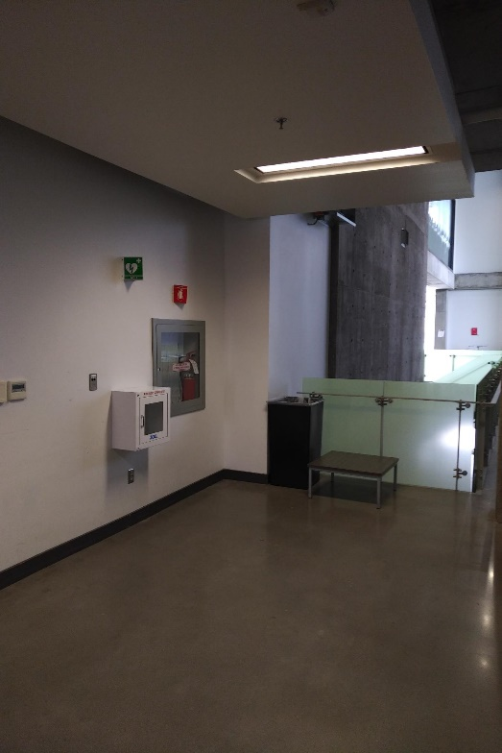
Teraanga Commons  The Caf | 3rd Floor  Located outside of the  manager’s  office near the front. | 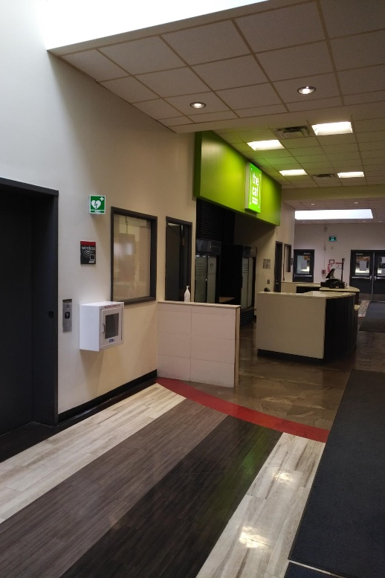
Richcraft Hall | 2nd Floor  Located on the wall bordering the patio in the Atrium, directly beside a fire hose cabinet. | 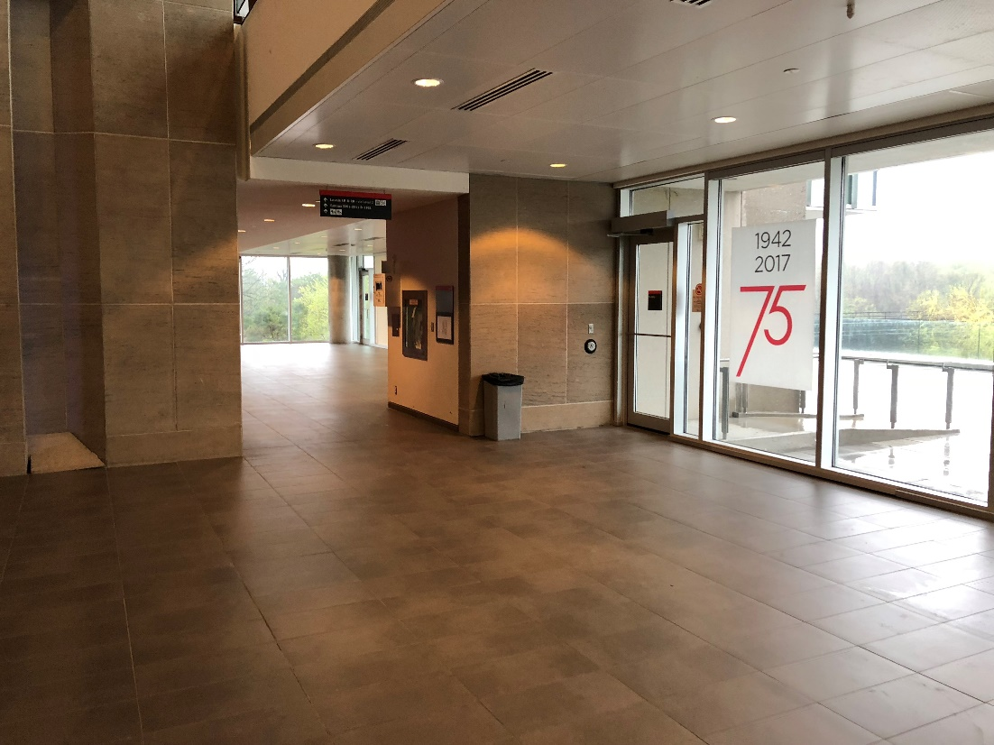
Pigiarvik | 6th Floor  Located in the elevator lobby next to room 602 (Senate Room). | 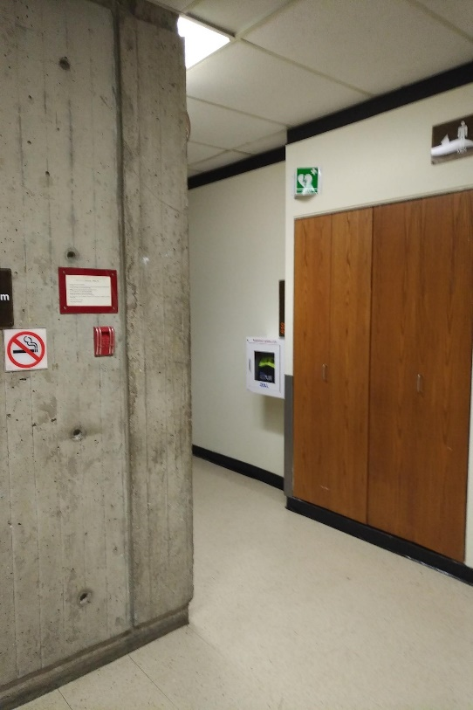
Pigiarvik | 2nd Floor  Inside front doors (main floor) | 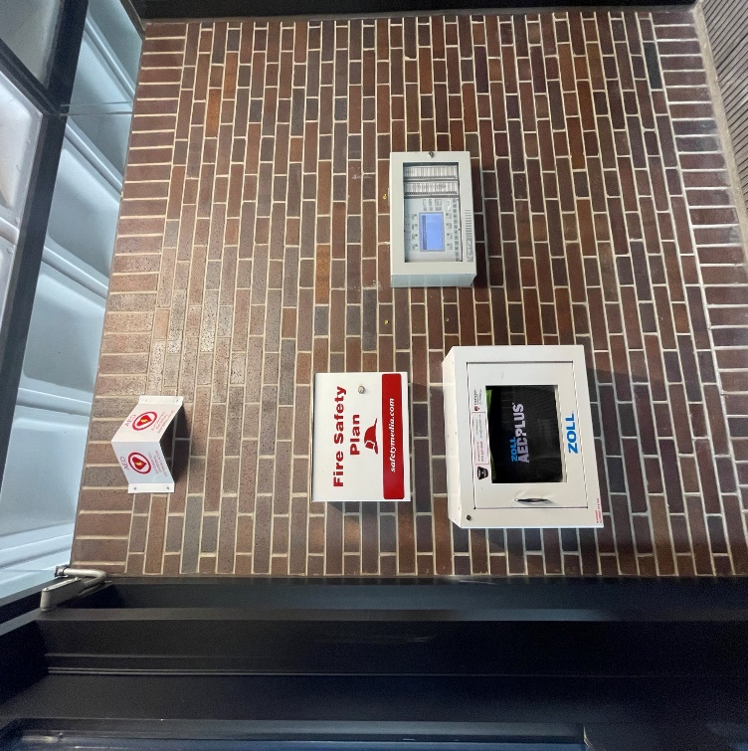
Southam Hall  Southam Hall | Tunnel Level  Located  outside of Theatre B,  in the lobby.  2nd Floor  Across from Kailash Mital Theatre | 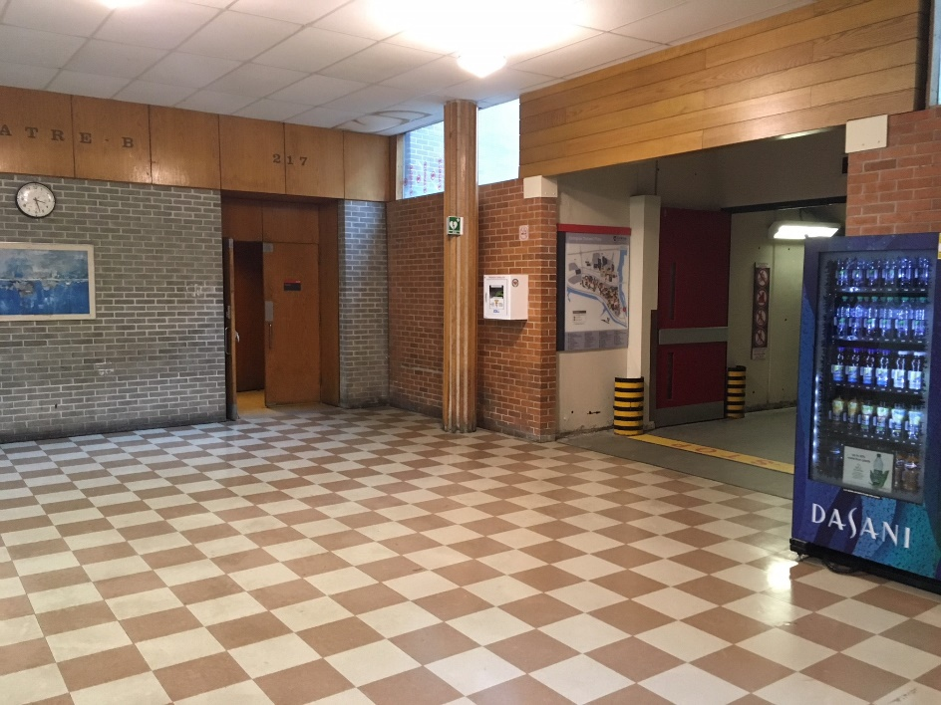  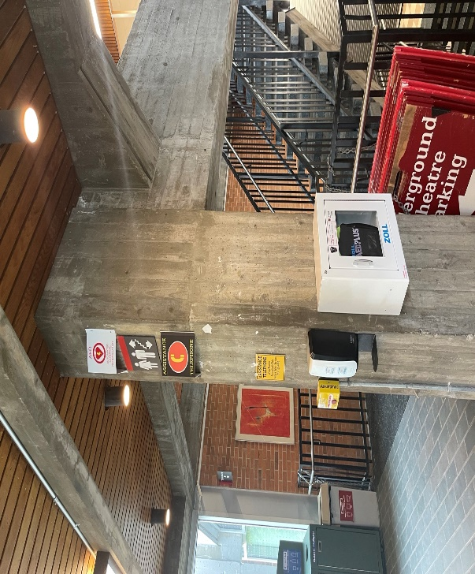
St. Patrick’s Building | 2nd Floor  Located by the Art Gallery,  on the wall by room 280B. | 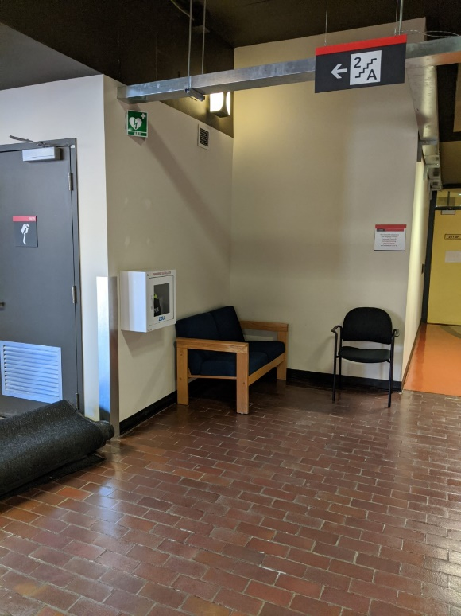
Steacie  Building | 1st Floor  Located directly across from  the main entrance door. | 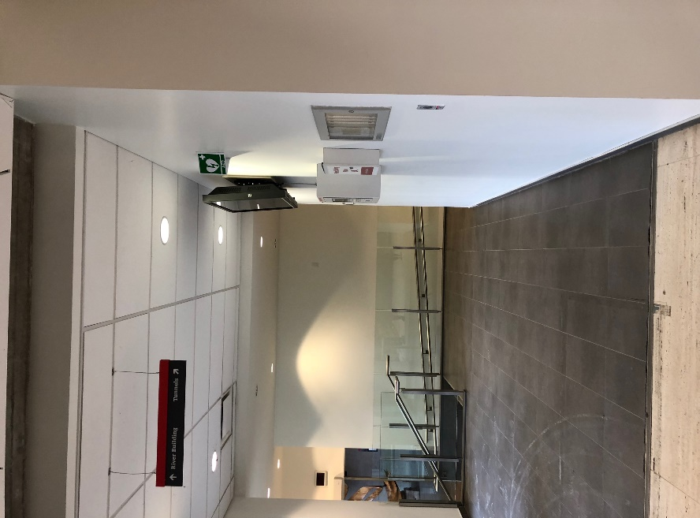
Tory Building  Tory Building | 3rd Floor  Located to the left of the Egg.  5th Floor  Outside Executive Offices adjacent to assistance phone. | 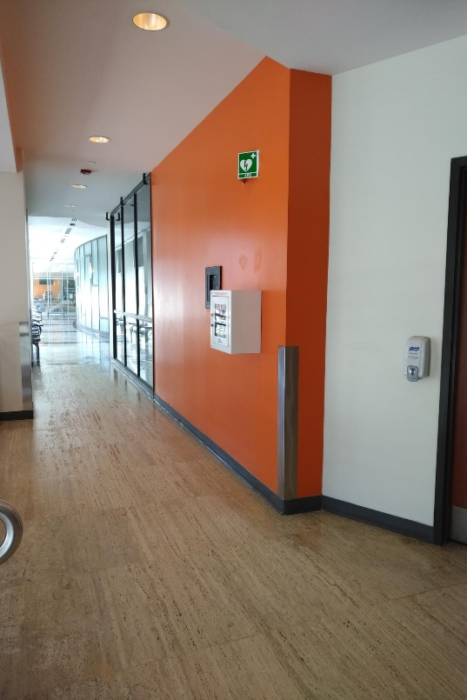  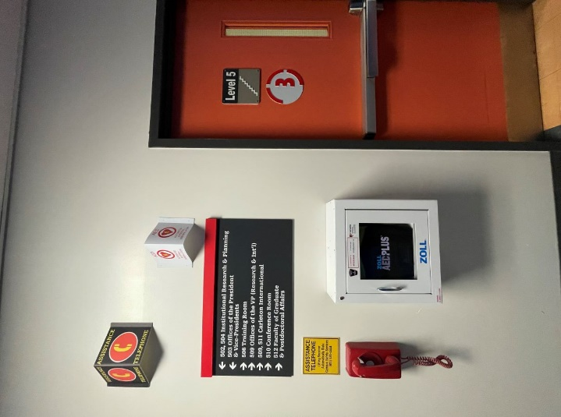
Nideyinan | 1st Floor  Next to quad side entrance/exit doors. | 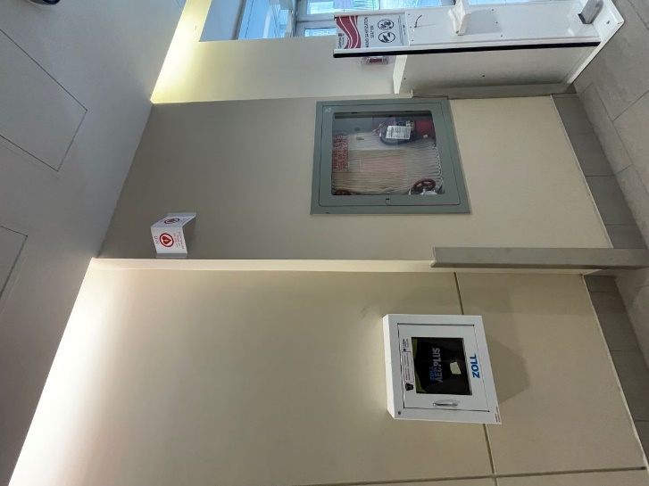
Nideyinan | 4th Floor  Located in the Galleria at the stairwell exit beside the wall of mirrors. | 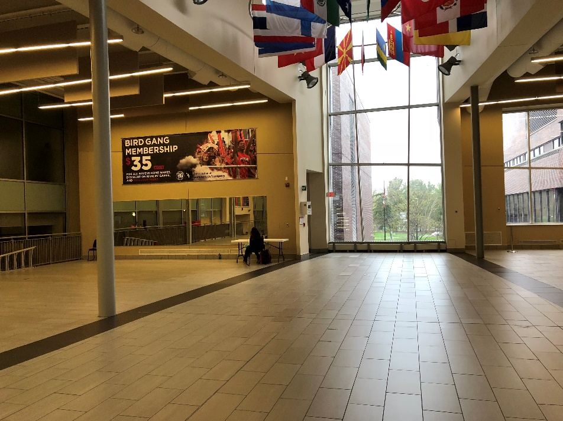
Social Science Research Building (SSRB) | Main Entrance  Next to fire panel. | 