Carleton University
Emergency Management and Continuity of Operations (EMCO) Program

Hot Work Program

-

Sponsoring Department: Department Of Risk Management
Signature Authority: Manager, EMCO
Approved: June , 2020
Version 2.0

Primary POC: Chad Thomison, Manager, EMCO, 613-218-4329
Chad.Thomison@carleton.ca
Executive Summary
The Hot Work Program was developed to help mitigate accidental fires due to hot work, as well as to lessen instances of accidental initiation of fire response due to false alarm(s) caused by hot work and/or dust-producing work. This guide provides a framework of the different components of the University’s Hot Work Program and how different departments across the University work together to ensure the safety of the Carleton community.
This guide provides an outline of how the Department of Risk Management and Facilities Management & Planning work with both internal and external contractors and technicians to prepare for hot work and dust-producing work. The process that is outlined ensures that Hot Work is conducted in a safe manner, while also ensuring that events that require emergency response activation are initiated in timely manner.
The Hot Work Program is based on relevant legislation, best practices, professional standards, and Carleton University’s capabilities.

Contents
1 Purpose 4
2 Scope 4
3 Applicable Regulations and Standards 4
4 Definitions 4
5 Responsibilities 5
5.1 Carleton University 5
5.2 Hot Work Supervisors 5
5.3 Carleton Project Representative 6
5.4 Electrical & Mechanical Managers 6
5.5 FMP Electricians 6
6 Restrictions on Permits 7
7 Procedure 7
7.1 Interior Spaces 7
7.2 Exterior Spaces 9
8 Hot Work Requirements 9
9 Permit Extension 11
9.1 Time Extension 11
9.2 Workspace Extension 11
10 Fire Watch and Signage 11
11 Communication 12
12 Monitoring 12
13 Accidental Alarms 12
14 Revision Control 12
15 Appendices 13
Appendix A: Process Flowcharts 14
Appendix B: Hot Work Permit Forms 20
Appendix C: Buildings with Zoned Devices 23

Purpose
The purpose of this procedure is to mitigate the risk of accidental fires associated with spark-producing or open flame work, to reduce the likelihood of false alarms, and to ensure that safeguards are in place for building occupants.

Scope
This program applies to the following type of work/activities performed in/on buildings and tunnel system at Carleton University:
- Any work that is “Hot Work” as defined in this document;
- Any work that is classified as dust or particulate producing;
- Any exterior or interior work that generates substantial vibration that could trigger a fire detection device; or Exterior work near fresh air intakes
- Any activity that requires the activation or draining of fire suppression systems.
NOTE: This program does not apply to smudging activities.

Applicable Regulations and Standards
- Occupational Health and Safety Act, R.S.O. 1990
- Regulations for Industrial Establishments, R.R.O. Reg. 851
- Ontario Fire Code, R.R.O. Reg. 213/07

Definitions
Building: Any structure on the Carleton University campus intended for occupant use.
Carleton Project Representative: A project manager/coordinator within the Facilities Management and Planning (FMP) group who oversees the project on behalf of Carleton University.
Dust Producing Work: Any work that can generate dust or particles that have the potential to trigger a smoke detector. Examples of such work include pressure washing, sanding, woodcutting, drywalling, or vapour generating.
FACP: Fire Alarm Control Panel
Fire Watch - Active: Active monitoring carried out by a qualified person in a dedicated role to identify hotspots or active fires while the fire system is isolated for the work area for 60 minutes after the completion of work or 180 minutes after the ceasing the application of hot surfaces.
Fire Watch - Passive: Monitoring conducted by staff in a fully occupied space who are notified of the loss of fire detection in their area of work and are capable of effectively initiating an alarm and notifying appropriate authorities (ie. Campus Safety Services).
Hot Work: Any work that involves the use of an open flame or the generation of sparks or heat that have sufficient heat to ignite nearby flammable or combustible materials. Examples of such work include but are not limited to metal cutting, welding, grinding, brazing, or torching.
Hot Worker: Trained and equipped personnel involved in the hot work activity.

Hot Work Supervisor: The Carleton University supervisor or contractor that is responsible for organizing and coordinating the hot work or dust-producing work at Carleton University.
Particulates: Material suspended in the air that is usually generated from burning, cutting/grinding or aerosolization activities.
Work Area: The location of the hot work activity and the area 10 metres from the source.

Responsibilities

Carleton University
Carleton University shall:
- Ensure that all hot and dust-producing work activities are coordinated to avoid, where practicable, the accidental activation of the fire detection and suppression system.
- Protect Carleton University employees, students and visitors from the hazards of the hot work activity.
- Ensure appropriate alternate measures are in place to protect building occupants when hot work activity affects the fire detection system.
- Inform affected organizations when the fire detection and suppression systems are compromised.
- Notify Ottawa Fire Service (OFS) when required due to fire detection or suppression issues that may impact OFS response.
- Ensure orientation of all employees and contractors who engage in activities identified within this document in the proper procedure to follow.

Hot Work Supervisors
Hot Work Supervisors shall:
- The contractor shall be responsible for any and all costs, fees, or penalties incurred as a result of false fire alarms deemed to be a direct result of hot work activities, including any charges issued by the City of Ottawa Fire Services.
- Review and understand how to apply the Hot Work Program to the work performed.
- Accurately identify the scope of work and the location of work in Part 1 of the Hot Work Permit (HWP).
- Complete and sign the HWP accepting the requirements of hot work.
- Submit the HWP to the Project Representative no less than ten (10) business days prior to the start of work.
- Protect all detectors within the identified area of work from exposure to particulates that could damage the detectors.
- Protect all sprinkler heads within the identified work area from physical or heat damage.
- Provide proper ventilation when there is a risk of smoke or dust exposure involving Carleton University staff, students, or visitors.
- Use alternate methods where practicable to limit dust, heat or smoke generation, such as wet cutting or welding assembly in an alternate location.
- Provide dedicated fire watch when required.
- Ensure that appropriate alternate measures are in place to initiate a building evacuation when required.
- Sign all affected fire alarm pull stations in accordance with this program.
- Ensure that they provide certified portable fire extinguishers of rating 4A40BC within 6 metres of persons using an open flame or other ignition sources.
- Train all workers involved in hot work to use fire extinguishers.
- Implement controls required by this program, their own Hot Work Program, and as required by all applicable regulations and the Ontario Fire Code.
- Not start hot or dust-producing work until notified by Carleton University electrician that isolations are completed.
- Assume responsibility for monitoring the affected area, initiating alarm, and notifying emergency responders in the event of a fire within the affected area for the scheduled bypass period.
- Remove all protective covering from fire detection and suppression equipment prior to the restoration of services.
- Supervise the work area until full restoration of all fire detection/suppression systems.
- Provide an onsite contact name and telephone number during operational hours.
- Complete the daily checklist with daily sign off.
- Post the most current copy of the daily checklist on site.
- Upon completion of all work, submit all copies of the daily prestart checklist along with the posted HWP and bypass log to the Project Representative.

Carleton Project Representative
Carleton Project Representative shall:
- Review all contractor submitted hot work permits to ensure completeness and legibility prior to completing Part 2 of the permit.
- Coordinate work activities with building occupants and other active projects when required.
- Coordinate alternate measures for fire detection when required with the contractor.
- Inform CSS and the Fire Protection Coordinator when there is a bypass of the fire detection or suppression systems.
- Submit the reviewed, completed, and signed permit to FMP Service Centre.

Electrical & Mechanical Managers
Electrical & Mechanical Managers shall:
- Ensure that a qualified worker completes proper isolations of the building systems.

FMP Electricians
FMP Electricians shall:
- FMP electricians shall notify Tyco Integrated Fire & Security (monitoring company) prior to initiating any fire alarm system bypass and instruct them to disregard any trouble or supervisory signals for the duration of the bypass period.
- Bypass fire detection systems when scheduled and notify the site contact.
- Complete Part 3 Panel Isolation/Reinstatement Log for each isolation/reinstatement performed.
- Post the HWP at the FACP.
- Reinstate fire detection systems when scheduled and notify management of any issues.

Restrictions on Permits
Permits are intended to provide a snapshot of daily activities on campus that could impact employee and community safety, fire detection or fire suppression systems on campus. This places the following limits on the permit:
- Permits start and end date period cannot exceed 30 days.
- Permits must be specific regarding the work area.
- If work activities need to be performed in a new work area, a new HWP must be taken out.
- An identified work area must be contiguous and actively occupied during the identified window otherwise a fire watch may be required.
- Any required extension to the hours on the permit must be coordinated with the FMP Service Centre and the Manager of Electrical Services.
- A new permit is required if the hot work extends beyond the end date of the permit.
- The contractor must maintain a presence in the area at all times during a bypass.

Procedure

Interior Spaces
Submission Procedure
- Prior to the start of work, the Hot Work Supervisor completes Part 1 of the HWP and submits the permit to the Carleton Project Representative.
- The Carleton Project Representative verifies that the bypass does not affect areas beyond the immediate scope of work. If impact extends beyond the work area, inform the supervisor of the need to implement a fire watch.
- The Carleton Project Representative confirms the scope of work, supervisor, and the site contact number and signs off on the permit.
- The Carleton Project Representative submits permit to the FMP Service Centre two working days prior to the proposed start time.
- The FMP Service Centre will generate a Work Order # and add it to the permit and panel bypass log (Part 3).
- The FMP Service Centre will scan and attach Parts 1, 2, and 3 of the permit to Maximo Work Order.
- The FMP Service Centre will arrange for fire system isolation with the Manager of Electrical and Mechanical Services by the scheduled start time for the hot work.
- If Applicable, FMP Service Centre will email scanned copies of the permit to the Manager of Electrical Services, Manager of EMCO and Carleton Project Representative indicating that the bypass has been scheduled.
- The Carleton Project Representative will notify the Hot Work Supervisor that work is scheduled.
System Bypass Procedure
- The assigned electrician will arrive at the FACP and bypass the identified work area. Note: On the first day of the bypass, the site contact needs to meet with the electrician to confirm the location of work and devices to protect.
- On subsequent bypass days, the assigned electrician will contact the onsite representative listed on the HWP using a text message.
- The electrician will post the original HWP at the FACP on the first day of the bypass, and update Part 3 indicating that the bypass was done.
- The permit and bypass information sheets will remain at the panel until the HWP has expired.
- The contractor will assume full responsibility for monitoring the workspace from the start time on the HWP through to confirmation of full reinstatement of the fire detection/suppression system.
- Each day prior to the start of work the site contract must complete Part 4 Daily Pre-start Checklist ensuring that all requirements are in place for the performance of work.
- Work involving dust or particulate generation will require the protection of all detection devices within 10 metres of the work using capping devices or bagging. *To be removed at end of each day
- The site contact will post Part 4 Daily Pre-start Checklist at an acceptable location at or near the worksite. Acceptable locations are on the project safety board or at the entrance to the work area. Note: Each checklist must include the project or work order #, date, and be signed by the supervisor or worker performing the hot work.
- The workers can then proceed with the hot work.
System Re-instatement Procedure
- At the predetermined time for reinstatement, the Hot Work Supervisor will ensure that all work that could affect the fire detection/suppression system has been completed.
- In the event that there is a need to extend the end-time for the hot work the Hot Work Supervisor must notify the FMP Service Centre as soon as possible so the electrician can be rescheduled for a later time
- The electrician will arrive at the fire alarm panel at the scheduled reinstatement time and begin reinstatement of all devices. In the event of device reinstatement issues, they will contact the site contact to resolve the issue.
- If there is a need to delay the reinstatement due to system issues or at the request of the supervisor, the electrician will notify the FMP Service Centre or Manager of Electrical and Mechanical maintenance to reschedule.
- The electrician will document the time and date of reinstatement in Part 3.
- Upon successful reinstatement, the Hot Work Supervisor will secure/release their site and be able to leave.
- Issues with reinstatement may require that the Hot Work Supervisor provide an appropriate fire watch.
Hot Work Completion Procedure
Upon completion of all scheduled hot work, the FMP electrician will collect Parts 1, 2, and 3 of the HWP from the FACP and return them to the FMP Service Centre.
- The contractor will collect all copies of the daily checklists and return them to the FMP Service Centre.
- Parts 1, 2, 3 and 4 of the HWP will be sent to the Fire Protection Coordinator for review and archiving.

Exterior Spaces
Submission Procedure
- Prior to the start of any work, the Hot Work Supervisor completes Part 1 of the HWP and submits the permit to the Carleton Project Representative.
- The Carleton Project Representative determines if the nature of the exterior work is likely to cause a false alarm due to smoke/dust drawn into the building ventilation or due to vibrations.
- If the Carleton Project Representative determines the work has a likelihood of triggering an alarm they need to proceed as if the work is in an interior space and issue the HWP under 7.1 Interior Spaces.
- If the work is determined to not be likely of causing a building system alarm the Carleton Project Representative will indicate no bypass required on the HWP.
- The Carleton Project Representative submits permit the FMP Service Centre.
- The FMP Service Centre will generate a Work Order # and add it to the permit.
- The FMP Service Centre will scan and attach the permit to Maximo Work Order.
- FMP will email copies of the permit to the Manager of Electrical Services, Fire Protection Coordinator and Carleton Project Representative indicating that the original permit has been processed.
- FMP Services Centre will arrange for the HWP to be posted at the panel in the event of an accidental alarm.
- Each day prior to the start of work the site must complete Part 4 Daily Pre-start Checklist ensuring that all requirements are in place prior to the start of work.
- The site contract will post Part 4 Daily Pre-start Checklist at an acceptable location at or near the worksite. Acceptable locations are on the project safety board or at the entrance to the work area. Note: Each checklist must include the project #, date, and be signed by the supervisor or worker performing the hot work.
- The workers can then proceed with work.
Hot Work Completion Procedure
- Upon completion of all scheduled hot work, the FMP electrician will collect Parts 1, 2, and 3 of the HWP from the FACP and return them to the FMP Service Centre.
- The contractor will collect all copies of the daily checklists and return them to the FMP Service Centre.
- Parts 1, 2, 3 and 4 of HWP will be sent to the Manager of EMCO for review and archiving.

Hot Work Requirements
Daily Pre-Start Checklist
Completion of a Daily Pre-Start Checklist (Part 4) is required for all supervisors using the HWP.
- A reliable method for contacting Campus Safety Services (CSS) in the event of an emergency must be in place and communicated to all workers.
- When performing work with an open flame, generating sparks, or creating hot slag, a certified extinguisher rated at a minimum of 4A40BC to contain accident fires must be present. Measures must also be in place to control fume and flash exposure of the Carleton University population when welding.
- Work shall only occur within the identified area of work. Any need to expand the work area requires a reassessment of the bypass and may require a second HWP be issued.
- When a bypass affects fire alarm pull stations rendering them inoperable the supervisor must provide signs identifying them as not in service and identify the nearest active pull station.
- All equipment used for hot work is in good operating condition in accordance with the manufacturer’s guidelines and applicable regulations.
- Reasonable precautions are in place for the safety of workers.
- Prescribed personal protective equipment provided is in good condition.
Requirements within 10 Metres of Work
- Appropriate hoarding of the work area must be in place to protect the Carleton population from fume or flash exposure.
- Protect all heat detectors, smoke detectors, and sprinkler heads in the area of work from damage.
- Adequate ventilation must be in place to reduce smoke or dust accumulation within the work area and beyond.
- Ensure that nearby activities do not pose a significant risk to the work. If activities are determined to pose a risk, the supervisor must notify their Carleton Project Representative to arrange a coordinated shutdown or removal of the risk.
- The supervisor must ensure there is no explosive atmosphere and if there are procedures are in place to eliminate it.
- All flammable products within 10 metres of hot work area must be removed when performing spark, flame, or welding type work.
- Remove or protect all combustible materials from sparks, flame or hot slag.
- Sweep floor for debris and combustible dust within 10 metres of hot work.
- All openings in floors, walls, or ceilings in which sparks or hot slag could travel are blocked or protected.
- Identify and control hazards to limit injury or property damage.
Hot Work Monitoring During and After Work
- Assign a competent worker to perform the hot work.
- The supervisor must ensure an extinguisher is immediately available to the hot worker.
- All workers must know how to sound the alarm, use an extinguisher, and notify CSS at (613) 520-4444 regarding a fire or false alarm.
- Provide a fire watch for 1 hour after non-open flamework or 3 hours after open flame work completion. Note: if using a handheld thermal scanner only a two-hour watch is required.
- Remove all covers from heat detectors, smoke detectors, and sprinklers within the area of work, prior to reinstatement.

Permit Extension

Time Extension
HWP will only be extended to the end of the workday for dates within the scheduled hot work window. If the HWP is required to be extended beyond the set end date period then a new HWP is required.
To ensure effective scheduling of extensions, the FMP Service Centre must be notified as soon as practicable of the need to extend.
Whenever there is an extension to the reinstatement time the supervisor assumes responsibility for ensuring the fire safety of the affected area through the appropriate use of a fire watch.

Workspace Extension
HWP workspace extension will only be permitted if there was an error in identifying the workspace and that the area extended is contiguous and logical to the original scope of work. Workspaces that are not logical or contiguous to the original scope of work will require a separate HWP be issued.

Fire Watch and Signage
Active Fire Watch
An active fire watch is required when the fire system bypass affects unobserved and unoccupied spaces outside the immediate work area. When this occurs the supervisor in charge must assign a dedicated worker to inspect these areas on an hourly basis to ensure there are no materials burning or fire starting.
Passive Fire Watch
A passive fire watch can be used when the space affected by the bypass is either regularly observed or regularly occupied on an hourly basis. When this is being used the affected occupants must be notified that if they observe a fire initiate an alarm through the nearest operable pull station and notify CSS at x4444 or 613-520-4444.
Signage
In the event that public fire alarm pull-stations are affected by the bypass rendering them inoperable, legible and clear signage must be posted at all affected pull-stations. Signage must be posted immediately prior to the bypass and removed once the system is reinstated. The sign must state the following:
FIRE ALARM PULL OUT OF SERVICE NEAREST ACTIVE PULL STATION IS AT
(LOCATION OF PULL)
IN CASE OF FIRE CALL CSS @ 4444 OR ACTIVATE NEAREST PULL STATION

Communication
Contractors – All contractors will be provided with a copy of this program, Hot Work Workflow, Hot Work Permit, and Checklist prior to the start of work activities on campus as part of the tender package.
Carleton FMP – All FMP Employees who have a need to use the HWP process will be trained by their supervisor in its use.
Carleton Users – Information regarding the need to use the HWP will be provided through the special events program.

Monitoring
Supervisors in charge of the hot work are responsible for monitoring all hot work performed under their direction.
Upon completion of work, the HWP and all part 3 and part 4 documents will be collected and provided to the Fire Protection Coordinator for review. Issues with the documentation will be provided to the Carleton Project Manager for follow-up with the Supervisor in charge and will be taken into consideration for all future work on the campus.

Accidental Alarms
In the event of an accidental alarm at any time there must not be any attempt to silence the alarms.
- Allow all audible devices to sound as we want the evacuation to proceed to the normal resolution for the occupants.
- Notify CSS at (613) 520-4444 with the exact cause of the alarm.
- CSS is to dispatch an officer to the building as if it was a normal fire alarm.
- If Ottawa Fire Services (OFS) has not been alerted of the alarm:
  - CSS will notify the Fire Protection Coordinator of the false alarm.
  - CSS officer(s) will monitor the evacuation and when they have determined that the building has been evacuated they will direct that the all-clear signal is to be initiated from the panel.
- If OFS has been alerted and are on their way to the Carleton Campus, CSS will inform OFS either on route or upon arrival that the suspected cause is human error, OFS will assess and direct the all-clear upon their arrival.
- Any fees associated with false alarms will be forwarded to the contractor if procedure was not followed.

Revision Control
Revision History
Revision # | Revised by | Details | Revision Date
1 | Chad Thomison, Fire Protection Coordinator | Program transferred to Campus Safety Services | June 26, 2020
2 | Chad Thomison, Manager EMCO | False alarm fees added | February 20, 2025
3
4
5

Appendices
The following tables identifies appendices to this document that support the Hot Work Program. All appendices listed are provided within this document. Any questions can be directed to the Fire Protection Coordinator at 613-520-2600 ext. 3131.
Appendices
Process Flowcharts | Appendix A
Hot Work Permit Forms | Appendix B
Buildings with Zoned Devices | Appendix C

Appendix A: Process Flowcharts
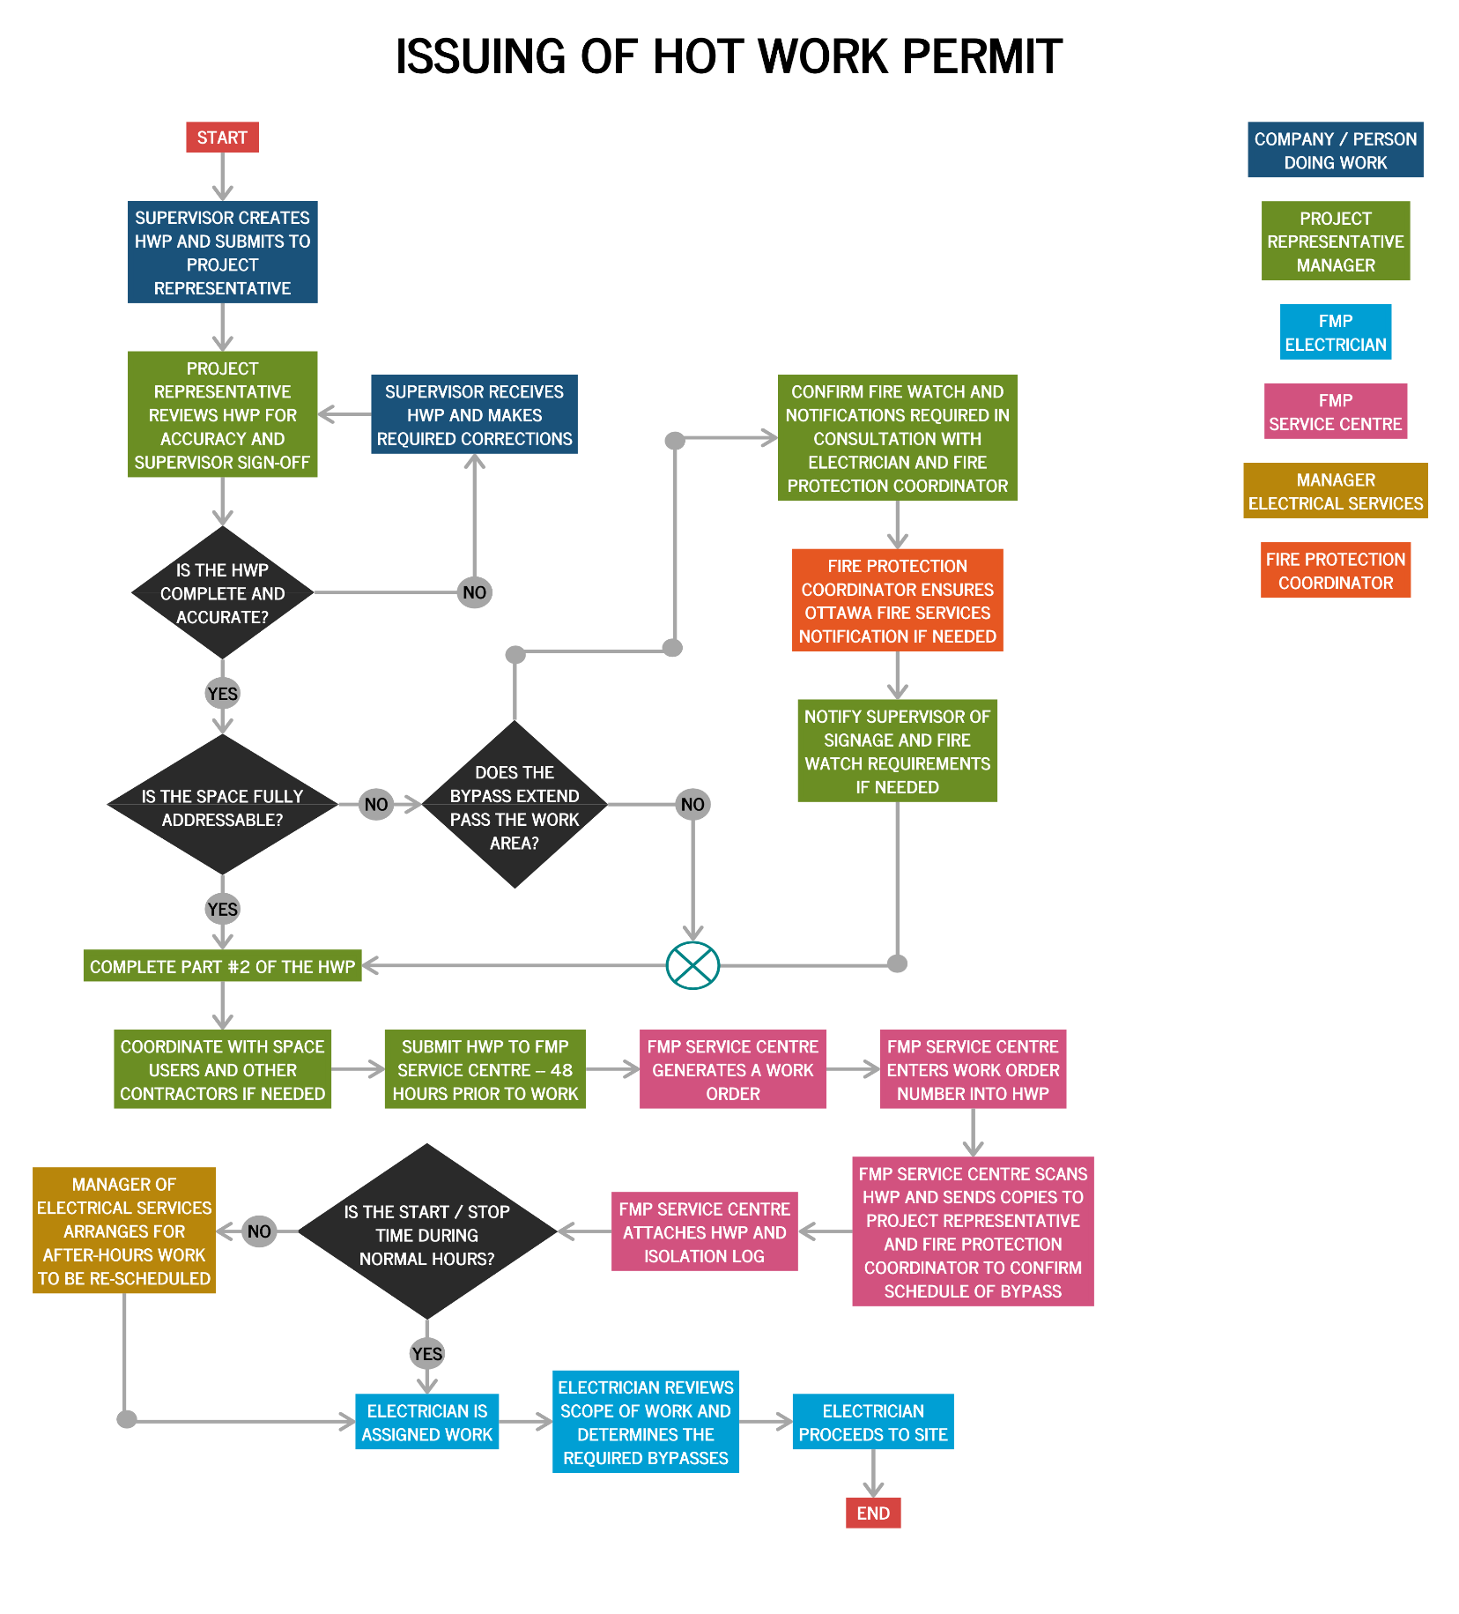
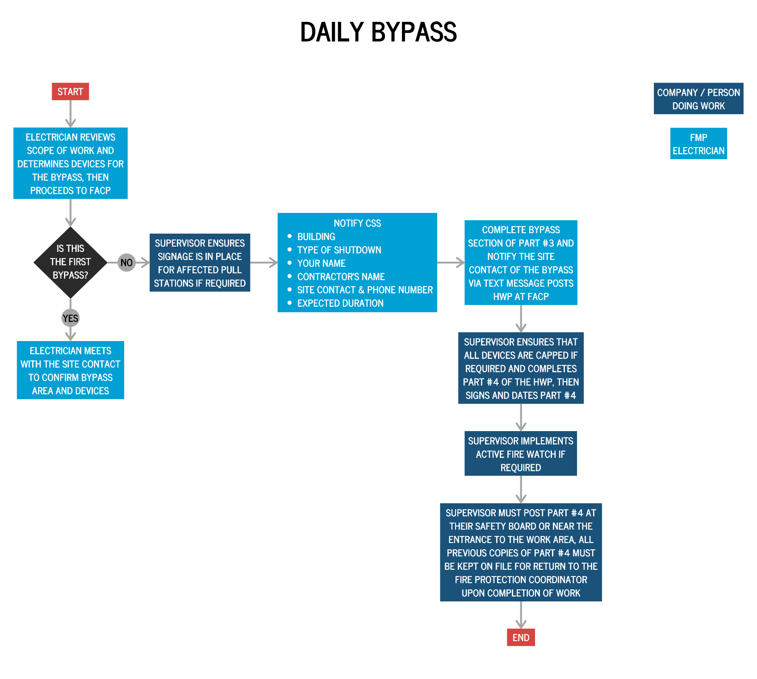

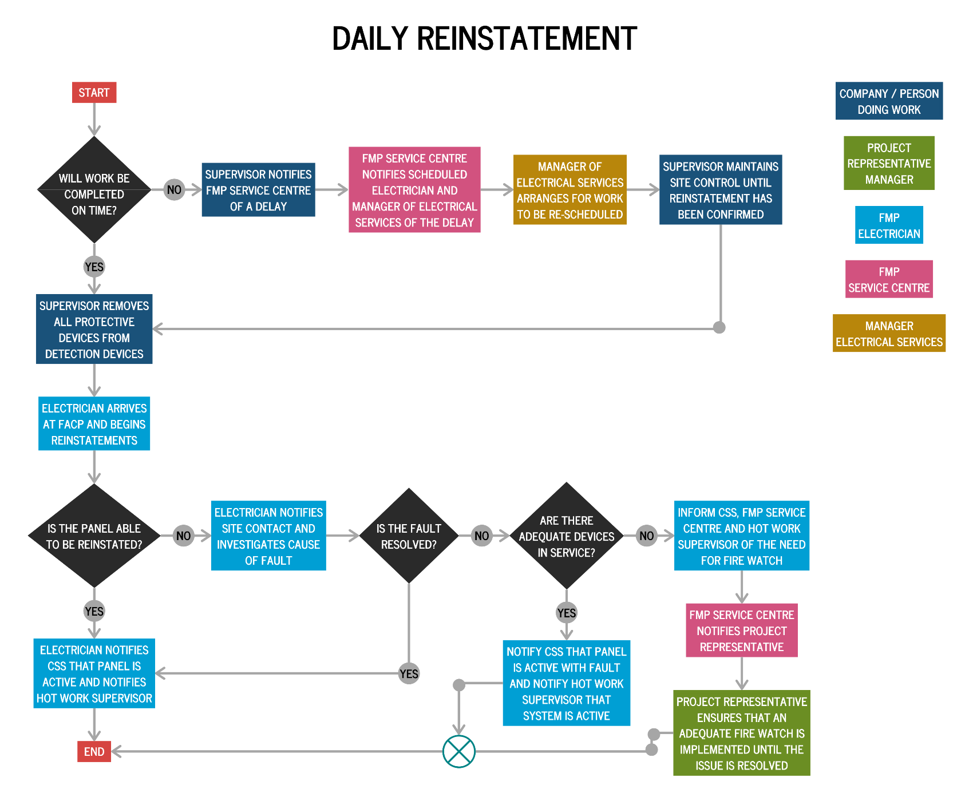

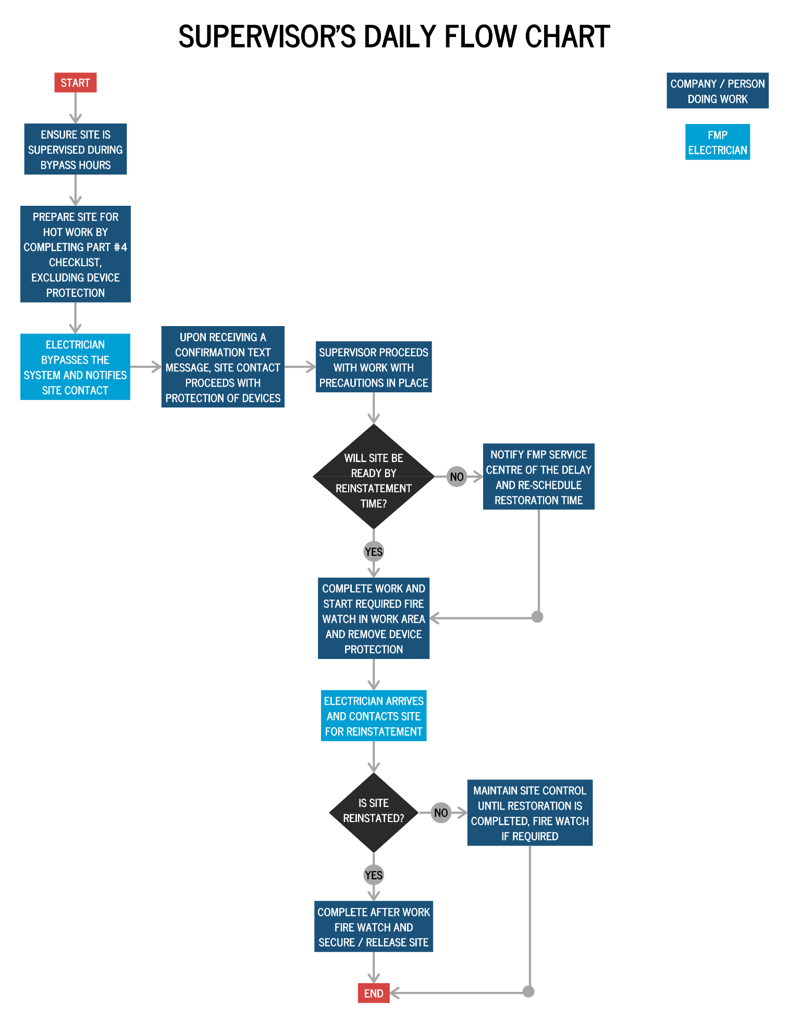
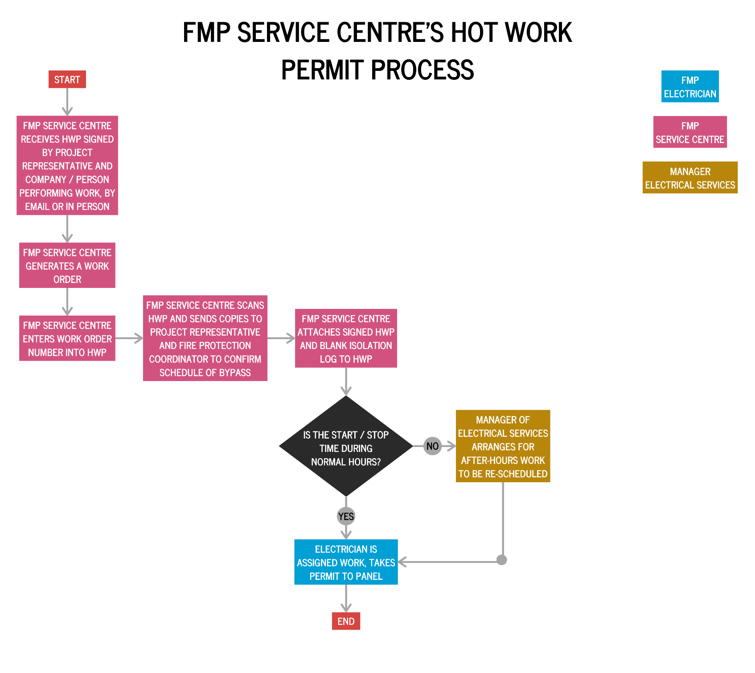

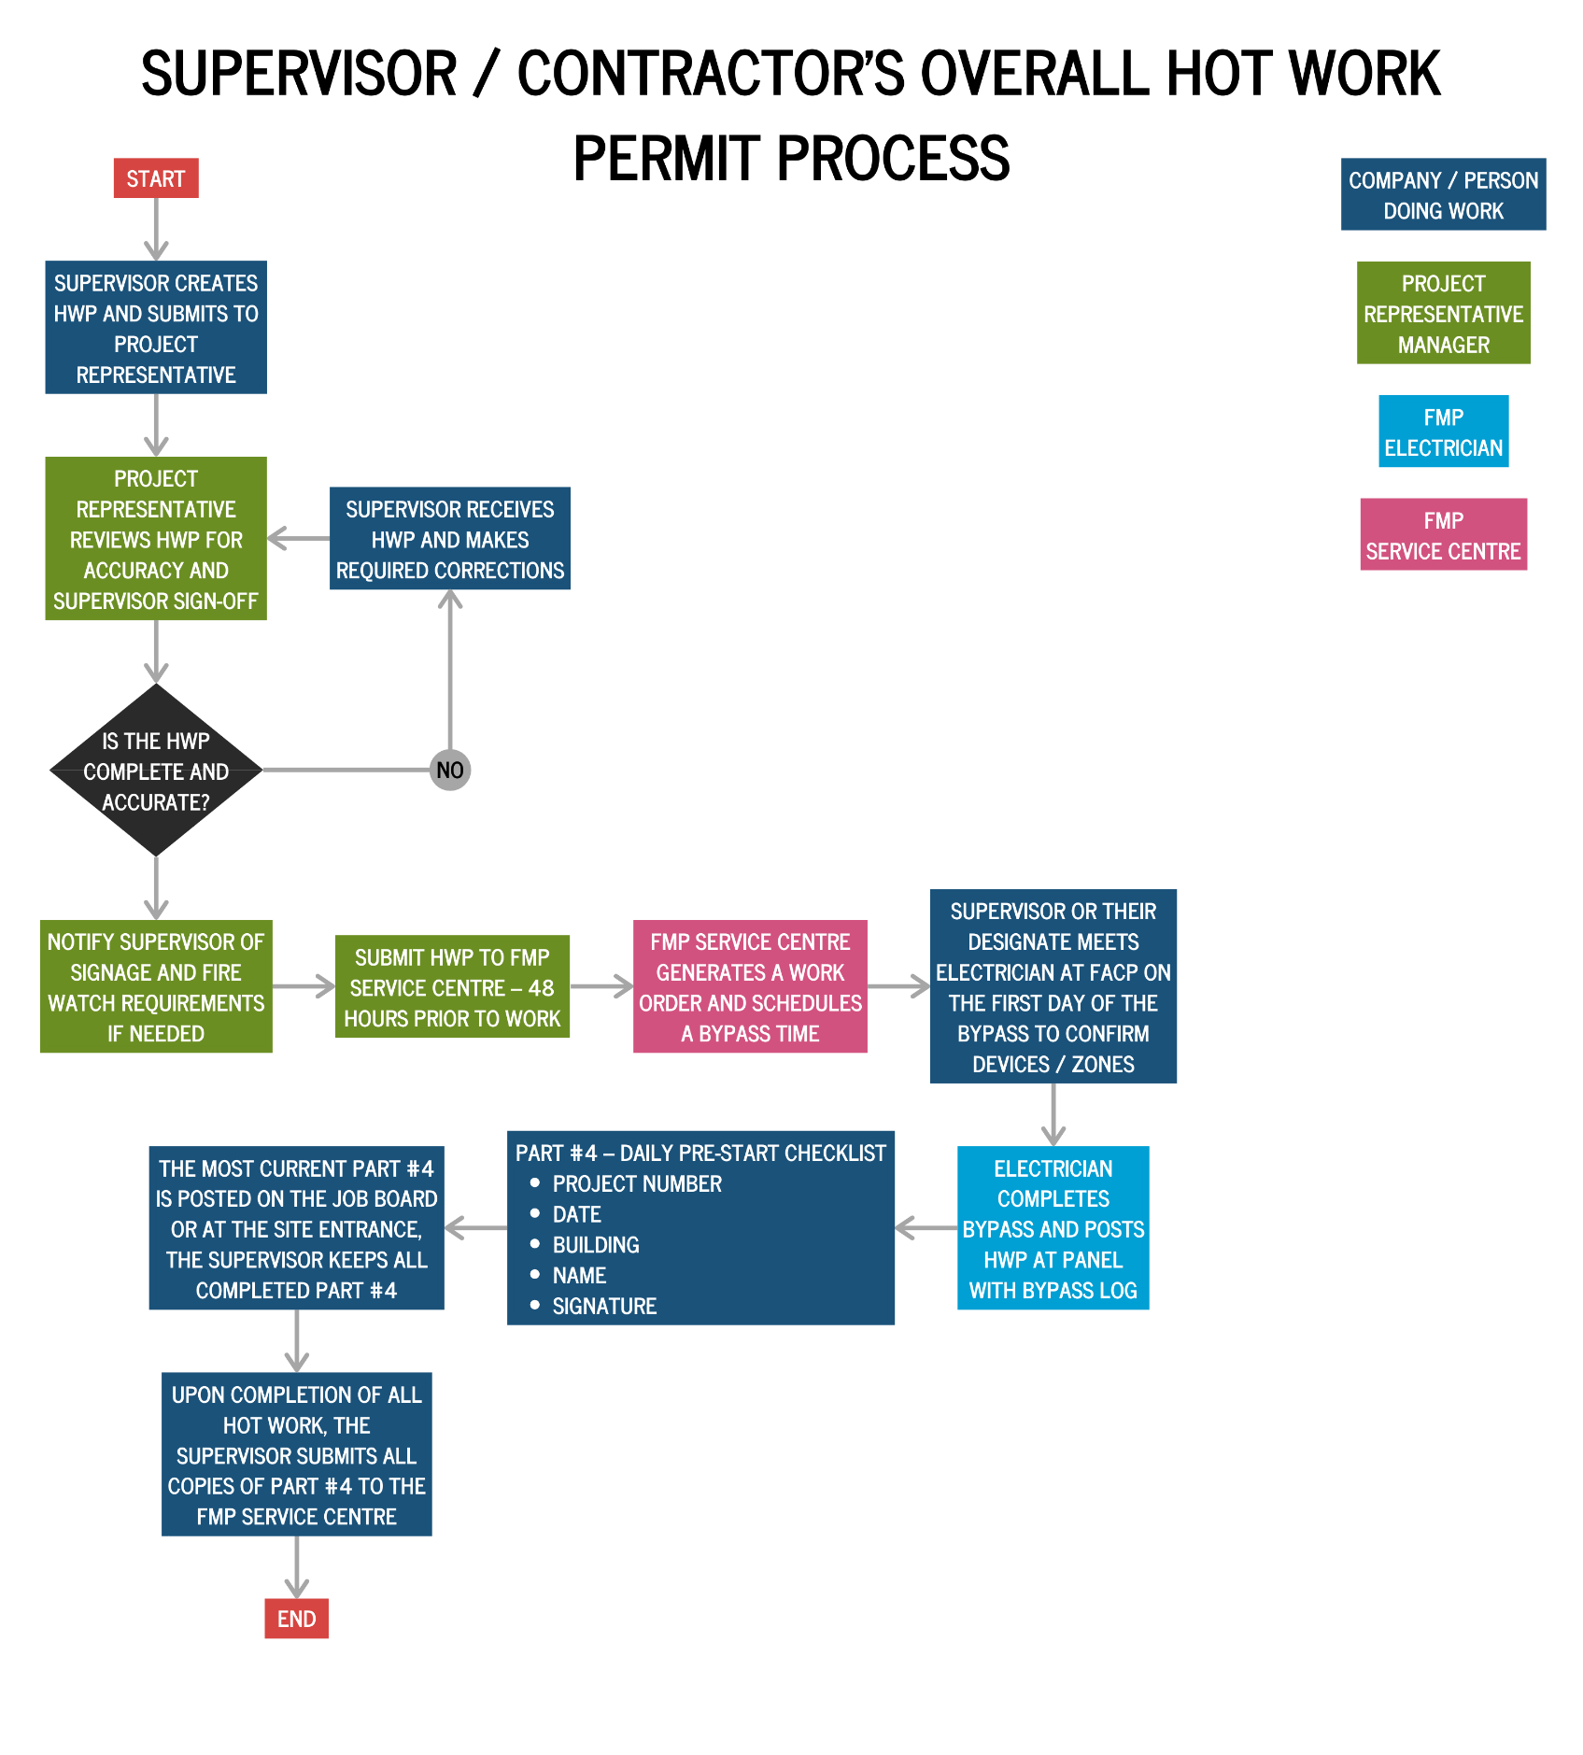

Appendix B: Hot Work Permit Forms
WORK ORDER/PROJECT #:
FORM #823-06/20
PART 1: WORK INFORMATION
 |  |  |  | To be completed by: |  |  | SU | SUPERVISOR
Work Performed By: |  | - CU Employee |  |  | - Contractor
Company/Department:
Building: |  |  |  |  | Room/Work Area:
Permit Start Date: |  |  |  |  | Permit Start Time:
Permit End Date: |  |  |  |  | Permit End Time:
Type of Work Performed (check all that apply)
- Welding ☐ Cutting ☐ Grinding ☐ Brazing ☐ Torching ☐ Sanding ☐ Soldering
- Other (Please Specify):
Description Of Work
ACCEPTANCE OF REQUIRED SAFETY PRECAUTIONS AND HOT WORK MONITORING
I have read and understand Carleton University’s Hot Work and Dust Producing Procedures and will complete the required Daily Pre-Start Checklist (Part 4) prior to the start of any hot work each day. In addition, appropriate monitoring will be in place and additional precautions will be implemented when
required by regulation.
Supervisor: |  |  |  |  |  | Phone:
Signature: |  |  |  |  |  | Date:
On site contact: |  |  |  |  |  | Phone:
Please Note: The electrician will notify the site contact by text that the bypass is completed. No work is to start prior to this notification.
For issues contact the FMP Service Center at 613-520-3668.
PART 2: WORK REQUEST REVIEW
 | To be completed by: |  |  | CARLETON PROJECT REPRESENTATIVE
Name: |  |  | Phone: |  |  |  | Date:
Zoned building? ☐ Yes ☐ No |  |  | Fire watch required beyond work zone? ☐ Yes ☐ No
Occupants notified? ☐ Yes ☐ No |  |  | Bypass required? ☐ Yes ☐ No
Additional Notes:
Signature:

WORK ORDER/PROJECT #:
PART 3: PANEL ISOLATION/
REINSTATEMENT LOG
PANEL ISOLATION |  |  |  |  | PANEL REINSTATEMENT
Electrician | Month | Day | Hour | Min. | Electrician | Month | Day | Hour | Min.
 |  |  |  |  |  |  |  | FORM #823-06/20
All copies of the daily panel isolation/reinstatement log checklist must be kept on site until the completion of the hot work. At the end of the project, all log sheets must be returned to the FMP Service Centre.

PART 4: DAILY PRE-START CHECKLIST
 | To be completed by: | WORKER/CONTRACTOR
Date: | Building: | Work Order / Project #:
GENERAL SAFETY PRECAUTIONS |  |  |  |  | YES | N/A
1. Communication device(s) (i.e., cell phone) is available for immediate use in case of an emergency
2. Fire extinguisher and safety devices (i.e., smoke eaters, welding screens) are present, in service and in
good operating condition. Note: Extinguishers to be UL Type 4A40BC per Construction Reg. 213
3. Identification of Smoke/fire detectors affected AND that the certified electrician has confirmed devices
are disabled.
4. Sign all affected fire alarm pull stations as not in service, indicate the nearest active pull station.
5. Hot Work equipment is in good operating condition.
6. An assessment and steps have been completed to mitigate worker risks when completing the work (i.e.,
ventilation needs, air purging/scrubbing)
7. Appropriate Personal Protection Equipment is provided and in good operating condition
REQUIREMENTS WITHIN 10 METRES OF HOT/DUST WORK |  |  |  |  | YES | N/A
8. Work Area is clearly delineated with signs and/or barriers to restrict access and exposure
9. All sprinkler heads and smoke detectors are covered if they are vulnerable due to the work
10. Ventilate the area with appropriate ventilating equipment, if there is a risk due to smoke or dust
exposure
11. Suspend any nearby activity that could constitute a risk (dust collector, nearby painter, use of solvents or
glues etc.)
12. No risk of explosive atmosphere, or it has been eliminated (gas, vapours, dust)
13. All flammable liquids, dust, powders and oily products have been removed
14. All combustible materials have been removed from the work area
15. Floors are swept and clear of debris
16. Openings in ceilings, floors and walls are protected
17. All other hazards that may result in damage, injury or loss to personnel and property are identified and
controlled
HOT WORK MONITORING (DURING AND AFTER WORK) |  |  |  |  | YES | N/A
18. A trained Hot Worker has been assigned
19. The Hot Worker was provided with suitable extinguishers
20. Workers are trained in use of equipment, sounding the alarm and notifying Department of University
Safety
21. A Fire Watch provided for 60 minutes after the completion of work, or for 3 hours after the completion
of open flame torch work (2 hours if a hand held thermal scanner is used)
22. All devices protected and covered prior to the start of work are uncovered and able to operate properly
Worker (PRINT) : | Signature: | Date:
All copies of the daily pre-start checklist must be kept on site until the completion of work. In the event of a fire or fire alarm the checklist may be required. At the end of the project all checklist must be returned to the FMP Service Centre.
FORM #823-06/20

Appendix C: Buildings with Zoned Devices
MacOdrum Library Fire Alarm Device Groupings
Level | Module/Zone | Device Locations
P3 | 01-02-0150 | Pull @ (P3 Stair F, G, & room P305)
P2 | 01-02-0151 | Pull @ (P2 Stairs F, G)
P1 | 01-02-0152 | Pull @ (P1 Stair F, G, room P109)
P1 | 01-02-0145 | Pull @ Tunnel to Southam elevator lobby, Heats @ (C&W supervisor office, Film storage room)
1 | 01-02-0153 | Pull @ (Stair C, D, E, room 146, 147), Heat @ (room 125, 144)
2 | 01-02-0154 | Pull @ (Stair C, D, E, room 246, 247) Heat @ (room 236, 244)
3 | 01-02-0130 | Pulls @ (Stair A, entry rooms 346, & 347), Heats @ (rooms 350, 350A, 352, 360, 360A, 360B, 360C, 360D, 360E, 360F, 360G, 360H, North east half of room 301)
3 | 01-02-0131 | Pull @ Stair B, Heats @ (Rooms 319, 381, South east half of 301)
3 | 01-02-0144 | Pull @ (Stair A, room 326, 346, 347), Heat room 344
3 | 01-02-0155 | Pull @ (Stair C, D, room 300, 326), Heat room 336
4 | 01-02-0132 | Pull @ Stair A, Heats @ (Rooms 402, 403, 404, 405, 408, 409, 410, 420, 421, 422, 450, 450a, 451, 452, North East half room 401)
4 | 01-02-0133 | Pull @ Stair B, Heats @ ( Rooms 416, 418, 418a, 419a, 423, 424, 425 and South East half of room 401)
5 | 01-02-0134 | Pull @ Stair A, Heats @ (room 504, 505, 506, 507, 508, 509, 509a, 511, 512, 550, 550a, 551, 552, North East half room 501)
5 | 01-02-0135 | Pull @ Stair B, Heats @ (rooms 517, 519, South east half of 501)
St. Patrick’s Alarm Device Groupings
Level | Module/Zone | Device Locations
1 | 01 02 0145 | Level 1 Mechanical room Heats
1 | 01 03 0001 | All Pulls and detectors on Level 1 (excluding room 118, 113, 114, 115,117, 119, smokes in art gallery)
1 | 01 03 0005 | Smokes in Art gallery
1 & 2 | 01 03 0006 | Smokes @ (Room 113,114, 118, 117, 119, 115, Level 2 Gallery)
2 | 01 03 0002 | All Pulls and detectors on Level 2 except Art Gallery
3 | 01 03 0003 | All Pulls and detectors on Level 3
4 | 01 03 0004 | All Pulls and detectors on Level 4

Paterson Hall Fire Alarm Device Groupings
Level | Module/Zone | Device Locations
0 | ZN1 | All devices room 001
0 | ZN2 | All devices @ (rooms 002, 003, 004, 005, 006, 007, 008, 010)
0 | ZN3 | Pull @ room 021, Heats @ room 021
1 | ZN4 | Pulls @ (Stair A, room 176, at tunnel), Heats @ (Rooms 115, 120, 125, 135A, 129, 133, 124, 132A, 123A )
1 | ZN5 | Pulls @ (Bank main entrance, Bank exit, room 160, Stair C exit), Heat @ room 168
2 | ZN15 | Smoke @ (Stair B level 2, Stair B level 4)
2 | ZN6 | Pulls @ (Stair A, room 276, 271), Heats @ (Rooms 225, 235A)
2 | ZN7 | Pulls @ (Stair C, room 290), Heats @ (Rooms 250, 258)
2A | ZN8 | Pulls @ (Stair C, room 2A90), Heats @ (Rooms 2A50, 2A94)
3 | ZN9 | Pulls @ (Stair A, 377), Heats @ (Room 325, 330F, 335A)
3A | ZN10 | Pull @ (3A90W, 3A91), Heats @ (3A94, 3A58)
4 | ZN11 | Pull @ (Stair A, room 476), Heats @ (room 413, 421, 425, 433, 423A, 472)
4 | ZN12 | Pull @ (Stair C, Room 426), Heats @ (room 450, 458)
4 | ZN13 | Heat @ (Top Elevator Shaft, Elevator room)
Social Sciences Fire Alarm Device Groupings
Level | Module/Zone | Device locations
1 | ZN1 | Pulls @ Level 1, All detectors except rooms 116 & 119
2 | ZN2 | Pulls @ Level 2, All detectors Level 2
3 | ZN3 | Pulls @ Level 3, All detectors Level 3
Southam Hall Fire Alarm Device Groupings
Level | Module/Zone | Device Locations
1 | 01-04-0006 | All Pulls and Heats @ Rm 107
1 & 2 | 01-04-0007 | Theatre Pulls @ (Stair E, F, exit room 217A, 217B), Smokes @  (Room 212), Heats (Room 218, 102, 102A, 102B, 103, Stair F)
1 & 2 | 01-05-0003 | Heats @ (Crawl space, Rooms 220A, 222)
2 | 01-04-0008 | Theatre Pulls @ (Mezzanine Loft, Lighting Control room), Heats @ (Costume Loft, Stage North, Stage South, Lighting control East, Lighting control East Centre, Lighting control West Centre, Lighting  control West, Lighting control Catwalk)
2 | 01-07-0001 | Pull @ room 237, Smoke @ room 235, Heats @ (room 237, 231)
2 | 01-08-0003 | Pulls @ (stairs E, F) Smokes @ (Stair E, room 205, 209) Heats @  (room 201, 202, 203, 204, 205, 206, 207, 208, 209, 210)
2 | 01-09-0005 | Pulls @ (at tunnels)
2 | 01-09-0007 | Pull @ tunnel theatre B, Smokes @ tunnel theatre B
2 | 01-09-0008 | Smokes in tunnel theatre B
3 | 01-02-0001 | Theatre Pulls @ (Stair A, Stair B, room 315, Exit near room 303,  room 307) Heats @ (Rm 321, 322)
3 | 01-02-0008 | Theatre Pulls @ (Lobby exit near 325A, Loading door, Stair E, Stair  F), Smokes @ (Room 324, Stair E, F), Heats @ (Room 326, 328A, Loft, 326B)
4 | 01-05-0004 | Pulls @ (stairs A, B, C, D) Heat @ room 421
5 | 01-08-0004 | Pulls @ (stairs A, B, C, D) Heat @ room 539A
6 | 01-09-0004 | Pulls @ (stairs A, B, C, D) Heats @ (room 601, 615, 617, 621, 641)
Minto CASE Alarm Device Groupings
Level | Module/Zone | Device Locations
1 | ZN29 | Pulls @ (lvl1 Stair A, B, C, D), Heat room 1021A
2 | ZN31 | Pulls @ (All Level 2 exits (except Stair C, D, south exit room 2060, Bell Theatre)), Heat room 2021A
2 | ZN37 | Pulls @ (Level 2 Stair C, D and south exit room 2060)
2 | ZN45 | Pulls @ Bell Theatre
3 | ZN39 | Pulls @ (All Level 3 except Bell Theatre), Heat Room 3021A
4 | ZN47 | Pulls @ (Level 4 Stair A, B, C, D, Mackenzie link), Heat room 4021A
5 | ZN3 | Pulls @ (lvl 5 Stair A, B, C, D, E), Heat room 5004A
6 | ZN5 | Pulls @ (Level 6 Stair A, B) Heat room 6002A
7 | ZN16 | Pulls @ (Top of Stair A, B, Elevator Machine room)
7 | ZN19 | Pulls @ (Stair A, B), Heat room 7025
Athletics and Fieldhouse Fire Alarm Device Groupings
Level | Module/Zone | Device Locations
1 | 01-01-001 | Pulls @ (NE under pool, Stair B, Tunnel entrance, Underpool window, entrance 1189), Heats @ (1178, 1174, 1175, 1176, 1171, 1172, entrance from tunnel, all underpool detectors,
1 | 01-01-002 | Pulls @ (Stair B, C, D, E, G, entrance at Tim Hortons, room 1183, 1163, 1115, 1110, 1120), Smokes @ (room 1180, entrance Tim Hortons, 1115A), Heats @ (room 1189, 1166G, 1166B, 1166, 1100E, 1103, 1103A 1103B, 1110F, 1106, 1163, 1164C, 1160, 1164, 1150, 1155, 1126, 1127, 1124, 1122,1115B, 1183A)
1 | 01-02-012 | Pulls @ (Fieldhouse All), Smokes @ (Rm 1205, 1206), Heats @ (Rm 1201, 1207)
2 | 01-01-003 | Pull @ (Stair B, Sun Deck, Rm 2140), Heat Rm 2140A
2 | 01-01-004 | Pull @ (Stair A-B-C-F-G, Rm 2185, Woman's Locker room, Link to gym) Smoke @ Stair A, Heats @ (Rm 2128, 2196, 2110, 2110A, 2110F, 2110G, 2110H, 2122, 2130, 2130A, 2131, 2127, 2182, 2104)
2 | 01-02-009 | Smokes @ Rm 2185
3 | 01-01-005 | Pulls @ (Stair A, E), Smoke @ Stair A, Heats @ (Rm 3130, 3103,  3102A, 3102B, 3103, 3104, 3190)
3 | 01-01-006 | Pull @ Rm 3110, Heats @ Rm 3110
3 | 01-01-007 | Pulls @ Rm 3101, Heats @ 3101
Herzberg Laboratories Fire Alarm Device Groupings
Level | Module/Zone | Device Locations
1 | 3-0002 | Pulls @ (Stair A - loading dock - room 1111 - Stair C - room 1119 - Stair D - room 1175 - room 1160 - Tunnel Junction), Heats @ (11XX and 10XX spaces, 12xx space, All Heats in tunnel, room 1301)
1 | 4-0183 | Pull @ (Stair F), All Heats in crawl space and room 1350
1 | 4-0380 | Pull @ (Stair G, West Exit), Smokes and Heats @ 14xx block
2 | 3-0003 | Pulls @ (Stair C, Stair D, entry to 2000 block), Heats @ 21xx block
2 | 3-0004 | Pulls @ (Stair B, Entry to 2000 Block), Heats @ 22xx Block
2 | 4-0179 | Pull @ (Stair F, exit room 2354, entry into block 2000), Heats @ 23xx block
2 | 4-0376 | Pulls @ (Stair F, Stair G), smokes and heats @ 24xx block
2 | 4-0378 | Pulls @ (Frieght elevator, Woman's washroom), Smokes and Heats @ 20xx block
3 | 3-0006 | Pulls @ (Stair A - Stair B), Heats @ 32xx block
3 | 4-0135 | Pulls @ (entry to 3000 block, Stair E, Stair F), Heats and Smokes  @ 33xx block
3 | 4-0137 | Pulls @ (Passenger elevator, Freight elevator), Smokes and Heats @ 30xx block
3 | 4-0178 | Pulls @ (Stair A, Stair D, Stair C), Heats @ 31xx block
4 | 3-0007 | Pulls @ (Stair B, Entry to 4000 Block), Heats @ 42xx block
4 | 4-0131 | Pulls @ (Entry to 4000 block, Stair E, Stair F), Heats and Smokes in 43xx block
4 | 4-0133 | Pull @ (Passenger Elevator, Freight elevator), Smokes and Heats @ 40xx block
4 | 4-0176 | Pulls @ (Stair D, Stair C, Stair A), Heats @ 41xx block
5 | 3-0008 | Pulls @ (Stairs A, Stairs B), Heats @ 52xx block
5 | 4-0127 | Pull @ (Freight elevator block 5000), Smokes @ 50xx block
5 | 4-0129 | Pull @ (Entries to 5000 block, Stair E, Stair F), Smokes and Heats @ 53xx block
5 | 4-0174 | Pull @ (Stair A, Stair C, Stair D), Heats @ 5100 block
Roof | 3-0005 | Pull @ (Top of Stair C), Heats at Observatory

Loeb Fire Alarm Device Groupings
Level | Module/Zone | Device Locations
Crawl | 1-1 | Heats and Smokes @ Tower D Crawl Space
1 | 1-3 | Pulls @ (Stair A, Room 110C, at entry to room 110C), heats and combo in A Block
1 | 1-4 | Pulls @ (Room 111A, Entry to 111A) Heat @ room 110D
1 | 25-4 | Pull @ (room 131 exit, Loeb café, exit at Loeb), Heats @ (Loeb café, room 142A, 142, 173, 175, 176, 170D, C164, C164A, 145A)
2 | 16-1 | Pull @ (Stair C, Pillar near Café) Heat @ room 245
2 | 16-2 | Pull @ (Stair D, At east fire doors tunnel) Heats @ room 270, 266, 266A, 264,264A, 264B)
2 | 2-4 | Pull @ (stair A, stair B), heats @ (room 205A and A240C)
3 | 17-1 | Pull @ (stair A, in stair A, stair B, in stair B) heat @ room 308C
3 | 17-2 | Pull @ (Stair C, In Stair C), Heat @ room 352C
3 | 17-3 | Pull @ (Stair D, in Stair D), Heat @ room 365C
3 | 17-4 | Pull @ (Stair E, in Stair E)
3 | 18-1 | Duct Smokes Stairs A - B - C - D Level 3
4 | 18-2 | Pull @ (Stair A, Stair B) Heat @ room 444C
4 | 18-3 | Pull @ (Stair C), Heat @ 451C
4 | 18-4 | Pull @ (Stair D), Heat @ room 478C
4 | 19-2 | Duct Smoke @ (Stairs A-B-C-D-E Level 4)
5 | 19-3 | Pull @ (Stair A, Stair B) Heat @ (room 537C, 514C, 556C)
5 | 19-4 | Pull at Stair C, Heat @ comms closet
5 | 20-1 | Pull @ Stair D, Heat @ room 569
5 | 20-3 | Duct Smokes @ (Stairs A - B - C - D-E) Level 5
6 | 20-4 | Pull @ (Stair A, Stair B), heat room 635C
6 | 21-1 | Pull at Stair C, Heat @ 645C
6 | 21-2 | Pull @ Stair D, Heat @ room 667C
6 | 21-4 | Duct Smoke @ (Stairs A-B-C-D Level 6)
7 | 22-1 | Pull @ (Stair A, Stair B) Heat @ room 710C
7 | 22-2 | Pull @ Stair C, Heat @ room 748C
7 | 22-3 | Pull @ Stair D, Heat @ room 777C
7 | 23-1 | Duct Smoke @ (Stairs A-B-C-D-E) Level 7
8 | 23-2 | Pull @ (Stair A, Stair B), Heat @ room 837C
8 | 23-3 | Pull @ Stair C, Heat @ room 861C
8 | 23-4 | Pull @ Stair D, Heat @ room 873C
8 | 24-2 | Smokes @ (Stairs A, B, C, D, E)
9 | 24-3 | Pull @ (Stair A, Stair B) Heat @ room 938C
9 | 24-4 | Pull @ Stair C, Heats @ (room B945, C950)
9 | 25-1 | Pull @ Stair D, Heats @ (room B945, C950)
9 | 25-2 | Pull @ Stair E, Heats @ (room D951, Stair D)

