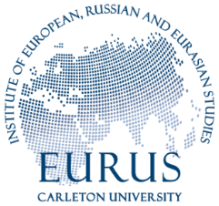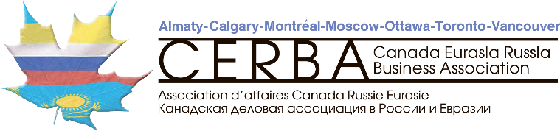

Preliminary program

In search of the new Eurasian pragmatism: Regional initiatives for economic development
Organizers : Carleton University, Canada Eurasia Russia Business Association, Eurasian Economic Union members countries
Date : 11 April, 2019
Participants : Ambassadors (RF, Armenia , China, Kazakhstan, Belarus, Mongolia, Thailand), business practitioners, and expert community
Venue : Carleton University, Ottawa

Overview:
In recent years, the world has witnessed rising opposition to globalism as we had understood it since the early 1990’s. The liberal order led by traditional players from North America and Europe have been challenged from within and by emerging economies. Global multilateral organizations such as the United Nations and the World Trade Organization are facing increasing headwinds and they appear to struggle adapting to the changing international environment.

In parallel, a range of regional organizations for economic development were created or gained momentum in order to better address the needs of the people and governments pertaining to trade, labour, customs, security, education, etc. The current conference will focus on such projects initiated in the greater Eurasian area as The Eurasian Economic Union (EEU) and
the Belt and Road Initiative (BRI) as well as their links to other integration formats, like the Association of South Eastern Asian Nations (ASEAN).
The roles and mandates of these organizations/projects differ significantly, but they all address development questions at the regional level. They also interact with each other on a range of questions, very often on economy and trade. The Government of Canada and Canadian companies are also called to cooperate with them in a variety of ways. The existence of the Canada-China Business Council, the Canada Eurasia Russia Business Association, and the Canada-ASEAN Business Council are a manifestation of the desire for economic dialogue and business between Canada and these regional economic blocs.

The proposed conference will aim to better understand dynamics of these regional development projects, the role Canada should embrace to remain relevant in the region, and the positive impact Canadian economic actors can play in bridging Canada with this dynamic region of the world.

Format and approach:
- Firstly, we will map the main versions of the connectivity projects as provided by their official narratives and will include Russia’s Eurasian Union, China’s Belt and Road Initiative, and the Association of Southeast Asian Nations.
- Secondly, we will conduct an analysis of connectivity focusing on finance, business, banking, investment, and regional planning.

See below schedule:

Preliminary outline:
10.00 – 10.30: Registration and coffee/tea in Room 617 Robertson Hall
10.30 Opening remarks :
Organizers : Andre Ploudre (Dean, Faculty or Public Affairs) , Gilles Breton (Chairman Canada Eurasia Russia Business Association), Piotr Dutkiewicz Professor Carleton and member of the Valdai Club of experts on Russia, and Jeff Sahadeo Associate Professor at the Institute of European, Russian, and Eurasian Studies at Carleton U.

10.45 – 12 . 30
First panel :
Ambassadors : Russian Federation , Armenia , China (PRC) , Kazakhstan, Mongolia and Thailand, and the Deputy Minister of Foreign Affairs of the Republic of Belarus

12.30 – 13.30 – Lunch
Second panel :
13. 30 – 15.00 Expert evaluation of EEU potential, accomplishments of ASEAN and future integration, BRI projects in Eurasia, business opportunities related to BRI, ASEAN and EEU.
Speakers include:
- Jeremy Paltiel , Professor Carleton University
- LEO XU: IP Lawyer at Jones & Co firm in Toronto
- Feizhen Lu: CEO of Polaris Capital Power and HiSEL Power Co
- Yana Lulakesh: Manager Government Affairs at Bombardier
- Reg Weiser: President at Positron Inc

