Information Session

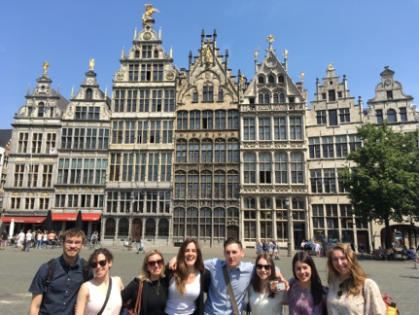

EU Study Tour and Internship Program 2019
Earn a 0.5 course credit this summer… in Europe!
Date: Wednesday December 5th, 6-8pm
Location: EURUS Boardroom, 3302 Richcraft Hall
The European Union Study Tour and Internship Program (EUST&IP) is an initiative of the European Studies Network (Canada), a consortium of Canadian universities of which Carleton is a member. The Tour consists of 21 days (May 12 – June 1, 2019) in Europe, involving meetings and consultations at a wide range of European institutions in Brussels, Strasbourg, Luxembourg, and Frankfurt. Students participating in the Tour may also apply to participate in an internship (2 months or more) in a European institution.
Eligibility: Permission of the Institute is required for registration. This will be assessed on the basis of your application.
The following guidelines may be helpful:
- Graduate students from any Carleton program are eligible to apply; graduate students should have course background on the EU or contemporary European studies.
- Undergraduate students who have third or fourth year standing by the beginning of the summer 2018 term are eligible to apply (i.e. current second-year students and above). Specific coursework recommended for eligibility would be EURR 2001 and EURR 2002, or PSCI 3207.
Read more about EUST&IP here!
The Centre for European Studies Jean Monnet Centre of Excellence, with support from the Erasmus+ Programme of the European Union and Carleton University, provides partial financial support to eligible students to help defray the cost of the program.
For further details and any questions, please contact:
Prof. Crina Viju, EURUS, crina.viju@carleton.ca 613-520-2600, ext. 8440

