Netspeak and the Internet: A Contextual Analysis

Following the advent of social media, our social lives have been deeply influenced by the online space, altering the way we socialize and communicate. Online communication has its own unique register which consists of a collection of genre specific features, referred to as Netspeak (Hadžiahmetović Jurida, 2015; Crystal, 2001). Some debate exists as to exactly which contexts we should expect Netspeak. Crystal (2006) claimed that as Netspeak was developed through the modality of the internet, it is apparent in all internet-based contexts due to the “electronic, global and interactive” nature of the internet. While this explains technological influences that the internet has had on online language, Squires (2010) argues that there are other contextual aspects that influence when and where an individual might choose to use Netspeak in contexts such as text, email, blogs, websites and so on. Social relationships of the users may also be an influence on this choice (Squires, 2010). As online communities continue to grow, understanding when to use netspeak becomes increasingly important. Accordingly this research asks: (i) to what extent are individuals using Netspeak in different contexts on the internet? And, (ii) are there attitudinal factors that play a role in the amount of Netspeak is generally being used? To address these research questions, I developed a survey to analyze Netspeak given different simulated contexts. First, participants (n = 34) created three writing samples: (a) an email to their boss, (b) a text to a friend, and (c) a Facebook post. For each of these contexts, I calculated the number of netspeak features included. Second, participants competed a survey about their attitudes toward and awareness of the use of Netspeak in varying contexts.
In this study, I found that people were more likely to use Netspeak if they were writing a hypothetical Facebook post or text message to a friend compared to an email to their employer (F (2,99) = 19.7, p < 0.0001). Linear regression modelling revealed that people were more likely to actually use Netspeak if they reported using it (p = 0.001). There was a trend indicating participants’ attitudes towards netspeak impacted the amount of netspeak they used in the text message condition (p = 0.07), but not the Facebook or email condition (see Figure 1).

Figure 1: Amount of Netspeak by Context (Email, Facebook, Text Message) and Attitudes about Netspeak.
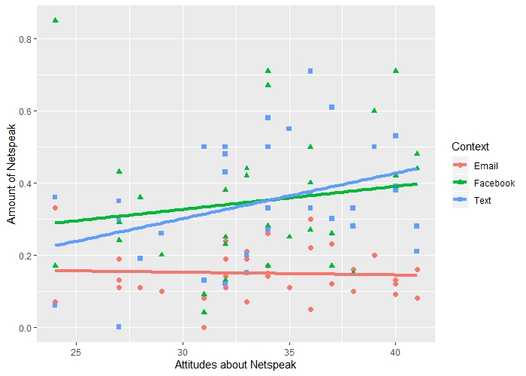

This study allowed me to not only assess the contextual use of Netspeak, but it provided insights into attitudes on Netspeak. Contrary to Crystal’s (2006) claim of Netspeak being apparent in all internet-based contexts, these results suggest that there are both attitudinal factors and contextual factors that play a role in where Netspeak is used. These insights provide an empirical basis for further research into online communication, which has become increasingly important for both our social and professional lives.

