Dear Traveller,
We have partnered with International SOS to ensure you are safe during your time abroad. We are happy to announce a feature that will allow you to forward your itinerary to a Service, powered by Traxo, to allow your trips to be followed in the case of a crisis or emergency.

If you have not registered for the MyTrips application please first do so at https://MyTrips.travelsecurity.com/Login.aspx?ci=GtBp2Fe9mwQ%3d. If you have any issues you can contact our onlinehelp@internationalsos.com team and they will help you to register for a MyTrips account.
You can then forward your itinerary email confirmations to an email-box specifically created for your needs. Please forward your trip confirmation emails to CarletonUniversityTravel@itinerary.internationalsos.com and your trip details will be processed into our system.
After we process your confirmation emails we will send you a notification email informing you of the status of your Itinerary. *Note: You may notice a slight delay if the Itinerary Forwarding Service does not recognize the vendor.

For a quick tutorial of the process, please visit the link for a video at https://vimeo.com/295300614/c1de85c7dc

Successfully loaded Itinerary into our system
If your itinerary is processed successfully, you will receive a confirmation email noting this.

Could not load the Itinerary into our system
If your confirmation email failed to process, there are several possible reasons for this:
- We are unable to read the format
- There are missing data elements that are required to process the itinerary into our system
- Attachments are missing. Some Itineraries require attachments, so please ensure you forward any attachments which are included in the original confirmation email

Things to Note
- Only flight, hotel and car rental bookings can be forwarded to the mailbox. Train bookings are not supported at this time.
- You should forward the original confirmation email without making any changes to the email. If you change the original email content or format, the trip details will not get processed. For example, if you receive two separate confirmation emails for two different trips, you should forward each original confirmation email to the mailbox separately.
- If the confirmation email includes a PDF document, please include the PDF document when forwarding the confirmation email.
- Whenever you forward an itinerary confirmation email to the mailbox, you will receive an automated email from MyTrips with the processing status. You can always log in to your MyTrips account to view or edit the trip details. The trips will be labelled as “Forwarded Itinerary.”
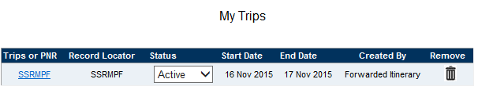
- If you make a change to the itinerary, please forward the latest version of the itinerary confirmation email to the mailbox.
- If you cancelled the trip through a vendor, log into MyTrips and remove the trip from the trip list.
- For any feedback about your trips in your MyTrips account, please use the Feedback link within the tool.

If you require any assistance with the itinerary forwarding service or registering for MyTrips, please contact the International SOS Online Help team at onlinehelp@internationalsos.com and they will be happy to assist.

