Project ID: 50 (Malaysia, Asia)

Designing Mobile Services for Ageing Women in Malaysia

- Research updates and dissemination

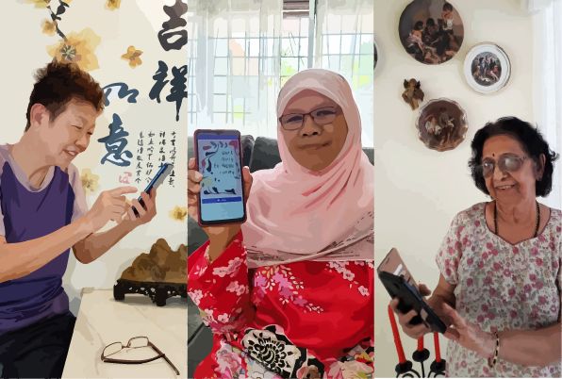

A) Dissemination Webinar for Project ID 50 - Malaysia
Name of Principal Investigator: Ah Choo KOO
Name of Co-Principal Investigator: Chui Yin WONG (was the Principal Investigator from 1st October 2020 until 19th September 2021. This was due to her change of career to join industry)
Institution: Multimedia University
Date: 28 October 2022

The project has the membership and supports from various expertise of different institutions. A dissemination Webinar was conducted on 26 September 2022 (Morning). It was a public event. Team ID50 presented their research experiences and findings. The sharing was focused on telecommunication expenditure, mobile usage experiences and behavioral patterns among the female elderly in Malaysia. This research was important to voice out the gender and age perspectives for better policies and development of technology and digital service plans. The webinar gave audiences insights of using mobile applications/services in the daily lives of female elderly users. From the sociological perspective, it also highlights the interwoven factors that influenced their mobile usage from an intersectionality approach. The webinar was attended by NGO members, academicians, researchers, and general public. Participants were interactive and provided their comments and viewpoint. Participant Rashidah observed that some female members of her NGO, were so afraid to use mobile messaging application, such as WhatsApp. There is still a gap between urban and rural area for their use of smart phones. Participant Lily expressed that smart phone training workshops offered to elderly learners were indeed beneficial, where such trainings should be promoted or multiplied at other areas, especially in rural regions. More concerted efforts should be conducted in designing mobile technology related programme for elderly women and other groups who needed awareness and education. The findings also benefit policymakers and telecommunication industry players.

(234 words; this content is already posted in the GDS gForm)

The video record of the said Dissemination Event for Project ID50:
https://youtu.be/Y1l5hh9yMTc

Event poster link:
https://drive.google.com/file/d/11vcEutPtcg73q-TpqZM5VPV2c-BMOuDX/view?usp=sharing

The brief of Project ID 50 overview (slide), presented in this webinar is (with both Phase 1 and Phase 2 of the research project).

https://drive.google.com/file/d/1J7dTEyUhEJ7sdQ-58t2vrKv4SSZ3LYav/view?usp=sharing

The newsflash information published of this event:
https://www.mmu.edu.my/2022/09/gaining-in-depth-insights-into-seniors-telecommunication-and-mobile-phone-usage/
-------------------

B) One journal publication to be published in 2022 under this project (Phase 2):-

Tan, JY et al. (2022). Intersectionality Lens to Female Elderly's Mobile Usage Experience under COVID-19: An Intimate or Intimidating Relationship? International Journal of Technology, to be published in Volume 13 Issue 6 (SE) 2022. Acknowledgement to the funder was stated in the paper.

C) Creative Works:

1) Sliver Lining of Ageing: Elderly Women's Relationship with their Smartphones
2) Silver Lining of Ageing: Gender and Telecommunication Expenditure in Malaysian Households

The creative infographic submitted for Bisik ("Whisper") and to be published in an eBook of Series 01: Bisik, by the Faculty of Creative Multimedia in early next year. This is the work submitted:

https://drive.google.com/drive/folders/1HNMP4mqn9fXaQXe1rcfs3paeT6ze0t1d?usp=sharing

It has the messages that the artists would like to convey: -

Malaysia is already an ageing nation and in 26 years’ time our 65+ age group population is to double from 7% to 14%. Meanwhile, Covid-19 pandemic has accelerated the goal of a Malaysian society towards being a digital nation that now embraces technology and digital transition, however are we ready to be more inclusive of the ageing and the marginalized group? Our research data showcase (as infographic art/3 posters) aim at giving seniors’ voices, especially female elderly to be considered in telecommunication devices/ services development and policies adhering to UN’s Sustainable Development Goals of Gender Equality (Goal 5) and Reduced Inequalities (Goal 10). In our research project, we are looking at gender non-binary perspectives, we focus on telling the story of our participants (elderly women) and their relationship (e.g., behavioral patterns, decision-making, gendered roles, etc.) with smartphones within the household and social wise. The findings showed that family and social interaction, digital literacy level, self-interest/ motivation, gendered roles, well-being were interconnected to one another that shaped the experience of the elderly women in accessing, learning, using their smartphones and the applications/services. Those are the contributing factors that established and strengthened the relationship between female elderly and their phone. (198 words)

-------------------------------------------

D) Other publications are:-

Lee, Y., Mat Din, H., Wong, C. Y., Lai, W. T., & Koo, A. C. (2022, July 25-27), A Study of Female- and Older Adults-led Households’ Telecommunication Expenditure in Digital Malaysia, Digital Futures International Congress (DIFCON) International Conference on Technology and Innovation Management (ICTIM) 2022, 25-27 July 2022, Selangor, Malaysia. *The Proceedings of the DIFCON Congress will be indexed in Open Access CPCI-WoS Indexed Proceedings by Atlantis Press (part of Springer Nature).

Tan, J. Y., Koo, A. C., Wong, C. Y., & Lai, W. T. (2022, July 25-27), Intersectionality and female elderly with their mobile during COVID-19 pandemic: An intimate or intimidating relationship?, Digital Futures International Congress (DIFCON) International Conference on Creative Multimedia (ICCM) 2022, 25-27 July 2022, Selangor, Malaysia. *The Proceedings of the DIFCON Congress will be indexed in Open Access CPCI-WoS Indexed Proceedings by Atlantis Press (part of Springer Nature).

Tan, J. Y., Wong, C. Y., & Koo, A. C. (2020, December 9-10), A Review on ageing and mobile technology in Malaysia, Presented at Research Innovation Commercialisation and Entrepreneurship Showcase (RICES) 2020, 9-10 December 2020, Selangor, Malaysia.

