GEOG 2600A Summer Term, 2020
GLOBAL CONNECTIONS

Andy Kusi-Appiah;
613 219-4659;
andykusiappiah@cunet.carleton.ca;
intercultural@gmail.com

Office Hours: TBA

Lecture Class: Livestream online (mandatory student attendance) –
Mondays & Wednesdays (Time: 18h05-20h55)

Prerequisite: Second year standing or permission

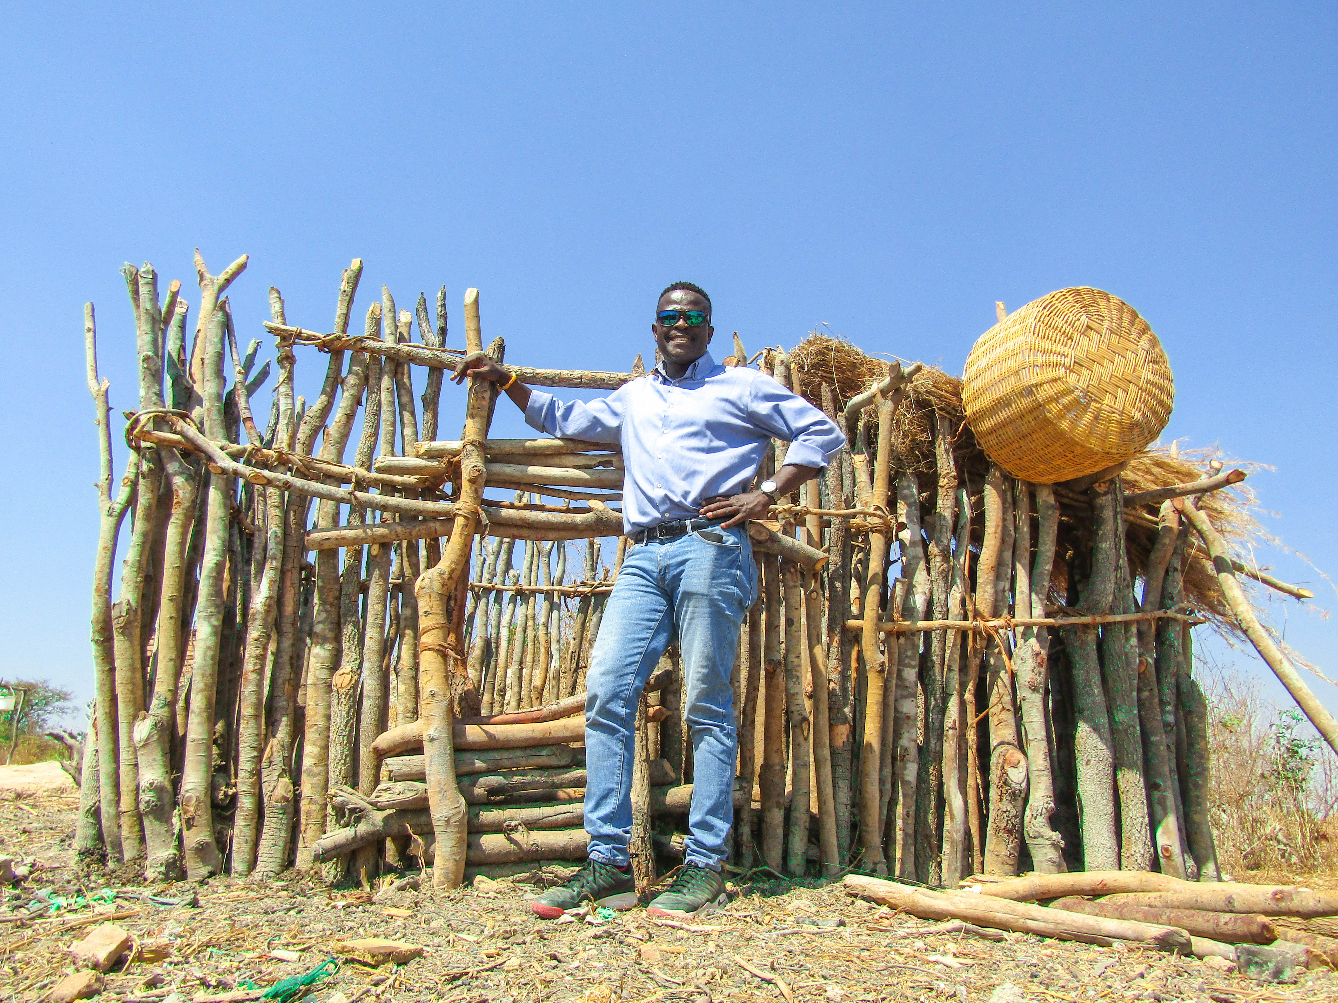
Course description
Do you see your time in the university as a period of personal development or as time invested in developing employable skills (or both)? Either way, you will be better equipped for the future if you have some conception of what drives the pattern of global change and the consequences thereof. This course is about making connections – between different aspects of human activities next door to us and on the other side of the world; between the changes and challenges emerging in different places and regions; and between conditions in the past, the present and the future. A wide range of issues and questions regarding the dynamics of “globalization” will be covered. Linking people and places, often across vast distances, globalization involves a complex set of cultural, political, and economic interactions embedded within our somewhat volatile relationship with the ‘natural’ environment. By the end of the course, you will have acquired a broad understanding of how differences between specific places and broader regions drive global connections, and how the global shapes – but also is itself shaped by – the local.

COURSE OBJECTIVES

- To understand the dimensions of globalization and how it effects domestic and local economies, politics and daily social life.
- To consider and form a view on global environmental change as a driver and as a result of globalizing processes.
- To identify drivers and results of globalization and relate them to your personal political, economic and social situations.
- To place current geopolitical and counter-globalizing movements in context and be able to anticipate possible developments in global connections.

CLASS FORMAT
The course meets online twice every week and consists of a 2-hour time slot per session. Classes will combine lectures, class discussions, case studies and audio-visual materials.

REQUIRED READINGS
Steger, M. (2017). Globalization: A Very Short Introduction. Fourth Edition. Oxford: Oxford University Press.

The above textbook can be ordered from Amazon.com.

Other readings will be assigned and available on cuLearn. Readings will be selected from academic, media and critical sources. They should be read in advance of the weekly online lectures.

COURSE WEBSITE
A web site for this course containing the course outline, a link to access the required readings, lecture slides, assignments, course-related links, an online discussion forum and occasional announcements can be found on cuLearn. Please note that lecture slides provide only a partial summary of the material presented in class; they are not a replacement for attending class and taking notes.

EVALUATION
Students will be evaluated on the basis of tree components:

- Two assignments of equal weight worth 30% (2X 15%) of the final grade combined.
- A midterm exam worth 30% of the final grade (this will cover first part of the course – (i.e., weeks 1-6).
- A term paper with 40% of the final grade (this is due on June 17, 2020).

PURPOSE OF LECTURES, ASSIGNMENTS AND READINGS
Readings, lectures, class discussions, audio-visual materials and assignments are designed to complement each other in meeting the course’s learning objectives. Required readings establish the overall theme for each class, introducing key concepts, issues and information. Class lectures expand upon the readings, clarify key terms or issues, provide additional background context and present case study material to illustrate key concepts. Lectures will also incorporate guest speakers and audio-visual materials, as appropriate. The assignments provide the opportunity to deepen understanding and analysis of course-related themes and concepts. Students are expected to come to class prepared to discuss the readings in an informed manner and will be evaluated on their active participation.

Submission and Grading of assignments

The penalty for late assignments is a 2% for each day past the assigned due date, unless accompanied by University approved documentation (i.e., self-declaration form).

Submit the electronic copy of your assignment, but please always keep your own copy of submitted assignments until after final grades have been posted for the course. In the assignments, use complete sentences that demonstrate your ability to convey ideas in a clear and grammatically correct manner. Each assignment should have a header with a title, your name, your student number, the course number, the professor’s name and the actual date of submission. Your assignments will be marked and grades will be posted on the course’s cuLearn site. Students are responsible for checking their assignment grades on cuLearn. Any questions regarding assigned grades must take place in written form (i.e., email) within 10 days after the assignment in question is returned in the tutorial. Final grades are subject to the Dean’s approval.

Late assignments are strongly discouraged, but can be submitted on the cuLearn assignment dropbox. Note this dropbox will be open for two weeks after the due date. After that it will be closed and no more assignments will be accepted.

The name of the professor must be on all pages of your assignment. Your electronic filename should include your surname, course code and assignment number: e.g. Kusi-Appiah GEOG 2200 #1

If you are having problems with submitting your assignment on cuLearn please contact the instructor via email with an attached copy of the assignment. For cuLearn support, contact Information Technology Service Desk (ITS). They are located on Floor 4 f the Library, or can be reached via phone at 613-520-2600 x3700 or via email at its.service.desk@carleton.ca

NOTE: Do not use this as an excuse to get more time to do the assignment.

LECTURE SCHEDULE
*Please note that lecture topics, required readings and audio-visual resources are subject to change at the discretion of the instructor.
Date | Topic | Reading | Assignment
May 4, 2020 | Introduction. | Introduction to course: topics, assignments, evaluation & overall approach.  Steger, Chapter 1 & 2
May 6, 2020 | Globalization: History and Concepts | Staeger, Chapter 1&2 | Assignment#1 instructions given.
May 11, 2020 | Economic Dimensions of Globalization | Steger, Chapter 3&4
May 13, 2020 | Globalization and the state | Steger, Chapter 3&4 | Assignment#2 instructions given.
May 18, 2020 | Statutory Holiday
May 20, 2020 | International Trade | Steger, Chapter 5
May 25, 2020 | Cultural dimensions of globalization | Steger, Chapter 5 | Assignment no. 1 due.
May 27, 2020 | Mid-term exam | Midterm exam | Mid-term examination questions will be emailed to students one hour before class.  Accommodations will be in place for PMC students
June 1, 2020 | The Ecological Dimension of Globalization | Steger, Chapter 6
June 3, 2020 | Migration and borders | TBA
June 8, 2020 | Canada and the world | TBA | Assignmen#2 due.
June 10, 2020 | Ideologies of Globalization | Steger, Chapter 7 | Mid-term examination returned to student on cuLearn.
June 15, 2020 | Future of Globalization | Steger, Chapter 8
June 17, 2020 | Course Review |  | Term paper due.
Instructional and Conduct Offences

Carleton University has clear and firm policies regarding instructional and conduct offences. Instructional offences include among other activities cheating, contravening examination regulations, plagiarism, submitting similar work in two or more courses without prior permission, and disrupting classes. Conduct offences apply in areas of discrimination and sexual harassment. Further information about University regulations which define and regulate these offences can be found at http://www1.carleton.ca/studentaffairs/academic-integrity/.

Plagiarism is one kind of instructional offence. Examples of plagiarism include:

- Reproducing or paraphrasing portions of someone else’s published or unpublished material, and presenting these as one’s own without proper citation or reference to the original source;
- Submitting an assignment written, in whole or in part, by someone else;
- Using ideas or direct, verbatim quotations, or paraphrased material, concepts, or ideas without appropriate acknowledgment in any academic assignment;
- Failing to acknowledge sources through the use of proper citations when using another’s works and/or failing to use quotation marks;
- Handing in "substantially the same piece of work for academic credit more than once without prior written permission of the course instructor in which the submission occurs."

For more information on how to cite sources, refer to the library web page “Citing Your Sources” available at http://www.library.carleton.ca/help/citing-your-sources.

Plagiarism is a serious offence which cannot be resolved directly with the course instructor. The Associate Deans of the Faculty conduct a rigorous investigation, including an interview with the student, when an instructor suspects a piece of work has been plagiarized. Penalties are not trivial. They include sanctions ranges from a grade of zero for the assignment to suspension from your program of study.

Academic Accommodations:
You may need special arrangements to meet your academic obligations during the term. For an accommodation request the processes are as follows:

Pregnancy obligation: write to us with any requests for academic accommodation during the first two weeks of class, or as soon as possible after the need for accommodation is known to exist. For more details visit the Department of Equity and Inclusive Communities (EIC) website: http://www.carleton.ca/equity/.

Religious obligation: write to us with any requests for academic accommodation during the first two weeks of class, or as soon as possible after the need for accommodation is known to exist. For more details visit the Department of Equity and Inclusive Communities website: http://www.carleton.ca/equity/.

Academic Accommodations for Students with Disabilities: The Paul Menton Centre for Students with Disabilities (PMC) provides services to students with Learning Disabilities (LD), psychiatric/mental health disabilities, Attention Deficit Hyperactivity Disorder (ADHD), Autism Spectrum Disorders (ASD), chronic medical conditions, and impairments in mobility, hearing, and vision. If you have a disability requiring academic accommodations in this course, please contact PMC at 613-520-6608 or pmc@carleton.ca for a formal evaluation. If you are already registered with the PMC, contact your PMC coordinator to send us your Letter of Accommodation at the beginning of the term, and no later than two weeks before the first in-class scheduled test or exam requiring accommodation (if applicable). After requesting accommodation from
PMC, meet with me to ensure accommodation arrangements are made. Please consult the PMC website for the deadline to request accommodations for the formally-scheduled exam (if applicable) at http://www.carleton.ca/pmc/students-registered-with-pmc/important-dates-and-deadlines/.

Survivors of Sexual Violence: For support regarding sexual violence, please refer to the following link, or feel free to make an appointment with an Equity Advisor in EIC. The support is survivor-centric, anonymous, and confidential. https://carleton.ca/equity/focus/exual-violence-prevention-survivor-support/

You can visit the Department of Equity and Inclusive Communities website to view the policies and to obtain more detailed information on academic accommodation at http://www.carleton.ca/equity/.

Campus Resources for Students
Student Experience Office:
http://www.carleton.ca/seo/

Health and Counselling Services: http://www.carleton.ca/health/resource-library/mental-health-resources

International Student Services Office http://www.carleton.ca/isso

Student Academic Success Centre http://www.carleton.ca/sasc

