PROF JANE CATHERINE NGILA: CURRICULUM VITAE

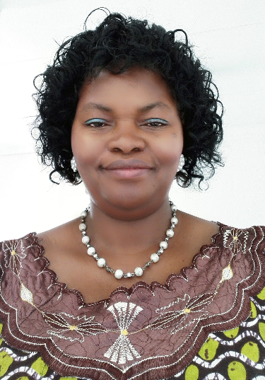
CONTACT ADDRESS

Prof Jane Catherine Ngila
Head, Department Applied Chemistry
University of Johannesburg, Doornfontein
P.O Box 17011, Doornfontein 2028 Johannesburg, SOUTH AFRICA
Off Tel +27 11 5596196; Fax +27 11 5596425/5596154;
Cell: +27716320106 /+27716320106:
Email: jcngila@uj.ac.za OR: jcngila2002@yahoo.com

SUMMARY OF BIOGRAPHY

Prof Catherine Ngila received her B.Ed in Science and MSc in Chemistry from Kenyatta University, Kenya in 1986 and 1992, respectively, and PhD from University of New South Wales, Australia. She received Awards from German Academic Exchange Service (DAAD) for MSc in 1987 and Australian International Development Assistance Bureau for her PhD in 1991. She was appointed a tutorial fellow in 1989 and a lecturer in 1996 at Kenyatta University. She also lectured at the University of Botswana (1998-2006), and at the University of KwaZulu Natal (2006-2011) before joining University of Johannesburg as a Full Professor of Analytical/Environmental Chemistry in April 2011. She is currently the Head of Applied Chemistry Department. She is South Africa National Research Foundation (NRF) rated with Google Scholar h-Index of 14. She has had previous membership in various Chemical Societies including American Chemical Society; Royal Society of Chemistry; South Africa Chemical Institute and Kenya Chemical Society. She has authored and co-authored about 120 peer-reviewed journal articles, review articles and book chapters. She has presented over 120 conference papers in different countries. Her research work focuses on water pollution monitoring, developing analytical methodologies for detecting pollutants including their speciation analysis in water. She has supervised and graduated over 60 Honours, MSc and PhD students including training of Postdoctoral Fellows. She is a Member of Advisory Board of the Africa Utility Week on Clean Power and Water. She sits in South Africa Department of science and Technology (DST) panels for bilateral cooperation on nanotechnology & water. She is regularly invited to chair the NRF Panels for funding applications as well as a member of Advisory Board of Water South Africa journal; a reviewer and reference member of South Africa Water Research Commission projects. She reviews articles in international journals including Water research, Water South Africa, Nanotechnology, Talanta, Analytical Letters, Journal of Hazardous Materials, Desalination and Water Purification, South Africa Journal of Chemistry, etc.

