Follow us on:
@CarletonHCon
#2016 HCS

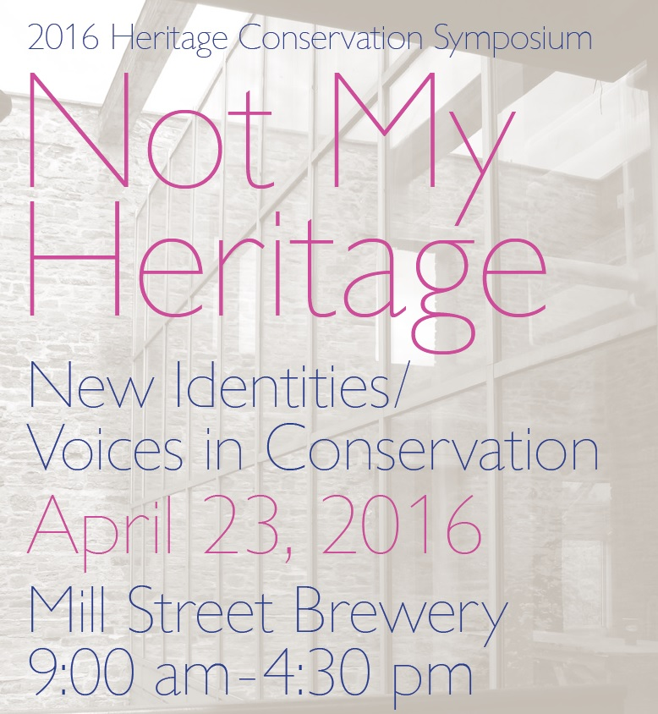

WELCOME to the 11th annual Carleton University Graduate Student Heritage Conservation Symposium, Not My Heritage: New Identities / Voices in Conservation!

In recent years, the identification and conservation of cultural heritage resources—the built environment, cultural landscapes, or intangible heritage—by heritage professionals, has needed to expand and broaden its understanding of community histories to address the plurality and the multi-narratives that exist in our communities.
‘NOT MY HERITAGE’, the theme of this year’s Heritage Conservation Symposium, aims to explore some of the areas, voices, and identities of Canadian cultural heritage that have not/are not being acknowledged or identified as significant cultural heritage resources in the current heritage discourse.
For eleven years this symposium has played a role in Ottawa’s heritage landscape, providing critical discussion on heritage and conservation, as the Heritage Conservation stream in Carleton’s School of Canadian Studies is uniquely positioned to facilitate such discussions. Today, we will question how colonial/post-colonial and transnational perspectives are being addressed in heritage conservation; and how we are engaging or interacting with minority groups who may not consider what they value to be ‘heritage’.
We hope you enjoy today’s thought-provoking and compelling speakers, and that you will be inspired to look critically and creatively at your own heritage and/or conservation work.
Enjoy!
James Arteaga, Amber Polywkan, Marie-Christine Blais, Elisabeth Boekhoven, Krista Gowan and Lindy Van Vliet
Co-Chairs, 2016 Heritage Conservation Symposium
MA Students, Canadian Studies – Heritage Conservation
April 2016

To our generous 2016
Corporate Sponsors
– THANK YOU!

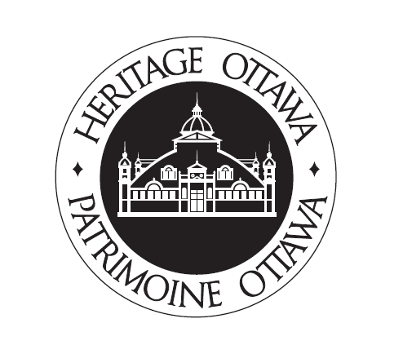
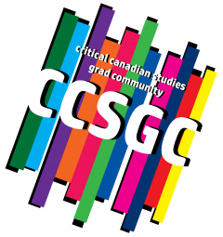
Thank you to our
Carleton University
Partners:

The School of Canadian Studies

The Centre for Indigenous Research, Culture, Language and Education (CIRCLE)

The Centre for Aboriginal Culture and Education (CACE)

2016 Programme
8:00 – Registration opens
9:00 – Introductory Remarks
Amber Polywkan
Co-Chair, 2016 Carleton University Heritage Symposium. M.A. Candidate, School of Canadian Studies - Heritage Conservation, Carleton University
Annie (Kishkwanakwad) Smith St. Georges
Elder, Anishinabek (Algonquin)
Peter Hodgins
Director, School of Canadian Studies, Carleton University

9:30 – Session 1: Community and Conservation:
The Human Dimension
Conservation as Reconciliation: The Russ Moses Residential School Memoir & Rattle as Context for an Indigenous Heritage
Conservation Ethic John Moses
Policy Analyst, Aboriginal Affairs Directorate, Canadian Heritage, and PhD Candidate, Cultural Mediations, Carleton University
More to Canadian Heritage Than Old, White, French & English Robert Shipley
Associate Professor, School of Planning, and Director, Heritage Resources Centre, University of Waterloo

Mapping Toronto’s Queer Asian Heritage
Thompson Nguyen
Student Intern, ERA Architects
10:20 – Questions
10:40 – 11:00 – Morning Break
11:00 – Session 2: Interrogating the Role of Space
in Cultural Heritage
Living with the Past: Rethinking Indigenous Cultural Landscapes Karen Aird
Indigenous Cultural Heritage Strategist, Treaty 8 Tribal Association
Alain Fournier
Architect and founding partner of EVOQ Architecture
“They call it Wishkubimin or sweet corn”: Threads of Food Heritage Continuity in Southwestern Ontario
Rick Fehr
Assistant Professor, First Nations Studies and Geography, Western University
Jared Macbeth
Project Review Coordinator, Walpole Island First Nation External Projects Program
Heritage at the Treaty Table: Negotiating Indigenous Heritage in the British Columbia Treaty Process
Jesse Robertson
MA in Public History, Carleton University
11:50 – Questions
12:10 - 1:30 – Lunch Break
1:30 – ‘Off the Page’ and Into Practice: Revisiting the Haudenosaunee Sky Woman Narrative
Kahente Horn-Miller
Assistant Professor, School of Canadian Studies, Carleton University

2:00 – Questions
2:20 - 2:40 – Afternoon Break
2:40 – Session 3: Communicating Cultural Heritage: New Directions and Reflections
Indigenous Peoples & Heritage Conservation –Gathering Strength from the “Circle”, Perspectives from Two Members of the former Circle of Aboriginal Heritage and Knowledge at Library and Archives Canada
Deborah Pelletier
Sr. Advisor, Education Branch, Indigenous and Northern Affairs Canada
Marie-Louise Perron
Retired Chief of Staff to the Commissioner of Official Languages in Ottawa
Indo-European Corruptions of Iroquoian Place Names
Rebekah Ingram
Ph.D. Candidate, School of Linguistics and Language Studies, Carleton University
Burning the Whitehouse, Sir Isaac Brock, and PolandBall:
An Analysis of Social Media as a Space for Government
Narrative Critique
Lindy Van Vliet
M.A. Candidate, School of Canadian Studies, Carleton University
3:30 – Questions
3:50 – Closing Remarks
Jurek Elżanowski
Assistant Professor, School of Canadian Studies, Carleton University

Annie (Kishkwanakwad) Smith St. Georges
Elder, Anishinabek (Algonquin)
Amber Polywkan
Co-Chair, 2016 Carleton University Heritage Symposium. M.A. Candidate, School of Canadian Studies - Heritage Conservation, Carleton University
2016 Presentation Abstracts
John Moses Conservation as Reconciliation: The Russ Moses Residential School Memoir & Rattle as Context for an Indigenous Heritage Conservation Ethic
Written in 1965, the Russ Moses Residential School Memoir presented here recounts the experiences of the late Russ Moses (Delaware band, Six Nations of the Grand River, 1932 - 2013) at the Mohawk Institute Indian Residential School in Brantford, Ontario, which he attended from 1942 to 1947. The conditions described by Moses in the Memoir argue for an interpretation of the Mohawk Institute of the 1940s as an agricultural forced labour enterprise in support of the industrial-scale civilian food production effort on the Canadian home front during the Second World War. Remarkably, the survival of a single photograph and a metal rattle associated with the Memoir, made and used in secret by the child inmates at the Institute in imitation of a traditional Haudenosaunee (Iroquois) longhouse rattle, attests to the retention of the intangible cultural heritage values embedded in objects, highlights the tension between “traditional” versus “non-traditional” forms of Indigenous cultural expression, and provides an opportunity to reflect upon notions of “heirloom” versus “artifact” versus “sacred object”.

Robert Shipley More to Canadian Heritage Than Old, White, French & English
When people say Canada is a young country they don’t realize how insulting and limiting that seemingly innocent phrase really is. Unpacked what it means is that 10,000 years of First Nations occupation is of no account in terms of heritage and that history in Canada only began with arrival of Europeans. By extension the heritage of other people who came later is also unimportant. Of course people who utter the young Canada phrase don’t mean to be impolite, they are Canadians after all, but I will argue that we ought to stop saying it. Instead we should be exploring our heritage as Canadians in the broadest possible context from the earliest human settlement up to the feelings of those who arrived last week to make Canada their home. Two questions arise: how can we honour the legacy of previous generations from whom we, as individuals, may not have descended genetically and can newcomers adopt/inherit the story of the country that is their new home? Some evidence from empirical research is shared and may be surprising.

Thompson Nguyen Mapping Toronto’s Queer Asian Heritage
Queer and trans (QT) Asian-Canadian youth have stories of resilience and solidarity that need greater recognition within mainstream queer history. In the Greater Toronto Area (GTA) - in particular within Toronto’s downtown core - there is a network of safe spaces and communities that allow QT youth to explore their identities. However, welcoming spaces for QT youth of East and Southeast Asian heritage can be harder to find. Pushed into the margins of the marginalized, racialized QT people often have to fight for an inclusive space within both their ethnic communities and their queer communities.
Racism, class and gender often exclude queer and trans people of colour (QTPOC) out of mainstream gay village spaces. On the other side, QTPOC often deal with homophobia and transphobia within their own ethnic cultural communities. The ambivalence felt from both communities force QTPOC to be at much greater risk of various challenges to their mental and physical health. Unfortunately, these factors make it harder for them to share their stories and affirm their value.
Organizations like the Asian Community for AIDS Services (ACAS) - along with their youth program Queer Asian Youth (QAY) - allow many Asian-Canadians within the GTA access to public outreach services as well as inclusion into an active ethnoracial community. Sharing the story of how these groups have established could influence space allocation for race-specific community groups.
As a young, queer-identified, Vietnamese-Canadian, middle-class man, I have been searching for the stories and spaces by people like me. I have found them in the back of bubble tea houses, in office buildings in Chinatown, and pushed to the corner at gay bars and clubs. The queering of Asian businesses and the struggle for representation in white gay spaces is a story of community building that needs to be documented and valued within the greater narrative of queer heritage.

Karen Aird and Alain Fournier Living With the Past: Rethinking Indigenous Cultural Landscapes
The conservation and management of living Indigenous heritage places, places where Indigenous people of the past and present practice their traditional ways of life, are important for maintaining the identity, health and well-being of Indigenous people. As urban and industrial development activities continue to expand at an unprecedented rate into Indigenous territories, often heavily impacting and destroying significant heritage places, Indigenous people are constantly challenged with how to manage their cultural landscapes and objects in such a way that the heritage values of each place is preserved for present and future generations. Moreover, when designing cultural spaces, such as museums and interpretive parks, situated on these sites - it is critical to ensure the protection, preservation and promotion of these places in a way that future generations can enjoy, understand and pass on their stories for years to come. In this presentation, we propose a new approach when developing strategies for cultural spaces of living heritage sites, clearly differentiating them from other sites, and also an innovative way of looking at the complexities of these sites when developing them for education or tourism purposes. In particular, this presentation describes recent efforts of several of the Treaty 8 First Nations in northeastern British Columbia to conserve and manage two important cultural landscapes while dealing with the constraints of heritage legislation and concurring demands of industry. Each of these two landscapes, including the sacred Twin Sisters Mts. with the associated Williston Reservoir Dinosaur Trackway and Tse’K’wa (the Charlie Lake Cave site), have required a unique value-based approach and unexpected collaborations. Based on a process developed in the Inuit Nunangat and Eyou Istchee territories, we will propose a different approach to creating new Indigenous spaces within these ancient and sacred places that incorporate Indigenous narratives and design elements. This approach implies going beyond traditional consultation methods and practices, finding new ways of truly engaging Indigenous stakeholders, a type of dialogue that will lead not only to their empowerment but to their control of the narrative.

Rick Fehr and Jared Macbeth “They call it Wishkubimin or sweet corn:” Threads of Food Heritage Continuity in Southwestern Ontario
Indigenous and settler land use in the first half of the eighteenth century reveals a dietary menu that is both nutritionally rich and dependent on biodiversity. However, contemporary farming and economic practices reduce the capacity for joint agricultural and ecological restoration initiatives.
Our research, a collaborative effort with members of the Walpole Island First Nation, considers the significance of ever decreasing marginal habitat in heritage conservation efforts. Through our inquiry, which includes the study of Indigenous and settler journals, field surveys, ground truthing, and Nishnaabemwin place names, we are helping to direct Heritage Planning in areas outside the reserve boundaries that are heavily developed for agriculture and industry. Documenting past and present Indigenous land use informs the identification of cultural heritage landscapes for conservation that are less known by the general public as opposed to the built heritage resources of Euro-Canadian origin that are currently celebrated.
In the municipality of Chatham – Kent, part of the traditional territory of the Anishinaabeg of Walpole Island, the public education that is emerging from these efforts is transforming the awareness of Indigenous and settler past practices and in some cases the threads of continuity. Ultimately, restoring historic food practices, food sources, and the ecological integrity required for land-based heritage conservation presents opportunities for the Indigenous community to identify with ideas of homeland that extend beyond reserve boundaries. Simultaneously, settler society receives a nuanced perspective into both Indigenous and settler land use that elevates the status of land and water as having the capacity to support multifunctional and culturally distinct livelihoods.
Jesse Robertson Heritage at the Treaty Table: Negotiating Indigenous Heritage in the British Columbia Treaty Process
Since the signing of the Nisga’a Final Agreement in 1999, Aboriginal land claims have become a significant and often contentious component of Canada’s legal and political landscape. While the implications of contemporary treaty negotiations have been the subject of a great deal of academic research, few have commented on their role as sites of public history. This paper hopes to add to scholarly conversations on contemporary negotiations by investigating heritage provisions within treaties negotiated under the contemporary British Columbia Treaty Process, each of which has included important provisions relating to culture and heritage. These range from the devolution of responsibility for the designation and management of heritage sites to the repatriation of artifacts from national and provincial museums. This presentation brings to light an important and rapidly shifting feature in the landscape of Canadian heritage conservation by exploring specific provisions within the Maa-nulth First Nations Final Agreement, which came into effect in 2011. So doing, this paper seeks to better understand the motivations of First Nation and settler governments in negotiating such provisions. How do heritage and cultural provisions support Aboriginal cultural revitalization? What limitations arise from negotiating heritage conservation within the legalized framework of treaty negotiation? By considering such questions, this project demonstrates that contemporary treaty negotiations has become a critical site for negotiating heritage, and suggests that the traditional dichotomy between politics and heritage may have less explanatory purchase when applied to Indigenous peoples’ struggles towards decolonization.

Kahente Horn-Miller ‘Off the Page’ and Into Practice: Revisiting the Haudenosaunee Sky Woman Narrative
This performative interpretation of the Sky Woman story is adapted from Horn-Miller’s doctoral thesis. This version contains teachings from the everyday lives of women who live in Kahnawà:ke and were the focus of the research. Narrated in the first person, this story presents a counter narrative to histories of the written page. Through its decolonization and rematriation, a story that was abstract and intangible becomes tangible and alive. In focus, this version presents another way of thinking about the practice of heritage conservation from within.

Deborah Pelletier and Marie-Louise Perron Indigenous Peoples & Heritage Conservation –Gathering Strength from the “Circle”, Perspectives from Two Members of the former Circle of Aboriginal Heritage and Knowledge at Library and Archives Canada
This paper will discuss the Library and Archives Canada (LAC) former approach of a “Circle” of librarians, archivists, genealogists, educators and other specialists in addressing the longstanding euro-centric perspective of history and heritage conservation. The LAC Circle had been established to enhance and support the inclusivity of Indigenous knowledge, culture and perspectives, in fulfilling its mandate to acquire, conserve, protect and make accessible Canadian documentary heritage.
In the context of this paper, “documentary heritage" refers to information in any format (e. g. paper, audio, photographic), original or published, created or collected by individuals during their lives or their functions, now held by LAC and other institutions, including Aboriginal communities.
In this context, the presenters will discuss how the lines between libraries, archives, museums, cultural centers, and other information-holding organizations intersect in the area of heritage preservation. The focus of the paper will be on how the Circle proceeded in developing effective relationships with Indigenous peoples and implementing activities respecting the needs and interests of both the institution and of the communities being represented and/or served.
This paper will provide an overview of the experience of the presenters with respect to their participation in a Circle of Aboriginal Heritage and Knowledge at LAC. It will speak to past initiatives in which the Circle engaged Indigenous peoples, in order to provide a more balanced perspective on the evolution of Canada, as it relates to the social, economic and political contributions of Aboriginal peoples in Canada (tangible and intangible), preserved by the institution.
The presenters will also provide a synopsis of lessons learned and discuss suggestions for roles played by leaders and practitioners within both the institutions and the communities.

Rebekah Ingram Indo-European Corruptions of Iroquoian Place Names
According to Warrick (2007), the St. Lawrence River valley and north shore of Lake Ontario was inhabited by an Iroquoian population numbering approximately 60,000 comprised of 50-60 villages. This area was mapped extensively by the major colonial entities throughout the process of colonization; subsequently, the resulting maps included many of the original indigenous place names. Despite this documentation, as of yet these maps have not been used to reconstruct the historical Iroquoian place names within the indigenous languages themselves.
This paper examines French representations of indigenous place names in cartographic discourse and attempts to filter out layers of colonization by exploring the underlying phonological structures of these names in the source and target languages. Through a systematic examination of their representations on these maps, several specific types of corruptions are identified and an approximation of the original forms in which they were transmitted to non-indigenous peoples is proposed. It is also demonstrated how these specific corruptions have created confusion by causing surface similarities between unrelated languages.
Lindy Van Vliet Burning the Whitehouse, Sir Isaac Brock, and PolandBall:
An Analysis of Social Media as a Space for Government Narrative Critique
The Canadian government’s decision to commemorate the War of 1812 was part of the nationalizing-state’s efforts to create a sense of shared community among citizens through the establishment of a historic myth. Increasingly, Canadian citizens have turned to social media platforms to share their opinions on government narratives. One platform in particular has exploded into mainstream social media use, the internet image-macro meme, known colloquially as a ‘meme.’ Memes offer an exciting new opportunity to study how people are interacting with government mediated heritage through online platforms. Using the War of 1812 as a case study, I examine how memes can act as a space for Canadians to question and critique government narratives, and create counter-narratives. I complete this research in a three stage process: First, I give an over-view of my theoretical framework and outline the limitations to meme-based research. Second, I conduct a review of the government’s mythology on the War of 1812 using the website 1812.gc.ca. During this review I pay particular attention to three different themes as they appear in the government narrative: American invasion and Canadian victory, Indigeneity, and Masculinity. Finally, I conduct an in-depth analysis of six different memes using the three frameworks identified above. Through this three step process I argue that memes can create a space for social media users to critique government narratives; however, there are limits to the responses and meme-users continue to propagate key aspects of the government-mandated version of the War.

A warm thank you to our many supporters:

Thank you to our Volunteers! Without your time and energy, the 11th annual Heritage Conservation Symposium would not have been possible.
Thank you to Mill Street Brewery for a fantastic venue and enormous support during the planning processes of the Symposium.
Thank you to Donna Malone for her immense knowledge and hard work throughout the organization of this event.
Thank you to Robert Tombs for his lovely poster designs.
Thank you to Susan Ross and Jurek Elzanowski for their tireless enthusiasm, their commitment to excellence, their valuable insight and their guidance in organization of this year’s Symposium,
despite busy schedules and other duties.
Thank you!

To all of our speakers, guests, and supporters:

We would like to thank each of you for attending and participating in the eleventh annual Heritage Conservation Symposium.
We are honoured to bring together so many brilliant minds discussing the subject. Carleton’s School of Canadian Studies is lucky to play host to so many of these voices and hopes to continue being critical and creative throughout the year.
We hope today’s speakers have inspired you to look differently at your respective fields and incorporate new voices and identities in your own work!

James Arteaga, Amber Polywkan, Marie-Christine Blais, Elisabeth Boekhoven, Krista Gowan and Lindy Van Vliet
Co-Chairs, Heritage Conservation Symposium 2016
MA Students, Canadian Studies – Heritage Conservation
April 2016

