Title
by

Firstname Lastname

A thesis submitted to the Office of Graduate Studies in partial fulfillment of the requirements for the degree of

Master of Design

in the

School of Industrial Design

Carleton University
Ottawa, Ontario

© 202X,

Firstname Lastname

Abstract
Throughout this template are context specific instructions. As you complete sections and/or no longer need the instructions they can be deleted. There will also be a ‘bare-bones’ version of this template made available.

Formatting has been completed as per the instructions found at: https://gradstudents.carleton.ca/resources-page/thesis-requirements/formatting-guidelines/

The Title Page requires:
- Your Thesis Title
- Your name, consistent with the name under which you registered at Carleton
- The correct year on the copyright statement.

Acknowledgements
You may use this section to extend your thanks to those who have helped and supported you throughout your thesis writing process. This may include your supervisor/co-supervisor, subject matter experts that were consulted with, friends and family or any person or organization who assisted you. Keep in mind that these acknowledgements are public and permanent.

Template Instructions
We have provided you with a usable template to format your thesis according to the formatting guidelines contained here. The library also provides a template that can be found here. We strongly recommend learning how to use and apply paragraph styles within Microsoft Word, as these large documents require a more nuanced approach to formatting, we have provided further information on the styles below. You can change the styles, so long as it meets the formatting guidelines stipulated by the university. This section can be deleted upon completion of your thesis. Most of the information you need to know about utilizing the template can be found here.
Quick Tips


Want to know what is going on with your paragraphs and page breaks? Hit the ‘Show Hidden Formatting Styles’
Use a Citation / Reference Manager! If you haven’t started this already, the best time to start is now. Popular options include Mendeley, Zotero and EndNote.
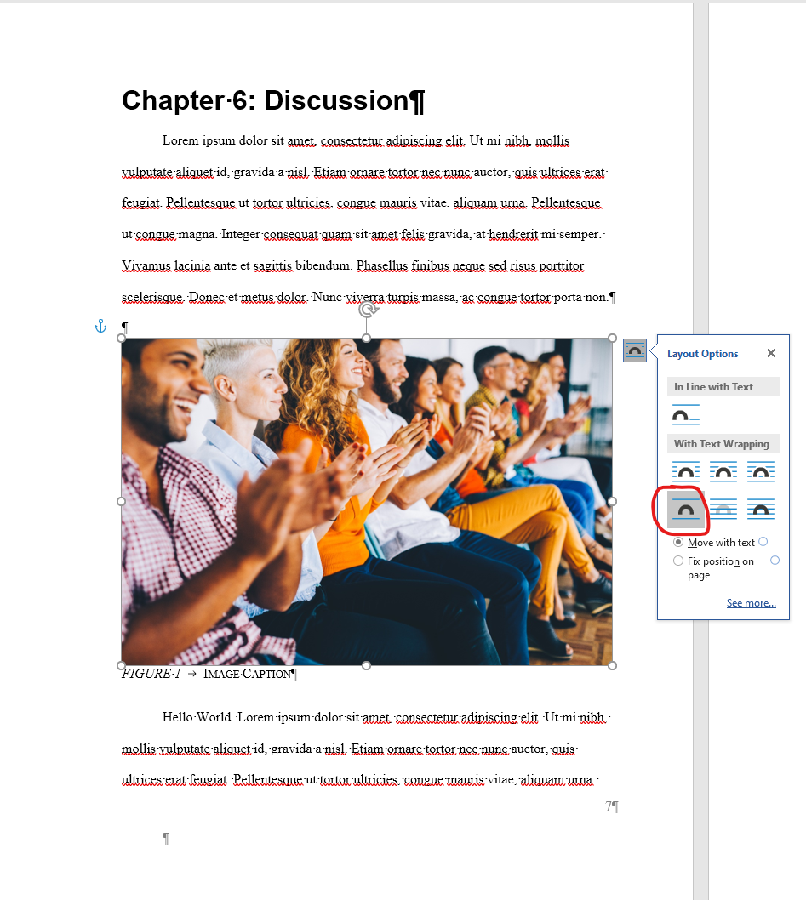
When putting images in your thesis you’ll have the most luck using the ‘top and bottom’ text-wrapping alignment for your images. Note the ‘Move with Text’ and ‘Fix position on page’ options as well. These you may choose to use in specific occurrences when appropriate.

Paragraph Styles

If you have not used styles in MS word, this tutorial will give you a quick introduction: https://www.youtube.com/watch?v=UOVU6qQ2iOM
Most of the styles you will need to use have already been created. On the following page is a list of the styles created for this document and use cases / tips.

Style List
Style Name | Notes
Heading 1 | This style is the parent style for all of the headings and section dividers. If you change the font on this style, it will change the font on the following styles: Chapter Headings, Heading 2, Heading 3, Heading 4, Appendix Level One, Appendix Level Two & Appendix Level 3
Normal | This style is the parent style for all of the body text within your thesis. Changing this style will affect the following styles: Figure Captions, Table Caption, Table Title, Table Header, Book Title, Emphasis, List Paragraph, Quote
- Chapter Headings | Use this style to denote the content sections of your thesis. It will automatically place ‘Chapter X:’ before your title. The standard chapters have already been added to this document
Heading 2 | Use to denote a primary section within a chapter. Paragraphs with this style will show up in your table of contents
Heading 3 | Use to denote a secondary section within a chapter. Paragraphs with this style will not show up in your table of contents
Heading 4 | Use to denote a tertiary section within a chapter. Paragraphs with this style will not show up in your table of contents
- Figure Caption | Use this style for your figure captions. Figures will be automatically labeled with ‘FIGURE X ‘ before your caption. Any paragraphs with this style will show up in the generated list of figures
- Table Caption | Use this style for your table captions. Tables will be automatically labeled with ‘TABLE X’ before the caption. Any paragraphs with this style will show up in the generated list of tables
Table Title | Use this style for titling your table at the top. See the top of this table for reference
Table Headers | Use this style to indicate your headers within tables. In this table the columns with ‘Style Name’ and ‘Notes’ have this style applied
Book Title | Use this style when referencing a book title within your text
Emphasis | You can use this style to indicate emphasis within your body text
List Paragraph | If you’re creating a numbered or bulleted list, apply this style before adding numbers or bullets. This will increase the list’s indentation
Quote | Use this style for large block quotes from sources
- Appendix Level One | Use this style for primary appendix sections. Sections will be automatically labeled with the text ‘Appendix X’. Paragraphs with this style will appear in the list of Appendices.
- Appendix Level Two | Use this style for secondary appendix sections. Sections will be automatically labeled with the text ‘Appendix X.Y’ Paragraphs with this style will appear in the list of Appendices.
- Appendix Level Three | Use this style for tertiary appendix sections. Sections will be automatically labeled with the text ‘Appendix X.Y.Z’ Paragraphs with this style will appear in the list of Appendices.
Thesis Title | Use this style only for your thesis title. It is independent of font changes made to ‘Normal’ or ‘Heading 1’
Title Info | Use this style for the rest of the information on your titlepage it inherits the font from the ‘Thesis Title’ style

Captions

To add captions to your tables or figures. Create a new paragraph below the relevant object and apply the appropriate style (Figure Caption or Table Caption). DO NOT right click on an image or table and press the ‘caption’ button. The automatic numbering and generation of lists for the front matter will not update correctly.
Table of Contents & Lists of Figures

This template will allow you to automatically update and generate the following lists:
- Table of Contents
- List of Tables
- List of Figures
- List of Appendices
To update one of these lists, you can right click on the relevant list and hit ‘update field’. If you need to re-generate one of these lists that can be done by going to the ‘References’ tab, selecting ‘Table of Contents’, scrolling to the ‘General’ section and selecting the relevant list.
References

Using a citation manager with a word plugin will allow for the automatic generation of your reference list at the end of your thesis. The Mendeley plugin will make in-text citations relatively easy and will take care of the formatting.
Page Numbers

Page numbers have been set as per the requirements laid out by the University. Front matter is numbered with lowercase roman-numerals starting after the title page with ‘ii’. The body of the document and the appendices are numerated with standard Arabic numerals starting at ‘1’.

Table of Contents
Abstract ii
Acknowledgements iii
Template Instructions iv
Table of Contents ix
List of Tables xi
List of Figures xii
List of Acronyms xiii
List of Appendices xiv
Chapter 1: Introduction 1
Chapter 2: Background 3
Chapter 3: Literature Review 4
1.1 Topic One 4
1.2 Topic Two 4
1.3 Topic Three 4
Chapter 4: Methodology 5
Chapter 5: Results 6
Chapter 6: Discussion 7
Chapter 7: Conclusion 9
References 10
Appendices 11
Appendix A Level One 11
Appendix A.1 Level Two 11
Appendix A.1.1 Level Three 11
Appendix A.1.2 Level Three Part Two 11
Appendix B Second Appendix 11

List of Tables
TABLE 1 Descriptive table caption that will show up in the list of tables 5
TABLE 2 Descriptive Table Caption for Table 2 5
TABLE 3 Descriptive Table Caption for Table 3 5
TABLE 4 Descriptive Table Caption for Table 4 6
TABLE 5 Descriptive Table Caption for Table 5 6

List of Figures
FIGURE 1 Test Figure Caption 6
FIGURE 2 Test 2 Figure 6
FIGURE 3 Image Caption 7
FIGURE 4 Description of Image 2 8

List of Acronyms
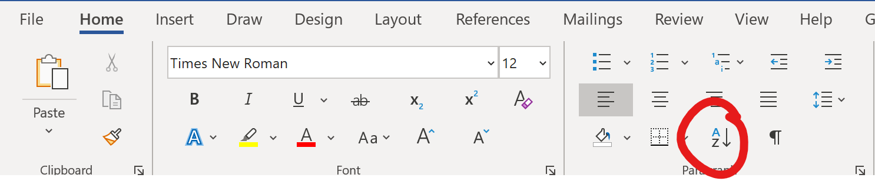
Place your commonly used acronyms on this page. With a new paragraph for each entry. Upon completion of your thesis this list can be sorted alphabetically by selection the ‘Sort’ option under the ‘Home’ tab.
ID – Industrial Design
CU – Carleton University
PD – Participatory Design

List of Appendices
Appendix A Level One 19
Appendix A.1 Level Two 19
Appendix A.1.1 Level Three 19
Appendix A.1.2 Level Three Part Two 19
Appendix B Second Appendix 19

- Introduction
Lorem ipsum dolor sit amet, consectetur adipiscing elit. Ut mi nibh, mollis vulputate aliquet id, gravida a nisl. Etiam ornare tortor nec nunc auctor quis ultrices erat feugiat. Pellentesque ut tortor ultricies, congue mauris vitae, aliquam urna.
Pellentesque ut congue magna. Integer consequat quam sit amet felis gravida, at hendrerit mi semper. Vivamus lacinia ante et sagittis bibendum. Phasellus finibus neque sed risus porttitor scelerisque. (Author, Date)
Donec et metus dolor. Nunc viverra turpis massa, ac congue tortor porta non. Lorem ipsum dolor sit amet, consectetur adipiscing elit. Ut mi nibh, mollis vulputate aliquet id, gravida a nisl. Etiam ornare tortor nec nunc auctor, quis ultrices erat feugiat. Pellentesque ut tortor ultricies, congue mauris vitae, aliquam urna.
- List Item One
- List Item Two
- List Item Three
Lorem ipsum dolor sit amet, consectetur adipiscing elit. Ut mi nibh, mollis vulputate aliquet id, gravida a nisl. Etiam ornare tortor nec nunc auctor, quis ultrices erat feugiat. Pellentesque ut tortor ultricies, congue mauris vitae, aliquam urna. Pellentesque ut congue magna. Integer consequat quam sit amet felis gravida, at hendrerit mi semper. Vivamus lacinia ante et sagittis ibendum. Phasellus finibus neque sed risus porttitor scelerisque.
Donec et metus dolor. Nunc viverra turpis massa, ac congue tortor porta non.
Lorem ipsum dolor sit amet, consectetur adipiscing elit. Ut mi nibh, mollis vulputate aliquet id, gravida a nisl. Etiam ornare tortor nec nunc auctor, quis ultrices erat feugiat. Pellentesque ut tortor ultricies, congue mauris vitae, aliquam urna. Pellentesque ut congue magna.
- Bullet Item One
- Bullet Item Two
- Bullet Item Three
Integer consequat quam sit amet felis gravida, at hendrerit mi semper. Vivamus lacinia ante et sagittis bibendum. Emphasis on a particular sentence within a paragraph.

- Background
- Literature Review

Topic One

Subtopic One

Sub-Subtopic One - Consider your Organization Schema if you end up here.

Topic Two

Topic Three
- Methodology
- Table Title
Table Heading | Column Heading
Row Heading
- Descriptive table caption that will show up in the list of tables
Table 2
Table Title
- Descriptive Table Caption for Table 2
Table 3
Table Title
- Descriptive Table Caption for Table 3
- Results
Table 4
Table Title
- Descriptive Table Caption for Table 4
- Discussion
Lorem ipsum dolor sit amet, consectetur adipiscing elit. Ut mi nibh, mollis vulputate aliquet id, gravida a nisl. Etiam ornare tortor nec nunc auctor, quis ultrices erat feugiat. Pellentesque ut tortor ultricies, congue mauris vitae, aliquam urna. Pellentesque ut congue magna. Integer consequat quam sit amet felis gravida, at hendrerit mi semper. Vivamus lacinia ante et sagittis bibendum. Phasellus finibus neque sed risus porttitor scelerisque. Donec et metus dolor. Nunc viverra turpis massa, ac congue tortor porta non.

- Image Caption
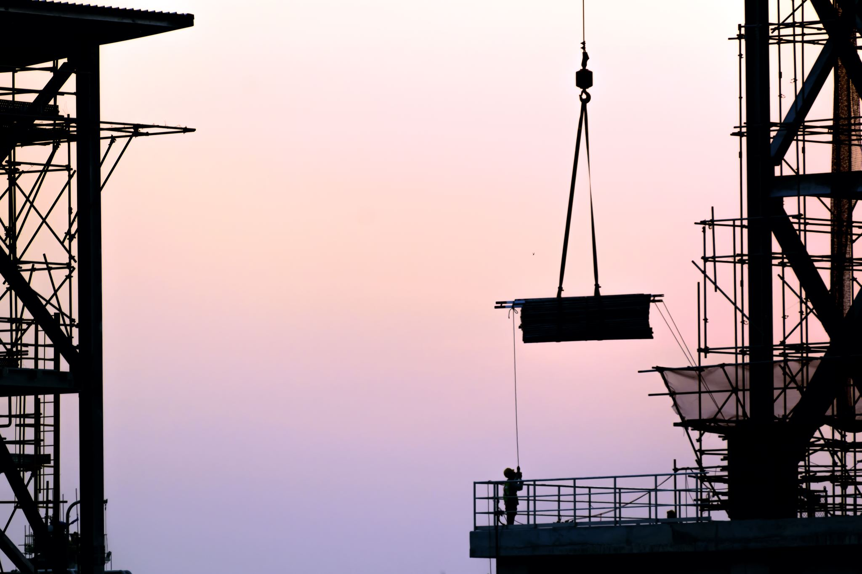
Hello World. Lorem ipsum dolor sit amet, consectetur adipiscing elit. Ut mi nibh, mollis vulputate aliquet id, gravida a nisl. Etiam ornare tortor nec nunc auctor, quis ultrices erat feugiat. Pellentesque ut tortor ultricies, congue mauris vitae, aliquam urna. Pellentesque ut congue magna. Integer consequat quam sit amet felis gravida, at hendrerit mi semper. Vivamus lacinia ante et sagittis bibendum. Phasellus finibus neque sed risus porttitor scelerisque. Donec et metus dolor. Nunc viverra turpis massa, ac congue tortor porta non.
- Description of Image 2
- Conclusion
communication between healthcare providers and patients, as well as patient satisfaction, is critical, due to their direct relation to patients’ health outcomes, and patient adherence respectively (Kessels, 2003; Street et al., 2009).

References
References should be done in APA style as per the Carleton APA guidelines: https://library.carleton.ca/help/apa-citation-style

Appendices
- Level One
  - Level Two
    - Level Three
    - Level Three Part Two
- Second Appendix

