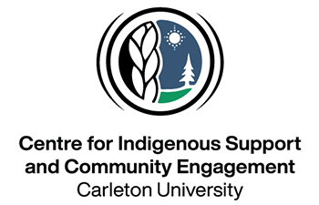

Application Form

INDG 4015: Pathways from Land to Nunavut Devolution

With land-based learning in Cambridge Bay, Nunavut, Fall 2026

- Travel for students covers flight, accommodation and meal expenses.
- Students with food allergies, sensitivities or dietary preferences (vegan, vegetarian) are advised that due to the remote location of Cambridge Bay, food options are extremely limited.

Applicant Information
Full Name: |  |  |  | Today’s Date:
 | First | Last | M.I.
Student Number:

Address:
 | Street Address | Apartment/Unit #

 | City | Prov. | Postal Code

Phone: |  | Student Email

Date of Birth (DD/MM/YYYY): |  | Age: |  | Gender:

 |  |  |  |  |  | Pronouns:
Are you Inuk?  *Applicants must be Inuk Beneficicary of the Nunavut Land Claims Agreement | YES |  | NO
If yes, what Community are you connected to?

What Inuit region does your family come from?
How long have you been living in the South?
Are you a student at Carleton University? | YES | NO

Have you ever been to Nunavut? | YES | NO

Have you ever participated in a land-based-learning opportunity before? | YES | NO

If yes, explain:

Emergency Contact Information
Please list two contacts in the event of an emergency.

Full Name (First/Last): |  | Cell Phone:
Relationship: |  | Alternate Phone:
Full Name (First/Last): |  | Cell Phone:
Relationship: |  | Alternate Phone:

Disclaimer and Signature
I certify that my answers are true and complete to the best of my knowledge.
If this application leads to participation in the exchange, I understand that I will need to be present for the scheduled dates, October 24-November 1, and may need to provide additional information to staff at the Centre for Indigenous Support and Community Engagement if needed.
Signature: |  | Date:

