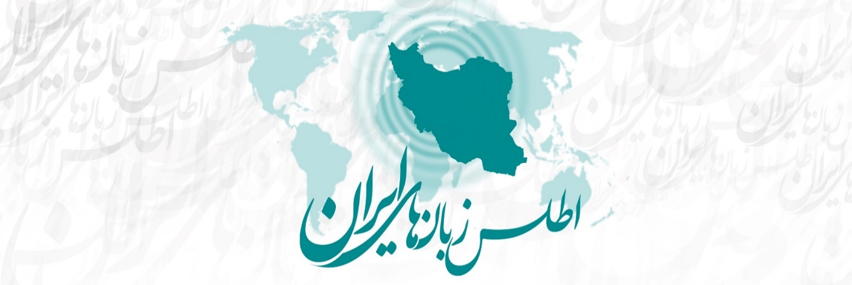Atlas of the Languages of Iran (ALI)
Language data questionnaire

Contents
General information
Permission text
Sociolinguistic context
Lexicon
Phonology
Morphosyntax (separate document)
Numbers (separate document)

Note: Please read the accompanying ALI questionnaire instructions before carrying it out in a research location.

General information
(to be filled out by the field researcher before or after fieldwork)

Name of person filling out this questionnaire: _________________________
Date filled out: _________________________
Email address: _________________________

Name of person(s) checking / analyzing the questionnaire data (checker to fill this in):
_________________________
Date checked / analyzed (checker to fill this in): _________________________
Date approved for upload (editors to fill this in): _________________________

Language variety (language, dialect, subdialect, etc.): _________________________
Language data from which province and which exact village(s)/town(s) (write the ALI unique ID beside the place name): _________________________
Is the data from your own fieldwork and/or from a published source?:
_________________________

If the data is from your own existing field notes, please ensure that it is from a single settlement. Then fill in the following details:
Field researcher(s):
Date of field research:
Location (province and district):
Language(s) of elicitation (indicate which are the main languages of elicitation, and which languages are used for clarification):
Sound recorder type _______ / Video recorder type _______ / Mic: internal or external?

If the data is from a published source, please fill in the following details:
Name of author(s):
Year of publication (if it’s in Persian, put both the Iranian and Western year):
Title:
(if an article or book chapter) Page numbers:
(if an article or book chapter) Journal or Book Title:
(if in an edited volume) Editor(s):
Place of publication:
Publisher:
Any other important information:

Permission text and speaker details

Before conducting the actual interview, please read the following text to the speakers you are working with, and record their answers:

My name is / our names are .... We come from .... We are linguists from the University of ... . We want to study and learn about the languages and dialects of [region]. Do you give us permission to ask you questions about your language, and to record and freely use what we learn, for research and eventual publication?

[make sure the answer is loud and clear enough to be audible on the recording]

If the speakers have given their consent, you can continue with the following questions, and the rest of the interview:

Would you like us to write your name(s) down, or would you like to remain anonymous?
______________________________

Name of speaker(s) (only put this if speakers have requested that their names be used):
(1) ____________________________
(2) ____________________________
(3) ____________________________

Other details about the speakers (include this information for all speakers):

Age:
(1) _________
(2) _________
(3) _________

Sex:
(1) _________
(2) _________
(3) _________

Profession:
(1) ______________
(2) _______________________--
(3) _______________________--

Languages spoken, and the speaker’s stated degree of proficiency (full = 5 / good = 4 / some = 3 / little = 2 / very little = 1)
(1) ______________________________________________________
(2) ______________________________________________________
(3) ______________________________________________________

Level of education (none / elementary / secondary / post-secondary):
(1) ______________________________________________________
(2) ______________________________________________________
(3) ______________________________________________________

Sociolinguistic context

The following portion of the questionnaire, which deals with language use in the context of a single settlement, is adapted from Anonby & Yousefian’s (2011) sociolinguistic study.

Please answer the questions as you are able, providing estimates if necessary. You may mark any item for which you are unable to provide an answer, with “?”.
- Community (city, town, village, etc.) name: _________________________________
- What languages are spoken in the community (city, town, village, etc.) as a mother tongue (that is, the first language a person learns at home as a child)?
____________________________________________________________________
- What proportion (approximate percentage) of the population speaks each of these languages as a mother tongue?
____________________________________________________________________
- What do the people in the community call their own language(s) (the most general language grouping possible) and dialect(s) (more local groupings at the regional and local level, i.e., their particular variety of the language they mention) in their own language(s)?
____________________________________________________________________
- What do the people in the community call their own ethnic group(s) (qom, tāifeh, etc.) in their own language(s)?
____________________________________________________________________
- What is the name of the community (city, town, village, etc.) in the language(s) that are spoken there?
____________________________________________________________________
- What proportion of the population (circle one answer for each):
speaks Persian fluently? all most some a few none
speaks some Persian? all most some a few none
speaks no Persian? all most some a few none
- Besides their mother tongue(s) and Persian, what additional languages and dialects do the people of the community speak?
____________________________________________________________________
- What proportion (all/most/some/a few/none) of the children in the community are not learning the mother tongue of their parents as their mother tongue? ___________
Which language communities do these children come from? (At the same time, specify the proportion of children – all/most/some/a few/none – who are not learning the mother tongue of their parents, for each language community.)
____________________________________________________________________
What language(s) are these children now learning as a mother tongue?
____________________________________________________________________

