Atlas of the Languages of Iran (ALI)
Questionnaire, Part I: Lexicon

Instructions
Please read carefully before each interview.
Fill out the wordlist in phonemic (not phonetic) transcription using the ALI transcription conventions (click to follow this link).
If you are collecting the data from a speaker, record the whole interview with a high-quality sound recording, using .wav file format if possible.
Make sure the speaker understands the exact meaning of each word; if the word is accompanied by an example sentence, clarification in parentheses, or picture, make sure to use it. However, make sure that the speaker does not translate words and sentences that are used for clarification. The speaker should only say the equivalent word, twice, in isolation (by itself), naturally and clearly.
The procedure for each word should therefore be as follows:
1. The researcher says the Persian word in isolation.
2. The researcher gives additional explanation or an example sentence.
3. The researcher says the Persian word again.
4. The speaker says the equivalent word in their own language, twice, in isolation.
Only elicit the most common and basic equivalent(s) for each word; do not elicit peripheral or figurative vocabulary. Generally, do not ask speakers if they use a particular word that they have not mentioned, unless you think that they have misunderstood the meaning of the wordlist item.
You can put any comments or explanations in the column to the right of the language data column. If speakers indicate that only a certain group of people uses a certain word (for example, only older people, or only younger people), make a note of this. If you are uncertain about any data, put your best transcription/hypothesis with a question mark beside it, or simply a question mark.
If you are filling out the questionnaire with data from a published source, put page numbers in the right column.
Notes
Swadesh 100-list items are underlined in the English list.
Verbs should be elicited in the third person singular (s/he) form. If a language makes a verbal distinction for she vs. he, elicit both forms.
The symbol * indicates additional instructions: either showing a picture to the speaker, or accompanying the elicitation with a specific action.
 | English  (Modern Standard) | Persian  (Western, Modern Standard) | Language data  (use phonemic transcription) | Comments  (may include explanations about the data in the language data column)  (for published sources, please put page numbers)

- 1. | hair (of head) | mu (muye sar)
- 3. | eye | češm
- 3. | eyebrow | abru
- 4. | nose | bini, damāġ
- 5. | ear | guš
- 6. | mouth | dahān
- 8. | tongue | zabān
- 10. | throat (inside)  (The food got stuck in her throat.) | galu (darune galu)  (ġazā tu galuyaš gir kard.)
- 11. | arm  *(show picture at end of wordlist) | dast (az šāne tā moče dast)  *(tasʋir dar pāyāne fehreste kalamāt)
- 12. | hand  *(show picture at end of wordlist) | dast (az moč be pāyin)  *(tasʋir dar pāyāne fehreste kalamāt)
- 13. | elbow | ārenǰ
- 13. | finger | angošt
- 16. | stomach (belly)  (I got hit in the stomach.) | šekam  (be šekamam zarbe xord.)
- 1ddd7. | stomach (organ, human)  (My stomach aches.) | me’de (me’deye ensān)  (me’deam dard mikonad.)
- 1ddd7. | navel | nāf
- 20. | leg  *(show picture at end of wordlist) | pā (az bālāye rān tā moče pā)  *(tasʋir dar pāyāne fehreste kalamāt)
- 22. | foot  *(show picture at end of wordlist) | pā (az moč be pāyin)  *(tasʋir dar pāyāne fehreste kalamāt)
- 21. | knee (whole knee) | zānu (kolle zānu)
- 24. | bone | ostoxān
- 25. | blood | xun
- 26. | urine | edrār, šāš
- 27. | heart (organ, human)  *(show pumping fist in front of own heart) | ġalb, del (andām, ensān)  *(mošte xod rā be mānande ġalb dar hālate pomp kardane xun nešān dahid)
 | liver | ǰegar
- 28. | man | mard
- 29. | woman | zan  (kalameye pāye)
- 29. | husband | šoʋhar
- 29. | wife | zan (hamsar)
- 30. | child | bače, bačče
- 30. | boy | pesar  (āġāye ǰaʋān)
- 30. | son | pesar  (farzand)
- 30. | girl | doxtar  (xānome ǰaʋān)
- 30. | daughter | doxtar  (farzand)
- 139. | brother  (basic term) | barādar  (kalameye pāye)
- 139. | sister  (basic term) | xāhar  (kalameye pāye)
- 35. | groom | dāmād (dar marāseme arusi)
- 35. | bride | arus (dar marāseme arusi)
- 74. | horse | asb
- 38. | dog | sag
- 38. | cat | gorbe
- 45. | wolf | gorg
- 74. | bear | xers
- 45. | fox | rubāh
- 47. | fish | māhi
- 51. | scorpion | aġrab
- 51. | ant | murče
- 51. | louse | šepeš
- 74. | sparrow | gonǰešk
- 74. | pigeon (domestic) | kabutar
- 74. | rooster | xorus
- 74. | wing | bāl
- 74. | feather | par
- 74. | wool | pašm
- 53. | tree | deraxt
- 54. | wood (substance) | čub (mādde)
- 54. | root | riše
- 54. | branch | šāxe
- 55. | leaf | barg
- 63. | sun | xoršid
- 63. | moon | māh
- 63. | day | ruz
- 65. | night | šab
- 66. | star | setāre
- 74. | water | āb
- 74. | fire | ātaš
- 74. | wind | bād
- 74. | smoke | dud
- 74. | ash | xākestar
- 63. | stone (10 cm. diameter) | sang (be ġotre 10 sāntimeter)
- 74. | west  (The sun sets in the west.) | maġreb  (āftāb dar maġreb ġorub mikonad.)
- 74. | year | sāl
- 74. | summer | tābestān
- 82. | winter | zemestān
- 74. | snow | barf
- 86. | house | xāne
- 86. | spoon | ġāšoġ
- 86. | salt | namak
- 93. | rice | berenǰ
- 96. | egg (e.g., chicken) | toxme morġ
- 98. | walnut | gerdu
- 74. | almond | bādām
- 74. | grape | angur
- 98. | hungry | gorosne
- 99. | thirsty | tešne
- 99. | bitter | talx
- 126. | fresh (e.g., milk) | tāze  (barāye mesāl, šir)
- 128. | long (thing) | derāz, boland  (barāye mesāl, šāxe)
 | big | bozorg
- 136. | dry | xošk
 | old (object)  (e.g., clothing) | kohne  (barāye mesāl, lebās)
 | full  (e.g., container) | por  (barāye mesāl, zarf)
- 137. | red  (e.g., blood) | ġermez, sorx  (barāye mesāl, xun)
- 139. | white  (e.g., snow) | sefid  (barāye mesāl, barf)
- 137. | green  (e.g., cucumber) | sabz  (barāye mesāl, xiyār)
- 139. | blue  (e.g., sky) | ābi  (barāye mesāl, āsemān)
- 141. | come (3s past) | āmad
- 141. | come (3s pres.) | miyāyad
- 156. | go (3s past) | raft
- 156. | go (3s pres.) | miraʋad
- 146. | fall (3s past)  (S/he fell onto the street.) | oftād  (ʋasate xiyābān oftād.)
- 146. | fall (3s pres.)  (S/he falls onto the the street.) | miyoftad  (ʋasate xiyābān miyoftad.)
- 156. | carry (3s past)  (S/he carried the boxes.) | bord  (ǰa’behā rā bord.)
- 156. | carry (3s pres.)  (S/he carries the boxes.) | mibarad  (ǰa’behā rā mibarad.)
- 156. | sleep (3s past) (deep sleep)  (S/he slept in the house.) | xābid (xābe amiġ)  (dar xāne xābid.)
- 156. | sleep (3s present) (deep sleep)  (S/he sleeps in the house.) | mixābad (xābe amiġ)  (dar xāne mixābad.)
- 166. | sit (3s past)  (S/he sat on the chair.) | nešast  (ruye sandali nešast.)
- 166. | sit (3s present)  (S/he sits on the chair.) | minešinad  (ruye sandali minešinad.)
- 166. | eat (3s past)  (S/he ate an apple.) | xord  (sibi xord.)
- 166. | eat (3s pres.)  (S/he eats an apple.) | mixorad  (sibi mixorad.)
- 166. | pour (tr., 3s past)  (S/he poured water into the glass.) | rixt (fe’le ***)  (tuye liʋan āb rixt.)
- 166. | pour (tr., 3s pres.)  (S/he pours water into the glass.) | mirizad (fe’le ***)  (tuye liʋan āb mirizad.)
- 196. | hit (3s past)  (S/he hit the rock with a stick.) | zad  (bā čubdasti be sang zad.)
- 196. | hit (3s pres.)  (S/he hits the rock with a stick.) | mizanad  (bā čubdasti be sang mizanad.)
- 170. | see (3s past)  (What did she see?) | did  (če did?)
- 170. | see (3s pres.)  (What does she see?) | mibinad  (če mibinad?)
- 170. | say (3s past)  (What did she say?) | goft  (če goft?)
- 170. | say (3s pres.)  (What is she saying?) | miguyad  (če miguyad?)
- 170. | know (something) (3s past only)  (S/he knew my name.) | midānest  (nāme man rā midānest.)
- 171. | think (3s past only)  (S/he thought about his plan.) | fekr kard  (dar moʋrade barnāmeaš fekr kard.)
- 195. | close (e.g., door) (3s past only)  (S/he closed the door). | bast (dar)  (dar rā bast.)
- 195. | tie (e.g., rope) (3s past only)  (S/he tied the rope.) | bast (band)  (band rā bast.)
- 201. | burn (intr.) (3s past only)  (The tree burned.) | suxt  (deraxt suxt.)
- 207. | sweep (3s past only)  (S/he swept the room.) | ǰāru kard  (otāġ rā ǰāru kard.)
- 211. | here | inǰā
- 213. | there | ānǰā
- 216. | under  (The donkey is under the bridge.) | zir(-e)  (xar zire pol ast.)
- 217. | today | emruz
- 217. | yesterday | diruz
- 217. | two days ago | pariruz
- 217. | tomorrow | fardā
 | the day after tomorrow | pasfardā

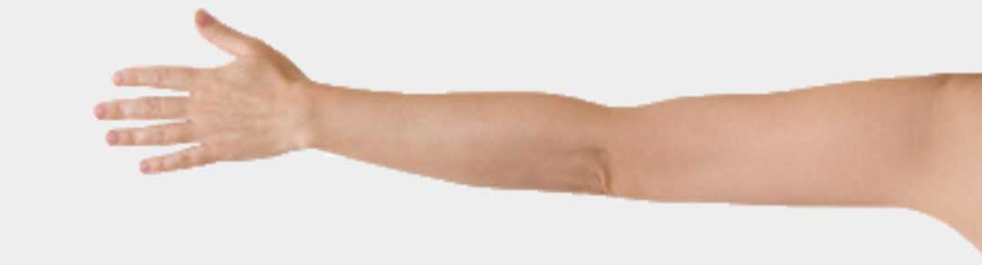

دست (از شانه تا مچِ دست) arm /

hand / دست (از مچ به پایین)

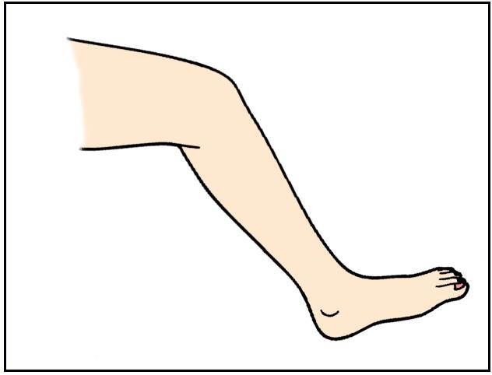

leg /پا (از بالای ران تا مچِ پا)
foot / پا (از مچ به پایین)

