CARLETON UNIVERSITY

SCHOOL OF
MATHEMATICS AND STATISTICS

HONOURS PROJECT

TITLE: Statistical Tests for Relative Reciprocity and Relative Interchange

AUTHOR: Liam Fitzpatrick

SUPERVISOR: Patrick Farrell

DATE: April 25, 2019

Contents
1. Introduction 2
2. Preliminaries 2
2.1. Relative Reciprocity and Relative Interchange 2
2.2. Qualitative Reciprocity 3
2.3. Sociomatrices 4
2.4. Kendall’s Tau 4
2.5. Motivation for the Kr Statistic 4
3. The Kr Statistic 5
3.1. Definition 5
3.2. The Kr Test 6
3.3. Important Remarks Regarding the Kr Test 6
3.4. Reasons for Using the Kr Statistic 7
3.5 Application: Grooming Interactions among Spider Monkeys 7
4. The Matrix Partial Correlation Statistic 8
4.1. Kendall’s Partial Rank Correlation Statistic 8
4.2. The Matrix Partial Correlation Test 9
4.3. Implementing the Matrix Partial Correlation Test 10
4.4. Application: Matrix Partial Correlation Test for Reciprocal Feeding in Vampire Bats 11
5. Conclusion 13

Appendix: R Code 14
A1. Kr3.R 14
A2. MCTfR.R 14
A3. MCTfI.R 15
A4. R code for testing relative reciprocity among spider monkeys 16
A5. MPCTfI.R 16
A6. MPCTfR.R 18
A7. R code which verifies the implementation of MPCTfR.R and MPCTfI.R 18
A8. Matrix Partial Correlation Test for Bats.R 19

References 21
1. Introduction
In zoology, altruism is defined as behaviour of an animal that benefits another at its own expense. At first glance, the existence of altruism seems to contradict evolutionary theory, as performing actions at one’s expense should necessarily reduce an individual’s fitness. In 1971, Trivers, R. (1971) reconciled altruism and evolutionary theory by proposing the model of reciprocal altruism. For example, reciprocal altruism is beneficial in a prisoner’s dilemma. As demonstrated in game theory, a selfish strategy is only dominant in the short-run, whereas altruistic behaviour can be the best strategy in the long-run if it is reciprocated.
A combination of common sense and specialized knowledge of a specific species can be applied to determine if behaviour is altruistic. However, in order to determine whether or not altruistic behaviour is truly reciprocal, rather than reciprocated by coincidence, statistical techniques need to be applied. While cases of reciprocal altruism are particularly points of interest to some biologists and psychologists, the statistical techniques in this report can be applied to any behaviour that is believed to be reciprocal, i.e. reciprocity. These techniques can also be applied to two behaviours that may be believed to be exchanged for one another, i.e. interchange.

2. Preliminaries
2.1. Relative Reciprocity and Relative Interchange
This report focuses on the definitions of reciprocity and interchange as defined by Charlotte Hemelrijk in 1990. Reciprocity is the exchange of similar acts. Interchange is the exchange of different kinds of acts. In each interaction, there is an actor and a receiver. For example, if individual X grooms individual Y, then X is the actor and Y is the receiver in this interaction. Reciprocity or interchange may be described as relative. For a particular type of action, a species may exhibit relative reciprocity if a typical individual will be more likely to act for individuals from whom they have received the action more frequently. For example, suppose chimpanzees exhibit relative reciprocity when grooming. If chimpanzee Y grooms chimpanzee X more often than chimpanzee Z grooms chimpanzee X, then it can be expected that chimpanzee X grooms chimpanzee Y more often than chimpanzee X grooms chimpanzee Z.
Similarly, interchange may be described as relative in the following case: Suppose individual X receives action B from individual Y more often than X receives B from individual Z. Then it can be expected than Y receives action A from X more often than Z receives A from X.

2.2. Qualitative Reciprocity
For a particular type of action, a species may exhibit qualitative reciprocity if a typical individual will be more likely to act for individuals from whom they have received the action at least once. For example, suppose vampire bats exhibit relative reciprocity when feeding other bats. If bat Y has regurgitated blood for bat X at some point, but bat Z has never regurgitated blood for bat X, then it can be expected that it is more likely that bat X may regurgitate blood for bat Y than bat X regurgitates blood for bat Z.
In fact, qualitative reciprocity for blood regurgitation among vampire bats has been demonstrated by data collected by Wilkinson, G. (1984). Twelve instances in which a bat was starving and would fall below viable weight within 24 hours were recorded in sequence. Eleven of these instances resulted in blood sharing, with the receiver and actor(s) both being noted in each instance. In six of these instances, the bat who was starving had previously regurgitated blood for another bat, who is considered a potential reciprocator. In four of these six cases, at least one donor had in fact previously received blood from the current receiver. Hence there were four cases if reciprocal feeding, out of six possible cases. One could state the null hypothesis is that each present bat is equally likely to feed the receiving bat in each case. Then one possible test statistic is the sum of six independent non-identical Bernoulli random variables, where the probability of success depends on the number of donors, the number of potential reciprocators and the number of bats in the same cage. Using this test statistic, Wilkinson’s analysis implies the presence of qualitative reciprocity for blood sharing among vampire bats with p = 0.009.
Another test statistic that may be used is the sum of non-identical hypergeometric random variables. For most observations, since there was only one donor or one potential reciprocator, these hypergeometric random variables would have the same distribution as a Bernoulli random variable. The one observation which had two donors and two potential reciprocators has parameters N=6, n=2 and r=2. When the data is viewed this way, there were five cases of reciprocal feeding out of seven possible cases, and the p-value is about 0.007.
2.3. Sociomatrices
Consider a population of n individuals. For each dyad (i, j), i≠j, one can record the number of times the i^{th} individual has done a particular action for the j^{th} individual. Then one can construct a nxn sociomatrix where the entry in the i^{th} row and j^{th} column is the number of times the i^{th} individual has done a particular action for the j^{th} individual. Suppose the action in question is grooming and consider the following sociomatrix as and example:
(1)
$$\begin{matrix} \begin{matrix} A & B\end{matrix} & \begin{matrix}C & D\end{matrix}\end{matrix}$$
$$X = \begin{matrix}\begin{matrix}A \\ B\end{matrix} \\ \begin{matrix}C \\ D\end{matrix}\end{matrix}\left(\begin{matrix}\begin{matrix}0 & 30 \\ 26 & 0\end{matrix} & \begin{matrix}25 & 20 \\ 16 & 11\end{matrix} \\ \begin{matrix}22 & 17 \\ 18 & 13\end{matrix} & \begin{matrix}0 & 7 \\ 8 & 0\end{matrix}\end{matrix}\right)$$
This matrix implies that A has groomed C 25 times and C has groomed A 22 times. This matrix will be discussed further when the Kr statistic is introduced.

2.4. Kendall’s Tau
Kendall’s Tau is a rank correlation statistic that describes the relation between two sets of rankings. Consider a set of n individuals and let $X=(x_{1}, ⋯, x_{n})$ and $Y=(y_{1},⋯,y_{n})$ be rankings according to two different variables. We can define $τ_{XY}$ as follows:
(2)
$$τ_{XY}=\frac{1}{\left({n \atop 2}\right)}\sum_{i=1}^{n-1}{\sum_{j=i+1}^{n}{sign((x_{j}-x_{i})(y_{j}-y_{i}))}}$$
The sign function is defined as follows:
(3)
$$sign(x) = \left\{\begin{aligned}1 if x>0 \\ 0 if x=0 \\ -1 if x<0\end{aligned}\right.$$
2.5. Motivation for the Kr Statistic
Suppose a population of three chimpanzees is observed until the number of grooming bouts for each if the six unidirectional dyads are different from each other. Assume further that each grooming bout takes place independently from each other and they are equally likely to take place within each of the six unidirectional dyads. When the data is recorded, it is reduced to ranks corresponding to the frequency of each interaction. For example, suppose the original data is as follows:
$$X = \left(\begin{matrix}\begin{matrix}0 & 12 \\ 13 & 0\end{matrix} & \begin{matrix}18 \\ 14\end{matrix} \\ \begin{matrix}19 & 16\end{matrix} & 0\end{matrix}\right)$$
The data would then be reduced to ranks as follows:
$$X_{ranks} = \left(\begin{matrix}\begin{matrix}0 & 1 \\ 2 & 0\end{matrix} & \begin{matrix}5 \\ 3\end{matrix} \\ \begin{matrix}6 & 4\end{matrix} & 0\end{matrix}\right)$$
The experiment may conclude with any of 6! = 720 equiprobable 3x3 “ranks” matrices. One may compute three Kendall’s Tau statistics (in this case n is reduced by one) by taking the non-zero entries in the i^{th} row and i^{th} column, i = 1,2,3. Each tau is either -1 or 1, each with probability 0.5. Assuming each of the three taus are independent, then the sum would be $2*B – 3$, where $B \sim bin(3,0.5)$.

However, if we add up the three taus for each of the 720 possible “ranks” matrices, we get the following frequency distribution (See Kr3.R in appendix):
$$\sum{τ}$$ | -3 | -1 | 1 | 3
Frequency | 132 | 204 | 276 | 108
Frequency if Taus are Independent | 90 | 270 | 270 | 90
Table 1. Frequency Distribution of sum of three Kendall’s Taus computed from rank matrices
Thus, despite efforts for making strong assumptions that may help for using the Tau statistic, it turns out that the taus cannot be treated independently. Therefore, we will consider the sum of the taus multiplied by $\left({n-1 \atop 2}\right)$ as one aggregate statistic, called $K_{r}$, and proceed using bootstrap methods, as described below.

3. The Kr Statistic
3.1. Definition
Consider two matrices X and Y. X is a sociomatrix. In a test for reciprocity, Y is the transpose of X. In a test for interchange, Y is the transpose of some other sociomatrix, so that the column indicates the actor and the row indicates the receiver. The order of individuals within a population must be kept the same for both X and Y.
The Kr statistic (Hemelrijk, 1990b) resembles Kendall’s Tau but is computed using two nxn matrices:
(4)
$$K_{r}^{XY}=\sum_{a=1}^{n}{\sum_{\begin{matrix}i=1 \\ i≠a\end{matrix}}^{n-1}{\sum_{\begin{matrix}j = i+1 \\ j ≠a\end{matrix}}^{n}{sign\left(\left(X_{a,i}-X_{a,j}\right)\left(Y_{a,i}-Y_{a,j}\right)\right)}}}$$
$K_{r}^{XY}$ is bounded between $-n\left({n-1 \atop 2}\right)$ and $n\left({n-1 \atop 2}\right)$. Diagonal entries are ignored because they are always zero in any social interaction matrix. If we consider the matrix X in equation (1) and let Y be the transpose of X, we obtain $K_{r}^{XY}= 12$.

3.2. The Kr Test
Hemelrijk (1990) proposed the following method for testing relative reciprocity or relative interchange:
First, compute the $K_{r}$ statistic using social interaction matrices X and Y. Then, keeping X fixed, generate N ≥ 1,000 permutations of Y independently of one another by changing the ordering of individuals in the population. The ordering of actors should correspond to the ordering of receivers so that each diagonal entry must be zero. Compute the $K_{r}$ value with respect to X and each on the N generated permutations of Y, and compare them to the original value of $K_{r}$. The p-value is the number of $K_{r}$ values generated via bootstrapping that are greater than or equal to the original $K_{r}$, divided by N.

3.3. Important Remarks Regarding the Kr Test
Consider once again the sociomatrix X in equation (1). Although the Kr statistic for X and its transpose attains the highest possible value of $4\left({4-1 \atop 2}\right)=12$, performing the Kr test provides a modestly significant p-value of about 0.04. For a population of 4 individuals, the p-value cannot lie below 0.04, because there are only 24 possible permutations of the population. Likewise, the Kr test among three individuals cannot pass a test of significance test with $α=0.1$ because only six permutations are possible. Therefore, a population of at least 5 individuals is strongly recommended, but be aware that there will be many missing data points if the observed population is too large.

Furthermore, when the data for each sociomatrix is collected, all pairs of individuals should have equal opportunity to interact among each other. If this is not the case, then the data should be adjusted to reflect the frequency of interactions per opportunities available. Otherwise, spurious significant results of the Kr test could result from the number of opportunities for interactions. Alternatively, if individuals need to be added or removed from the population during the experiment, a new set of data can be started when the population changes, or the new individual(s) and/or absent individual(s) may be ignored.
3.4. Reasons for Using the Kr Statistic
Different species of animals behave very differently from one another, which causes two major challenges for designing appropriate statistical tests. First, the type of social interaction in question may not be able to occur at the discretion of the researcher, which limits one’s ability to set up controlled experiments. See Seyfarth et al (1984) for an example of a controlled experiment that is closely related to our definition of relative interchange. Secondly, there seems to be no distributional assumption that is appropriate for all species when testing for reciprocity or interchange at a group level. For example, it is usually not reasonable to assume that all individuals within a population are equally active in partaking in a particular social interaction. It is therefore natural to resort to non-parametric statistical testing.
3.5 Application: Grooming Interactions among Spider Monkeys
Leiva et al. (2008) created a social interaction matrix for grooming bouts among six spider monkeys. Using this data, they performed their own statistical tests and found strong evidence against absolute reciprocity. The criterion for relative reciprocity is much more relaxed than the criterion for absolute reciprocity. This leaves relative reciprocity among spider monkeys open for investigation. Applying the Kr test (Figures 2-4 in appendix) to the data yields a Kr value of 13 and a p-value of about 0.14, so there is weak evidence in favour of relative reciprocity among spider monkeys.

4. The Matrix Partial Correlation Statistic
4.1. Kendall’s Partial Rank Correlation Statistic
Consider a set of n individuals and let $X=(x_{1}, ⋯, x_{n})$, $Y=(y_{1},⋯,y_{n})$ and $Z=(z_{1},⋯,z_{n})$ be rankings according to three different variables. There are $N=\left({n \atop 2}\right)$ pairs of individuals. For each pair $(i,j), i<j$, we consider the direction of inequality for the following three pairs: $(x_{i}, x_{j})$, $(y_{i}, y_{j})$, and $(z_{i}, z_{j})$. Let $a$ be the number of pairs $(i,j)$ for which the direction of inequality agrees for all three rankings. Let b, c and d be the number of pairs $(i,j)$ for which the direction of inequality agrees for only X and Z, only Y and Z, and only X and Y, respectively. We have the relation $N=a+b+c+d$.
We have the following equivalent definition for Kendall’s Tau:
(5)
(7)
(6)
$$τ_{XY}= \frac{(a+d) - (b+c)}{N}$$
$$τ_{XZ}= \frac{(a+b) - (c+d)}{N}$$
$$τ_{XY}= \frac{(a+c) - (b+d)}{N}$$
M. G. Kendall (1970) defines the partial rank correlation coefficient of X and Y with Z as follows:
(8)
$$τ_{XY,Z}=\frac{ad - bc}{\sqrt{(a+b)(c+d)(a+c)(b+d)}}$$
Kendall proved that the definition of the partial rank correlation coefficient is equivalent to the following:
(9)
$$τ_{XY,Z}=\frac{τ_{XY} - τ_{XZ}τ_{YZ}}{\sqrt{(1 - τ_{XZ}^{2})(1 - τ_{YZ}^{2})}}$$

4.2. The Matrix Partial Correlation Test
Suppose the Kr test produced significant results in favour for relative reciprocity for social interaction matrices X and Y, but it is believed that this relation is a by-product of another matrix Z. Hemelrijk (1990b) proposed the following partial correlation test to determine if a significant part of the reciprocity is not explained by Z:
First, when computing the Kr statistic between X and Y, there may be the following numbers of ties in the k^{th} row of the matrices X and Y, respectively:
(10)
$$T_{k}^{X}=\sum_{\begin{matrix}i=1 \\ i≠k\end{matrix}}^{n-1}{\sum_{\begin{matrix}j = i+1 \\ j ≠k\end{matrix}}^{n}{1_{\{0\}}\left(X_{k,i}-X_{k,j}\right)}}$$
$$T_{k}^{Y}=\sum_{\begin{matrix}i=1 \\ i≠k\end{matrix}}^{n-1}{\sum_{\begin{matrix}j = i+1 \\ j ≠k\end{matrix}}^{n}{1_{\{0\}}\left(Y_{k,i}-Y_{k,j}\right)}}$$

Then we can make the following adjustment to express the Kr statistic as a value between -1 and 1:
(11)
$$τ_{K_{r}}^{XY}=\frac{K_{r}^{XY}}{\sum_{k=1}^{n}{\sqrt{\left({n-1 \atop 2}\right)-T_{k}^{X}}\sqrt{\left({n-1 \atop 2}\right)-T_{k}^{Y}}}}$$
Similar to Kendall’s partial rank correlation coefficient, we can define the matrix partial correlation coefficient as follows:
(12)
$$τ_{K_{r}}^{XY,Z}=\frac{τ_{K_{r}}^{XY} - τ_{K_{r}}^{XZ}τ_{K_{r}}^{YZ}}{\sqrt{1-{(τ_{K_{r}}^{XZ})}^{2}}\sqrt{1-{(τ_{K_{r}}^{YZ})}^{2}}}$$
The procedure for the matrix partial correlation test is very similar to the Kr test. Given X, Y and Z, the observed $τ_{K_{r}}^{XY,Z}$ is computed first. Next, holding Z constant, permutations of X and Y are generated independently of one another N ≥ 1,000 times. For each iteration, the value of $τ_{K_{r}}^{XY,Z}$ among the new matrices is compared to the original; The p-value is the number of generated matrix partial correlation coefficients that are greater than or equal to the original, divided by N.

4.3. Implementing the Matrix Partial Correlation Test
Figures 5 and 6 contain the R code which can perform the matrix partial correlation test for any sociomatrices. MPCTfI.R tests for interchange, and it requires two sociomatrices X and Y, and a third matrix Z of equal dimension. MPCTfR.R tests for reciprocity, and it requires only one sociomatrix X and another matrix Z. The code in figure 7 simply verifies that MPCTfI.R and MPCTfR.R obtain the same results summarized by Hemelrijk, 1990: Table 2.
Consider, for example, the data in Seyfarth, 1980: Table IV regarding grooming bout initiations among group A of vervet monkeys. Since individual LL was not involved in any alliances (Seyfarth Fig. 4), that individual is omitted from the sociomatrix. The resulting sociomatrix is as follows:
$$X=\left(\begin{matrix}0 & 103 & 26 & 14 & 29 & 0 & 9 \\ 92 & 0 & 5 & 12 & 6 & 9 & 2 \\ 42 & 18 & 0 & 51 & 22 & 7 & 8 \\ 36 & 19 & 49 & 0 & 40 & 13 & 17 \\ 28 & 13 & 15 & 26 & 0 & 4 & 5 \\ 4 & 23 & 10 & 25 & 14 & 0 & 15 \\ 10 & 9 & 9 & 10 & 1 & 2 & 0\end{matrix}\right)$$
The alliances in group A expressed in figure 4 of Seyfarth can be expressed as a matrix as follows:
$$Y = \left(\begin{matrix}0 & 3 & 1 & 0 & 0 & 0 & 0 \\ 3 & 0 & 0 & 0 & 0 & 0 & 0 \\ 1 & 0 & 0 & 1 & 0 & 0 & 0 \\ 0 & 1 & 0 & 0 & 1 & 0 & 0 \\ 0 & 0 & 0 & 0 & 0 & 0 & 0 \\ 0 & 0 & 0 & 0 & 1 & 0 & 0 \\ 0 & 1 & 0 & 0 & 0 & 0 & 0\end{matrix}\right)$$
It should be noted that when doing the matrix partial correlation test, Y should be transposed so that the rows represent the receivers and the columns represent the actors. Also note that since categorical data was provided, each category is assigned a number such that a larger number corresponds to a category with a larger rate of alliance. A zero entry corresponds to no alliance, a one corresponds to a rate of alliance between 0.01 and 0.04, and a three corresponds to a rate of alliance of at least 0.1. Only the direction of inequality between entries matter, so the choice of numbers is somewhat arbitrary.
Finally, individuals are already placed in order of dominance rank. Since we want to determine whether or not the relationship between grooming bouts and alliances is a by-product of dominance rank, we take the third matrix Z as follows:
$$Z= \left(\begin{matrix}\begin{matrix}1 & 2 & 3 \\ 1 & 2 & 3 \\ 1 & 2 & 3\end{matrix} & \begin{matrix}4 & 5 & \begin{matrix}6 & 7\end{matrix} \\ 4 & 5 & \begin{matrix}6 & 7\end{matrix} \\ 4 & 5 & \begin{matrix}6 & 7\end{matrix}\end{matrix} \\ \begin{matrix}1 & 2 & 3 \\ 1 & 2 & 3 \\ \begin{matrix}1 \\ 1\end{matrix} & \begin{matrix}2 \\ 2\end{matrix} & \begin{matrix}3 \\ 3\end{matrix}\end{matrix} & \begin{matrix}4 & 5 & \begin{matrix}6 & 7\end{matrix} \\ 4 & 5 & \begin{matrix}6 & 7\end{matrix} \\ \begin{matrix}4 \\ 4\end{matrix} & \begin{matrix}5 \\ 5\end{matrix} & \begin{matrix}6 & 7 \\ 6 & 7\end{matrix}\end{matrix}\end{matrix}\right)$$
Note that there are a few ways Z could have been chosen to get the exact same results. In Z as selected above, 1 denotes the column for an individual with highest dominance rank, and 7 denotes the column for an individual with lowest dominance rank. Reversing the meaning of these numbers, i.e. 1 for lowest and 7 for highest, gives exactly the same results for this test. To see why this is true, consider equations 4, 11 and 12. Changing Z this way gives the additive inverses of the original $K_{r}^{XZ}$, $K_{r}^{YZ}$, $τ_{K_{r}}^{XZ}$ and $τ_{K_{r}}^{YZ}$, which in turn provides the same result in equation 12. The same end result would also be obtained if each entry in Z represented difference in dominance rank.
Performing the matrix partial correlation test for these three matrices provides the values $τ_{K_{r}}^{XY,Z}=0.2739$ for interchange and $τ_{K_{r}}^{XY,Z}=0.561$ for reciprocity, which exactly agrees with the results in Table 2 of Hemelrijk.
4.4. Application: Matrix Partial Correlation Test for Reciprocal Feeding in Vampire Bats
Carter G. and Wilkinson G (2013c) conducted an experiment in which one randomly selected bat was fasted on each day of the experiment, and food sharing would be observed between the donor bat(s) and the fasted bat. In each case, the fasted bat was the receiver and the donor(s) were the actors. The amount of food shared was quantified by the total duration of mouth licking bouts, divided by the number of opportunities for each bat to be fed by the donor.
Carter and Wilkinson used permutation tests involving regression to analyze their data. While permutation tests work around the issue that errors are unlikely to be independently normal, it is questionable to be fitting linear models in data sets containing many zeroes. Therefore, the data will be reconsidered using the matrix partial correlation test. In this case, the social interaction matrix X represents the amount of food shared, and Y is the transpose of X. See the R code in figure 8 of appendix. Mouth-licking_observations2012.csv can be found in the data supplement from Carter and Wilkinson. The data in relatedness25.csv was obtained by using Kalinowski’s ML-Relate program (2006) to analyze Carter and Wilkinson’s genotypes2012.csv.
Unfortunately, we did not have access to the data for which bats were present for each day of the experiment. Since the ongoing addition and removal of bats could cause spurious result strongly in favour of reciprocity, the data was analyzed for three different periods: December 6, 2010 to January 1, 2011, August 7, 2011 to August 27, 2011, and January 3, 2012 to January 22, 2012. This does not mitigate the problem entirely, but the populations in each of these three periods were relatively stable compared to the duration of the entire experiment. For each period, only the bats which were fasted and subsequently received a food donation were considered for the matrix partial correlation test. Here, the number of opportunities for feeding is taken as the number of times each receiving bat was starved.
When using the Kr test for reciprocity, the Kr values are 78, 4 and 48, and the p-values are 0.0005, 0.2835 and 0.0405 for each respective period. Using Fisher’s combined probability test gives a p-value less than 0.001, which is strongly in favour for relative reciprocity for food sharing among vampire bats.
Now we check if this relation may be a by-product of relatedness. The matrix partial correlation coefficient for each period is 0.3267, -0.0019 and 0.1556, with respective p-values 0.003, 0.5435 and 0.047. The p-value for Fisher’s combined probability test is less than 0.005, which strongly suggests reciprocity is not merely a by-product of relatedness.
These results should be taken with a grain of salt due to the inability to exactly account for the number of feeding opportunities between each dyad given the data available. It is worth noting, however, that the results here somewhat coincide with Carter and Wilkinson’s results; their best multivariate regression model for explaining food donated included food received, but not pairwise relatedness.

5. Conclusion
The reader should be aware that this report only discusses a few possible interpretations of reciprocity. As it stands, discussion of reciprocity “requires crossing an unfortunate semantic quagmire” (Carter & Wilkinson, 2013b). Relative reciprocity, as discussed in this report, depends on the receipt of actions from specific individuals. Other types of reciprocity include generalized reciprocity, where the individual who receives an action is not concerned with the actor of each action, and absolute reciprocity, which implies perfectly symmetric behaviour within each dyad. See Rutte & Taborsky (2007) for discussion on generalized reciprocity. See Leiva et al. (2008) for a statistical test for absolute reciprocity. Image scoring, in which individuals are most likely to act altruistically for individuals who have been observed to act altruistically, is another plausible mechanism for which altruism may emerge in evolution. See Bshary & Grutter (2006) for a discussion on image scoring.
The matrix partial correlation test has the advantage of being able to determine if an extraneous variable is responsible for reciprocity or interchange observed in the Kr test. This is useful when methods for performing controlled experiments are not available. However, the partial matrix correlation test does not provide any way to consider more than one extraneous variable simultaneously. Performing permuted multiple regression as Carter and Wilkinson did does provide a way to consider many variables, at the expense of either using many zero entries in regression or omitting many data points. Thus, there is plenty of room for improvement in statistical tests for reciprocity.

Appendix: R Code
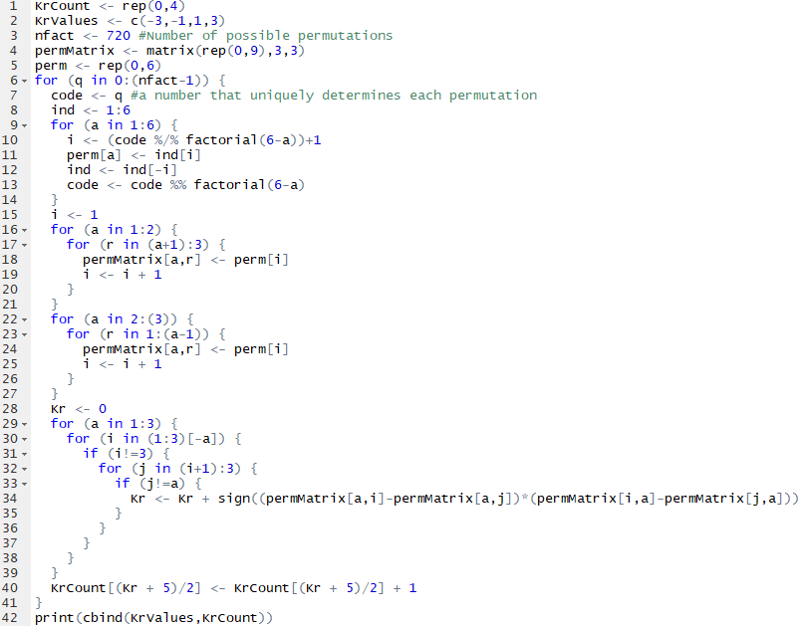
Figure A1: Kr3.R
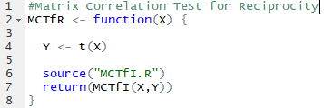
Figure A2: MCTfR.R
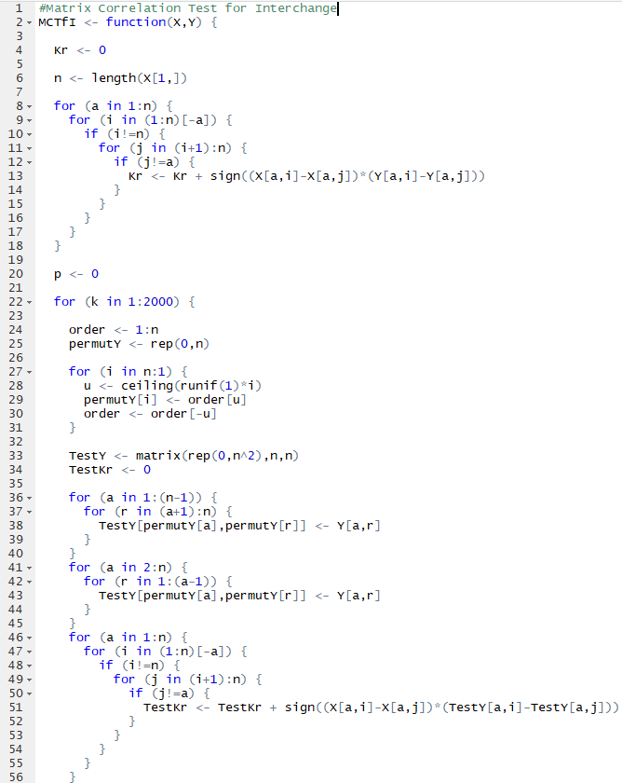
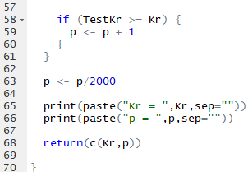
Figure A3. MCTfI.R
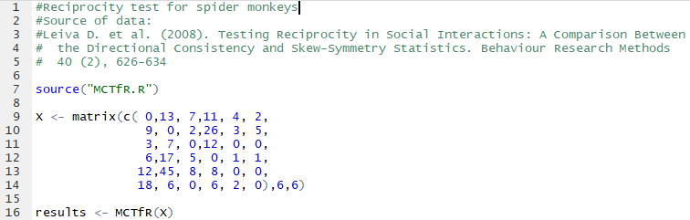
Figure A4. R code for testing relative reciprocity among spider monkeys
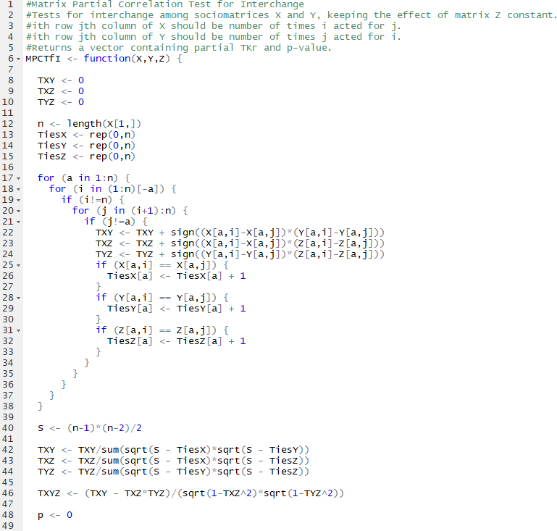
Figure A5a. MPCTfI.R, Part 1

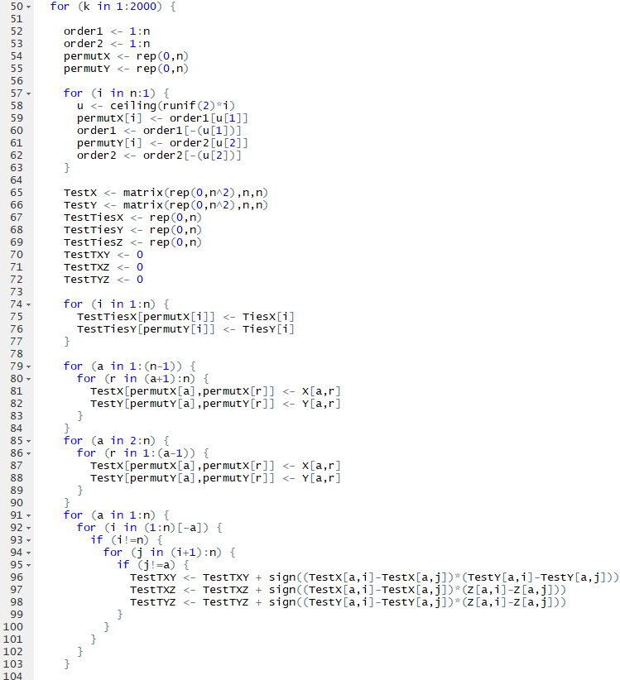
Figure A5b. MPCTfI.R, Part 2
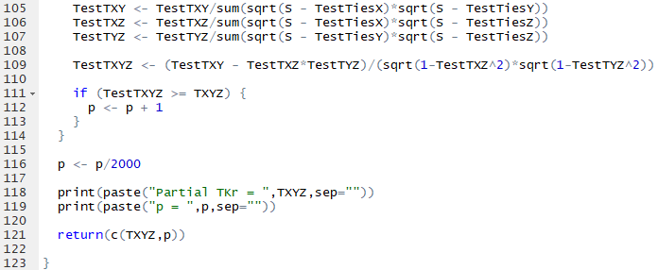
Figure A5c. MPCTfI.R, Part 3
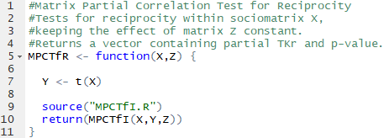
Figure A6. MPCTfR.R
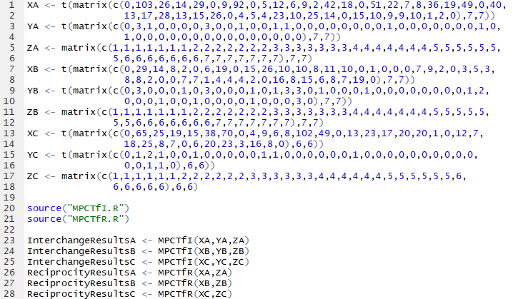
Figure A7. R code which verifies the implementation of MPCTfR.R and MPCTfI.R

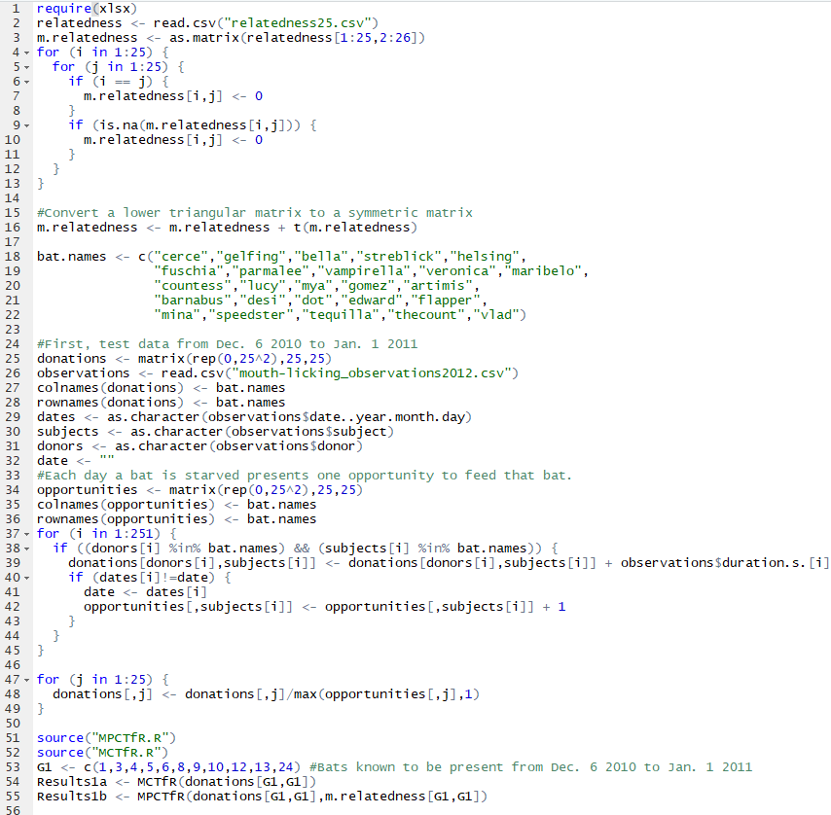
Figure A8a. Matrix Partial Correlation Test for Bats.R, Part 1

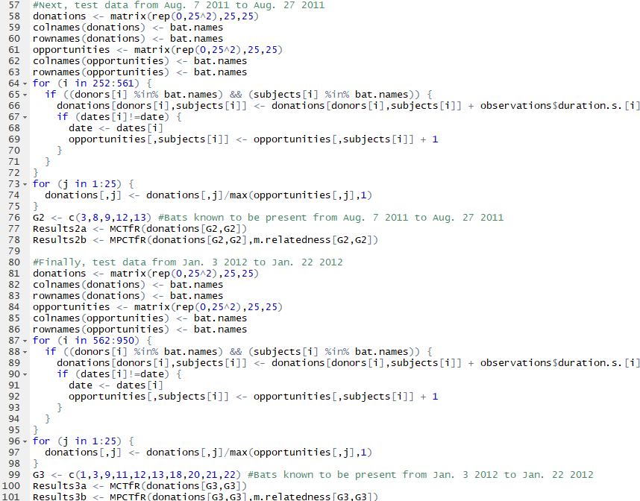
Figure A8b. Matrix Partial Correlation Test for Bats.R, Part 2

References
1. | Bshary, R., Grutter, A. S. (2006). Nature. 441, 975-978.
2. | Carter, G. G., Wilkinson, G. S. (2013a). Data from: Food sharing in vampire bats: reciprocal help predicts  donations more than relatedness or harassment. Dryad Digital Repository. https://doi.org/10.5061/dryad.tg7b1
3. | Carter, G. G., Wilkinson, G. S. (2013b). Does food sharing in vampire bats demonstrate reciprocity?, Communicative & Integrative Biology, 6:6, e25783, DOI: 10.4161/cib.25783
4. | Carter, G. G., Wilkinson, G. S. (2013c). Food sharing in vampire bats: reciprocal help predicts donations  more than relatedness or harassment. Proc R Soc B 280: 20122573. http://dx.doi.org/10.1098/rspb.2012.2573
5. | Hemelrijk, C. K. (1990a). Anim. Behav. 39, 1013-1029
6. | Hemelrijk, C. K. (1990b). J. theor. Biol. 143, 405-420
7. | Kalinowski S. T. et al. (2006). Mol. Ecol. Notes. 6, 576– 579. (doi:10.1111/j.1471-8286.2006.01256.x)
8. | Kendall, M. G. (1970). Rank Correlation Methods. 4th edition, Charles Griffin, London
9. | Leiva D. et al. (2008). Behaviour Research Methods. 40 (2), 626-634
10. | Rutte, C., Taborsky, M. (2007). Generalized reciprocity in rats. PLoS Biol 5(7): e196. doi:10.1371/journal.pbio.0050196
11. | Seyfarth, R. M. et al. (1980). Anim. Behav., 28, 798-813
12. | Seyfarth, R. M. et al. (1984). Nature. 308, 541-543
13. | Trivers, R. (1971). Quarterly Review of Biology. 46 (1), 35-57
14. | Wilkinson, G. S. (1984). Nature. 308, 181-184

