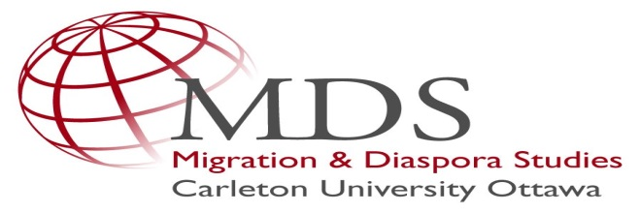

Migration & Diaspora Studies (MDS) provides support for projects and events that will help strengthen the MDS community at Carleton University, and bring research and expertise about the movement of people to a broader audience at Carleton and beyond. Key topics in MDS include, but are not limited to, citizenship, the global refugee regime, multiculturalism, state security, and transnational identities.

Purpose of the funding
MDS welcomes applications that support events and activities such as conferences, seminars, talks, short films, and artistic installations that:

- fall within the framework of the Migration & Diaspora Studies initiative to study the cultural, economic, political and social implications of the movement of people. Please see the MDS website for more details.
- provide intellectual benefits to the interdisciplinary and diverse MDS community.
- raise the profile of the Migration & Diaspora studies initiative at Carleton, and with national and international communities of scholars and outside partners. This could include a media plan or a peer-reviewed publication.

We welcome applications from any discipline, and especially encourage applications for interdisciplinary activities, but please note that these funds are not intended for individual research projects.

Types of Awards
MDS will offer two types of awards differentiated by their monetary value.

Awards under $1,000 to support low-cost activities such as bringing in a speaker from outside the university. There is no deadline for applications for funding under $1,000.

Awards over $1,000 to support higher-cost activities such as seminars, conferences, lecture series, performances, readings, and exhibitions. The value of these awards will not exceed $10,000 and the expectation is that most awards in this category will be no more than $5,000. The next deadline for higher-cost event funding proposals is February 23, 2018 Applicants who wish to secure notice of matching funds in advance of October 2017 may submit their applications earlier in the term, and specify the date by which they intend to secure matching funds in advance of applications to SSHRC or other research funding agencies.

The funds will be administered through the Carleton University Research Office.

Who can apply?
Applicants must be affiliated with Carleton University either as faculty, adjunct faculty, or graduate students.

How to apply?
Your application should include an itemized budget, a short proposal outlining the project, and a completed application form (provided below), and should be submitted to mds@carleton.ca

Adjudication
Applications will be adjudicated by an MDS Awards Committee at Carleton University that will normally comprise of MDS members drawn from a least two faculties.

Reporting
Within a month of the completion of the event or activity, successful applicants must submit a report to the MDS Awards Committee. This report will include:
- an itemised description of how the funds were actually used;
- indication of any unspent funds;
- a brief reflection (1000 words) on how the event/activity contributed to the MDS
community at Carleton (content delivered, exchanges facilitated, any specific outputs, short-term and long-term implications etc.).

Application Form
Proposed Event Title:
Names of Applicants and Co-Applicants:
Affiliation and Contact Details of Project Lead:
E-Mail Project Lead:
Date of Event:
Location:
Closed or Public Event. In case of a closed event, please provide information how the event is beneficial to MDS and the outlined objectives of MDS sponsorship
Co-Sponsors (actual or potential):
Total Event Budget:
Funding Requested from MDS:
Itemized Budget of Requested Funding:
Description of Event (250 words):
Intended Outcomes:
Value to MDS (100 words):
Involvement of MDS at Event:
How do you plan to advertise the event?
How do you plan to communicate outcomes, results, etc. to other members of the MDS community and beyond?
Faculty Contact (in case of student applications):

