Carleton University
Winter 2025
ICSLAC/Department of English/MDS

CLMD 6106W/ENGL 5004W/MGDS 5002D
MEMORY AND MIGRATION

Fridays 11:35 am - 2:25 pm
Location: Location Available in Carleton Central
Format: In-person

Instructor: Professor Sarah Phillips Casteel
Email: sarah.casteel@carleton.ca
Office: 201J St. Patrick’s
Office Hours: Fridays 2:30-3:30 and by appointment

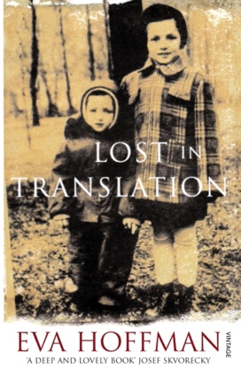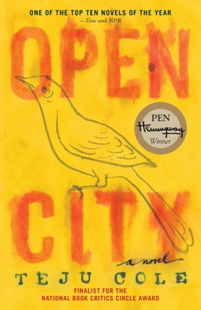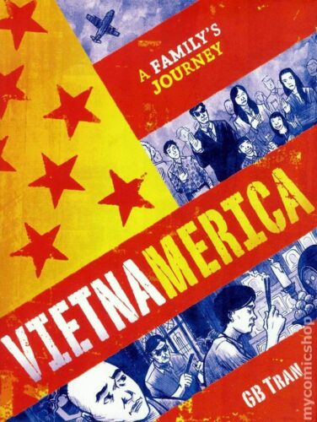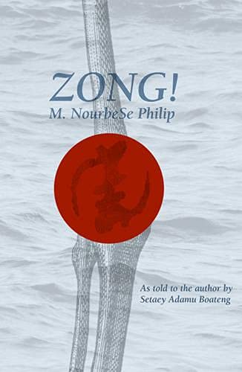

COURSE DESCRIPTION:

This class explores the relationship between memory, migration, and aesthetic representation. We will consider the role of particular literary and artistic genres in producing, preserving, shaping, and circulating migrant memories. How do diasporic writers and visual artists negotiate between personal or familial memory and official, state memory? How do they reconstruct memories that have been disrupted, fragmented or lost as a result of forced or voluntary migration? What is the role of creativity and the imagination in these acts of mnemonic recovery? Among the literary genres and artistic mediums we will address are memoir, graphic memoir, fiction, poetry, installation art, photographic portraiture and photomontage.

READINGS:

Please purchase the following texts (available at the Carleton University Bookstore under the course code CLMD 6106):
- Teju Cole, Open City. Faber and Faber, 2011. 978-0812980097 [$23.00]
- Eva Hoffman, Lost in Translation: A Life in a New Language. Vintage, 2008 [1989]. 978-0140127737 [$15.00]
- Marlene NourbeSe Philip, Zong! Wesleyan UP, 2011 [2008]. 978=0819571694 [$26.75]
- G.B. Tran, Vietnamerica: A Family's Journey. Villard, 2011. 978-0345508720 [$30.00]

*Please purchase hard copies if possible so that we will have the same pagination and be able to follow along together in class.

All other course readings will be available in electronic format via Brightspace and the Ares Course Reserves system (https://reserves.library.carleton.ca/ares/). If you find that a required reading is not available for a given week, please notify me immediately by email. Students are expected to come to class having prepared all of the required readings for a particular week.

Links to artworks will be provided under the relevant weeks on our Brightspace page.

COURSE REQUIREMENTS AND GRADING SCHEME (the use of AI is not permitted for this course):

15% | attendance and participation  - the attendance and participation grade will reflect consistent attendance, active involvement in class discussion, and informed comments about issues raised by the readings that help to advance the discussion  - this seminar is in-person and cannot be followed virtually  - students will not be penalized for absences due to illness or religious observance
15% | weekly responses to the assigned readings (1 paragraph)  - due by midnight the night before each class meeting for which we have readings  - these responses should be brief but thoughtful; they can address any or all of the assigned readings and artworks  - no plot summaries please! instead, raise questions about the readings or identify a passage or motif that you found particularly striking, intriguing, or troubling and that you would like to discuss in class  - come to class prepared to talk about your response
20% | Key Terms presentation  - you will each be assigned one key term to introduce to the class; the term will relate either to a concept in memory studies, an artistic genre or medium, or an historical event  - 1. write a one-paragraph definition of the term and post it in Brightspace by midnight the day before the class in question (please include a short bibliography)  - for the memory studies concepts, genres and mediums, see bibliography of suggested theorists and readings posted in Brightspace  - for the memory studies concepts, your definition should identify which theorist coined the term or is particularly associated with it  - over the course of the term, we will collect your definitions to build a glossary for the class  - 2. give a 10-minute presentation in which you:  - 1. present and explain your definition of the key term  - 2. explore the key term’s relevance to the text or artwork we are discussing that week (this may include tensions or divergences between conventional definitions of the term and perspectives that emerge from the artworks)
15% | conference-paper style presentation  - a preliminary version of your final paper (see below) that will allow you to test your ideas and receive some feedback from the class  - length: 5 double-spaced pages; length of oral version tba  - paper titles and 1-paragraph abstract: due on March 17  - once I have received the abstracts, I will organize the conference papers into panels to be held during class on March 28 and April 4  - please upload to Brightspace the 5-page version of your presentation by 10 am on the day you are giving your paper and please bring me a hard copy
35% | final paper  - the final paper is an opportunity to explore the relationship between memory and migration in the context of the particular genres, media, cultural histories and disciplinary perspectives that drive your own research interests  - final papers should go substantially beyond the conference paper version, not just adding length but also incorporating feedback received during the mini-conference and from me  - please feel free to discuss potential paper topics and approaches with me  - length and format: 15 pages, 12-point font, double-spaced (not including Works Cited and endnotes)  - due date: April 8  - late papers will be penalized one third of a letter grade per day late including weekends (i.e. from B+ to B, etc.); extensions will be granted only in cases of serious illness (with doctor’s note), bereavement, or religious observance

SCHEDULE OF READINGS AND ASSIGNMENTS:

January 10: INTRODUCTION TO THE COURSE

January 17: THEORIZING MEMORY AND MIGRATION
Key term: memory studies
- Astrid Erll, "Travelling Memory." Parallax 17.4 (2011): 4-18.
- Siobhan Brownlie, “The Roles of Literature and the Arts in Representing the Migrant and
Migration.” Figures of the Migrant: The Roles of Literature and the Arts in Representing Migration, ed. Siobhan Brownlie and Rédouane Abouddahab. New York: Routledge, 2022. 3-20.
- Ann Rigney, “The Dynamics of Remembrance: Texts Between Monumentality and Morphing.” A Companion to Cultural Memory Studies. Ed. Astrid Erll and Ansgar Nünning. DeGruyter, 2010. 345-53.
- Anne Ring Petersen, “The Locations of Memory: Migration and Transnational Cultural Memory as Challenges for Art History.” Crossings: Journal of Migration and Culture 4.2 (2013): 121-136.

January 24: AUTOBIOGRAPHICAL ESSAYS AND ART
Key terms: life writing, sites of memory

- Edward Said, Out of Place (Preface and Chapter 1). Vintage, 1999. ix-19.
- André Aciman, "Shadow Cities." Letters of Transit: Reflections on Exile, Identity, Language, and Loss. Ed. André Aciman. The New Press, 1999. 19-34.
- Salman Rushdie, "Imaginary Homelands." Imaginary Homelands: Essays and Criticism 1981-1991. Granta Books, 1992. 9-21.

- Selected works from the exhibition When Home When Let You Stay: Migration Through Contemporary Art (Do Ho Suh, Mona Hatoum, Yinka Shonibare)

January 31: MEMOIR
Key terms: postmemory, translation, the migrant’s time

- Eva Hoffman, Lost in Translation: A Life in a New Language

February 7: VISUAL ART

11:35-12:30: CARLETON UNIVERSITY ART GALLERY VISIT TO SEE WAN WORD
- Please meet at 11:35 at the Carleton University Art Gallery, located across from ICSLAC in the St. Patrick’s Building
- *NB for your weekly response this week, please write a response to our visit to the gallery and upload it to Brightspace by Friday at midnight

1:00-2:25: guest talk by Pansee Abou El Atta, curator of A Dream of Return

February 14: FICTION
Key terms: traumatic memory, intertextuality, cities of migration

- Teju Cole, Open City

February 21: Winter Break

February 28: POETRY
Key terms: archive, critical fabulation, the Zong Massacre

- M. NourbeSe Philip, selections from Zong!: “Os,” “Notanda,” and “Gregson v. Gilbert”
- Saidiya Hartman, “Introduction” to the 15th Anniversary edition of Zong! Wesleyan University Press, 2023. xxvii-xxxi.

March 7: class cancelled

March 14: GRAPHIC MEMOIR
Key terms: graphic memoir, refugee writing, the Vietnam War

- GB Tran, Vietnamerica

March 21: PHOTOGRAPHIC PORTRAITURE AND PHOTOMONTAGE
Key terms: portraiture, performemory

- Rafael Goldchain, Familial Ground (2002)
- Raphael Goldchain, "Artist Statement." I Am My Family: Photographic Memories and Fictions. Princeton Architectural Press, 2008. 16-24.
- Martha Langford, “The Varieties of Goldchain Experience.” Ciel variable No. 75 (March 2007): 7-11.
- Beautifully Broken: The Life and Work of Rafael Goldchain, dir. Vladimir Kabelik (2012); clips screened in class
- Maud Sulter, Syrcas (1993)
  - Maud Sulter, "Blood Money (Remix)." Sekhmet: A Decade or So of Poems. Dumfries and Galloway Council, 2005. 47-48.
  - Deborah Cherry, "The Ghost Begins By Coming Back: Revenants and Returns in Maud Sulter's Photomontages." Revival: Memories, Identities, Utopias, ed. Ayla Lepine, Matt Lodder, and Rosalind McKever. The Courthauld Institute of Art, 2015. 29-44.

March 28: MINI-CONFERENCE PART I
- schedule TBA

April 4: MINI-CONFERENCE PART II
- schedule TBA

COURSE POLICIES

Sensitivity of Class Materials

Given the topic of this course, we will frequently confront difficult and sensitive materials. Much of the material we read and view will be emotionally and intellectually challenging. I will do my best to make the classroom a space where we can engage bravely, empathetically, and thoughtfully with difficult content.

Inclusivity

I am committed to fostering an environment for learning that is inclusive for everyone regardless of race, ethnicity, religion, sexual orientation, gender identity, gender expression, ability, age, and class. All students in the course, the instructor, and any guests should be treated with respect during all interactions. Please feel free to contact me if you have any concerns. I also welcome emails or other communication to let me know your preferred name or pronoun.

Student Wellbeing

The COVID-19 pandemic and other recent events have made the past several years extraordinarily stressful and challenging for many students. While encouraging rigorous academic work in this class, I am mindful of your health and wellbeing and the need to balance academic commitments with other responsibilities. Please feel free to contact me if you are encountering difficult circumstances, feeling overwhelmed by class assignments, or if you would like help connecting with academic support or health resources.

WINTER 2025 IMPORTANT DATES AND DEADLINES

January 6 | Winter term begins.
January 17 | Last day for registration and course changes (including auditing) in full winter and late winter courses.
January 31 | Last day to withdraw from full winter and the winter portion of fall/winter courses with a full fee adjustment (financial withdrawal).
February 17 | Statutory holiday. University closed.
February 17-21 | Winter Break. No classes.
March 15 | Last day for academic withdrawal from full winter, late winter and fall/winter courses.
April 8 | Winter term ends.  Last day of full winter, late winter and fall/winter term classes.  Last day for take home examinations to be assigned.
April 11-26 | Final examinations in full winter, late winter and fall/winter term courses will be held.
18-Apr-25 | Statutory holiday. University closed.
26-Apr-25 | All take home examinations are due on this day.

STATEMENT ON PLAGIARISM

The University Academic Integrity Policy defines plagiarism as “presenting, whether intentionally or not, the ideas, expression of ideas or work of others as one’s own.” This includes reproducing or paraphrasing portions of someone else’s published or unpublished material, regardless of the source, and presenting these as one’s own without proper citation or reference to the original source. Examples of sources from which the ideas, expressions of ideas or works of others may be drawn from include but are not limited to books, articles, papers, literary compositions and phrases, performance compositions, chemical compounds, artworks, laboratory reports, research results, calculations and the results of calculations, diagrams, constructions, computer reports, computer code/software, material on the internet and/or conversations.

Examples of plagiarism include, but are not limited to:

- any submission prepared in whole or in part, by someone else, including the unauthorized use of generative AI tools (e.g., ChatGPT).
- using ideas or direct, verbatim quotations, paraphrased material, algorithms, formulae, scientific or mathematical concepts, or ideas without appropriate acknowledgment in any academic assignment.
- using another’s data or research findings without appropriate acknowledgement.
- submitting a computer program developed in whole or in part by someone else, with or without modifications, as one’s own; and
- failing to acknowledge sources through the use of proper citations when using another’s work and/or failing to use quotations marks.

Plagiarism is a serious offence that cannot be resolved directly by the course’s instructor. The Associate Dean of the Faculty conducts a rigorous investigation, including an interview with the student, when an instructor suspects a piece of work has been plagiarized. Penalties are not trivial. They can include a final grade of “F” for the course.

MENTAL HEALTH

As a University student you may experience a range of mental health challenges that significantly impact your academic success and overall well-being. If you need help, please speak to someone. There are numerous resources available both on- and off-campus to support you.

Emergency Resources (on and off campus): https://carleton.ca/health/emergencies-and-crisis/emergency-numbers/

Carleton Resources:
• Mental Health and Wellbeing: https://carleton.ca/wellness/
• Health & Counselling Services: https://carleton.ca/health/
• Paul Menton Centre: https://carleton.ca/pmc/
• Academic Advising Centre (AAC): https://carleton.ca/academicadvising/
• Centre for Student Academic Support (CSAS): https://carleton.ca/csas/
• Equity & Inclusivity Communities: https://carleton.ca/equity/

Off Campus Resources:
• Distress Centre of Ottawa and Region: (613) 238-3311 or TEXT: 343-306-5550, https://www.dcottawa.on.ca/
• Mental Health Crisis Service: (613) 722-6914, 1-866-996-0991, http://www.crisisline.ca/
• Empower Me: 1-844-741-6389, https://students.carleton.ca/services/empower-me-counselling-services/
• Good2Talk: 1-866-925-5454, https://good2talk.ca/
• The Walk-In Counselling Clinic: https://walkincounselling.com

ACADEMIC ACCOMMODATION

Carleton is committed to providing academic accessibility for all individuals. You may need special arrangements to meet your academic obligations during the term. The accommodation request processes, including information about the Academic Consideration Policy for Students in Medical and Other Extenuating Circumstances, are outlined on the Academic Accommodations website (students.carleton.ca/course-outline).

