The Migration & Diaspora Studies Initiative (MDS) provides support for graduate students engaged in topics relating to the cultural, social, economic and political implications of the movement and transnational settlement of people.

As part of its commitment to support student research, MDS would like to invite incoming and current students to submit applications to mds@carleton.ca for a $20,000 TD Fellowship in Migration and Diaspora Studies by September 17, 2018.

TD Fellowship in Migration and Diaspora Studies

Description: Awarded annually by the Dean of Graduate and Postdoctoral Affairs to a full-time graduate student who is pursuing courses in Migration and Diaspora Studies. Recipients may be residents of any province or territory in Canada and must qualify as entitled to the Canadian Resident Tuition Fee Structure. Established in 2014 by the TD Bank Group.

The award seeks to recognize students who will use their studies to contribute to scholarship on migration and diaspora and the recipient will be recommended to the Dean of the Faculty of Graduate and Postdoctoral Affairs by the awards committee of the Migration and Diaspora Studies Initiative.

Value: $20,000 (scholarship)

Tenure: 1 year

Application: Application forms must be accompanied by a summary of research, CV and letter of support from the applicant’s advisor or Graduate Supervisor.

NB: The summary of research should include, but is not limited to, a research statement; key research questions; potential sources and archives; theoretical and methodological approaches. It should not exceed 2,000 words.

Criteria: Academic Excellence. Interest in themes of migration, diaspora, and associated social and cultural exchange where relevant.

Selection: Dean of Graduate and Postdoctoral Affairs and the Migration and Diaspora Studies Initiative awards committee.

Registration Requirement and Eligibility:
Students must fulfill Canadian residency requirements. They must be registered full-time in a graduate program at Carleton University in the term for which the fellowship is awarded and must maintain fulltime registration for the duration of the award. Students conducting research will normally be registered in the thesis, research essay or major research paper.

Reporting:
Students are requested to submit a yearly written report on the progress of their research and will be asked to give a public lecture on their research at the conclusion of the Fellowship. TD’s support must be mentioned in all relevant media releases and communications related to the TD Fellowship in Migration and Diaspora Studies.

TD Bank will be given the name and email address of the successful candidate unless a request for anonymity is received at the time of the application.

Office of the Dean
Faculty of Graduate and Postdoctoral Affairs
512 Henry Marshall Tory Building
1125 Colonel By Drive
Ottawa, Canada K1S 5B6
Tel: (613) 520-2525
Fax: (613) 520-4049

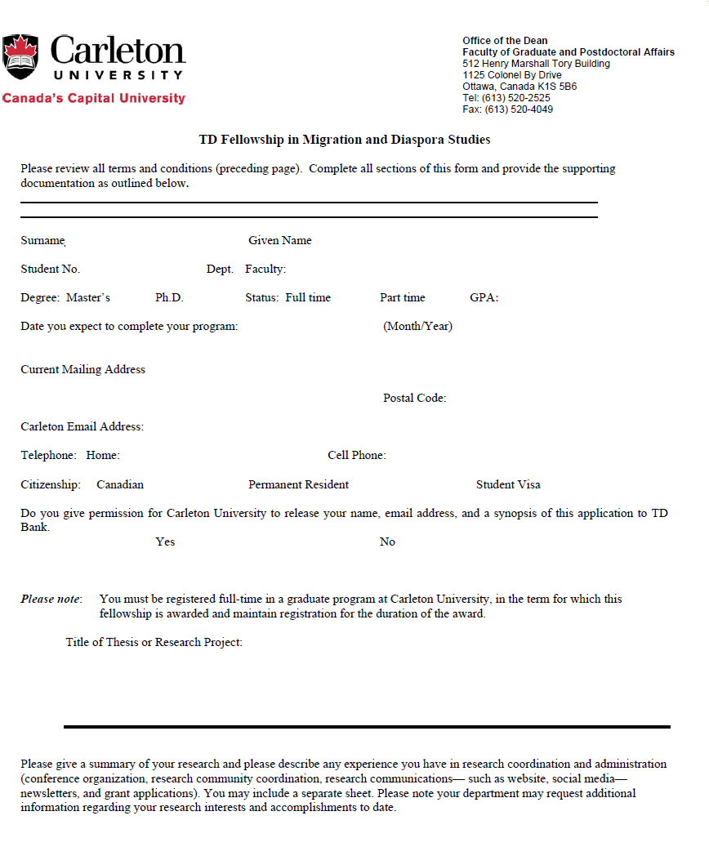

Date: Signature:

