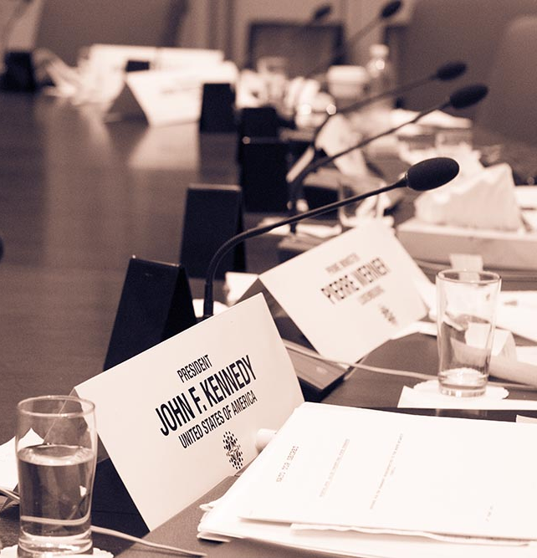
Application: Student Bursary
Carleton Model NATO
Conference 2024

About the MNATO Student Bursary
Terms and Conditions
Carleton Model NATO provides funds to students in financial need who require assistance to participate in the annual Model NATO conference. The fund may cover a portion of the cost related to conference expenses such as accommodation, travel and registration fees.
The bursary account contains a limited amount of funds. Approval of each application is dependent on the availability of funds.
The maximum amount of the bursary is $300 CAD, paid as a reimbursement upon approval of actual eligible expenses.
Deadline for Applications
Applications are considered on first-come-first served basis. Application forms will be accepted up to 2 weeks prior to the MNATO conference (Feb.08, 2024). All applications must be submitted by email to carletonmnato@gmail.com.
Eligibility
All students interested in attending the Carleton Model NATO conference are eligible to apply.
Successful applicants will only receive the bursary funding after the conference concludes and upon receipt of an approved expense report. Only actual eligible expenses up to the maximum approved amount will be reimbursed.
The fund is intended to cover modest costs where other sources of support are not available. Those receiving full funding from another source (e.g. university travel funds) are ineligible to apply. However, where an applicant is only given partial funding from another source, they may apply to cover the remainder of conference related expenses.
Reporting Requirement

Students are required to submit an expense sheet (template will be provided to all successful applicants) after attending the conference. The expense sheet will request detailed information on the final cost of their conference related expenses, supporting documentation, and evidence of other financial support.
Carleton Model NATO Conference 2024 Student Bursary Application Form
First Name
Last Name
E-mail |  | Cell Phone

Address (Street Number, Street Name, Province):

Level of Study (in the 2023/2024 academic year):

☐ First Year ☐ Second Year ☐ Third Year ☐ Fourth Year ☐ Fifth+ Year

Current Program of Study and Institution
(Please fill out this section if you are a student in the 2023/2024 academic year):

Please state why the bursary is required and why you are interested in attending Carleton MNATO 2024:

Have you attended Carleton MNATO in the past?
☐ Yes ☐ No
Have you applied for any other source of travel funding for Carleton MNATO?
☐ Yes ☐ No

If yes, please describe all other funding sources you are applying for (the amount requested and the amount of funding confirmed from other sources):

Please describe your anticipated conference expenses and how much funding you are requesting for this bursary:

Expenses

Expenses | Estimated Cost (CAD)
Registration Fee
Airfare
Surface Travel
Accommodation
Other

If ‘other’, please describe

Total anticipated expenses:

Amount of funding requested (up to maximum of $300):

Thank you for applying for Model NATO 2022 Student Bursary! Please submit your completed application form to carletonmnato@gmail.com with the subject line "Model NATO 2024 Student Bursary” by Feb. 08, 2024.

I have read and understood the Terms and Conditions of the Carleton MNATO Student Bursary. I hereby certify that the information given in this application is correct. I fully understand that any false statements made by me on this application or any supplement thereof may be sufficient cause for rejection of my application.

Date: Signature:

