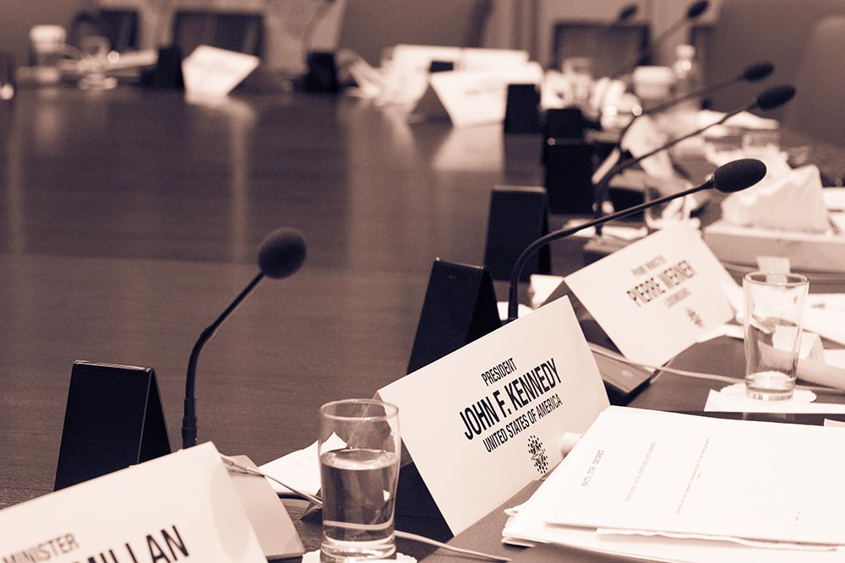
Staff Application: Secretariat and Chairs
Carleton Model NATO
Conference 2022

About MNATO
The Carleton Model NATO conference is a four-day conference/simulation that brings together students from across Canada to debate and appreciate the transatlantic alliance. The core of the event is an intensive and immersive two-day simulation of NATO decision-making and crisis management. By assuming the role of NATO member state representatives, students gain a rich and unique understanding of Alliance politics, priorities and challenges facing. Committee topics and crisis scenarios are designed to challenge delegates to think critically and creatively about NATO’s current operations, priorities, and future directions.

Carleton MNATO will be taking place from February 24-27, 2022 in Ottawa. This year’s conference is currently being planned as a hybrid conference, with opportunities for delegates to participate either in-person or remotely.

MNATO 2022 is recruiting for staff and secretariat positions. Click here for a full description of all available positions and descriptions.

Please note that these descriptions are non-exhaustive. The time commitment varies, but all applicants must be available for the conference dates (February 24-27). Please note that Secretariat positions are much more intensive than Chair positions. However, all positions allow Staff and Secretariat members to work collaboratively in developing a strong conference for university students from across Canada, as well as run and oversee the committee simulations during the course of the conference.

If you have any questions, please do not hesitate to contact Judy Perpose, Project Manager for Carleton MNATO 2022, at carletonmnato@gmail.com.

Please submit your completed application form and résumé to carletonmnato@gmail.com with the subject line "Staff Application for MNATO 2022” by the deadline, September 17, 2021.

We will respond to all successfully submitted applications within 24 hours. If you have not received a confirmation email within 24 hours please contact carletonmnato@gmail.com.

Carleton Model NATO Conference 2022 Application Form
First Name
Last Name
E-mail |  | Cell Phone

Level of Study (in the 2021/2022 academic year):

☐ First Year ☐ Second Year ☐ Third Year ☐ Fourth Year ☐ Fifth+ Year
☐ I am not a student or I am no longer a student

Current Program of Study and Institution
(Please fill out this section if you are a student in the 2021/2022 academic year):

If you are no longer a student, please provide a brief synopsis of your academic background (including degrees obtained, program information, and graduation dates):

Please indicate your preferences for the following available positions (up to 3):

Secretariat: | Chair:
- Finance and Logistics Coordinator | - Chair, North Atlantic Council
- Secretary General | - Chair, Military Committee
- Media Director | - Chair, Civilian Intelligence Committee
- Crisis Director | - Chair, Euro-Atlantic Partnership

First Choice:
Second Choice:
Third Choice:

Briefly discuss your position choices:

Do you have any experience attending or staffing a Model NATO simulation?
☐ Yes ☐ No

Please describe why you are an excellent candidate for a Model NATO Secretariat Member or Chair?

What do you think is one of the main issues facing NATO today?

What do you hope to gain from MNATO 2022 as a Secretariat member or Chair?

Are you available for the entirety of the conference (February 24-27, 2022)?
☐ Yes ☐ No

Thank you for applying for Model NATO 2022! Please submit your completed application form and résumé to carletonmnato@gmail.com with the subject line "Staff Application for MNATO 2022” by the deadline, September 17, 2021.

