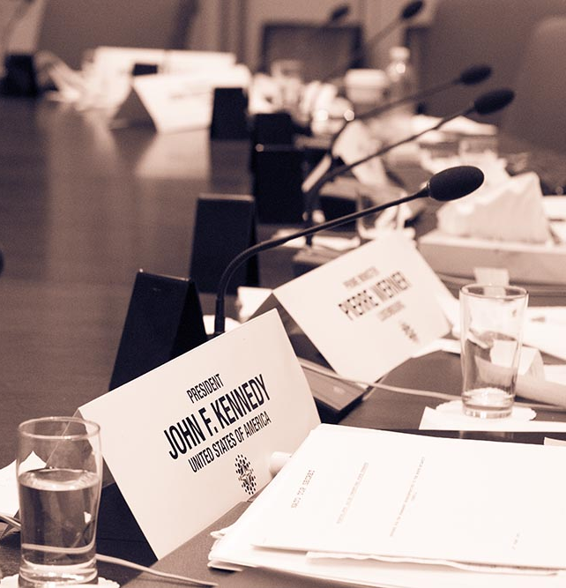
Application: Student Funding
Carleton Model NATO
Conference 2023

About the 2023 MNATO Student Bursary/Fee Waiver
Terms and Conditions
Carleton Model NATO provides funds to students in financial need who require assistance to participate in the annual Model NATO conference. There are two distinct categories of CMNATO financial assistance – (i) waivers for the participation fee or accommodations, and (ii) student bursaries.
The bursary account, specifically, contains a limited amount of funds. Approval of each application is dependent on the availability of funds – we will not be able to determine the total amount of available funds until shortly before the conference.
After evaluation of projected expenses, funding packages may be granted for one or more of the following:
- A financial bursary for students of up $250CAD
- Conference registration fee waiver
- Sponsored hotel accommodations*
Deadline for Applications
Applications will be considered in two rounds:
Round 1 Funding Deadline: January 27th, 2023
Round 2 Funding Deadline: February 10th, 2023
All application forms must be submitted by email to carletonmnato@gmail.com.
Most initial funding decisions will be made immediately after the ‘Round 1 Funding Deadline’ of January 27th, 2023. Remaining funding decisions (i.e. those submitted in time for the Round 2 funding deadline) will be made immediately prior to the conference based on remaining funds.
Eligibility
All students interested in attending the Carleton Model NATO conference are eligible to apply.
Successful applicants may receive approved funding at two different points:
- Prior to the conference: Delegate fee waivers and/or sponsored accommodations will go into effect immediately after the application has been approved by the Secretariat; conference attendees who have already paid the conference fee will have that amount refunded.
- Following the conclusion of the conference: Based on available conference funds, bursary funds will be distributed to successful bursary applicants who:
- Submit a position paper prior to the conference
- Attend all scheduled committee sessions (barring excused absences)
- Attend at least one Embassy Tour or other approved conference activity
We at CMNATO strongly believe in reducing barriers to participation, especially for delegates hailing from underrepresented groups – we will be approaching the distribution of student bursaries/fee waivers as equitably as possible.
The fund is intended to cover modest costs where other sources of support are not available. Those receiving full funding from another source (e.g.,university travel funds) are ineligible to apply. However, where an applicant is only given partial funding from another source, they may apply to cover the remainder of conference related expenses. This application will primarily rely on the honour system through delegates’ self-reported projected needs.
Further questions on student funding eligibility can be directed to: carletonmnato@gmail.com
* Sponsored hotel accommodations may only be available to delegates if they are in a room that is fully occupied.

Carleton Model NATO Conference 2023 Student Funding Application Form
First Name:
Last Name:
E-mail |  | Cell Phone

Post Secondary Institution:

Level of Study (in the 2022/2023 academic year):

☐ First Year ☐ Second Year ☐ Third Year ☐ Fourth Year ☐ Fifth+ Year

Current Program of Study

Have you applied for any other sources of travel funding?

☐Yes☐No

If yes, please describe all other funding sources you are applying for (the amount requested and the amount of funding confirmed from other sources):

Please describe your projected conference expenses:

Expenses

Expenses | Projected Cost (CAD)
Airfare
Surface Travel
Accommodation
Food
Other

If ‘other’, please describe

Total projected expenses:

Please describe, in detail, the rationale behind each estimated cost listed in the above expense table. Please include additional attachments to this form if needed.

Amount of bursary funding requested (up to maximum of $250):

How do you hope to contribute to Carleton MNATO as a participant and what do you hope to learn? (150-200 words)

Do you have a preference for which form(s) of support (i.e. fee waiver, accommodations waiver, student bursary) you will receive?

Thank you for applying for Model NATO 2022 Student Funding! Please submit your completed application form to carletonmnato@gmail.com with the subject line "Model NATO 2023 Student Funding” by Jan 27, 2023 (Round I) or Feb. 10, 2023 (Round II).

I have read and understood the Terms and Conditions of the Carleton MNATO Student Funding. I hereby certify that the information given in this application is correct. I fully understand that any false statements made by me on this application or any supplement thereof may be sufficient cause for rejection of my application.

Date: Signature:

