NPSIA Spring/Summer 2026 Classes
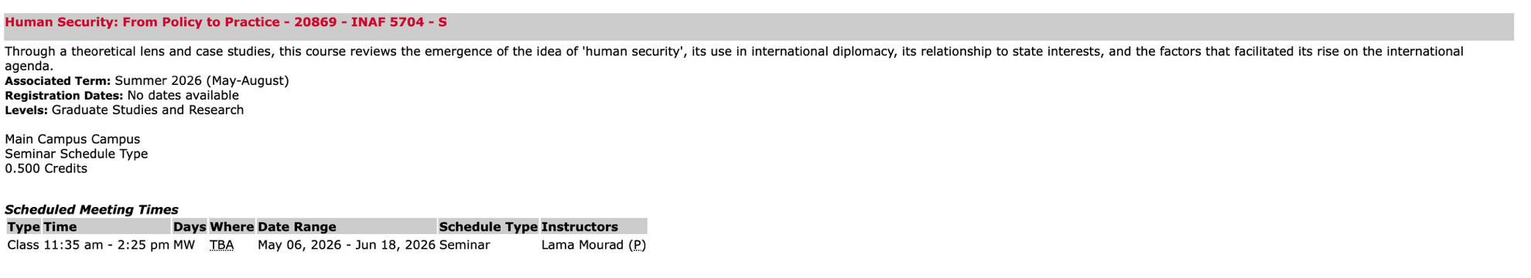
Selected Topic - Illegalities and Conflict
