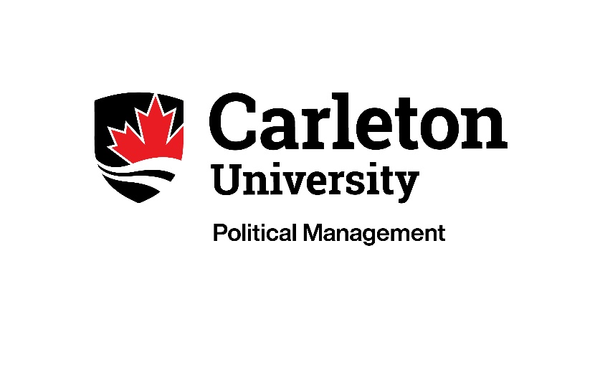

POLM 5007: Writing in a Political Context
Instructor: Prof. Jeni Armstrong
NOTE: POLM 5007 is normally taught in two sections (A, B). While the course content (readings, lectures, assignments) is the same across both sections, specific due dates vary and are not included in this online version of the course outline. Registered students will have access to the more detailed course outlines — which will also included week-by-week assigned readings and A/V — via Brightspace.

I. Course description:
This six-week (0.25 credit) course will introduce students to the art (and craft) of effective political writing. We will look at what separates passable prose from really great writing, and will put those concepts to the test in a series of practical, real-world assignments.
The course will be taught in a hybrid format that will rely heavily on self-directed learning, combined with weekly classes (in-person or via Zoom, depending on the section). In addition to the work required to complete the assignments, you can expect to read (on average) 75 pages a week for this course and spend around half an hour each week watching pre-recorded content (this will vary week to week). Though it won’t be a regular part of this course, we may be joined by outside experts as guest speakers.
II. Preclusions

None.

III. Learning Outcomes:

By the end of this course, successful students will have demonstrated an understanding of how to write professionally and effectively in a political context, and demonstrated their ability to:
- Reflect on their personal goals. This includes the ability to think about—and articulate—their motivations for studying political management / political writing.
- Follow through with self-directed learning to support and strengthen their skills as writers. This includes the ability to complete weekly readings and quizzes that address some of the technical aspects of writing (spelling, punctuation) that can’t be covered in a six-week course.
- Produce written products that are well written, properly formatted, and delivered on time. This includes the ability to create compelling first drafts; a willingness to work with peer feedback to produce final, polished documents; and a proven ability to meet formatting expectations and submission deadlines.
- Act in a supportive and professional manner. This includes the ability to provide constructive and meaningful feedback on others students’ written work, and a demonstrated commitment to meeting all the deadlines laid out in this course outline.

IV. Texts:

- Garner, B.A., & Wallace, D. F. (2013). Quack This Way: David Foster Wallace & Bryan A. Garner Talk Language and Writing. Dallas, Texas: RosePen Books.
- Dreyer, B. (2019). Dreyer’s English: An utterly correct guide to clarity and style. New York: Random House.
- McCarten, J. (2021). The Canadian Press Stylebook: A Guide for Writers and Editors (19th ed.). The Canadian Press. (NOTE: If you have an earlier edition, it will likely still be fine, but note that the course outline references page numbers from the 19th edition, and the 19th edition will be the “final word” in cases where editions offer different guidance.)
- McCarten, J. (2022). The Canadian Press Caps and Spelling (23rd ed.). The Canadian Press.
- Additional readings as assigned.

V. Course calendar:

A range of topics will be covered in this six-week course:

Week | Topic
Week 1 | Introduction to Writing in a Political Context
Week 2 | How To Be A Better Writer
Week 3 | Just the Facts: News Releases, Backgrounders
Week 4 | Policy and Politics: Briefing Notes
Week 5 | Opinion: Speeches, Op-Eds
Week 6 | Messaging: Key Messages, Political Q&A

VI. Evaluation:

A range of assignments will be used to assess student performance and progress in the course. These include:
Assignment | Percentage | Due Date
Reflection Letter | 15% | Due before Week 2 class.
Weekly Quizzes | 25%  Each short quiz is worth 5%; there are five quizzes in total:  - Language and Writing  - Spelling and Capitalization  - Punctuation  - Plain Language  - Frequently Confused Words | New quiz posted each week. Quizzes can be completed at any time during the week but are always due before the next class.
Written Assignments | 60%  Each assignment is worth 15%; there are four assignments in total:  - News Release  - Briefing Note  - Speech  - Key Messages / Political Q&A | See detailed course outline and/or Brightspace for specific due dates, and for further information on how each component of the assignment (initial draft, peer review, final draft) will be assessed.
Standing in a course is determined by the course instructor subject to the approval of the Faculty Dean. This means that grades submitted by the instructor may be subject to revision. No grades are final until they have been approved by the Dean.

VII. Statement on Plagiarism
Carleton’s Senate defines plagiarism as “presenting, whether intentionally or not, the ideas, expression of ideas, or work of others as one’s own.” This can include:

- Reproducing or paraphrasing portions of someone else’s published or unpublished material, regardless of the source, and presenting these as one’s own without proper citation or reference to the original source;
- Submitting assignments prepared, in whole or in part, by someone else, including the unauthorized use of generative AI tools (eg: ChatGPT); please note that because POLM 5007 is a foundational writing course designed to help assess and improve your skills as a writer, use of generative AI for your assignments is not authorized/allowed;
- Using ideas or direct, verbatim quotations, paraphrased material, algorithms, formulae, scientific or mathematical concepts, or ideas without appropriate acknowledgment in any academic assignment;
- Using another person’s data or research findings without appropriate acknowledgement;
- Failing to acknowledge sources through the use of proper citations when using another person’s works and/or failing to use quotation marks.

Additionally, in this course you may not hand in a completed assignment that you have previously submitted, or intend to submit, to another course (including this course, if you have taken it previously).
You should know that plagiarism is a serious offense which cannot be resolved directly with me. If I suspect that you have submitted plagiarized work, a rigorous investigation will be launched by the Faculty Dean. The penalties for plagiarism are not trivial, and can include a final grade of “F” for the course. You can read more about the process and potential sanctions here.

VIII. Statement on Student Mental Health
As a university student you may experience a range of mental health challenges that significantly impact your academic success and overall wellbeing. If you need help, please speak to someone. There are numerous resources available both on- and off-campus to support you. Here is a list that may be helpful:

Emergency Resources (on and off campus): https://carleton.ca/health/emergencies-and-crisis/emergency-numbers/

Carleton Resources:
• Mental Health and Wellbeing: https://carleton.ca/wellness/
• Health & Counselling Services: https://carleton.ca/health/
• Paul Menton Centre: https://carleton.ca/pmc/
• Academic Advising Centre (AAC): https://carleton.ca/academicadvising/
• Centre for Student Academic Support (CSAS): https://carleton.ca/csas/
• Equity & Inclusivity Communities: https://carleton.ca/equity/

Off Campus Resources:
• Distress Centre of Ottawa and Region: (613) 238-3311 or TEXT: 343-306-5550, https://www.dcottawa.on.ca/
• Mental Health Crisis Service: (613) 722-6914, 1-866-996-0991, http://www.crisisline.ca/
• Empower Me: 1-844-741-6389, https://students.carleton.ca/services/empower-me-counselling-services/
• Good2Talk: 1-866-925-5454, https://good2talk.ca/
• The Walk-In Counselling Clinic: https://walkincounselling.com

Academic Accommodations

You may need special arrangements to meet your academic obligations in this class. For an accommodation request, the processes are as follows:

Students with Disabilities: The Paul Menton Centre for Students with Disabilities (PMC) provides services to students with learning disabilities, psychiatric/mental health disabilities, attention deficit hyperactivity disorder, autism spectrum disorders, chronic medical conditions, and impairments in mobility, hearing, and vision. If you have a disability requiring academic accommodations in this course, please contact PMC at 613-520-6608 or pmc@carleton.ca for a formal evaluation. If you are already registered with the PMC, contact your PMC coordinator to send me your letter of accommodation at the beginning of the term, and no later than two weeks before the first in-class scheduled test or exam requiring accommodation (if applicable). After the request for accommodation has been made, please also schedule a time to meet with me, so that we can make sure that the accommodations you need are in place.
Pregnancy or Religious Observation: As soon as you are aware that accommodation for these reasons may be needed, please contact me directly via email. We will work together to find a way for you to satisfy your course requirements in a way that does not disadvantage you academically.

Survivors of Sexual Violence: As a community, Carleton University is committed to maintaining a positive learning, working and living environment where sexual violence will not be tolerated, and where survivors are supported through academic accommodations as per Carleton’s Sexual Violence Policy. For more information about the services available at the university and to obtain information about sexual violence and/or support, visit: https://carleton.ca/equity/sexual-assault-support-services

Student Activities: Carleton University recognizes the substantial benefits, both to the individual student and for the university, that result from a student participating in activities beyond the classroom experience. Reasonable accommodation will be provided to students who compete or perform at the national or international level. Write to me with any requests for academic accommodation during the first two weeks of class, or as soon as possible after the need for accommodation is known to exist.

