CUREB CuResearch User Guide

Browser Compatibility
Internet Explorer 9, 10 or 11, Firefox 25, 26, or 27, or Google Chrome
(Safari DOES NOT provide full functionality)
CuResearch Researcher Portal

Table of Contents (control + click to navigate to a specific section)
CUREB CuResearch User Guide 1
Browser Compatibility 1
How to submit a new CUREB Ethics Application: 3
How to submit revisions to a CUREB Ethics Application: 10
Submit an Event in CuResearch (a Renewal Request, Closure Report, Change to Protocol or Adverse Events form, or Protocol form following a release of funds) in CuResearch 15
How to Re-Submit an Event in CuResearch 19
Frequently Asked Questions 24
1. What is the limit for attachments? 24
2. What does “user not validated” mean? How does a user become validated? 24
3. How do I remove the Errors tab? 24
4. Will I receive notifications in CuResearch? 24
5. I think I locked my account. How do I fix it? 24
6. I am having trouble with the forms. Do I need specific software to fill out the forms before I upload them to CuResearch? 25

How to submit a CUREB Ethics Application:
The CUREB protocol form, Very Low Risk Form, Request to Release Funds form, Course Based Research Form, and Secondary Use form are all submitted as new applications.

- First time users should email the Research Ethics Coordinator at ethics@carleton.ca to request a user account in CuResearch.
  - Provide: researcher name, department, Carleton email address, status (Honour’s, Master’s Ph.D., or Post Doc, faculty, staff), student/employee number, and the name of their faculty supervisor (if applicable).
  - The coordinator will send a confirmation email when the new user account is created.

- Log into the CuResearch Researcher Portal with your MyCarletonOne credentials.

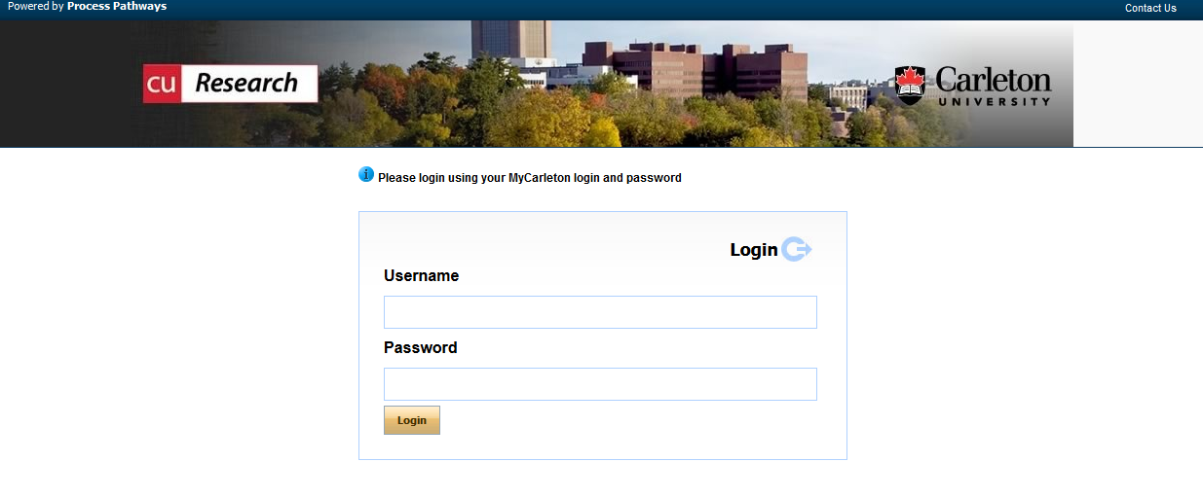

- Select Apply New on the home page to view a list of all available application forms.

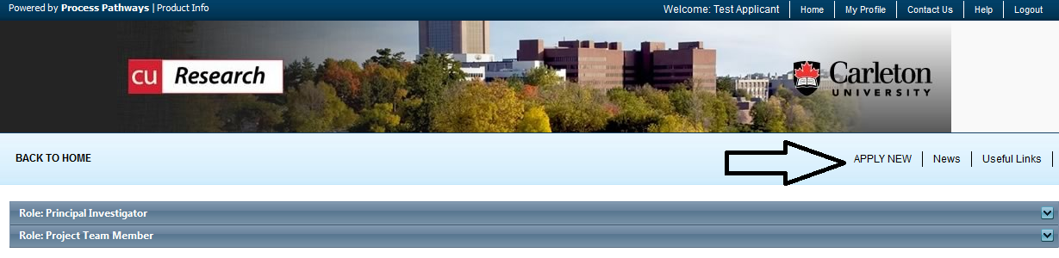

- Select the name of the application for the certification are applying for:
  - CUREB-A Applicants - select the CUREB-A Protocol Form;
  - CUREB-B applicants - select the CUREB-B Protocol Form.

Example: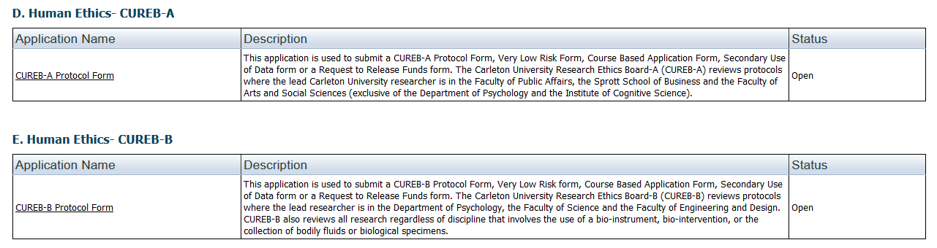

NOTES:
- Closing the file without saving first may cause the file to be locked and information entered to be lost.
  - Contact the Research Ethics Coordinator at ethics@carleton.ca to unlock the file.
- Fields marked with a red asterisk are mandatory.

- Under the Project Info tab:
  - Project title: enter the title of your project
  - Enter the Start Date and End Date of the study
  - Key Words: not required

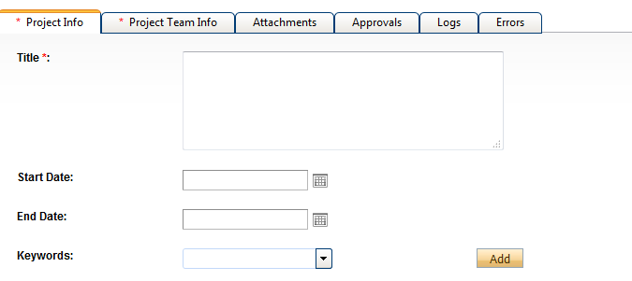

  - Related Awards - If an award is linked to the study:
    - Click on the Search key located under Related Awards,
    - You will be brought to a screen, similar to the one that follows, and all awards associated with the PI’s should appear.
    - Please note: If this is a teaching protocol, you are not required to select an award.
    - If your award is not listed, please advise the Research Ethics Coordinator for CUREB at ethics@carleton.ca.

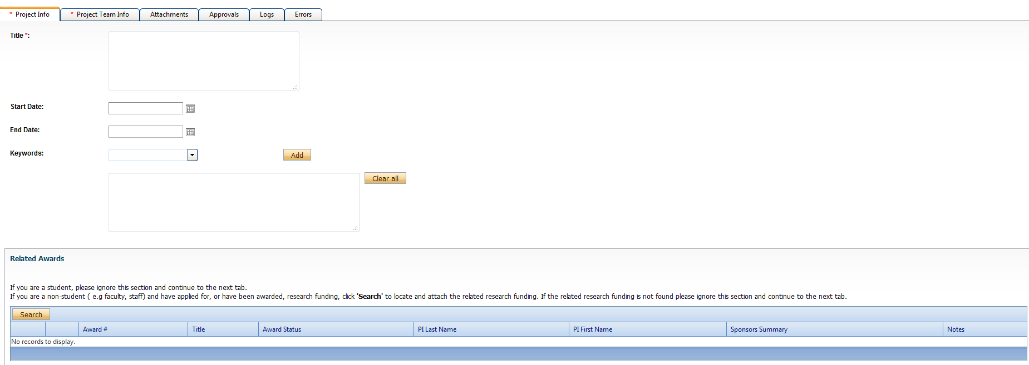
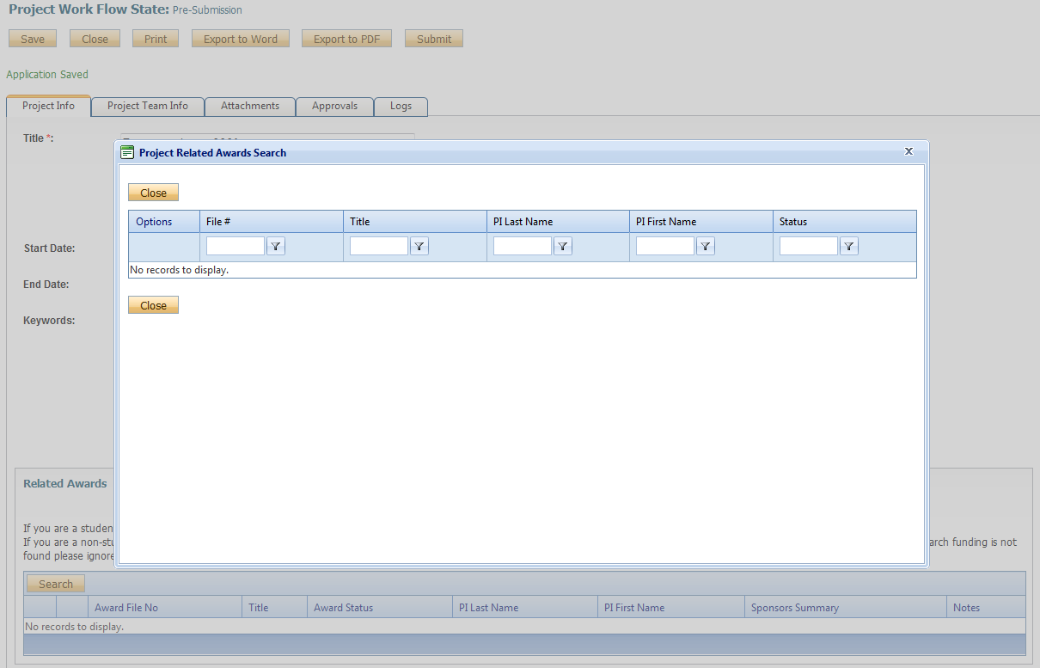
- Project Team Info tab.
  - If you are a student, ensure your supervisor is listed under Project Members, if they are not listed as the PI.
  - Search and select Other Project Members that have been given access to CuResearch by the Office of Research Ethics
  - Note: When searching you must click “Search Profiles,” instead of selecting enter.
        - Project team members must be given a role in the project (such as Supervisor, Research Assistant, Collaborator, or Co-Investigator).
        - Adjunct faculty members and external supervisors should also be listed in the Project Team Member tab.
  - If the person you want to add does not come up, do not type in the information, email ethics@carleton.ca to give them access to CuResearch
    - For each person, provide the following information:
- First and last names
- Banner ID/Employee number
- Carleton email
- Rank or position (i.e., staff, student, professor etc.)
- Faculty and Department

- Attachments - Attach your completed CUREB Protocol.
  - Forms can be found at https://carleton.ca/researchethics/forms-and-templates/

  - Note: the limit for attachments is 10MB per attachment. You may attach files in WORD or PDF format.
- Select Add Attachment.
- Enter a description, if applicable (e.g. Ethics Protocol, Study Appendices, TCPS2 completion certificate).
- Click Browse to add the appropriate attachment.
- Enter the version date (date of submission) using the calendar tool.
- Select the Doc/Agreement to identify a broad category of attachment (E.g. Project Form or Consent Form).
- Click Add Attachment to upload the attachment to the protocol form.

- If your application is complete, select “Submit”. If you would like to return to work on the application, click “Save.”
-The application will be saved under Applications: Drafts in the drop-down menu on your home page when you login.

- A text-box window will pop-up after you select “submit.” In this box, researchers can leave any pertinent notes for the Research Ethics Coordinator regarding the application. When the textbox pops up afterward, click “Submit,” type something in the box, and then click “Submit” again – if you do not, it does not go into the system.

Note: Student Researchers: The CUREB requires proof of review by your faculty supervisor/sponsor; this can be done in one of two ways:
  - Faculty Supervisor/Sponsor signs form confirming review
      - The student researcher may have the supervisor sign a form confirming their review of the application
        - Form: https://carleton.ca/researchethics/forms-and-templates/ - Supervisor/Sponsor Signature Form
      - Upload signed form to application
      - Submit application (see #8, above)
      - A brief comment, to the Research Ethics Coordinator can be added to the pop up window.

  - Faculty Supervisor/Sponsor emails ethics@carleton.ca to notify CUREB of their approval of a student’s protocol submission.

- An email confirmation will be sent from CuResearch when the application has been submitted.

How to submit revisions to a CUREB Ethics Application:

- The research team can expect to receive an email from the Office of Research Ethics when CUREB comments have been released.
  - This email will contain a list of the required revisions.

- Log into the CuResearch Researcher Portal with your MyCarletonOne credentials.

- Click Applications: Requiring Attention in the Principal Investigator or Team Member sections of the CuResearch home page.

  - The location of the protocol will depend on your role in the study.

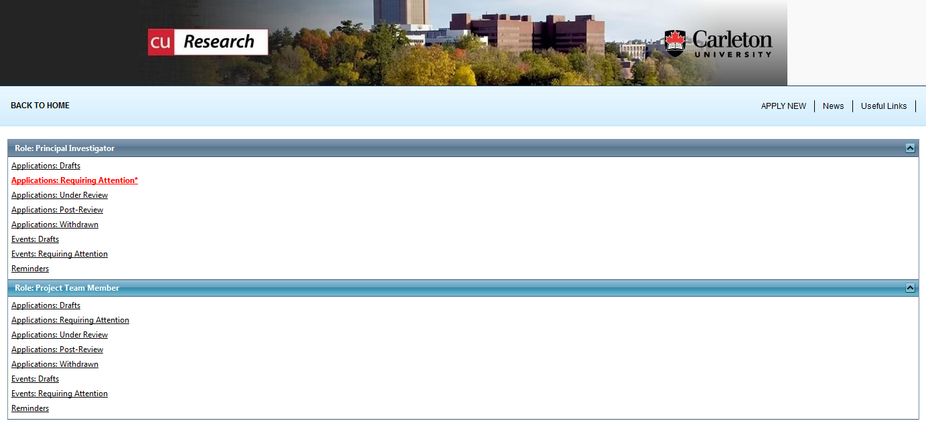

- Protocols in this list can be viewed or edited
  - Click Edit
    - The project status will say “Pending” at this time.

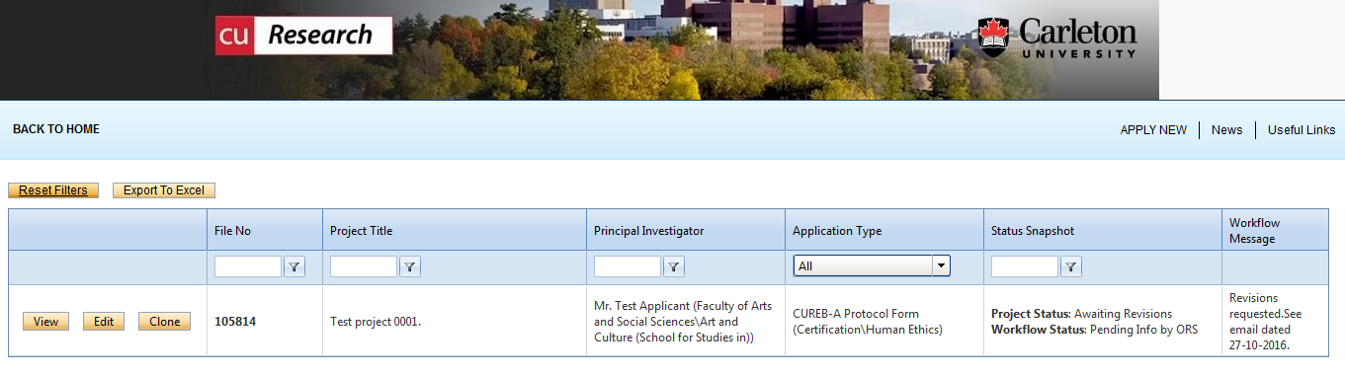

- Proceed to the Attachments tab. Attach your revised CUREB Protocol Form and appendices, as required:
  - Note: the limit for attachments is 10MB per attachment. You may attach files in WORD or PDF format.
  - Select Add Attachment to add a revised protocol. Please do not edit or delete existing attachments; CUREB will keep all previous versions of the protocol and appendices on file for record keeping purposes.
  - Enter a description, if applicable (e.g. Revised Protocol, Revised Study Appendices, TCPS2 Certificate).
  - Click Browse to add the appropriate attachment.
  - Enter the version date or select the appropriate date using the calendar tool.
  - Select the Doc/Agreement to identify a broad category of attachment (E.g. Application Form or Consent Form).
  - Click Add Attachment to upload the attachment to the project file.
  - Note: do not delete the original attachments, which we keep for our records,

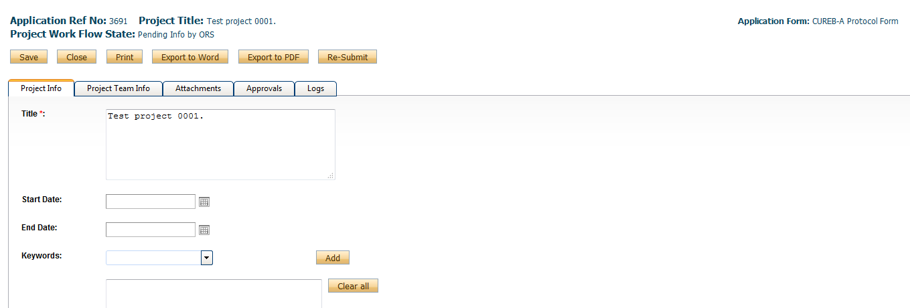

- When the revisions have been completed, click Re-Submit.

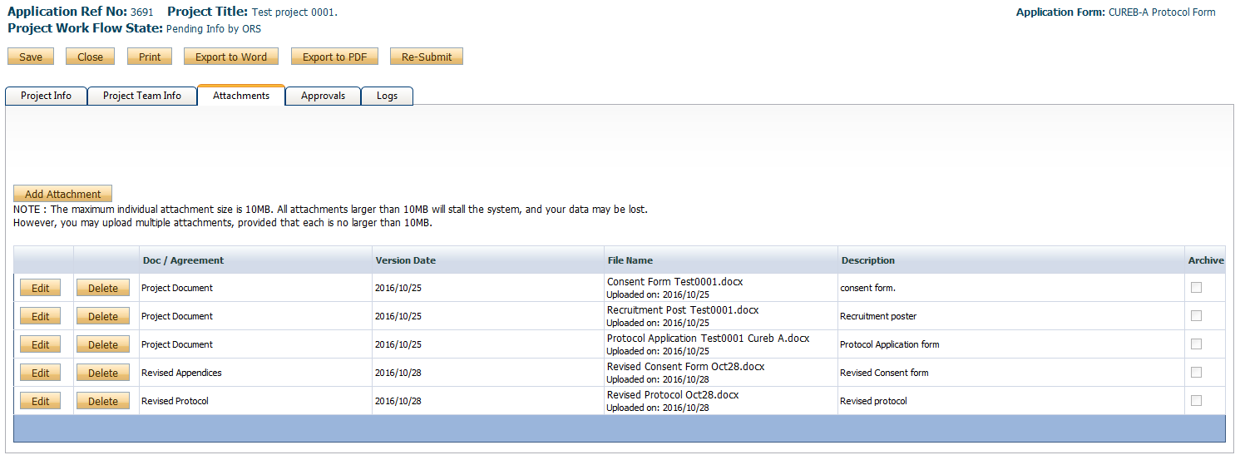

- A text-box window will pop-up after you select “re-submit.” In this box, researchers can leave any pertinent notes for the Research Ethics Coordinator regarding the application. When the textbox pops up afterward, click “re-submit,” type something in the box, and then click “Submit” again – if you do not, it does not go into the system.

- Your application will now move to the Applications Submitted-Under Review section of the CuResearch home page.

- An email confirmation will be sent from CuResearch when the application has been re-submitted.

- You will be able to check the status of the application in the Log, which tracks all data and workflow activities.
  - Workflow Status: ORS Review- the applications is being reviewed by the ORS (Office of Research Services);
  - Pending Info by ORS (the office has requested additional information/clarification/revisions from the researcher);
  - Approval Decisions Made- the protocol has been cleared.

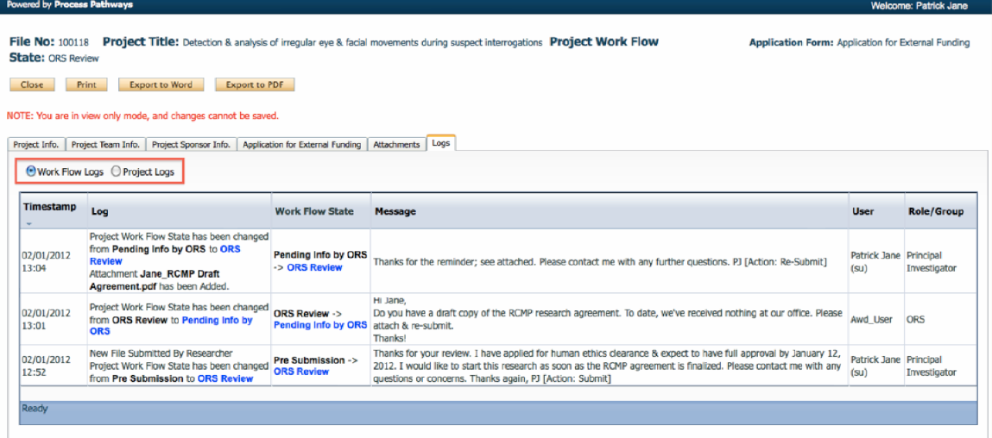

- All cleared protocols may be viewed in Applications (Submitted-Post Review)

Submit a Renewal Request, Closure Report, Change to Protocol or Adverse Events form in CuResearch

  - The CUREB Annual Renewal or Closure Form and Change to Protocol Form may be found on the website.
  - For incident reports, please find the Adverse Events and Unanticipated Problems Form on our website.

- Log into the CuResearch Researcher Portal with your MyCarletonOne credentials.

- The protocol will be sorted under the “Principal Investigator” or the “Project Team Member” menu, depending on the researcher’s role in the study. Select Applications: Post-review to view all cleared protocols.

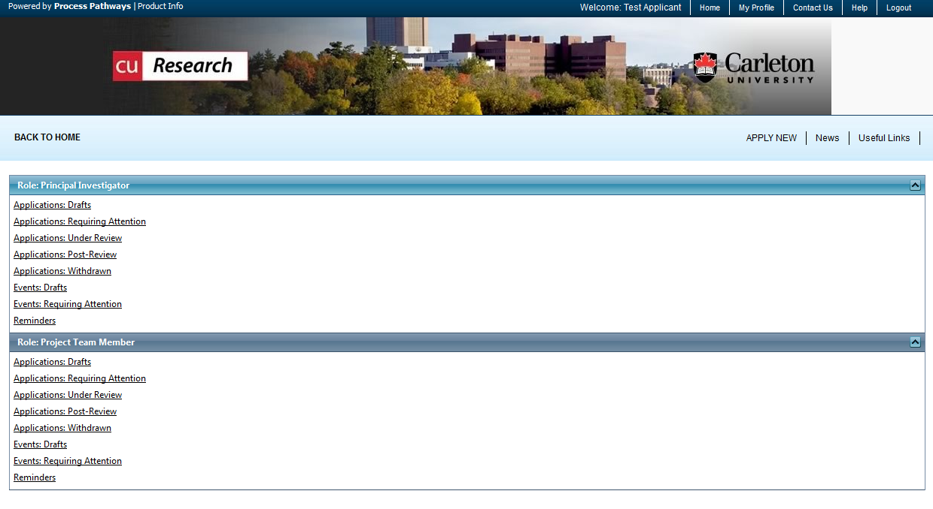

- Renewals, Closures, Changes to Protocols, and Incident Report will be submitted as Events to the cleared protocol.
  - Click Event button to the left of the protocol title.

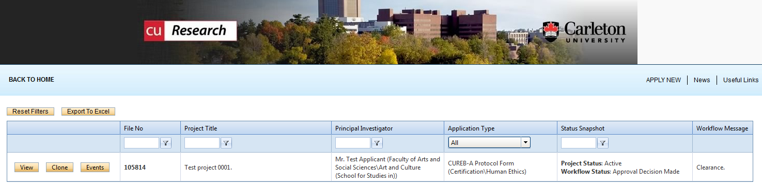

- Create a new event.
  - Select the CUREB Event Form under Create a New Event
    - CUREB-A researchers should select the CUREB-A Event Form;
    - CUREB-B researchers should select the CUREB-B Event Form.

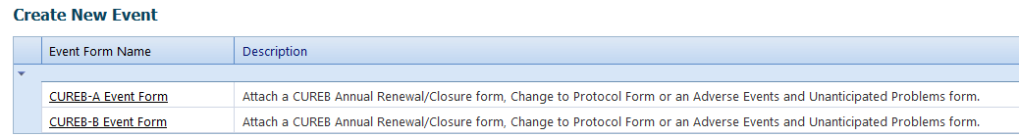

- Describe the event in the Event Info box (e.g. this is a renewal/closure/change to protocol/adverse event report).

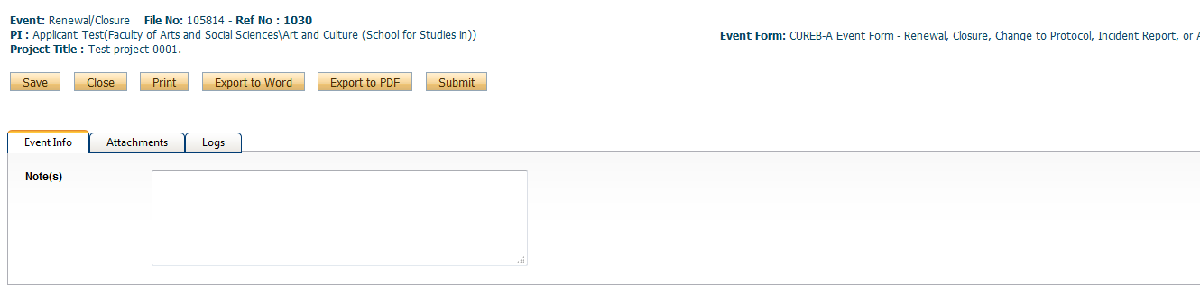

- Select the Attachments tab. Attach one of the following forms the website: CUREB Renewal or Closure Form or Change to Protocol Form.
  - An incident form may be submitted by attaching a Word or PDF file in CuResearch detailing the incident.

- You may enter a description of the attachment in the Description box.
- You may upload an attachment using the Browse button.
- Select today’s date as the Version Date (by selecting the calendar icon next to Version Date).
- Select the type of document in the Doc/Agreement drop down menu (e.g. Project Document, Other Document).

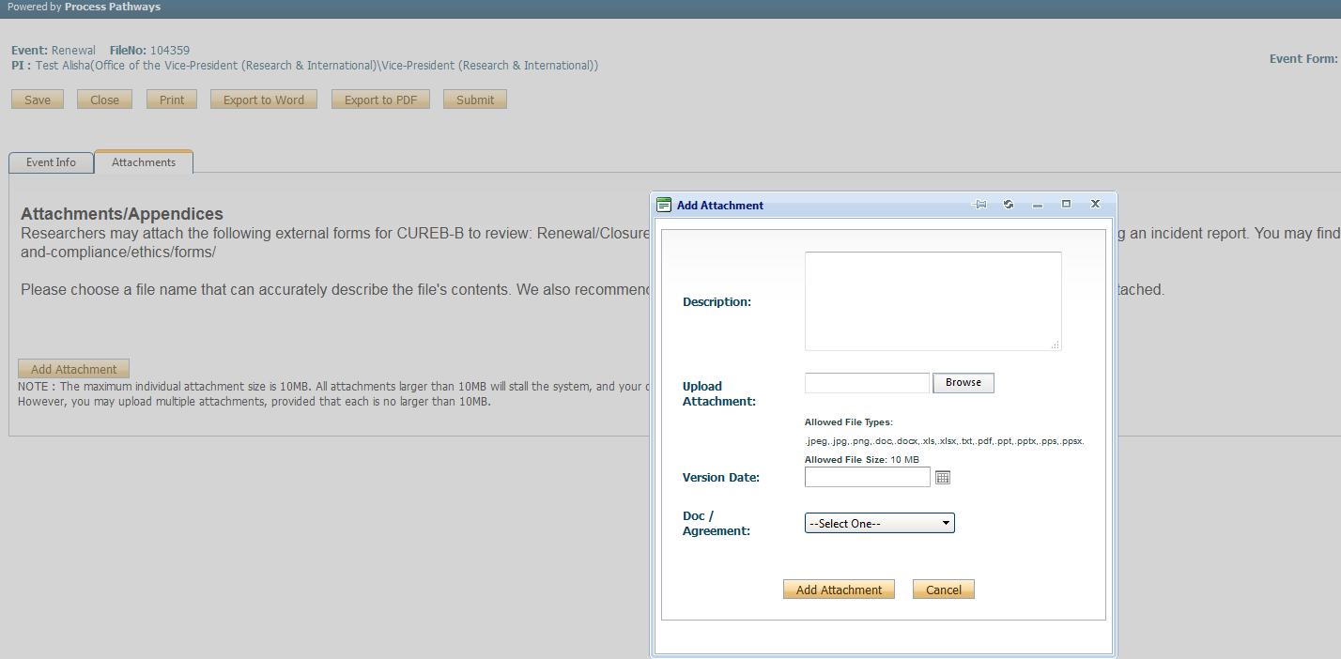

- When all documents (CUREB Renewal Closure Form, Change to Protocol Form, or Incident Report) have been attached, select the yellow Submit button at the top of the page.

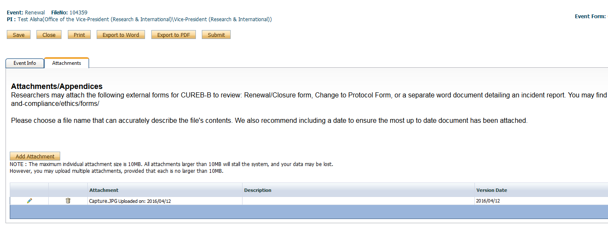
- A text-box window will pop-up after you select “submit.” In this box, researchers can leave any pertinent notes for the Research Ethics Coordinator regarding the application. When the textbox pops up afterward, click “Submit,” type something in the box, and then click “Submit” again – if you do not, it does not go into the system.

- Your application will now move to the Events Submitted-Under Review section of the CuResearch home page.

- An email confirmation will be sent from CuResearch when the application has been submitted.

How to Re-Submit an Event in CuResearch

- Log into the CuResearch Researcher Portal with your MyCarletonOne credentials.

- Select the “Events: Requiring Attention” section in the drop down menu,

  - The location of the protocol will depend on your role in the study.

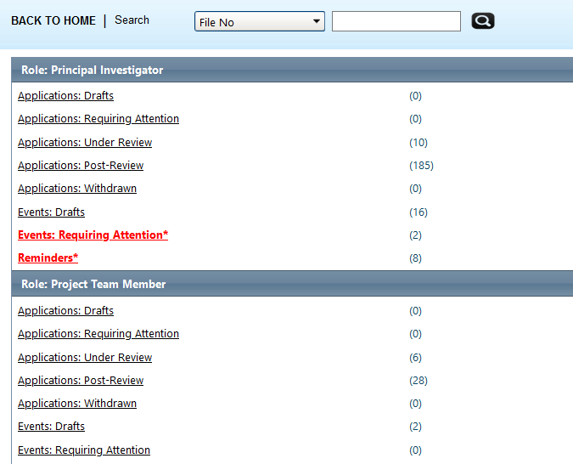

- Select the “Event” button next to the protocol title,

- Under the “Events: requiring Attention” drop down menu, select “Edit,”
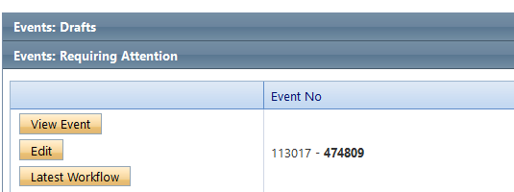
- Upload the revised change to protocol and attachments in the “Attachments” tab,
- Note: do not delete the original attachments, which we keep for our records,

- If all is in order, select the yellow “Re-Submit” button.

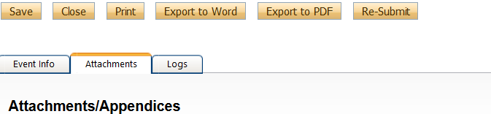

- A text-box window will pop-up after you select “re-submit.” In this box, researchers can leave any pertinent notes for the Research Ethics Coordinator regarding the application. When the textbox pops up afterward, click “re-submit,” type something in the box, and then click “Submit” again – if you do not, it does not go into the system.

- An email confirmation will be sent from CuResearch when the application has been re-submitted

Frequently Asked Questions

What is the limit for attachments?

The limit for attachments is 10MB per attachment.

What does “user not validated” mean? How does a user become validated?

A user must be validated administratively; if you see this error message in CuResearch, please contact ethics@carleton.ca.

How do I remove the Errors tab?

The errors tab displays a list of all required fields and will display until all required fields are complete. All required fields will be marked with a red asterisks (*). An application cannot be submitted while the errors tab is visible.
- Click the Errors tab to review a list of all required fields not yet complete.
- The Errors tab listing will detail the required tab & field name.
- Complete all required fields (with a red asterisk) to hide the Errors tab.
- When the required fields are completed, the errors tab will disappear; you can then to save and submit the application.

Will I receive notifications in CuResearch?
Please note: confirmation emails will be sent when the protocol has been submitted.

I think I locked my account. How do I fix it?

Files automatically lock while they are being edited by a member of the research team. The file will unlock automatically when the researcher saves and closes the file. If the file is not saved before it is closed, it will become locked. Accounts can only be unlocked administratively. Please contact ethics@carleton.ca. Saving before you close your work will prevent the account from being locked.

I am having trouble with the forms. Do I need specific software to fill out the forms before I upload them to CuResearch?

Please note that all of our forms are compatible with Microsoft Office. Students and staff members can download a free copy of MS Office at no charge.

Students: https://carleton.ca/its/ms-offer-students/

Staff/Faculty: https://carleton.ca/its/all-services/computers/site-licensed-software/ms-offer-faculty/

