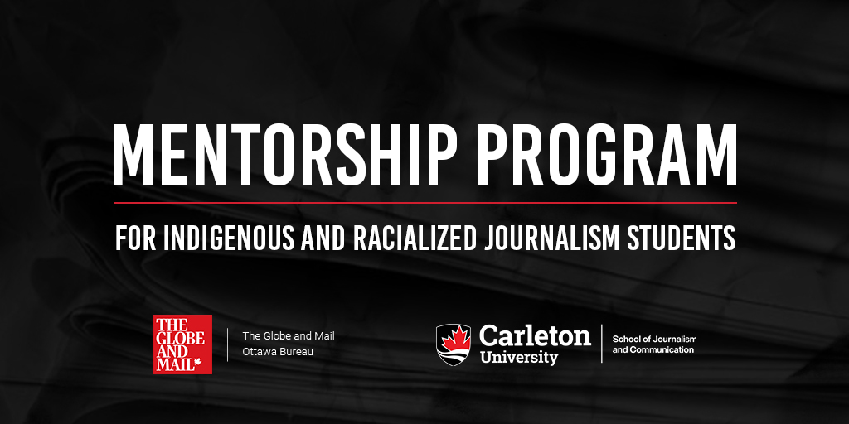

**Globe and Mail Ottawa Bureau / Carleton University School of Journalism  
Mentorship Program for Indigenous and Racialized Journalism Students**

**APPLICATION FORM**

This partnership between the Globe and Mail and Carleton University’s School of Journalism and Communication provides two mentorship opportunities for Indigenous and Racialized students enrolled in the journalism program through direct interaction with journalists in the Globe’s Ottawa bureau. Mentees will interact with Globe reporters and editors, participate in daily news meetings, and cover such events as Question Period, committees and news conferences. The Globe and Mail will provide students with mentorship through opportunities to interact with Globe reporters and with bureau chief Robert Fife. Students will also receive guidance in how to use the access to information system, the lobbyist registry, spending reports and the courts as well as other resources. Students will also be given the opportunity to assist Globe reporters with reporting assignments and also to write stories of their own that could be considered for publication.

Successful candidates will have the opportunity to work one day per week with the bureau and will be paid the equivalent of the Globe’s freelance day-rate of $206 for each full day spent with the bureau. Payments are subject to tax.

Racialized and Indigenous students in the third and fourth year of Carleton’s Bachelor of Journalism program, as well as those in both years of the Master of Journalism program are eligible to apply.

Applicants are instructed to complete and submit this application along with a current CV to the journalism program’s Permanent Working Group on Anti-Racism and Inclusion by **November 8, 2024 at 5 p.m.**

Successful candidates will be selected by the end of the third week in November.

**PART I:**

|  |  |
| --- | --- |
| **Applicant Name:** |  |

|  |  |  |  |
| --- | --- | --- | --- |
| **Address** | | | |
| Suite / Apt. / Floor |  | | |
| Number and Street Name |  | | |
| RR # / Postal Station |  | City / Town /First Nation |  |
| Province |  | Postal Code |  |

|  |  |  |
| --- | --- | --- |
| **Contact** | | |
| Phone Number |  | Email |  |
| Twitter Handle |  | Website |  |

**PART II:**

Two professional references. Please choose references who can speak about your work and suitability for the mentorship. Your references do not need to be from inside the School of Journalism and Communication and do not have to be journalism related.

|  |  |  |  |  |
| --- | --- | --- | --- | --- |
|  | **Name** | **Title** | **Email** | **Telephone** |
| Referee No.1: |  |  |  |  |
| Referee No. 2: |  |  |  |  |

**PART III:**

|  |
| --- |
| **LETTER OF INTENT (250 word maximum):** Briefly introduce yourself and speak to your eligibility for this program. Outline how participating in this program would support your journalistic career aspirations. |
|  |

**PART IV:**

|  |
| --- |
| **STORY PITCH (250 word maximum):** Pitch a story you believe you could pursue as a member of (or with the help of colleagues at) the Globe’s Ottawa bureau. |
|  |

**PART V:**

Download a copy of your academic audit so that it can be included with your completed application form. You can obtain instructions on how to obtain your academic audit at the following link:<https://carleton.ca/academicadvising/your-academic-audit/how-to-read-your-audit/>

**PART VI:**

Attach a copy of your current CV and your academic audit along with your completed application form to your email message and submit to: AdrianHarewood@cunet.carleton.ca

**FOR MORE INFORMATION**

|  |  |
| --- | --- |
| Adrian Harewood  Permanent Working Group on Anti-Racism and Inclusion  AdrianHarewood@cunet.carleton.ca |  |