CARLETON UNIVERSITY
DEPARTMENT OF SOCIOLOGY AND ANTHROPOLOGY

SOCI 1005B
WINTER 2024
SOCIOLOGY FOR BACHELOR OF COMMERCE STUDENTS

Instructor: Dr. Philip Primeau
Email: phillipprimeau@cunet.carleton.ca

Method of Delivery: Virtual- synchronous

Course Description:

The origins of sociology, why sociology matters, and how it is practiced. Concepts such as class, race, ethnicity, gender, sexual orientation, work, organization, and social movements help students develop their sociological 'eye' for thinking critically about society and their place within it. Precludes additional credit for SOCI 1002. Prerequisite(s): restricted to B.Com. students.

Reading (s)/Textbook (s):

TEXTBOOK: Little, W. (2023). Introduction to Sociology (3rd Canadian ed). BCcampus. https://opentextbc.ca/ introductiontosociology3rdedition/

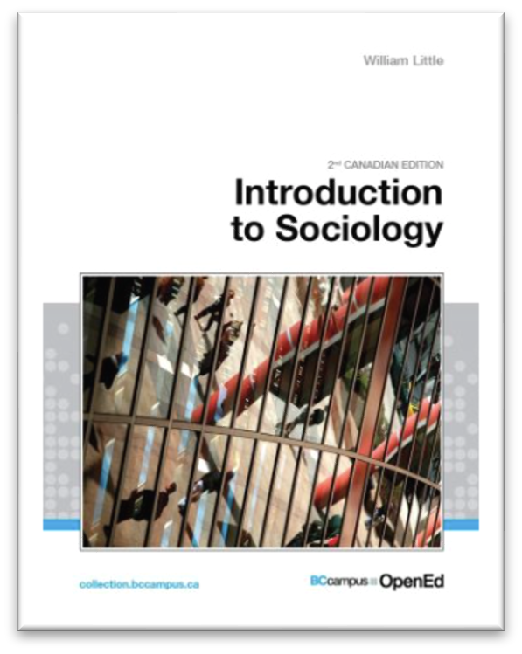
TEXTS: All other required readings will be available online & on the course’s Brightspace page. There are no texts to purchase. Some material could require remote access to the university’s online catalogue.
For this course, you can access and download your free, Open Source copy of the textbook in PDF format (Use the ‘Print PDF’ version—Watch out: large file!) on Brightspace in the ‘Course Textbook’ section. Alternatively, you can consult the book online. The PDF ‘print’ version has page numbers, whereas the website does not.

PODCASTS & VIDEOS: We’ll be watching a variety of videos and listening to different podcast episodes and music in and out of class. Links will be provided in Brightspace under each appropriate week. The course schedule below also contains some of these links, but make sure to check Brightspace as I will be adding links as the term progresses.

Course Requirements & Methods of Evaluation:

ASSIGNMENTS | % OF GRADE
Attendance & Participation Activities | 20%
Discussion Forum Activities  (2 x 15% each) | 30%
Application Analysis | 20%
Final Assignment | 30%

