CARLETON UNIVERSITY
DEPARTMENT OF SOCIOLOGY AND ANTHROPOLOGY

ANTH 1001C
WINTER 2024
INTRODUCTION TO SOCIO-CULTURAL ANTHROPOLOGY

Instructor: Matthew Hawkins
Email: matthewhawkins@cunet.carleton.ca

Method of Delivery: In-person

Course Description: Socio-cultural anthropology is the study of the diverse ways of being human: the different ways people think and act and about the relationships that they form with other people, beings, and things. This course will introduce you to how anthropologists explore these cultural differences and learn from different cultural examples from around the world. We will look at concepts of power, race/ethnicity, gender, the environment, economy and development, memory, and reconciliation to better understand the conditions of how people make social relationships. We will read ethnographies, which represent one of the important ways that anthropologists share knowledge about society and culture. In this class we will learn about social and cultural differences from around the world and in Canada. We will be exposed to ethnography and practice some of the anthropologist’s research methods.

To write or create an ethnography, anthropologists use a research method called participant-observation. The researcher participates in the lived realities of other people and observes how they construct meaning in their lives to gain an understanding of what we call “culture”.

Fundamental to how anthropologists do research is the concept of cultural relativity. Cultural relativity is not moral relativity, which would be to say all ways of being/acting are equally good. Rather, as anthropologist Marshall Sahlins writes, cultural relativity “is the simple prescription that, in order to be intelligible, other people’s practices and ideals must be placed in their own historical context [and] in the field of their own cultural relationships.” To learn about other people’s culture therefore is to engage in a relationship with other people and to be present in and participate with their lived realities.

Reading (s)/Textbook (s):

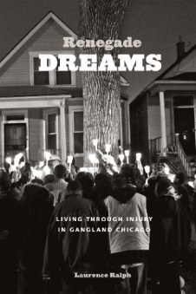
There is one required course book:
Renegade Dreams: Living Through Injury in Gangland Chicago by Laurence Ralph (2014). University of Chicago Press.
You can purchase this book at Haven Books, 43 Seneca St, at the corner of Somerset, a few blocks from the Campus entrance, and online in print and digital copies (links on Brightspace).
Other assigned readings are posted in the week’s module on the Brightspace page, as well as links to assigned podcasts and videos.

Course Requirements & Methods of Evaluation:

TA Group 20% (total)
- Attendance 10%
- Weekly Question 10%
Annotated Bibliography 15%
Decolonization Reflection 15%
Observation, Description, Analysis 25%
Renegade Dreams Take-Home Paper 25%
Total 100%

